LAB 9: BJT Common Emitter Biasing

**Date: Reg-No: 2019-EE-360**

**2019-EE-364**

**2019-EE-366**

## OBJECTIVES:

* To implement the emitter biasing scheme for BJT.
* To plot the output characteristics for common emitter biased configuration.

## EQUIPMENT AND COMPONENTS:

* Basic Circuits Training Board
* 2N3904 Transistor
* Jumper Wires
* Scope / DMM
* Resistors
* DC Power Supply

---------------------------------------------------------------------------------------------------------------------

## Biasing of common emitter BJT

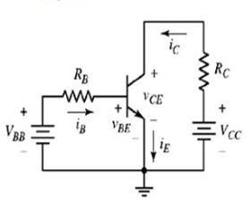In this lab, the next transistor bias arrangement will be studied called common emitter configuration. As we already know the fact that for normal transistor action, the emitter-base junction should be forward biased, and the collector-base junction should be reverse biased. Here, we will be concerned with adjusting the value of the bias, as needed, to obtain specific values of input and output currents and voltages. In other words, we accept the fact that both junctions must be biased in the proper direction and concentrate on a practical means for changing the degree of bias so that the output voltage, for example, is exactly the value we want it to be. When we have achieved a specific output voltage and output current, we say that we have set the bias point to those values.

*Fig. Common emitter biased configuration*

The biasing of common base npn bipolar junction transistor is shown below. The external bias resistors are connected to the collector and base respectively. The emitter terminal is common. The input current is base current, and the input voltage is base-emitter voltage which is normally 0.7 V for silicon transistor. The output current is collector current and the output voltage is VCE.

## Input and output current

The input current can be obtained by applying KVL to the input side. Applying the KVL to input gives the following equation.

$$V_{CC}=I_{B}R_{B}+V_{BE}$$

From this equation, the input current can be calculated as

$$I_{B}=\frac{V_{CC}-V_{BE}}{R_{B}}$$

As the output current is related by the following expression

$$I_{c}={βI}_{B}$$

where $β$ is the current amplification factor.

## Input and output voltage

The input voltage is base-emitter voltage which is approximately $0.7 V$ for silicon transistor. The output voltage can be calculated by applying KVL to the output side of the circuit diagram.

$$V_{CE}-V_{CC}+I_{C}R_{C}=0$$

$$V_{CE}=V_{CC}-I_{C}R_{C}$$

The output voltage can be simply be interpreted as the voltage equal to the supply voltage Vcc minus the voltage that has dropped across the external bias collector resistance Rc.

## Output characteristics and load line

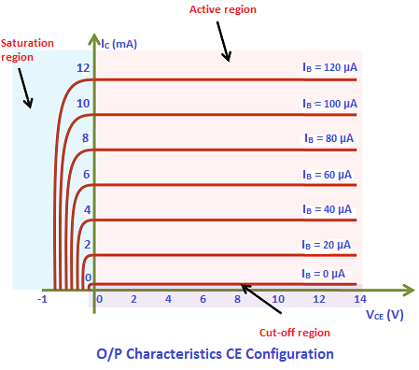The output characteristics are plotted between the output current and output voltage for fixed values of input current. These characteristics are often called collector characteristics.

The blue region indicates the saturation region. As we already know that in saturation region, both the emitter-base and collector-base junctions are forward biased. The negative value of the output voltage $V_{CE}$ corresponds to the fact that the collector-base junction is no more reverse biased.

When the input current is zero, it corresponds to the fact that the emitter-base junction is reverse biased. At the output, $V_{CE}$ is exactly equal to the supply voltage $V_{CC}$, which implies that the collector-base junction is reverse biased too. Recall that a transistor is said to be in a cut-off state when both the emitter-base and collector-base junctions are operating in the reverse biased mode. In the above figure, the region below $I_{B}=0$ corresponds to the cut-off region.

The active region is shown in the shaded red area. The active region represents the normal properties of a transistor action, in which the emitter-base junction is forward biased and the collector-base junction is reverse biased.

From the output equation, the collector current can be written in this form as below

$$I_{C}=-\frac{1}{R_{C}}V_{CE}+\frac{V_{CC}}{R_{C}}$$

If the output current and output voltage are regarded as variables and Vcc and Rc are regarded as constants, the above equation represents the equation of a straight line. When plotted on a set of Ic-VCE axes, the line has a slope of $-1/{R_{C}}$ and it intercepts the Ic-axis at Vcc/Rc. It is the line through all possible combinations of output voltage and output current. The actual bias point must be a point lying somewhere on the line. The precise location of the point is determined by the input current.

The point where the load line intercepts the VCE-axis can be found by setting IC = 0 in the above equation and solving for VCE. Similarly, the point where the load line intercepts the Ic-axis can be found by setting VCE = 0 and solving for Ic. Thus, the load line can be drawn by drawing a line through the two points VCE = 0, Ic = Vcc/Rc and Ic = 0, VCE = Vcc.

## Procedure

* Connect the circuit as shown in the diagram and set the supply voltage Vcc.
* Measure the input current (base current) and output current (collector current) with the help of an ammeter and record the reading in the table.
* Measure the output voltage VCE with a voltmeter and record the value in the table.
* Calculate the error percentage between the calculated and measured values.
* Now fix the supply voltage Vcc and external bias resistors and vary the supply voltage VBB to plot the dc load line for at least 5 different Q-points/operating points.

## Observations

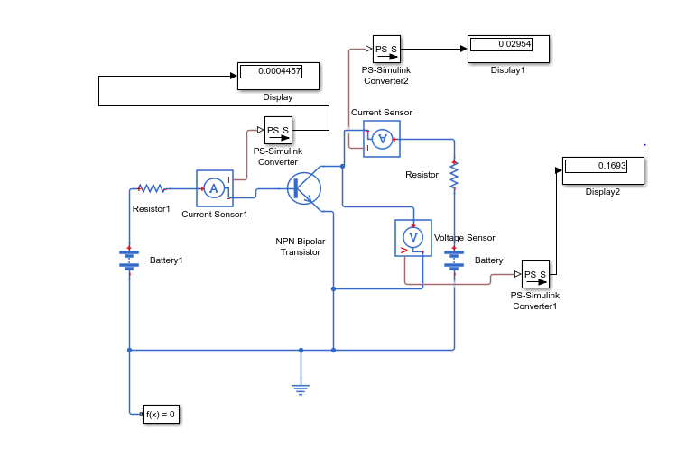

Vcc = ____15 V_____, Rc = ___500_Ω__, RB = ___10 kΩ_______, β = ____100_______

|  |  |  |  |
| --- | --- | --- | --- |
| $V_{BB}=$ 1 V | Calculated | Measured | Error Percentage |
| Input current (IB) | 0.03 mA | 0.05 mA | 40 % |
| Output current (IC) | 3 mA | 6.8 mA | 55 % |
| Output voltage (VCE) | 13.5 V | 11.58 V | 14.2 % |

|  |  |  |  |
| --- | --- | --- | --- |
| 2 V | Calculated | Measured | Error Percentage |
| Input current (IB) | 0.13 mA | 0.14 mA | 7.14 % |
| Output current (IC) | 13 mA | 16.2 mA | 19.7 % |
| Output voltage (VCE) | 8.5 V | 6.86 V | 19.2 % |

|  |  |  |  |
| --- | --- | --- | --- |
| 3 V | Calculated | Measured | Error Percentage |
| Input current (IB) | 0.23 mA | 0.24 mA | 4.16 % |
| Output current (IC) | 23 mA | 22.8 mA | 0.86 % |
| Output voltage (VCE) | 3.5 V | 3.54 V | 1.13 % |

|  |  |  |  |
| --- | --- | --- | --- |
|  | Calculated | Measured | Error Percentage |
| Input current (IB) | 0.33 mA | 0.34 mA | 2.9 % |
| Output current (IC) | 33 mA | 27.7 mA | 16 % |
| Output voltage (VCE) | -1.5 V | 1.08 V | 28 % |

|  |  |  |  |
| --- | --- | --- | --- |
| 5 V | Calculated | Measured | Error Percentage |
| Input current (IB) | 0.43 mA | 0.44 mA | 2.27 % |
| Output current (IC) | 43 mA | 29.5 mA | 31.35 % |
| Output voltage (VCE) | -6.5 V | 0.169 V | 97.4 % |

## Tasks

* Perform all the calculations for the input current, output current and output voltage on separate pages.
* Plot the output characteristics using MS EXCEL. Plot both the measured and calculated values on the same graph.

# REVIEW QUESTIONS:

Q: **What is the difference between the common base and common emitter configuration?**

**Ans:**

 The **configuration** in which the **emitter** is connected between the collector and base is known as a **common emitter configuration**. The input circuit is connected between **emitter** and base, and the output circuit is taken from the collector and **emitter**.

 The **configuration** in which the **base** of the transistor is **common** between emitter and collector circuit is called a **common base configuration**. ... In **common base**-emitter connection, the input is connected between emitter and **base** while the output is taken across collector and **base**.

**Common Base Configuration** – has Voltage Gain but no Current Gain. **Common Emitter Configuration** – has both Current and Voltage Gain. **Common** Collector **Configuration** – has Current Gain but no Voltage Gain.

Q**: How the current amplification factor can be measured?**

**Ans:**

Three terminal **measurements** of **current amplification factors** of controlled rectifiers ... sections constituting the Controlled Rectifier **can** be separately **determined**, ...

Q**: Is it possible to bias the CE circuit if the supply $V_{BB}$ is not used?**

**Ans:**

Yes ; See the Voltage Divider **Bias** ; ... Why is the e-MOSFET **not used** in the designing **of** a self-**bias circuit**

Q**: Why the resistance connected to the base terminal is of high value?**

**Ans:**

For a three terminal device like transistor to work as an amplifier it should have the operating point or (“Q-point ”) at the middle of DC-LOAD line or at the centre of active region in order to meet this requirement ,we need to limit the base current , so as to limit the base current we use resistance at base terminal of transistor,we can change the resistor values according to the transistor characteristics,because not every transistor has same gain factor

Q**: What will be the value of the supply voltage $V_{CC}$ if the output voltages are 12 V and the voltage drop across the collector resistance is 4 V?**

**Ans:**

Vcc=? ;Vce=12V ;Voltage across collector resistance =IcRc=4V

As Vcc=Vce+IcRc

By putting Values

Vcc=12+4

**Vcc=16V**