**Traffic Lights system To Reduce Negative Impacts Of Transport On Urban Environment**



**Submitted By**

**Umar Hayyat Fatima Shafiq**

**(2019-EE-360) (2019-EE-362)**

**Aswa Arif Abdul Jabbar**

**(2019-EE-370) (2019-EE-376)**

**Muhammad Shaheed Ahmad Hafeez**

**(2019-EE-408) (2019-EE-432)**

**Supervised By**

**Kamran Shaheen**

**Sr. Lecturer**

**Electrical & Electronic Engineering**

**January 2021**

**Department of Electrical and Electronic Engineering UNIVERSITY OF ENGINEERING AND TECHNOLOGY LAHORE,FAISALABAD CAMPUS**

**APPROVAL**

The project report “Traffic light system to reduce the negative impacts of tranport on urban environment”, submitted by Umar Hayyat, Fatima Shafiq, Aswa Arif, Abdul Jabbar, Muhammad Shaheed, Ahmad Hafeez students of the department of Electrical and Electronic Engineering, UET Lahore, Faisalabad campus, has been accepted as satisfactory for the partial fulfillment of the requirements for the degree of Bachelor of Science (B.Sc) in Electrical & Electronic Engineering of the year 2021 and approved to its style and contents.

**Board of Examination**

1)…………………………………………. (Supervisor)

Kamran Shaheen

Sr. Lecturer

Department of Electrical & electronic Engineering

UET Lahore, Faisalabad campus

2)

…………………………………………

Lecturer

Department of Electrical & electronic Engineering UET Lahore, Faisalabad campus

3)

……………………………………………

Lecturer

Department of Electrical & electronic Engineering UET Lahore, Faisalabad campus

1. …………………………………………..

Lecturer

Department of Electronics & Communication Engineering UET Lahore, Faisalabad campus

**DECLARATION**

We, hereby, declare that the work presented in this project is the outcome of the project work performed by us under the supervision of Kamran Shaheen, Sr. Lecturer, Dept. of EEE, UET . We also declare that no part of this project has been submitted elsewhere for the award of any degree.

**Countersigned Signature**

…………………………………

Umar Hayyat (2019-EE-360)

### …………………………….

Fatima Shafiq (2019-EE-362)

Supervisor, ………………………………..

Aswa Arif (2019-EE-370)

Kamran Shaheen

Sr. Lecturer ………………………………

Abdul Jabbar (2019-EE-376)

Department of Electrical & electronic Engineering

UET Lahore, Faisalabad campus ………………………………

Muhammad Shaheed(2019-EE-408)

**Acknowledgments**

In the word no work has been completed smoothly where there is no guidance and help. The project work is the result of an effort of more than Four month duration during which we have been accompanied and supported by many people. It is a pleasure that we have now the opportunity to express our gratitude to all of them.

Firstly we offer millions of thanks to almighty Allah, Who has given us strength to complete of this project successfully. At the very beginning, we would like to express our immense gratitude and delightful thanks to our supervisor Kamran Shaheen, Sr. Lecturer Dept. of EEE, UET Lahore, Faisalabad campus for giving us an opportunity to work on this topic, in which we found interest compared convention course work. Our respect is also due to him for his wisdom, guidance, supervision and faithful discussion with us throughout the work. He not only agrees to supervise the project wholeheartedly, but from the beginning of our study here, he supported us with incessant generosity.

I would also like to extend my warmest thanks to all the officers and stuffs related to our departmental laboratories

Finally big thanks to our parents to our family and friends for their invaluable encouragement and support all the way.

#### The Authors January, 2021

*To*

*Our parents*

May their world be filled with happiness, love and peach

# Contents

#### Chapter-1 Page NO

Introduction

* 1. [Introduction… 1](#_TOC_250017)
  2. [History 1-2](#_TOC_250016)
  3. Objectives 3
  4. Typical sequence of color 3
  5. Three colors and their meanings 3
  6. [Standards of Traffic Signal… 4-5](#_TOC_250015)
  7. [Lane Control 5-6](#_TOC_250014)
  8. [Light Design 6](#_TOC_250013)
  9. [Types 6-8](#_TOC_250012)

[Chapter-2](#_TOC_250011)

Literature Review and Working principle

2.2 Review of Literature…………………………………………….………………

[2.3 Working principle 9-11](#_TOC_250010)

[Chapter-3](#_TOC_250009)

[Major Components Used For The Project](#_TOC_250008)

* 1. [Required Apparatus 12](#_TOC_250007)
  2. [Bridge Rectifier… 13-15](#_TOC_250006)
  3. [LM 7805 Positive Voltage Regulator 16-17](#_TOC_250005)
  4. [LM555C Timer IC 18-25](#_TOC_250004)
  5. [BC547 Transistor 26-27](#_TOC_250003)

[3.6 Relay (5V,1C/O) 28](#_TOC_250002)

* 1. [Capacitor 29-30](#_TOC_250001)
  2. [Transformer 31-42](#_TOC_250000)

#### Chapter-4 Page No

Project Figure and Result

* 1. Introduction… 43
  2. Schematic Diagram of Traffic Controller 44
  3. Hardware Implementation Of Traffic Controller 45
  4. Different View of project 46

#### Chapter-5

Conclusion 47

**References** 48-49

# List of Figure

#### Page No

Figure 1.1: installation of a traffic signal in [San Diego](http://en.wikipedia.org/wiki/San_Diego) in December 1940 2

Figure 2.1: main three line shorted with another 9

Figure 2.2: first step of traffic controller 10

Figure 2.3: second step of traffic controller… 10

Figure 2.4: final step of traffic controller 11

Figure 3.1: Bridge Rectifier 13

Figure 3.2: I/O Wave shape of Bridge Rectifier 15

Figure 3.3: Waveform in the full-wave peak Rectifier 15

Figure 3.4: LM 7805 voltage regulator 16

Figure 3.5: circuit diagram LM 7805 Voltage Regulator 17

Figure 3.6: 555Timer IC 18

Figure 3.7: Pin Diagram of 555 18

Figure 3.8: Schematic of Monostable Mode 20

Figure 3.9: Schematic of Bistable Mode 21

Figure 3.10: Schematic of Astable Mode 22

Figure 3.11: Schematic diagram of 555Timer IC 25

Figure 3.12: BC 547 Transistor 26

Figure 3.13: Out-put wave shape of BC 547… 27

Figure 3.14 : Relay 28

Figure 3.15: Circuit Diagram of Relay 28

Figure 3.16: 0.1μf capacitor… 29

Figure 3.17: 1000 μf capacitor 29

Figure 3.18: 470 μf Capacitor 30

Figure 3.19: 0.1 μf Capacitor 30

Figure 3.20: Faraday's experiment with induction between coils of wire 32

Figure 3.21: Faraday's ring transformer 33

Figure 3.22: An ideal transformer 33

Figure 3.23: The ideal transformer as a circuit element… 35

Figure 3.24: Leakage flux of a transformer 36

Figure 3.25: Eddy current loss 40

Figure 3.26: Transformer equivalent circuit 41

Figure 4.1: Main circuit diagram of Traffic controller… 44

Figure 4.2: Hardware implementation of Traffic controller 45

Figure 4.3: Front View 46

Figure 4.4: Side View 46

**Chapter 1 Introduction**

## Introduction

Traffic lights, also known as traffic signals, traffic lamps, signal lights, robots are signaling devices positioned at or near road intersections, [pedestrian crossings](http://en.wikipedia.org/wiki/Pedestrian_crossing) and other locations to control competing flows of traffic. Traffic lights were first installed in 1868 in [London,](http://en.wikipedia.org/wiki/London) [United Kingdom](http://en.wikipedia.org/wiki/United_Kingdom); now used in almost every city of the world. Traffic lights alternate the [right](http://en.wikipedia.org/wiki/Right-of-way_%28traffic%29) [of way](http://en.wikipedia.org/wiki/Right-of-way_%28traffic%29) accorded to road users by displaying lights of a standard color (red, yellow/amber, and green) following a universal [color code](http://en.wikipedia.org/wiki/Color_code) (and a precise sequence to enable comprehension by those who are [color blind](http://en.wikipedia.org/wiki/Color_blindness)).

## History

On 10 December 1868, the first traffic lights were installed outside the [British Houses of](http://en.wikipedia.org/wiki/Palace_of_Westminster) [Parliament](http://en.wikipedia.org/wiki/Palace_of_Westminster) in London, by the railway engineer [J. P. Knight.](http://en.wikipedia.org/wiki/J._P._Knight) They resembled [railway signals](http://en.wikipedia.org/wiki/Railway_signal) of the time, with [semaphore](http://en.wikipedia.org/wiki/Railway_semaphore_signal) arms and red and green gas lamps for night use. The gas lantern was turned with a lever at its base so that the appropriate light faced traffic. It exploded on 2 January 1869, injuring or killing the policeman who was operating it. The modern electric traffic light is an American [invention](http://en.wikipedia.org/wiki/Invention). As early as 1912 in [Salt Lake City, Utah](http://en.wikipedia.org/wiki/Salt_Lake_City%2C_Utah), policeman [Lester Wire](http://en.wikipedia.org/wiki/Lester_Wire) invented the first red-green electric traffic lights. On 5 August 1914, the [American Traffic Signal Company](http://en.wikipedia.org/w/index.php?title=American_Traffic_Signal_Company&action=edit&redlink=1) installed a traffic signal system on the corner of East 105th Street and [Euclid Avenue](http://en.wikipedia.org/wiki/Euclid_Avenue_%28Cleveland%2C_Ohio%29) in [Cleveland, Ohio](http://en.wikipedia.org/wiki/Cleveland%2C_Ohio). It had two colors, red and green, and a [buzzer](http://en.wikipedia.org/wiki/Buzzer), based on the design of James Hoge, to provide a warning for color changes. The design by James Hoge allowed police and fire stations to [control the signals in case of](http://en.wikipedia.org/wiki/Traffic_signal_preemption) [emergency.](http://en.wikipedia.org/wiki/Traffic_signal_preemption) The first four-way, three-color traffic light was created by police officer [William](http://en.wikipedia.org/wiki/William_Potts) [Potts](http://en.wikipedia.org/wiki/William_Potts) in [Detroit, Michigan](http://en.wikipedia.org/wiki/Detroit%2C_Michigan) in 1920. In 1922, T.E. Hayes patented his "Combination traffic guide and traffic regulating signal" (Patent # 1447659). [Ashville, Ohio](http://en.wikipedia.org/wiki/Ashville%2C_Ohio) claims to be the location of the oldest working traffic light in the United States, used at an intersection of public roads until 1982 when it was moved to a local museum. The first interconnected traffic signal system was installed in Salt Lake City in 1917, with six connected intersections

controlled simultaneously from a manual switch. Automatic control of interconnected traffic lights was introduced March 1922 in [Houston, Texas](http://en.wikipedia.org/wiki/Houston%2C_Texas). The first [automatic](http://en.wikipedia.org/wiki/Automatic) experimental traffic lights in England were deployed in [Wolverhampton](http://en.wikipedia.org/wiki/Wolverhampton) in 1927.

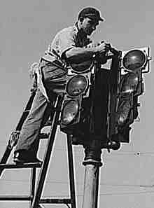

Figure 1.1: installation of a traffic signal in [San Diego](http://en.wikipedia.org/wiki/San_Diego) in December 1940

In 1923, [Garrett Morgan](http://en.wikipedia.org/wiki/Garrett_Morgan) patented his own version. The Morgan traffic signal was a T-shaped pole unit that featured three hand-cranked positions: Stop, go, and an all -directional stop position. This third position halted traffic in all directions to give drivers more time to stop before opposing traffic started. Its one "advantage" over others of its type was the ability to operate it from a distance using a mechanical linkage. Toronto was the first city to computerize its entire traffic signal system, which it accomplished in 1963. The color of the traffic lights representing stop and go might be derived from those used to identify port (red) and starboard (green) in maritime rules governing [right of way,](http://en.wikipedia.org/wiki/Port_and_starboard#Right-of-way_for_other_vessels) where the vessel on the left must stop for the one crossing on the right. Countdown [timers](http://en.wikipedia.org/wiki/Timer) on traffic lights were introduced in the 1990s. Though uncommon in most American urban areas, timers are used in some other Western Hemisphere countries. Timers are useful for drivers/pedestrians to plan if there is enough time to attempt to cross the intersection before the light turns red and conversely, the amount of time before the light turns green.

#### 1.3 Ojectives

The objective is:

* + - to limit the stoppage time.
    - to regulate the traffic flow.
    - to reducing the traffic jams in order to reduce traffic congestion.
    - to protect pedestrians and vehicles at busy intersections.
    - to reduce the severity and frequency of accidents.

## 1.4 In the typical sequence of color phases

* + - Illumination of the green light allows traffic to proceed in the direction denoted, if it is safe to do so
    - Illumination of the orange/amber light denoting prepare to stop short of the intersection, if it is safe to do so
    - Illumination of the red signal prohibits any traffic from proceeding

Usually, the red light contains some orange in its [hue](http://en.wikipedia.org/wiki/Hue), and the green light contains some blue, said to be for the benefit of people with red-green color blindness.

## 1.5 The three colors and their meanings

There are three colors (or traffic lights):

#### RED - personal for named recipients only

In the context of a meeting, for example, RED information is limited to those present at the meeting. In most circumstances, RED information will be passed verbally or in person.

#### AMBER - limited distribution

The recipient may share AMBER information with others within their organization, but only on a „need-to-know‟ basis. The originator may be expected to specify the intended limits of that sharing.

#### GREEN - community wide

Information in this category can be circulated widely within a particular community. However, the information may not be published or posted publicly on the Internet, nor released outside of the community.

## Standards of Traffic Signal

#### 1.6.1 Australian Standard

* + - * Green: a green man means cross.
      * Flashing Red: a red flashing man means finish crossing.
      * Red: a red man means do not cross.
      * Some traffic lights in [Melbourne](http://en.wikipedia.org/wiki/Melbourne) have countdown timers for pedestrian crossing lights, usually they countdown from 30 when the red flashing man appears.

#### 1.6.2 European Standard

The light sequence is:

* + - * Green: Cross.
      * Yellow/Orange: Continue to cross only if unable to stop safely.
      * Flashing Yellow/Orange: Cross with caution (usually used when lights are out of order or shut down).
      * Red: Do not cross.

#### 1.6.3 British Standard

* + - * In the United Kingdom, [British Crown Dependencies](http://en.wikipedia.org/wiki/British_Crown_Dependencies) and dependent territories, and former possessions like Hong Kong:
      * Green walking-man: Cross with caution (pedestrians have the right of way; motorists turning left or right must yield to pedestrians
      * Flashing green walking-man: Continue to cross if already in the intersection, but do not start to cross
      * Red/Orange standing-man: Do not cross

The same system is used also in [Macau.](http://en.wikipedia.org/wiki/Macau)

#### 1.6.4 China Standard

* + - * Green: Cross.
      * Yellow/Orange: Do not cross.
      * Flashing Yellow/Orange: Do not cross.
      * Red: Do not cross.

#### 1.6.5 North American Standard

The light sequence is:

* + - * Green/white walking human or Walk: Cross with caution (pedestrians have the right of way; motorists turning left or right must yield to pedestrians)
      * Flashing red/orange stop hand or Don't Walk: Do not cross unless in middle of intersection
      * Red/orange stop hand or Don't Walk: Do not cross intersection

## 1.7 Lane Control

Lane-control lights are a specific type of [traffic light](http://en.wikipedia.org/wiki/Traffic_lights) used to manage traffic on a multi-way road or highway. Typically, these lights allow or forbid traffic to use one or more of the available lanes by the use of green lights or arrows (to permit) or by red lights or crosses (to prohibit). In the US, lane-control lights are often used to control and/or direct the flow of traffic through toll plazas and highway tunnels, such as during unusually-heavy traffic flow when more lanes may be required in one direction than in the other direction, or during a hurricane evacuation, when the lane signals for all lanes will show green for one direction to assist in more rapid traffic flow from the evacuation site. Lane-control lights are also used at highway weigh stations to direct tractor-trailers and other heavy or oversized vehicles into the proper lanes for weighing, inspection or exit.

In the US, most notably the Southeastern, there often is a "continuous-flow" lane. This lane is protected by a single, constant-green arrow pointing down at the lane(s) permitting the continuous flow of traffic, without regard to the condition of signals for other lanes or cross streets. Continuous lanes are restricted in that vehicles turning from a side street may not cross over the double-white line to enter the continuous lane, and no lane changes are permitted to the continuous lane from an adjacent lane or from the continuous lane to an adjacent lane, until the double-white line has been passed. Some continuous lanes are protected by a raised curb located between the continuous lane and a normal traffic lane, with white and/or yellow reflective paint or tape, prohibiting turning or adjacent traffic from entering the lane. Continuous-flow traffic lanes are found only at "T" intersections where there is no side street or driveway entrance on the right side of the main thoroughfare; additionally, no pedestrians are permitted to cross the main thoroughfare at intersections with

a continuous-flow lane, although crossing at the side street may be permitted. Intersections with continuous-flow lanes will be posted with a white regulatory sign approximately 500 feet before the intersection with the phrase, "Right Lane Continuous Traffic," or other similar wording. If the arrow is extinguished for any reason, whether by malfunction or design, traffic through the continuous lane will revert to the normal traffic pattern for adjacent lanes, except that turning or moving into or out of the restricted lane is still prohibited.

## 1.8 Light Design

In the United States, traffic lights are currently designed with lights approximately 12 inches (300 mm) in diameter. Previously the standard had been 8 inches (200 mm), however those are slowly being phased out in favor of the larger and more visible 12 inch lights. Variations used have also included a hybrid design, which had one or more 12 inch lights along with one or more lights of 8 inches (200 mm) on the same light. For example, these "12-8-8" (along with 8-8-8) lights are standard in most jurisdictions in Ontario, Manitoba, and British Columbia (that, is, the red light is 12 and others 8, making the red more prominent). In the United Kingdom, 12 inch lights were implemented only with Mellor Design Signal heads designed by [David Mellor](http://en.wikipedia.org/wiki/David_Mellor_%28designer%29). These were designed for symbolic optics to compensate for the light loss caused by the symbol. With the invention of anti-phantom, highly visible SIRA lenses, lights of 8 inches (200 mm) could be designed to give the same output as plain lenses, so a larger surface area was unnecessary. Consequently lights of 12 inches (300 mm) are no longer approved for use in the UK and all lights installed on new installations have to be 200 millimeters (8 in) in accordance with TSRGD (Traffic Signs Regulations and General Directions). Exemptions are made for temporary or replacement signals.

## 1.9 Types

There are two primary types of traffic signal:

#### 1.9.1 Pre-timed Signals (fixed)

At pre-timed traffic signals each signal phase or traffic movement is serviced in a programmed sequence that is repeated throughout the day. Main street traffic receives a fixed amount of green time followed by the amber and red clearance intervals. The same interval

timing is then repeated for the minor or side street. The amount of time it takes to service all conflicting traffic movements is referred to as the cycle length. The signal timings and cycle lengths may vary by time of day to reflect changes in traffic volumes and patterns. During peak traffic periods for example, cycle lengths may range from 90 -128 seconds to accommodate heavier volumes, particularly on the busier arterial roadways. During off peak times of day cycle lengths are reduced as traffic volumes are much lighter and therefore not as much green time is required to effectively service all movements. With pre-timed signals the pedestrian walk/don‟t walk signal indications are automatically displayed in conjunction with the green signal for vehicles. Pre-timed signals can provide fairly efficient operation during peak traffic periods, assuming signal timing settings reflect current conditions. However, during off-peak times, particularly at night, traffic on the major roadways are often stopping for no reason because of little or no traffic or pedestrians on the cross streets. With pre-timed signals the only method to avoid this unnecessary delay was to program the signals for flashing operation during the night time hours, generally 12:30 - 6:00 a.m. Night flash operation was once common practice by many cities and municipalities but with advancements in signal technology and detection devices over the years it is rarely used. Many of the older signals in the former City of Halifax still use night flash but this is gradually being phased out where appropriate.

#### 1.9.2 Actuated Signals

Actuated signal control differs from pre-timed in that it requires “actuation” by a vehicle or pedestrian in order for certain phases or traffic movements to be serviced. Actuation is achieved by vehicle detection devices and pedestrian push buttons. The most common method of detecting vehicles is to install inductive loop wires in the pavement at or near the painted stop bar. Video detection is also used at select locations. Actuated signals consist of two types : semi-actuated and fully-actuated.

1. ***Semi-actuated*** - vehicle loop detectors are installed on the minor street approaches and push buttons are provided for pedestrians wanting to cross the major roadway. The traffic signals remain green on the major roadway until either a cross street vehicle is detected or a pedestrian pushes the button. When this occurs a “call” is sent to the traffic signal controller and at the appropriate time in the cycle main street green will terminate and time its clearance

intervals before the minor street is serviced. If the side street is servicing vehicle demand only, a minimum green of 5-7 seconds is provided which can extend up to a preset maximum provided additional vehicles are being detected. After the last vehicle passes over the detector loop or the preset maximum green time has been reached, the signals will return to a green state on main street. If the side street is servicing a pedestrian demand, the “walk” & “flashing don‟t walk” signal indications will be displayed, again at the appropriate time in the cycle. At pedestrian actuated signals, the “walk” indication is displayed for 5-7 seconds. This allows the pedestrian to enter the crosswalk and begin crossing. At the end of the “walk” signal the “flashing don‟t walk” indication is displayed which provides the pedestrian already in the crosswalk sufficient time to safely complete their crossing and clear the intersection before conflicting traffic receives a green signal. Pedestrians who are already in the crosswalk at the start of this interval continue to have the right of way over turning vehicles. Pedestrians who have not begun to cross when this interval begins should wait until the next cycle.

1. ***Fully-actuated*** - vehicle detector loops and pedestrian push buttons are installed on all approaches. All signal phases including left turn arrows have preset minimum and maximum greens and will be serviced on demand only. Pedestrians must activate the push buttons in order to receive the “walk” & “flashing don‟t walk” indications. A single press of the button locks the “call” in the controllers memory that a pedestrian has requested service. Fully- actuated signals are most efficient at isolated locations where coordination with adjacent signals is not a concern and where the intersecting roadways have similar traffic volumes. Actuated signal control provides greater efficiency compared to pre-timed signals by servicing cross street traffic and pedestrians only when required. The primary disadvantage with pre-timed signals is avoided as main street traffic is not interrupted unnecessarily. This is particularly beneficial during off peak conditions. The result is fewer stops and delays to traffic on the major arteries, while still providing for safe pedestrian crossings as and when required, which ultimately leads to a decrease in fuel consumption and pollution.

# Chapter-2

# **Literature Rview and Working Principle of Traffic Controller**

#### 2.1 Review of literature

#### 2.2 Working principle

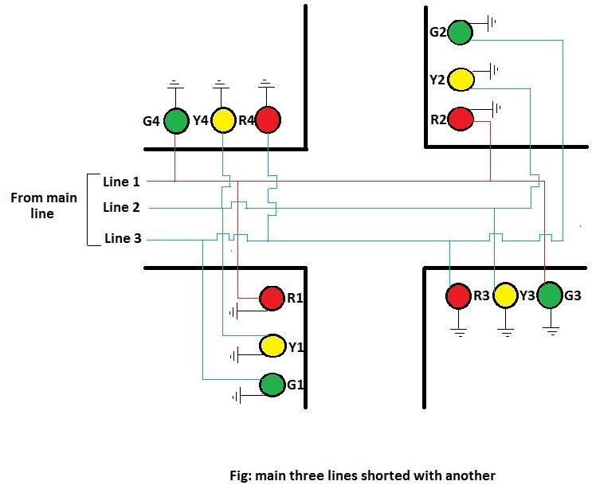

Figure 2.1: main three line shorted with another

At first main power is stepped down by transformer X1 to deliver a secondary output of 9v, 300 mA. The transformer out put is rectified by a full-wave bridge rectifier comprising diodes D1 through D4. Filtered by capacitor C1 and regulated by voltage regulator IC1 7805. IC2 is wired as a multivibrator with „ON‟ and „OFF‟ periods of 35 and 30 seconds. As soon as main power is switched on, pin 3 of IC2 goes high for 35 seconds. This in turn energies relay RL1 its normally-open(N/O) contact through transistor T1 then the red lamp R1, R2 glows for stopping Road1 and Road2‟s vehicle also green lamp G3, G4 glows through its normally-open contact to running Road3 and Road4‟s vehicle for 35 seconds shown in figure.

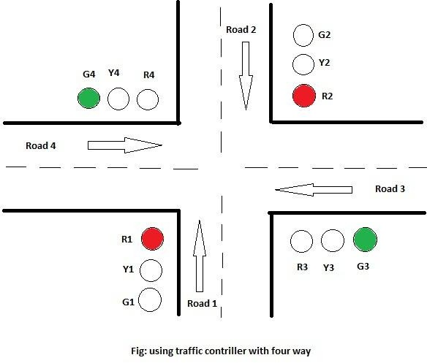

Figure 2.2: first step of traffic controller

At the same time main power is disconnected from the pole of relay RL2. As the on time of IC2, a pulse at its pin 3 triggers IC3 through C5. IC3 is configured as a monostable with „ON‟ time of about 5 second. which means pin 3 of IC3 will remain high for this period and energies relay RL2 through driver transistor T2. The yellow lamps Y1,Y2,Y3 and Y4 lights up for 5 seconds shown in figure.

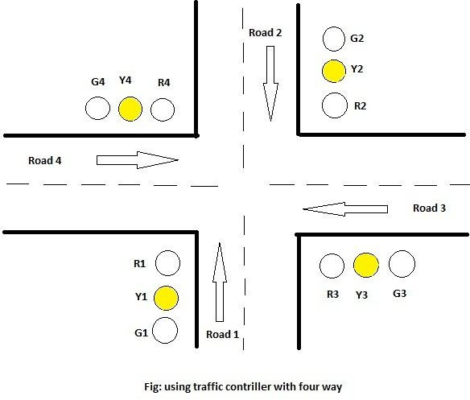

Figure 2.3: second step of traffic controller

As soon as 5 second time period of timer IC3 at pin 3 lapses, relay RL2 de-energies and finally the red lamp R3, R4 glows for stopping Road3 and Road4‟s vehicle also green lamp G1,G2 glows through its normally-closed (N/C)contact to running Road1 and Road2‟s vehicles for 30 seconds shown in figure.

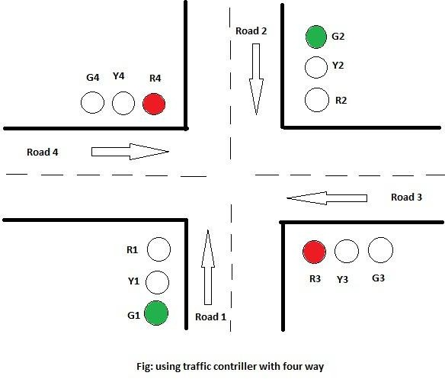

Figure 2.4: final step of traffic controller

# Chapter 3

# Major Components Used For The Project

## Required Apparatus

### 220/9v Center taped Transformer.

* + - 1N4001 Diode (06 pcs).
    - 1000 μF capacitor(01 pcs).
    - 470 μF capacitor(02 pcs).
    - 0.01 μF capacitor(03 pcs).
    - 0.1 μF capacitor(01 pcs).
    - 7805 Voltage Regulator(01 pcs).
    - 555 Timer IC(02 pcs).
    - 1C/O Relay(02 pcs).
    - BC 547 Transistor(02 pcs).
    - 10 K Resistor(04 pcs).
    - 100 K Resistor(01 pcs).
    - 1 K Resistor(01 pcs).
    - 15W,230v Dim Light(12 pcs).
    - Others some necessary things.

#### Bridge Rectifier

A diode bridge is an arrangement of four (or more) [diodes](http://en.wikipedia.org/wiki/Diode) in a [bridge circuit](http://en.wikipedia.org/wiki/Bridge_circuit) configuration that provides the same [polarity](http://en.wikipedia.org/wiki/Polarity_%28physics%29) of output for either polarity of input. When used in its most common application, for conversion of an [alternating current](http://en.wikipedia.org/wiki/Alternating_current) (AC) input into a [direct current](http://en.wikipedia.org/wiki/Direct_current) (DC) output, it is known as a bridge [rectifier](http://en.wikipedia.org/wiki/Rectifier). A bridge rectifier provides [full-wave](http://en.wikipedia.org/wiki/Rectifier#Full-wave_rectification) [rectification](http://en.wikipedia.org/wiki/Rectifier#Full-wave_rectification) from a two-wire AC input, resulting in lower cost and weight as compared to a rectifier with a 3-wire input from a [transformer](http://en.wikipedia.org/wiki/Transformer) with a [center-tapped](http://en.wikipedia.org/wiki/Center_tap) secondary winding.

The essential feature of a diode bridge is that the polarity of the output is the same regardless of the polarity at the input. The diode bridge circuit is also known as the Graetz circuit after its inventor, physicist [Leo Graetz,](http://en.wikipedia.org/wiki/Leo_Graetz) and the single-phase version, with four diodes, may also referred to as an [H bridge.](http://en.wikipedia.org/wiki/H_bridge)

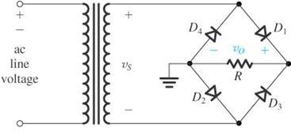

Figure 3.1: Bridge Rectifier

#### Basic operation of bridge Rectifier

According to the [conventional model](http://en.wikipedia.org/wiki/Conventional_current) of [current](http://en.wikipedia.org/wiki/Current_%28electricity%29) flow , current is assumed to flow through [electrical conductors](http://en.wikipedia.org/wiki/Electrical_conductor) from the positive to the negative pole. In actuality, [free electrons](http://en.wikipedia.org/wiki/Free_electron_model) in a conductor nearly always flow from the negative to the positive pole. In the vast majority of applications, however, the actual direction of current flow is irrelevant. Therefore, in the discussion below the conventional model is retained.

In the diagrams below, when the input connected to the left corner of the diamond is positive, and the input connected to the right corner is negative, current flows from the upper supply terminal to the right along the red (positive) path to the output, and returns to the lower supply terminal via the blue (negative) path.

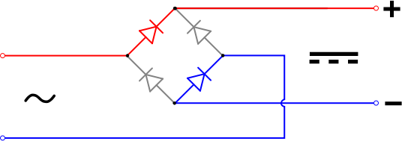

When the input connected to the left corner is negative, and the input connected to the right corner is positive, current flows from the lower supply terminal to the right along the red (positive) path to the output, and returns to the upper supply terminal via the blue (negative) path.

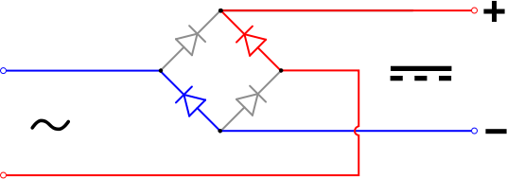

In each case, the upper right output remains positive and lower right output negative. Since this is true whether the input is AC or DC, this circuit not only produces a DC output from an AC input, it can also provide what is sometimes called "reverse polarity protection". That is, it permits normal functioning of DC-powered equipment when [batteries](http://en.wikipedia.org/wiki/Battery_%28electricity%29) have been installed backwards, or when the leads (wires) from a DC power source have been reversed, and protects the equipment from potential damage caused by reverse polarity.

#### Input And Output Waveshape

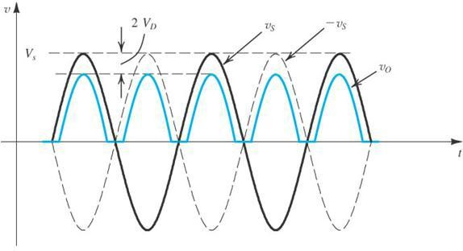

Figure 3.2: I/O Waveshape of Bridge Rectifier

#### The Rectifier with a Filter Capacitor –The Peak Rectifier

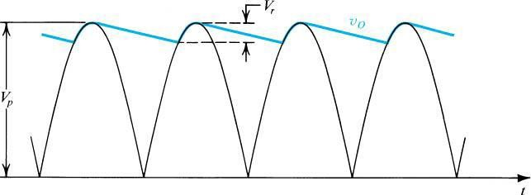

Figure 3.3: Waveform in the full-wave peak rectifier

#### LM 7805 Positive Voltage Regulator

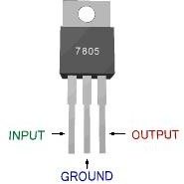

Figure 3.4: LM 7805 voltage regulator

#### Description

7805 is a voltage regulator integrated circuit. It is a member of 78xx series of fixed linear voltage regulator ICs. The voltage source in a circuit may have fluctuations and would not give the fixed voltage output. The voltage regulator IC maintains the output voltage at a constant value. The xx in 78xx indicates the fixed output voltage it is designed to provide. 7805 provides +5V regulated power supply. Capacitors of suitable values can be connected at input and output pins depending upon the respective voltage levels.

#### Features

* + - * Output Transistor Safe Operating Area Protection
      * Screening options available
      * 5 volt regulator
      * Output current up to 1.5a
      * Thermal overload protection
      * Short circuit protection

#### Application

* + - * Post regulator for switching DC/DC converter
      * Bias supply for analog circuits.

#### Circuit Diagram of LM 7805

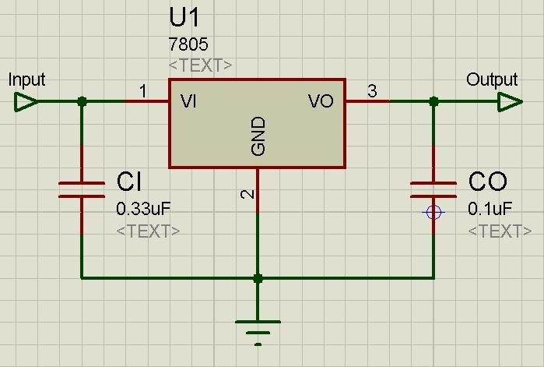

Figure 3.5: circuit diagram LM 7805 Voltage Regulator

|  |  |  |
| --- | --- | --- |
| **Pin**  **No** | **Function** | **Name** |
| 1 | Input voltage (5V-18V) | Input |
| 2 | Ground (0V) | Ground |
| 3 | Regulated output; 5V (4.8V-5.2V) | Output |

#### LM555C Timer IC

The 555 timer IC is an [integrated circuit](http://en.wikipedia.org/wiki/Integrated_circuit) (chip) used in a variety of [timer](http://en.wikipedia.org/wiki/Timer), pulse generation, and [oscillator](http://en.wikipedia.org/wiki/Electronic_oscillator) applications. The 555 can be used to provide time delays, as an [oscillator,](http://en.wikipedia.org/wiki/Oscillator) and as a [flip-flop element.](http://en.wikipedia.org/wiki/Flip-flop_element) Derivatives provide up to four timing circuits in one package.

Introduced in 1972 by [Signetics,](http://en.wikipedia.org/wiki/Signetics) the 555 is still in widespread use, thanks to its ease of use, low price, and good stability. It is now made by many companies in the original [bipolar](http://en.wikipedia.org/wiki/Bipolar_junction_transistor) and also in low-power [CMOS](http://en.wikipedia.org/wiki/CMOS) types. As of 2003, it was estimated that 1 billion units are manufactured every years.

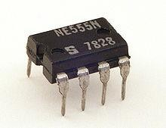

Figure 3.6: 555Timer IC

#### Pinout Diagram Of Timer IC

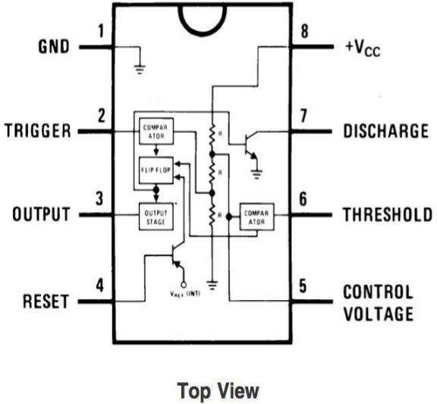

Figure 3.7: Pin Diagram of 555

#### The connection of the pins for a DIP package is as follows:

|  |  |  |
| --- | --- | --- |
| **Pin** | **Name** | **Purpose** |
| 1 | GND | Ground reference voltage, low level (0 V) |
| 2 | TRIG | The OUT pin goes high and a timing interval starts when this input falls below  1/2 of CTRL voltage (which is typically 1/3 of *V*CC, when CTRL is open). |
| 3 | OUT | This output is driven to approximately 1.7V below [+](http://en.wikipedia.org/wiki/Vcc)*[V](http://en.wikipedia.org/wiki/Vcc)*[CC](http://en.wikipedia.org/wiki/Vcc)or GND. |
| 4 | RESET | A timing interval may be reset by driving this input to GND, but the timing does  not begin again until RESET rises above approximately 0.7 volts. Overrides TRIG which overrides THR. |
| 5 | CTRL | Provides "control" access to the internal voltage divider (by default, 2/3 *V*CC). |
| 6 | THR | The timing (OUT high) interval ends when the voltage at THR is greater than  that at CTRL. |
| 7 | DIS | [Open collector](http://en.wikipedia.org/wiki/Open_collector) output which may discharge a capacitor between intervals. In  phase with output. |
| 8 | *V*CC | Positive supply voltage, which is usually between 3 and 15 V depending on the  variation. |

Pin 5 is also sometimes called the CONTROL VOLTAGE pin. By applying a voltage to the CONTROL VOLTAGE input one can alter the timing characteristics of the device. In most applications, the CONTROL VOLTAGE input is not used. It is usual to connect a 10 nF capacitor between pin 5 and 0 V to prevent interference. The CONTROL VOLTAGE input can be used to build an astable with a frequency modulated output.

#### Modes of Timer IC

The 555 has three operating modes:

* + - * **[Monostable](http://en.wikipedia.org/wiki/Monostable)** mode: In this mode, the 555 functions as a "one-shot" pulse generator. Applications include timers, missing pulse detection, bouncefree switches, touch switches, frequency divider, capacitance measurement, [pulse-width modulation](http://en.wikipedia.org/wiki/Pulse-width_modulation) (PWM) and so on.
      * **[Astable](http://en.wikipedia.org/wiki/Astable)** (free-running) mode: The 555 can operate as an [oscillator](http://en.wikipedia.org/wiki/Oscillator). Uses include [LED](http://en.wikipedia.org/wiki/Light-emitting_diode) and lamp flashers, pulse generation, logic clocks, tone generation, security alarms, [pulse position modulation](http://en.wikipedia.org/wiki/Pulse_position_modulation) and so on. The 555 can be used as a simple [ADC](http://en.wikipedia.org/wiki/Analog-to-digital_converter),

converting an analog value to a pulse length. E.g. selecting a [thermistor](http://en.wikipedia.org/wiki/Thermistor) as timing resistor allows the use of the 555 in a temperature sensor: the period of the output pulse is determined by the temperature. The use of a microprocessor based circuit can then convert the pulse period to temperature, linearize it and even provide calibration means.

* + - * **[Bistable](http://en.wikipedia.org/wiki/Flip-flop_%28electronics%29)** mode or [Schmitt trigger](http://en.wikipedia.org/wiki/Schmitt_trigger): The 555 can operate as a [flip-flop,](http://en.wikipedia.org/wiki/Flip-flop_%28electronics%29) if the DIS pin is not connected and no capacitor is used. Uses include bounce-free latched switches.

#### Monostable Mode

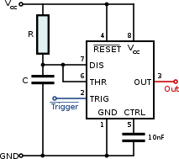

Figure 3.8: Schematic of Monostable Mode

The relationships of the trigger signal, the voltage on C and the pulse width in monostable mode

In the monostable mode, the 555 timer acts as a "one-shot" pulse generator. The pulse begins when the 555 timer receives a signal at the trigger input that falls below a third of the voltage supply. The width of the output pulse is determined by the time constant of an RC network, which consists of a [capacitor](http://en.wikipedia.org/wiki/Capacitor) (C) and a [resistor](http://en.wikipedia.org/wiki/Resistor) (R). The output pulse ends when the voltage on the capacitor equals 2/3 of the supply voltage. The output pulse width can be lengthened or shortened to the need of the specific application by adjusting the values of R and C.

The output pulse width of time *t*, which is the time it takes to charge C to 2/3 of the supply voltage, is given by

t = RC\ln(3) \approx 1.1 RC

where t is in seconds, R is in ohms and C is in farads.

While using the timer IC in [monos](http://en.wikipedia.org/wiki/Ohm)table mode, [the](http://en.wikipedia.org/wiki/Farads) main disadvantage is that the time span between any two triggering pulses must be greater than the RC time constant.

#### Bistable Mode

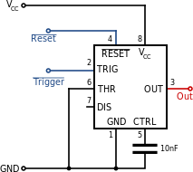

Figure 3.9: Schematic of Bistable Mode

In bistable mode, the 555 timer acts as a basic flip-flop. The trigger and reset inputs (pins 2 and 4 respectively on a 555) are held high via [Pull-up resistors](http://en.wikipedia.org/wiki/Pull-up_resistor) while the threshold input (pin

6) is simply grounded. Thus configured, pulling the trigger momentarily to ground acts as a 'set' and transitions the output pin (pin 3) to Vcc (high state). Pulling the reset input to ground acts as a 'reset' and transitions the output pin to ground (low state). No capacitors are required in a bistable configuration. Pin 5 (control) is connected to ground via a small-value capacitor (usually 0.01 to 0.1 uF); pin 7 (discharge) is left floating.

#### Astable Mode

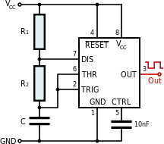

Figure 3.10: Schematic of Astable Mode

In astable mode, the 555 timer puts out a continuous stream of rectangular pulses having a specified frequency. Resistor R1 is connected between VCC and the discharge pin (pin 7) and another resistor (R2) is connected between the discharge pin (pin 7), and the trigger (pin 2) and threshold (pin 6) pins that share a common node. Hence the capacitor is charged through R1 and R2, and discharged only through R2, since pin 7 has low impedance to ground during output low intervals of the cycle, therefore discharging the capacitor.

In the astable mode, the frequency of the pulse stream depends on the values of R1, R2 and C:

f = \frac{1}{\ln(2) \cdot C \cdot (R_1 + 2R_2)}[[7]](http://en.wikipedia.org/wiki/555_timer_IC#cite_note-7)

The high time from each pulse is given by:

\mathrm{high} = \ln(2) \cdot (R_1 + R_2) \cdot C

and the low time from each pulse is given by:

\mathrm{low} = \ln(2) \cdot R_2 \cdot C

where R1 and R2 are the values of the resistors in [ohms](http://en.wikipedia.org/wiki/Ohm) and C is the value of the capacitor in [farads.](http://en.wikipedia.org/wiki/Farad)

The power capability of R1 must be greater than \frac{V_{cc}^{2}}{R_1}.

Particularly with bipolar 555s, low values of R1 must be avoided so that the output stays saturated near zero volts during discharge, as assumed by the above equation. Otherwise the output low time will be greater than calculated above. It should be noted that the first cycle will take appreciably longer than the calculated time, as the capacitor must charge from 0V to 2/3 of VCC from power-up, but only from 1/3 of VCC to 2/3 of VCC on subsequent cycles.

To achieve a [duty cycle](http://en.wikipedia.org/wiki/Duty_cycle) of less than 50% a diode (that is fast enough for the application) can be added in parallel with R2 towards the capacitor. This bypasses R2 during the high part of the cycle so that the high interval depends approximately only on R1 and C. The presence of the diode is a voltage drop that slows charging on the capacitor so that the high time is longer than the often-cited ln(2)\*R1C = 0.69 R1C. The low time is the same as without the diode as shown above. With a diode, the high time is

\mathrm{high} = R_1 C \cdot \ln(\frac{2V_{cc}-3V_{diode}}{V_{cc}-3V_{diode}}) 

where Vdiode is determined when the diode has a current of 1/2 of Vcc/R1. As an extreme example, when Vcc= 5 and Vdiode= 0.7, high time = 1.00 R1C which is 45% longer than the "expected" 0.693 R1C. At the other extreme, when Vcc= 15 and Vdiode= 0.3, high time = 0.725 R1C, 4.6% longer. The equation reduces to 0.693 R1C if Vdiode= 0.

The operation of RESET in this mode is not well defined, some manufacturers' parts will hold the output state to what it was when RESET is taken low, others will send the output either high or low.

#### LM555 Technical Description:

The LM555 is a highly stable device for generating accurate time delays or oscillation. Additional terminals are provided for triggering or resetting if desired. In the time delay mode of operation, the time is precisely controlled by one external resistor and capacitor. For astable operation as an oscillator, the free running frequency and duty cycle are accurately controlled with two external resistors and one capacitor. The circuit may be triggered and reset on falling waveforms, and the output circuit can source or sink up to 200mA or drive TTL circuits.

#### LM555 Features

* Direct replacement for SE555/NE555
* Timing from microseconds through hours
* Operates in both astable and monostable modes
* Adjustable duty cycle
* Output can source or sink 200 mA
* Output and supply TTL compatible
* Temperature stability better than 0.005% per °C
* Normally on and normally off output
* Available in 8-pin MSOP package.

#### LM555 Applications

* Precision timing
* Pulse generation
* Sequential timing
* Time delay generation
* Pulse width modulation
* Pulse position modulation
* Linear ramp generator

#### LM555 Circuit Schematic:

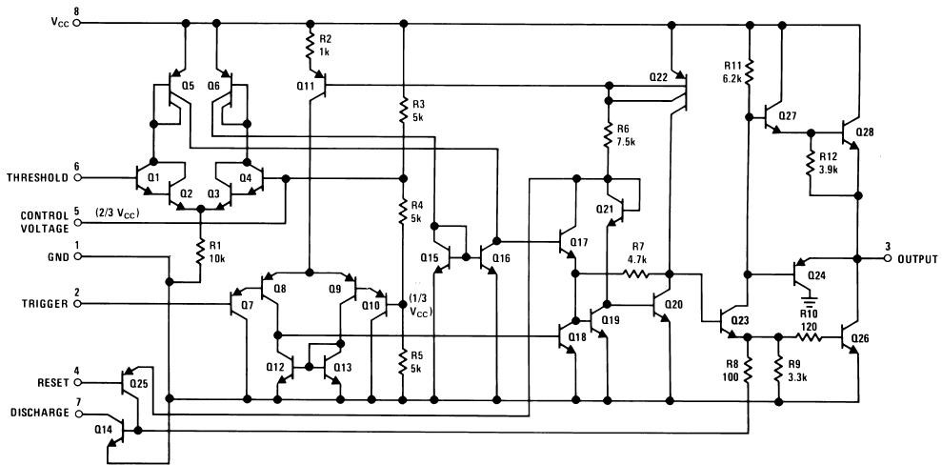

Figure 3.11: Schematic diagram of 555Timer IC

#### BC547 Transistor

* + 1. **General Description**

A BC547 [transistor](http://www.wisegeek.com/what-is-a-transistor.htm) is a negative-positive-negative (NPN) transistor that is used for many purposes. Together with other electronic components, such as resistors, coils, and capacitors, the BC547 transistor can be used as the active component for switches and amplifiers. Like all other NPN transistors, the BC547 transistor has an [emitter](http://www.wisegeek.com/what-is-an-emitter.htm) terminal, a base or control terminal, and a collector terminal. In a typical configuration, the current flowing from the base to the emitter of the BC547 transistor controls the [collector current.](http://www.wisegeek.com/what-is-the-collector-current.htm) A short vertical line, which is the base, can indicate the transistor schematic for an [NPN transistor](http://www.wisegeek.com/what-is-an-npn-transistor.htm), and the emitter, which is a diagonal line connecting to the base, is an arrowhead pointing away from the base.

The BC547 transistor is a bipolar junction transistor (BJT). There are also transistors that have one junction, such as the junction field-effect transistor, or no junctions at all, such as the metal oxide field-effect transistor ([MOSFET](http://www.wisegeek.com/what-is-a-mosfet.htm)). During the design and manufacture of transistors, the transistor characteristics can be predefined and achieved. The negative (N)- type material inside an NPN transistor has an excess of electrons, while the positive (P)-type material has a lack of electrons, both due to a contamination process called doping.

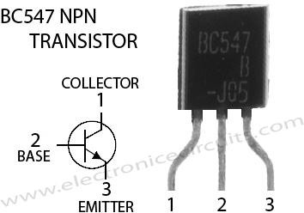

Figure 3.12: BC 547 Transistor

#### Features

* + - * Collector-Emitter Volt (Vceo): 45V
      * Collector Current (Ic): 0.1A
      * hfe: 110-800 @ 2mA
      * Power Dissipation (Ptot): 625mW
      * Current-Gain-Bandwidth (ftotal): 300MHz
      * Type: NPN

#### Out-put wave shape of BC 547

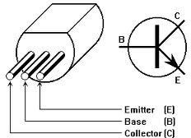

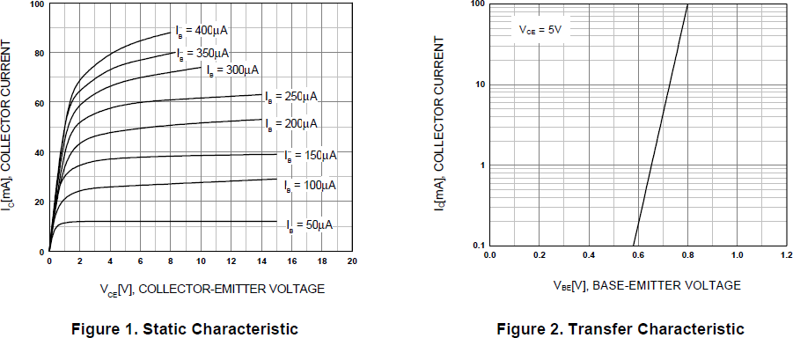

Figure 3.13: Out-put wave shape of BC 547

#### Relay (5V,1C/O)

a relay consists of two separate and completely independent circuits. The first is at the bottom and drives the electromagnet. In this circuit, a switch is controlling power to the electromagnet. When the switch is on, the electromagnet is on, and it attracts the armature (blue). The armature is acting as a switch in the second circuit. When the electromagnet is energized, the armature completes the second circuit and the light is on. When the electromagnet is not energized, the spring pulls the armature away and the circuit is not complete.

There are four parts in every relay:

**a.** Electromagnet **b.** Armature that can be attracted by the electromagnet

**c.** Spring **d.** Set of electrical contacts

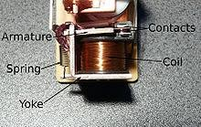

Figure 3.14 : Relay

#### 3.6.1. Circuit Diagram of Relay

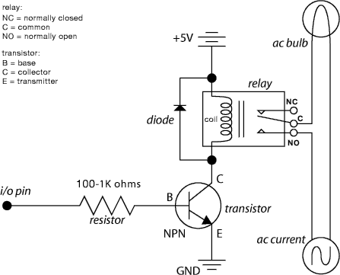

Figure 3.15: Circuit Diagram of Relay

#### Capacitor

**3.7.1 Function:** Capacitors store electric charge. They are used with resistors in [timing circuits](http://www.kpsec.freeuk.com/555timer.htm) because it takes time for a capacitor to fill with charge. They are used to [smooth](http://www.kpsec.freeuk.com/powersup.htm#smoothing) varying DC supplies by acting as a reservoir of charge. They are also used in filter circuits because capacitors easily pass AC (changing) signals but they block DC (constant) signals.

#### Capacitance

This is a measure of a capacitor's ability to store charge. A large capacitance means that more charge can be stored. Capacitance is measured in farads, symbol F. However 1F is very large, so prefixes are used to show the smaller values.

#### 0.1μf Capacitor

Type: Tantalum,25V DC

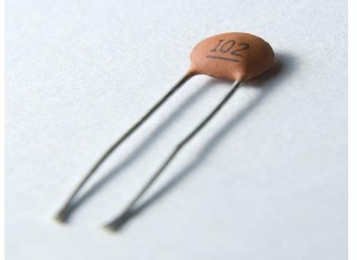

Figure 3.16: 0.1μf capacitor

#### 1000 μf Capacitor

Type: [6.3V Radial Electrolytic Capacitor](http://www.talonix.com/shop/item.aspx?itemid=13161)

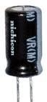

Figure 3.17: 1000 μf capacitor

#### 470 μf Capacitor

Type: [50V Radial Electrolytic Capacitor](http://www.talonix.com/shop/item.aspx?itemid=13560)

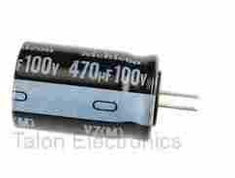

Figure 3.18: 470 μf Capacitor

#### 0.1 μf Capacitor

Type: 0.1-μf ceramic disc capacitor

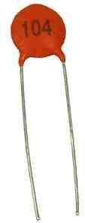

Figure 3.19: 0.1 μf Capacitor

#### Transformer:

A transformer is an electrical device that transfers energy by [inductive coupling](http://en.wikipedia.org/wiki/Inductive_coupling) between two or more of its windings. A varying [current](http://en.wikipedia.org/wiki/Electric_current) in the primary winding creates a varying [magnetic](http://en.wikipedia.org/wiki/Magnetic_flux) [flux](http://en.wikipedia.org/wiki/Magnetic_flux) in the transformer's core and thus a varying magnetic flux through the secondary winding. This varying magnetic flux [induces](http://en.wikipedia.org/wiki/Electromagnetic_induction) a varying [electromotive force (EMF)](http://en.wikipedia.org/wiki/Electromotive_force), or "[voltage](http://en.wikipedia.org/wiki/Volt)", in the secondary winding. This effect is called [inductive coupling.](http://en.wikipedia.org/wiki/Inductive_coupling)

If a [load](http://en.wikipedia.org/wiki/Electrical_load) is connected to the secondary winding, current will flow in this winding, and electrical energy will be transferred from the primary circuit through the transformer to the load. Transformers may be used for AC-to-AC conversion of a single power frequency, or for conversion of signal power over a wide range of frequencies, such as audio or radio frequencies.

In an ideal transformer, the induced voltage in the secondary winding (Vs) is in proportion to the primary voltage (Vp) and is given by the ratio of the number of turns in the secondary (Ns) to the number of turns in the primary (Np) as follows:

\frac{V_\text{s}}{V_{\text{p}}} = \frac{N_\text{s}}{N_\text{p}} 

By appropriate selection of the ratio of turns, a transformer thus enables an [alternating current](http://en.wikipedia.org/wiki/Alternating_current) (AC) voltage to be "stepped up" by making Ns greater than Np, or "stepped down" by making Ns less than Np. The windings are coils wound around a [ferromagnetic core,](http://en.wikipedia.org/wiki/Magnetic_core) [air-core](http://en.wikipedia.org/wiki/Transformer#Cores) transformers being a notable exception.

Transformers range in size from a thumbnail-sized coupling transformer hidden inside a stage [microphone](http://en.wikipedia.org/wiki/Microphone) to huge units weighing hundreds of tons used in [power stations](http://en.wikipedia.org/wiki/Power_plant), or to interconnect portions of [power grids](http://en.wikipedia.org/wiki/Power_grid). All operate on the same basic principles, although the range of designs is wide. While new technologies have eliminated the need for transformers in some electronic circuits, transformers are still found in nearly all electronic devices designed for [household ("mains") voltage.](http://en.wikipedia.org/wiki/Mains_electricity) Transformers are essential for high-voltage [electric](http://en.wikipedia.org/wiki/Electric_power_transmission) [power transmission,](http://en.wikipedia.org/wiki/Electric_power_transmission) which makes long-distance transmission economically practical.

#### Discovery

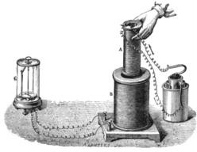

Figure 3.20: Faraday's experiment with induction between coils of wire

The principle behind the operation of a transformer, [electromagnetic induction](http://en.wikipedia.org/wiki/Electromagnetic_induction), was discovered independently by [Michael Faraday](http://en.wikipedia.org/wiki/Michael_Faraday) and [Joseph Henry](http://en.wikipedia.org/wiki/Joseph_Henry) in 1831. However, Faraday was the first to publish the results of his experiments and thus receive credit for the discovery. The relationship between [electromotive force](http://en.wikipedia.org/wiki/Electromotive_force) (EMF) or "[voltage](http://en.wikipedia.org/wiki/Volt)" and [magnetic](http://en.wikipedia.org/wiki/Magnetic_flux) [flux](http://en.wikipedia.org/wiki/Magnetic_flux) was formalized in an [equation](http://en.wikipedia.org/wiki/Equation_%28mathematics%29) now referred to as "[Faraday's law of induction](http://en.wikipedia.org/wiki/Faraday%27s_law_of_induction)":

 |\mathcal{E}| = \left|{{d\Phi_B} \over dt}\right|.

where |\mathcal{E}|is the magnitude of the EMF in volts and Φ*B* is the [magnetic flux](http://en.wikipedia.org/wiki/Magnetic_flux) through the circuit in [webers.](http://en.wikipedia.org/wiki/Weber_%28Wb%29)

Faraday performed the first experiments on induction between coils of wire, including winding a pair of coils around an iron ring, thus creating the first [toroidal](http://en.wikipedia.org/wiki/Toroid_%28geometry%29) closed-core transformer. However he only applied individual pulses of current to his transformer, and never discovered the relation between the turns ratio and EMF in the windings.

#### Induction coils

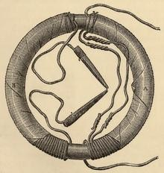

Figure 3.21: Faraday's ring transformer

The first type of transformer to see wide use was the [induction coil](http://en.wikipedia.org/wiki/Induction_coil), invented by Rev. [Nicholas Callan](http://en.wikipedia.org/wiki/Nicholas_Callan) of [Maynooth College](http://en.wikipedia.org/wiki/Maynooth_College), Ireland in 1836. He was one of the first researchers to realize that the more turns the secondary winding has in relation to the primary winding, the larger is the increase in EMF. Induction coils evolved from scientists' and inventors' efforts to get higher voltages from batteries. Since batteries produce [direct current](http://en.wikipedia.org/wiki/Direct_current) (DC) rather than [alternating current](http://en.wikipedia.org/wiki/Alternating_current) (AC), induction coils relied upon vibrating [electrical contacts](http://en.wikipedia.org/wiki/Electrical_contact) that regularly interrupted the current in the primary to create the flux changes necessary for induction. Between the 1830s and the 1870s, efforts to build better induction coils, mostly by trial and error, slowly revealed the basic principles of transformers.

#### Basic principles

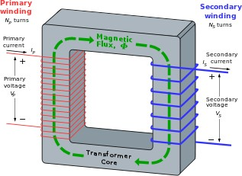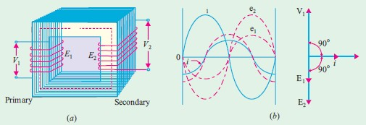

Figure 3.22: An ideal transformer

An ideal transformer. The secondary current arises from the action of the secondary EMF on the (not shown) load impedance.

The transformer is based on two principles: first, that an [electric current](http://en.wikipedia.org/wiki/Electric_current) can produce a [magnetic field](http://en.wikipedia.org/wiki/Magnetic_field) ([electromagnetism](http://en.wikipedia.org/wiki/Electromagnetism)) and second that a changing magnetic field within a coil of wire induces a voltage across the ends of the coil ([electromagnetic induction](http://en.wikipedia.org/wiki/Electromagnetic_induction)). Changing the current in the primary coil changes the magnetic flux that is developed. The changing magnetic flux induces a voltage in the secondary coil.

An ideal transformer is shown in the adjacent figure. Current passing through the primary coil creates a [magnetic field](http://en.wikipedia.org/wiki/Magnetic_field). The primary and secondary coils are wrapped around a [core](http://en.wikipedia.org/wiki/Magnetic_core) of very high [magnetic permeability](http://en.wikipedia.org/wiki/Permeability_%28electromagnetism%29), such as [iron,](http://en.wikipedia.org/wiki/Iron) so that most of the magnetic flux passes through both the primary and secondary coils. If a load is connected to the secondary winding, the load current and voltage will be in the directions indicated, given the primary current and voltage in the directions indicated (each will be [alternating current](http://en.wikipedia.org/wiki/Alternating_current) in practice).

#### Induction law

The voltage induced across the secondary coil may be calculated from [Faraday's law of](http://en.wikipedia.org/wiki/Faraday%27s_law_of_induction) [induction](http://en.wikipedia.org/wiki/Faraday%27s_law_of_induction), which states that:

V_\text{s} = N_\text{s} \frac{\mathrm{d}\Phi}{\mathrm{d}t}, 

where Vs is the instantaneous [voltage](http://en.wikipedia.org/wiki/Voltage), Ns is the number of turns in the secondary coil and Φ is the [magnetic flux](http://en.wikipedia.org/wiki/Magnetic_flux) through one turn of the coil. If the turns of the coil are oriented perpendicularly to the magnetic field lines, the flux is the product of the [magnetic flux](http://en.wikipedia.org/wiki/Magnetic_flux_density) [density](http://en.wikipedia.org/wiki/Magnetic_flux_density) B and the area A through which it cuts. The area is constant, being equal to the cross- sectional area of the transformer core, whereas the magnetic field varies with time according to the excitation of the primary. Since the same magnetic flux passes through both the primary and secondary coils in an ideal transformer,[[34]](http://en.wikipedia.org/wiki/Transformer#cite_note-flanagan_p2.1-34)the instantaneous voltage across the primary winding equals

V_\text{p} = N_\text{p} \frac{\mathrm{d}\Phi}{\mathrm{d}t}. 

Taking the ratio of the two equations for Vs and Vp gives the basic equation[35] for stepping up or stepping down the voltage

\frac{V_\text{s}}{V_\text{p}} = \frac{N_\text{s}}{N_\text{p}}. 

Np/Ns is known as the turns ratio, and is the primary functional characteristic of any transformer. In the case of step-up transformers, this may sometimes be stated as the reciprocal, Ns/Np. Turns ratio is commonly expressed as an [irreducible fraction](http://en.wikipedia.org/wiki/Irreducible_fraction) or ratio: for example, a transformer with primary and secondary windings of, respectively, 100 and 150 turns is said to have a turns ratio of 2:3 rather than 0.667 or 100:150.

#### Ideal power equation

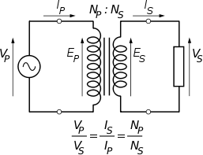

Figure 3.23: The ideal transformer as a circuit element The ideal transformer as a circuit element

If the secondary coil is attached to a load that allows current to flow, electrical power is transmitted from the primary circuit to the secondary circuit. Ideally, the transformer is perfectly efficient. All the incoming energy is transformed from the primary circuit to the [magnetic field](http://en.wikipedia.org/wiki/Magnetic_field) and into the secondary circuit. If this condition is met, the input [electric power](http://en.wikipedia.org/wiki/Electric_power) must equal the output power:

P_\text{incoming} = I_\text{p} V_\text{p} = P_\text{outgoing} = I_\text{s} V_\text{s},\! 

giving the ideal transformer equation

\frac{V_\text{s}}{V_\text{p}} = \frac{N_\text{s}}{N_\text{p}} = \frac{I_\text{p}}{I_\text{s}}. 

This formula is a reasonable approximation for most commercial built transformers today.

If the voltage is increased, then the current is decreased by the same factor. The [impedance](http://en.wikipedia.org/wiki/Impedance_%28electrical%29) in one circuit is transformed by the *square* of the turns ratio. For example, if an impedance *Z*s is attached across the terminals of the secondary coil, it appears to the primary circuit to have an impedance of (*N*p/*N*s)2*Z*s. This relationship is reciprocal, so that the impedance *Z*p of the primary circuit appears to the secondary to be (*N*s/*N*p)2*Z*p.

#### Physics of magnetization and EMF

The ideal model not only neglects basic physics factors in terms of primary current required to establish a magnetic field in the core and the contribution to the field due to current in the secondary circuit but also assumes a core of negligible [reluctance](http://en.wikipedia.org/wiki/Magnetic_reluctance) with two windings of zero [resistance.](http://en.wikipedia.org/wiki/Electrical_resistance) When a voltage is applied to the primary winding, a small current flows, driving [flux](http://en.wikipedia.org/wiki/Magnetic_flux) around the [magnetic circuit](http://en.wikipedia.org/wiki/Magnetic_circuit) of the core.:[[36]](http://en.wikipedia.org/wiki/Transformer#cite_note-Say_.281984.29-36) The current required to create the flux is termed the magnetizing current. Since the ideal core has been assumed to have near-zero reluctance, the magnetizing current is negligible, although still required, to create the magnetic field.

The changing magnetic field induces an [electromotive force](http://en.wikipedia.org/wiki/Electromotive_force) (EMF) across each winding. Since the ideal windings have no impedance, they have no associated voltage drop, and so the voltages VP and VS measured at the terminals of the transformer, are equal to the corresponding EMFs. The primary EMF, acting as it does in opposition to the primary voltage, is sometimes termed the "[back EMF](http://en.wikipedia.org/wiki/Counter-electromotive_force)". This is in accordance with [Lenz's law,](http://en.wikipedia.org/wiki/Lenz%27s_law) which states that induction of EMF always opposes development of any such change in magnetic field.

#### Leakage flux

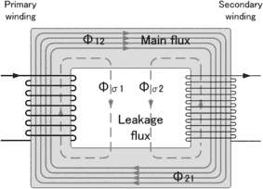

Figure 3.24: Leakage flux of a transformer

The ideal transformer model assumes that all flux generated by the primary winding links all the turns of every winding, including itself. In practice, some flux traverses paths that take it outside the windings Such flux is termed leakage flux, and results in leakage inductance in series with the mutually coupled transformer windings. Leakage flux results in energy being alternately stored in and discharged from the magnetic fields with each cycle of the power supply. It is not directly a power loss (see "Stray losses" below), but results in inferior voltage regulation, causing the secondary voltage to not be directly proportional to the primary voltage, particularly under heavy load.Transformers are therefore normally designed to have very low leakage inductance. Nevertheless, it is impossible to eliminate all leakage flux because it plays an essential part in the operation of the transformer. The combined effect of the leakage flux and the electric field around the windings is what transfers energy from the primary to the secondary.

In some applications increased leakage is desired, and long magnetic paths, air gaps, or magnetic bypass shunts may deliberately be introduced in a transformer design to limit the [short-circuit](http://en.wikipedia.org/wiki/Short-circuit) current it will supply.Leaky transformers may be used to supply loads that exhibit [negative resistance](http://en.wikipedia.org/wiki/Negative_resistance), such as [electric arcs](http://en.wikipedia.org/wiki/Electric_arc), [mercury vapor lamps](http://en.wikipedia.org/wiki/Mercury_vapor_lamp), and [neon signs](http://en.wikipedia.org/wiki/Neon_sign) or for safely handling loads that become periodically short-circuited such as [electric arc welders.](http://en.wikipedia.org/wiki/Arc_welding)

Air gaps are also used to keep a transformer from saturating, especially audio-frequency transformers in circuits that have a direct current component flowing through the windings.

Leakage inductance is also helpful when transformers are operated in parallel. It can be shown that if the "per-unit" inductance of two transformers is the same (a typical value is 5%), they will automatically split power "correctly" (e.g. 500 [kVA](http://en.wikipedia.org/wiki/Kilovolt-ampere) unit in parallel with 1,000 kVA unit, the larger one will carry twice the current.

#### Effect of frequency

**Transformer universal EMF equation**

If the flux in the core is purely [sinusoidal,](http://en.wikipedia.org/wiki/Sinusoidal) the relationship for either winding between its **[rms](http://en.wikipedia.org/wiki/Root_mean_square) voltage** Erms of the winding, and the supply frequency f, number of turns N, core cross- sectional area a and peak [magnetic flux density](http://en.wikipedia.org/wiki/Magnetic_flux_density) B is given by the universal EMF equation:



If the flux does not contain even [harmonics](http://en.wikipedia.org/wiki/Harmonics) the following equation can be used for **half-cycle average voltage** Eavg of any waveshape:

The time-derivative term in [Faraday's Law](http://en.wikipedia.org/wiki/Faraday%27s_law_of_induction) shows that the flux in the core is the [integral](http://en.wikipedia.org/wiki/Integral) with respect to time of the applied voltage. Hypothetically an ideal transformer would work with direct-current excitation, with the core flux increasing linearly with time. In practice, the flux rises to the point where [magnetic saturation](http://en.wikipedia.org/wiki/Saturation_%28magnetic%29) of the core occurs, causing a large increase in the magnetizing current and overheating the transformer. All practical transformers must therefore operate with alternating (or pulsed direct) current.[[44]](http://en.wikipedia.org/wiki/Transformer#cite_note-billings-44)

The EMF of a transformer at a given flux density increases with frequency. By operating at higher frequencies, transformers can be physically more compact because a given core is able to transfer more power without reaching saturation and fewer turns are needed to achieve the same impedance. However, properties such as core loss and conductor [skin effect](http://en.wikipedia.org/wiki/Skin_effect) also increase with frequency. Aircraft and military equipment employ 400 Hz power supplies which reduce core and winding weight. Conversely, frequencies used for some [railway](http://en.wikipedia.org/wiki/Railway_electrification_system) [electrification systems](http://en.wikipedia.org/wiki/Railway_electrification_system) were much lower (e.g. 16.7 Hz and 25 Hz) than normal utility frequencies (50 – 60 Hz) for historical reasons concerned mainly with the limitations of early [electric traction motors](http://en.wikipedia.org/wiki/Traction_motor). As such, the transformers used to step down the high over-head line voltages (e.g. 15 kV) were much heavier for the same power rating than those designed only for the higher frequencies.

Operation of a transformer at its designed voltage but at a higher frequency than intended will lead to reduced magnetizing current. At a lower frequency, the magnetizing current will increase. Operation of a transformer at other than its design frequency may require assessment of voltages, losses, and cooling to establish if safe operation is practical. For example, transformers may need to be equipped with "volts per hertz" over-excitation [relays](http://en.wikipedia.org/wiki/Protective_relay) to protect the transformer from overvoltage at higher than rated frequency.

One example of state-of-the-art design is transformers used for [electric multiple unit](http://en.wikipedia.org/wiki/Electric_multiple_unit) [high](http://en.wikipedia.org/wiki/High-speed_rail) [speed trains,](http://en.wikipedia.org/wiki/High-speed_rail) particularly those required to operate across the borders of countries using

different electrical standards. The position of such transformers is restricted to being hung below the passenger compartment. They have to function at different frequencies (down to

16.7 Hz) and voltages (up to 25 kV) whilst handling the enhanced power requirements needed for operating the trains at high speed.

Knowledge of natural frequencies of transformer windings is necessary for the determination of winding transient response and switching surge voltages.

#### Energy losses

An ideal transformer would have no energy losses, and would be 100% efficient. In practical transformers, energy is dissipated in the windings, core, and surrounding structures. Larger transformers are generally more efficient, and those rated for electricity distribution usually perform better than 98%.

Experimental transformers using [superconducting](http://en.wikipedia.org/wiki/Superconductivity) windings achieve efficiencies of 99.85%.The increase in efficiency can save considerable energy, and hence money, in a large heavily loaded transformer; the trade-off is in the additional initial and running cost of the superconducting design.

Losses in transformers (excluding associated circuitry) vary with load current, and may be expressed as "no-load" or "full-load" loss. Winding [resistance](http://en.wikipedia.org/wiki/Electrical_resistance) dominates load losses, whereas [hysteresis](http://en.wikipedia.org/wiki/Hysteresis) and [eddy current](http://en.wikipedia.org/wiki/Eddy_current) losses contribute to over 99% of the no-load loss. The no-load loss can be significant, so that even an idle transformer constitutes a drain on the electrical supply and a running cost. Designing transformers for lower loss requires a larger core, good- quality [silicon steel,](http://en.wikipedia.org/wiki/Electrical_steel) or even [amorphous steel](http://en.wikipedia.org/wiki/Electrical_steel#Amorphous_steel) for the core and thicker wire, increasing initial cost so that there is a [trade-off](http://en.wikipedia.org/wiki/Trade-off) between initial cost and running cost (also see [energy efficient](http://en.wikipedia.org/wiki/Energy_efficient_transformer) [transformer](http://en.wikipedia.org/wiki/Energy_efficient_transformer)).

Transformer losses arise from:

#### Winding Joule losses

Current flowing through winding conductors causes [Joule heating](http://en.wikipedia.org/wiki/Joule_heating). As frequency increases, [Skin effect](http://en.wikipedia.org/wiki/Skin_effect) and [proximity effect](http://en.wikipedia.org/wiki/Proximity_effect_%28electromagnetism%29) causes winding resistance and, hence, losses to increase.

#### [Core losses](http://en.wikipedia.org/wiki/Magnetic_core#core_loss) Hysteresis losses

Each time the magnetic field is reversed, a small amount of energy is lost due to [hysteresis](http://en.wikipedia.org/wiki/Hysteresis) within the core. For a given core material, the loss is proportional to the frequency, and is a function of the peak flux density to which it is subjected.

#### Eddy current losses

[Ferromagnetic](http://en.wikipedia.org/wiki/Ferromagnetic) materials are also good [conductors](http://en.wikipedia.org/wiki/Electrical_conductor) and a core made from such a material also constitutes a single short-circuited turn throughout its entire length. [Eddy currents](http://en.wikipedia.org/wiki/Eddy_current) therefore circulate within the core in a plane normal to the flux, and are responsible for [resistive heating](http://en.wikipedia.org/wiki/Resistive_heating) of the core material. The eddy current loss is a complex function of the square of supply frequency and inverse square of the material thickness. Eddy current losses can be reduced by making the core of a stack of plates electrically insulated from each other, rather than a solid block; all transformersoperating at low frequencies use laminated or similar cores.

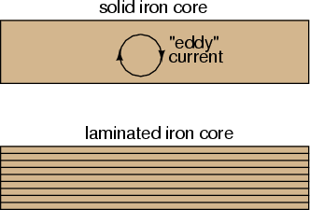

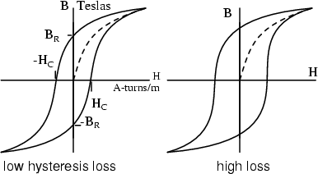

Figure 3.25: Eddy current loss

#### Magnetostriction related losses

Magnetic flux in a ferromagnetic material, such as the core, causes it to physically expand and contract slightly with each cycle of the magnetic field, an effect known as [magnetostriction](http://en.wikipedia.org/wiki/Magnetostriction). This produces the buzzing sound commonly associated with

transformers that can cause losses due to frictional heating. This buzzing is particularly familiar from low-frequency (50 Hz or 60 Hz) [mains hum](http://en.wikipedia.org/wiki/Mains_hum), and high- frequency (15,734 Hz (NTSC) or 15,625 Hz (PAL)) [CRT noise](http://en.wikipedia.org/wiki/Cathode_ray_tube#High-frequency_audible_noise).

#### Stray losses

Leakage inductance is by itself largely lossless, since energy supplied to its magnetic fields is returned to the supply with the next half-cycle. However, any leakage flux that intercepts nearby conductive materials such as the transformer's support structure will give rise to eddy currents and be converted to heat. There are also radiative losses due to the oscillating magnetic field but these are usually small.

#### Mechanical losses

In addition to magnetostriction, the alternating magnetic field causes fluctuating forces between the primary and secondary windings. These incite vibrations within nearby metalwork, adding to the [buzzing noise](http://en.wikipedia.org/wiki/Mains_hum) and consuming a small amount of power.

#### Equivalent circuit

Winding Joule losses and leakage reactances are represented by the following series loop impedances of the model:

* + - * Primary winding: *R*P, *X*P
      * Secondary winding: *R*S, *X*S.

*R*S and *X*S are in practice usually referred to the primary side by multiplying these impedances by the scaling factor (*N*P/*N*S) 2.

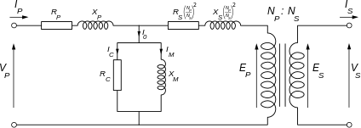

Figure 3.26: Transformer equivalent circuit

Transformer equivalent circuit, with secondary impedances referred to the primary side Core loss and reactance is represented by the following shunt leg impedances of the model:

* + - * Core or iron losses: RC
      * Magnetization reactance: XM.

RC and XM are sometimes collectively termed the magnetizing branch of the model.

Core losses are caused mostly by hysteresis and eddy current effects in the core and are proportional to the square of the core flux for operation at a given frequency. A core with finite [permeability](http://en.wikipedia.org/wiki/Permeability_%28electromagnetism%29) requires a magnetizing current IM to maintain the mutual flux in the core. Magnetizing current is in phase with the flux. Saturation effects cause the relationship between the two to be non-linear, but for simplicity this effect tends to be ignored in most circuit equivalents. With [sinusoidal](http://en.wikipedia.org/wiki/Sinusoidal) supply, core flux lags the induced EMF by 90°. With open-circuited secondary winding, magnetizing branch current I0 equals transformer no-load current.

The resulting model, though sometimes termed 'exact' equivalent circuit based on [linearity](http://en.wikipedia.org/wiki/Linearity) assumptions, retains a number of approximations. Analysis may be simplified by assuming that magnetizing branch impedance is relatively high and relocating the branch to the left of the primary impedances, thus allowing combination of primary and referred secondary resistances and reactances by simple summation as two series impedances.

Transformer equivalent circuit impedance and transformer ratio parameters can be derived from the following tests: [Open-circuit test,](http://en.wikipedia.org/wiki/Open_circuit_test) [short-circuit test,](http://en.wikipedia.org/wiki/Short_circuit_test) winding resistance test, and transformer ratio tests.

# Chapter 4

**Project Figure and Result:**

## Introduction:

This simple traffic controller can be used to teach children rudiments of traffic rules. The circuit shown in Figure uses readily available components. It mainly comprises rectifier diodes (1N4001), a 5V regulator 7805, two timers IC 555, two relays (5V, single- changeover), three 15W, 230V bulbs and some discrete components. Mains power is stepped down by transformer X1 to deliver a secondary output of 9V, 300 mA. The transformer output is rectified by a full-wave bridge rectifier comprising diodes D1 through D4, filtered by capacitor C1 and regulated by IC 7805 (IC1). IC2 is wired as a multivibrator with „on‟ and

„off‟ periods of approximately 30 seconds each with the component values selected. As soon as mains power is switched on, pin 3 of IC2 goes high for 35 seconds. This, in turn, energises relay RL1 through transistor T1 and the red lamp (B1) glows through its normally-open (N/O) contact. At the same time, mains power is disconnected from the pole of relay RL2. As the „on‟ time of IC2 ends, a high-to-low pulse at its pin 3 triggers IC3 through C5. IC3 is configured as a monostable with „on‟ time of about 5 seconds, which means pin 3 of IC3 will remain high for this period and energise relay RL2 through driver transistor T2. The amber lamp (B2) thus lights up for 4 seconds. As soon as 4-second time period o f timer IC3 at pin 3 lapses, relay RL2 de-energises and the green lamp (B3) lights up for the rest of „off‟ period of IC2, which is about 26 seconds. The green lamp is activated through the normally closed (N/C) contacts of relay RL2. So when mains power is switched on, red light glows for 30 seconds, amber for 5 seconds and green for 30 seconds. We can assemble this circuit on a general-purpose PCB and enclose in an insulated box. The box should have enough space for mounting transformer X1 and two relays. It can be fixed near 230V AC, 50Hz power supply.

#### Schematic Diagram of Traffic Controller

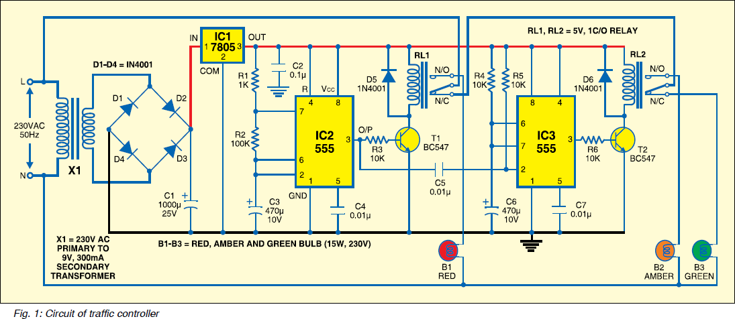

Figure 4.1: Main circuit diagram of Traffic controller

#### Hardware Implementation Of Traffic Controller

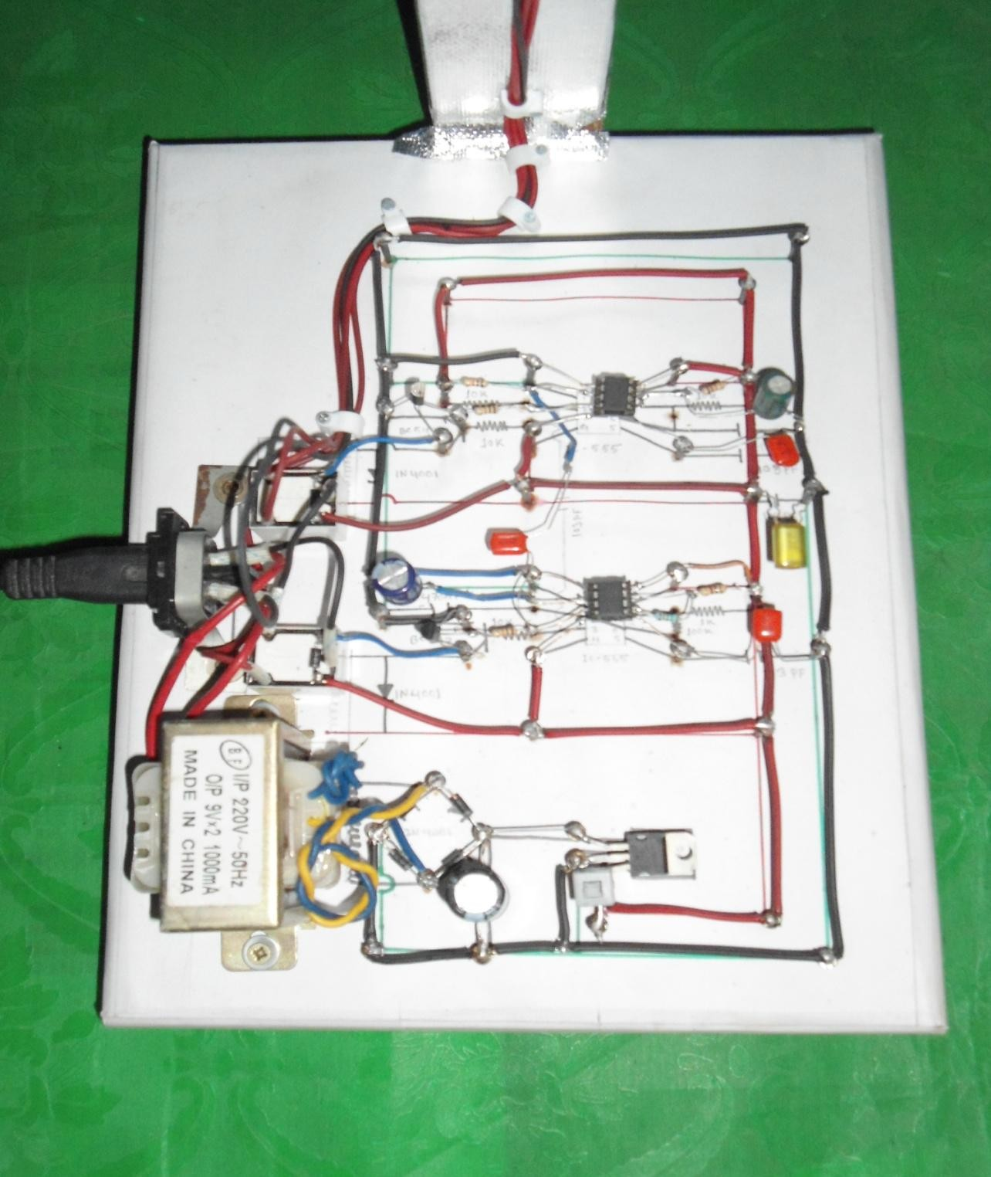

Figure 4.2: Hardware implementation of Traffic controller

## Different View of project

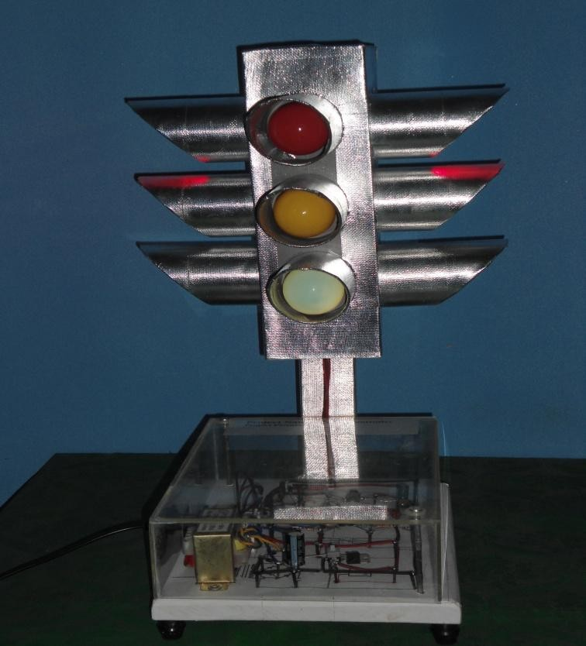

Figure 4.3: Front View

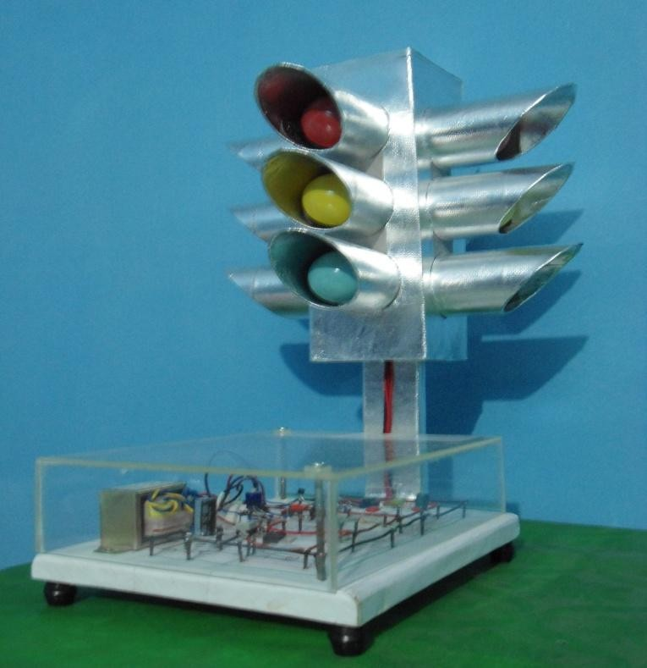

Figure 4.4: Side View

# Chapter 5 Conclusion

## Conclusion

Bangladesh is a populated country. Specially our city area is over populated and congested. Traffic jam is the common phenomena in city area. Dhaka city is the most traffic jam affected area . Traffic jam is obstructing for trade and commerce also waste valuable time. The main reason of traffic jam can be not maintain traffic rules, faulty traffic signaling systems . Illegal parking is another reason for traffic jam. Cars, trucks and other vehicles are parked almost everywhere. Faulty traffic signaling systems, inadequate manpower and narrow road spaces and overtaking tendency of drivers create pro-longed traffic congestions and intensify sufferings of commuters keeping people motionless as well as creating suffocating condition in the streets. Also there are bus terminals not authorized by the traffic department and drivers do not go by traffic rules. VIP protocol maintaining is another reason for frequent traffic jams in the streets and divider problem in the city‟s different important roads also causes congestion. So if we want to overcome this problem we must install a modern traffic controller system also grow up the tendency of maintaining traffic rules. The reason of taking Traffic Controller as a project to reduce that problem, hopefully this is a good effort.

To reduce traffic jam we can take steps such as:

* + - Have a good public transport system so people would use it
    - Install modern and good traffic controller system
    - Keep continuous repair and maintenance of traffic controller and signaling system
    - Good traffic system
    - Good lane system
    - Traffic police should do their duty properly
    - Use zebra cross and foot over bridge
    - Respect the law

APPENDIX

* References

1. *The Authoritative Dictionary of IEEE Standards Terms, Seventh Edition*, IEEE Press, 2000,ISBN 0-7381-2601-2, page 588
2. [MIT open-courseware, Power Electronics, Spring 2007](http://ocw.mit.edu/courses/electrical-engineering-and-computer-science/6-334-power-electronics-spring-2007/lecture-notes/ch9.pdf)
3. Griffith, P. (2005, February). Designing Switching Voltage Regulators With the TL494. Dallas, Texas, USA: Texas Instruments.
4. Hart, D. (2010). *Power Electronics.* McGraw-HIll.
5. International Rectifier. (2004, September 10). IR2304(S) & (PbF) Half-Bridge Driver. El Segundo, California: International Rectifier.
6. [Ward, Jack (2004). The 555 Timer IC – An Interview with Hans Camenzind. The Semiconductor Museum. Retrieved 2010-04-05](http://www.semiconductormuseum.com/Transistors/LectureHall/Camenzind/Camenzind_Page2.htm)
7. Scherz, Paul (2000) "Practical Electronics for Inventors", p. 589. McGraw-Hill/TAB Electronics. ISBN 978-0-07-058078-7. Retrieved 2010-04-05.
8. Jung, Walter G. (1983) "IC Timer Cookbook, Second Edition", pp. 40–41. Sams Technical Publishing; 2nd ed. ISBN 978-0-672-21932-0. Retrieved 2010-04-05.
9. van Roon, Chapter "Monostable Mode". (Using the 555 timer as a logic clock)
10. <http://www.national.com/ds/LM/LM555.pdf>
11. van Roon Chapter: "Astable operation".
12. [http://www.customsiliconsowww.alldatasheet.com(CD4017BC)](http://www.customsiliconsolutions.com/products-for-ASIC-solutions/standard-IC-products.aspx)
13. www.DatasheetCatalog.com(LM7808)
14. www.st.com(stp55nf06l)
15. [www.baylinear.comCentral Electricity Generating Board](http://www.baylinear.com/) (1982). *Modern Power Station Practice*. Pergamon. [ISBN](http://en.wikipedia.org/wiki/International_Standard_Book_Number) 0-08-016436-6.
16. Daniels, A.R. (1985). *Introduction to Electrical Machines*. Macmillan. [ISBN](http://en.wikipedia.org/wiki/International_Standard_Book_Number) 0-333- 19627-9.
17. Flanagan, William (1993). *Handbook of Transformer Design and Applications* (2nd ed.). McGraw-Hill. [ISBN](http://en.wikipedia.org/wiki/International_Standard_Book_Number) 0-07-021291-0.
18. Gottlieb,Irving (1998). *Practical Transformer Handbook*. Elsevier. [ISBN](http://en.wikipedia.org/wiki/International_Standard_Book_Number) 0-7506-3992-X.
19. Hammond, John Winthrop. *Men and Volts, the Story of General Electric*, published 1941 by J.B.Lippincott. Citations: design, early types - 106-107; design, [William Stanley,](http://en.wikipedia.org/wiki/William_Stanley_%28physicist%29) first built - 178; oil-immersed, began use of - 238.
20. Harlow, James (2004). *Electric Power Transformer Engineering*. CRC Press. [ISBN](http://en.wikipedia.org/wiki/International_Standard_Book_Number) 0- 8493-1704-5.
21. Heathcote, Martin (1998). *J & P Transformer Book* (12th ed.). Newnes. [ISBN](http://en.wikipedia.org/wiki/International_Standard_Book_Number) 0-7506- 1158-8.
22. Hindmarsh, John (1977). *Electrical Machines and Their Applications* (4th ed.). Exeter: Pergammon. [ISBN](http://en.wikipedia.org/wiki/International_Standard_Book_Number) 0-08-030573-3.
23. Kulkarni, S.V.; Khaparde, S.A. (2004). *Transformer Engineering: Design and Practice*. CRC Press. [ISBN](http://en.wikipedia.org/wiki/International_Standard_Book_Number) 0-8247-5653-3.
24. McLaren, Peter (1984). *Elementary Electric Power and Machines*. Ellis Horwood.  [ISBN](http://en.wikipedia.org/wiki/International_Standard_Book_Number) 0-470-20057-X.
25. (Copyright © Jaycar Electronics, 2000)
26. *[www.futurlec.com/Transistors/BC547pr.shtml](http://click.infospace.com/ClickHandler.ashx?du=http%3a%2f%2fwww.futurlec.com%2fTransistors%2fBC547pr.shtml&ru=http%3a%2f%2fwww.futurlec.com%2fTransistors%2fBC547pr.shtml&ld=20130203&ap=1&app=1&c=acproy&s=acproy&coi=239137&cop=main-title&euip=202.134.13.138&npp=1&p=0&pp=0&pvaid=24e25ca8b3f740739393d04e03ea1934&ep=1&mid=9&hash=B1A81CEC1D6E11324B2E8B7A8121E424)*
27. [www.webs1.uidaho.edu/](http://www.webs1.uidaho.edu/trafficsignalcontrol/glossary.htm)**[trafficsignal](http://www.webs1.uidaho.edu/trafficsignalcontrol/glossary.htm)**[control/glossary.htm](http://www.webs1.uidaho.edu/trafficsignalcontrol/glossary.htm)
28. **[^](http://en.wikipedia.org/wiki/Traffic_Light_Protocol#cite_ref-1)** ["OECD: Development of Policies for Protection of Critical Information Infrastructures".](http://www.oecd.org/dataoecd/25/10/40761118.pdf) Oecd.org. Retrieved 2012-11-25.
29. **[^](http://en.wikipedia.org/wiki/Traffic_light#cite_ref-1)**[The meaning of traffic lights/red green and amber robots – South Africa](http://www.mydriverslicence.co.za/driving_%20road_signs.htm). Mydriverslicence.co.za.
30. **[^](http://en.wikipedia.org/wiki/Traffic_light#cite_ref-2)** [A Brief History of Traffic Signals- UC Berkeley](http://www.techtransfer.berkeley.edu/newsletter/07-4/traffic_signals.php). Techtransfer.berkeley.edu.



[View publication stats](https://www.researchgate.net/publication/271646983)