ISTE 240.600 Web and Mobile II
Spring 2026
Final Report
Project Title: Shatter Realms Portal
Group 4
Arina Baiazitova 761008753
Masifah Mazhar 418003492
Safia Siddique 761008460

Rubrics
FRONTEND (20 pts) – CLOS 2, 3 and 5
├── 18-20: Professional + Bootstrap + responsive + toasts + loading states
├── 14-17: Clean + responsive + basic response messages
├── 10-13: Basic CSS + not responsive
└── 0-9: No CSS or broken

REST API (25 pts) – CLOS 4 and 5
├── 22-25: Each student has own controller + All 6 methods
├── 17-21: Each has controller + 4-5 methods
├── 12-16: Only 1-2 controller + 2-3 methods
└── 0-11: Only one controller + Less than 2 methods

JPA (20 pts) – CLO 4
├── 17-20: Each student has own repository + 5+ methods + entity classes
├── 13-16: Each has repository + 3-4 methods
├── 9-12: Only 1-2 repository + 1-2 methods
└── 0-8: One repository for all → ZERO for section

GIT (10 pts) – CLO 1
├── 9-10: Branches + 5+ commits + good messages + PRs
├── 7-8: Branches + 3-4 commits
├── 5-6: One branch + 1-3 commits
└── 0-4: Single commit

DEMO (15 pts) – CLOS 2, 3 and 5
├── 13-15: 5+ pages + all CRUD + no errors
├── 10-12: 4-5 pages + most CRUD
├── 7-9: 3 pages + basic CRUD
└── 0-6: Less than 3 pages

FINAL REPORT (10 pts) – CLO 1
├── 9-10: Complete documentation + API docs + team contributions + screenshots
├── 7-8: Most sections present + basic API docs
├── 5-6: Basic report + missing key sections
└── 0-4: No report or very incomplete

FINAL PRESENTATION (10 pts) – CLO 1
├── 9-10: Clear explanation + live demo works + answers questions confidently
├── 7-8: Good presentation + minor demo issues
├── 5-6: Basic presentation + demo has problems
└── 0-4: Cannot explain code + demo fails

Critical Deductions (Applied AFTER scoring)
Violation | Deduction
Missing student names/IDs in README | -10 points
Missing student names/IDs (as comments) at the top of their own classes | -10 points
Only one repository for all entities (not per student) | -8 points (ZERO for JPA section)
Using Mustache templates instead of HTML/JS/REST APIs | -10 points
Only one controller/service for all students | -11 points
No proper database seeding (0 records) or missing/incorrect configuration | -10 points
Absence during the presentation | -20 points

Manifesto
Our Commitment: As a team, we commit to building a high-quality, immersive web experience for the D&D community. We prioritize clean code, responsive design, and collaborative development.
Core Values:
- Consistency: Ensuring a clean, themed aesthetic for all pages.
- Accountability: Meeting all deadlines and taking full responsibility for code quality.
- Quality: Using best coding practices for every element.
Communication: We communicated instructions and work to do through a private group chat. Code changes were reviewed through GitHub pull requests.
Roles: Every member was assigned an entity and its corresponding handlers. It was divided as so:
- Arina: Cart entity with its controller, service, repository, and data seeding
- Masifah: Member entity with its controller, service, repository, and data seeding
- Safia: Merch entity with its controller, service, repository, and data seeding
Additional files, such as the CSS and the static pages, were done collaboratively.

Abstract
The Shattered Realms project is a full-stack web application designed to manage a Dungeons & Dragons campaign. It provides players with a comprehensive guide to character creation and world lore, while offering a shop interface for campaign merchandise. The system is built on Spring Boot with MariaDB used for relational database handling.

Problem Definition
Information and guides about D&D campaigns are often scattered everywhere or gatekept behind paywalls and subscriptions. Our solution is a free, one-stop guide for everything D&D.
- Context: A D&D campaign about a fragmented world recovering from a cataclysm.
- Problem: Players need to be able to browse the lore and character options, register for the campaign, and support the Dungeon Master.
- Solution: A centralized portal with a character guide, interactive lore timeline, member registration, and a fully functional CRUD-enabled shop.

Current Similar Solutions
- D&D Beyond: A professional-grade tool for character sheets and digital books.
- World Anvil: A world-building wiki.
While these portals do exist, they lock their most powerful tools behind monthly subscriptions, limiting the player/user’s potential. Our website offers a freer, more specialised environment for players.

Technologies Used
- Frontend: HTML5, CSS3, JavaScript (Fetch API, Bootstrap 5).
- Backend: Java 25, Spring Boot 3, Spring Data JPA.
- Database: MariaDB (Relational storage for Products and Cart Items).
- Development: Git/GitHub for version control.

Technical Architecture
Figure 1 shows how the backend and frontend components interact in our application, and Table 1 shows what each method in all of our APIs does.
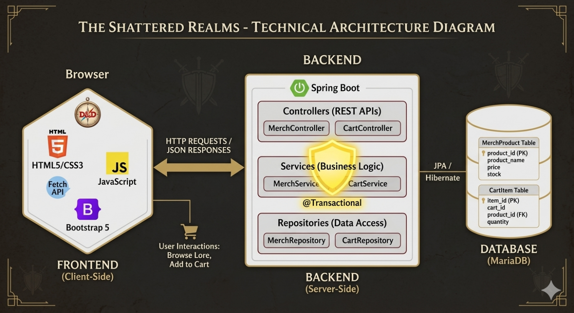
Figure 1 Frontend and Backend components interaction
HTTP Method | Endpoint Example | Purpose
GET | /api/cartitem | Get all records
GET | /api/merch/{id} | Get one record by ID
GET | /api/member/search?name=xxx | Search by field
POST | /api/cartitem | Create new record
PUT | /api/merch/{id} | Full update
DELETE | /api/member/{id} | Delete by ID
Table 1 API Documentation

Key Website Features and Design Summary
- Immersive Lore Engine: An interactive timeline and faction guide explaining the lore of the world.
- Character Creation Guide: Detailed rules for starting/ selecting characters.
- Member Registration: Registration form for new members.
- Admin Merch Dashboard: Full interface for merchandise.
- Shopping Cart: A real-time system to add items to a cart with stock management.

- Styling Decisions: We used a "Gold and Maroon" color palette to evoke a high-fantasy feel. Hexagonal containers were implemented on the home page to symbolize the fractured "fragments" of the world.
- Interaction Scenarios:
  - Player: Browses the lore, checks the Character Guide, and adds a "Dice Set" to their cart.
  - Admin: Logs in to update stock levels or delete a discontinued "Enamel Pin".
Figures 2-5 show the CRUD functionality in action.
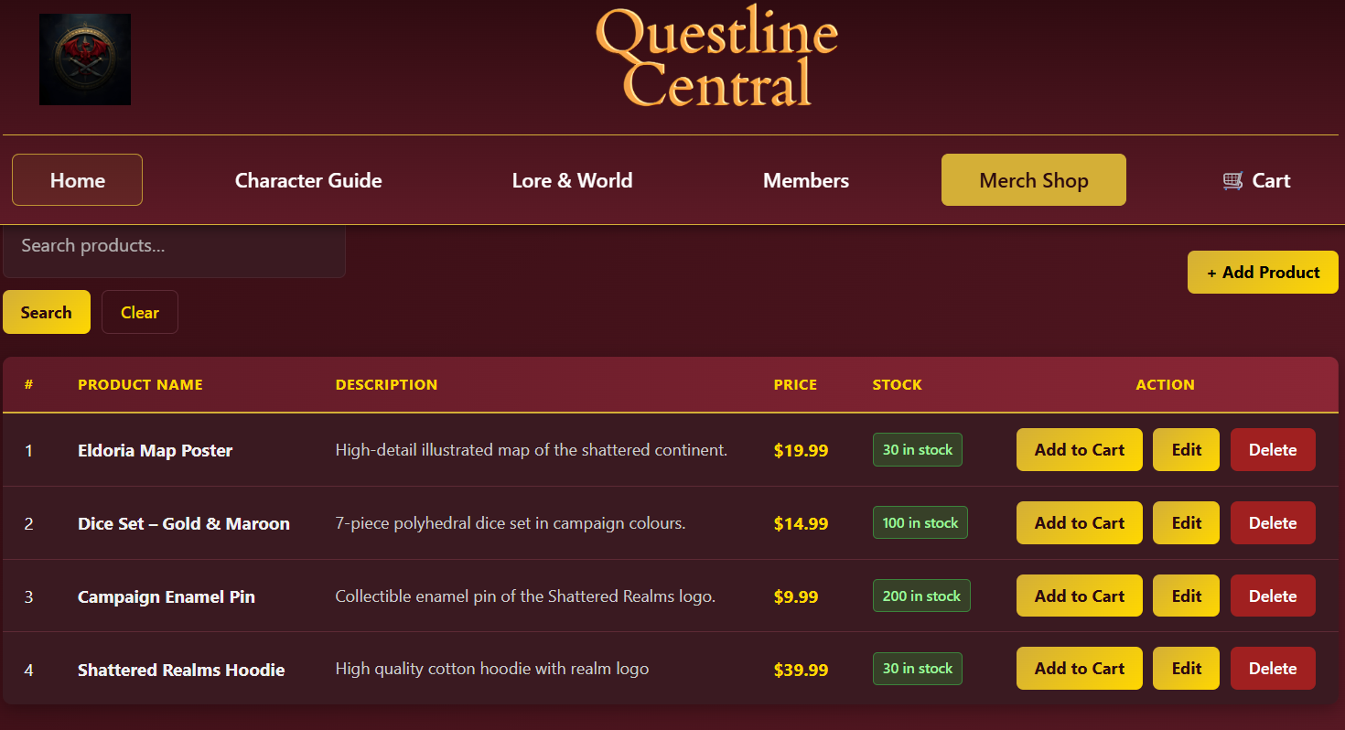
Figure 2 Retrieving merchandise products
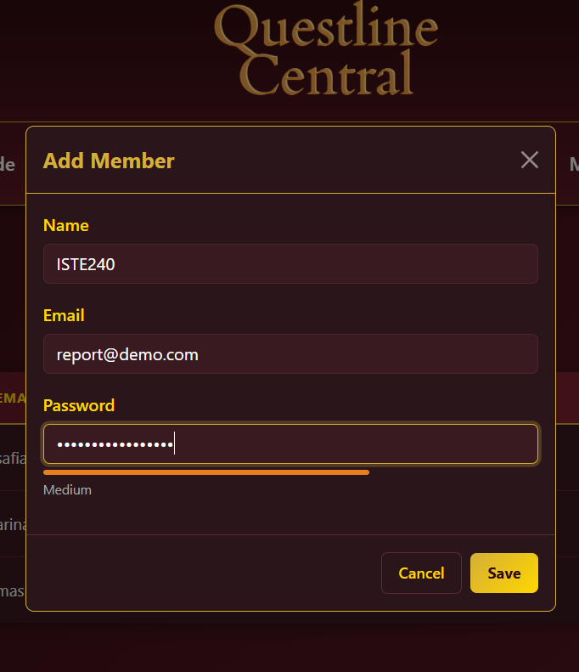
Figure 3 Creating new member
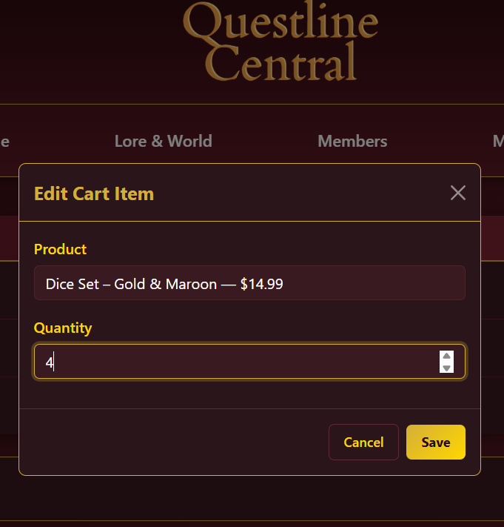
Figure 4 Editing cart item quantity
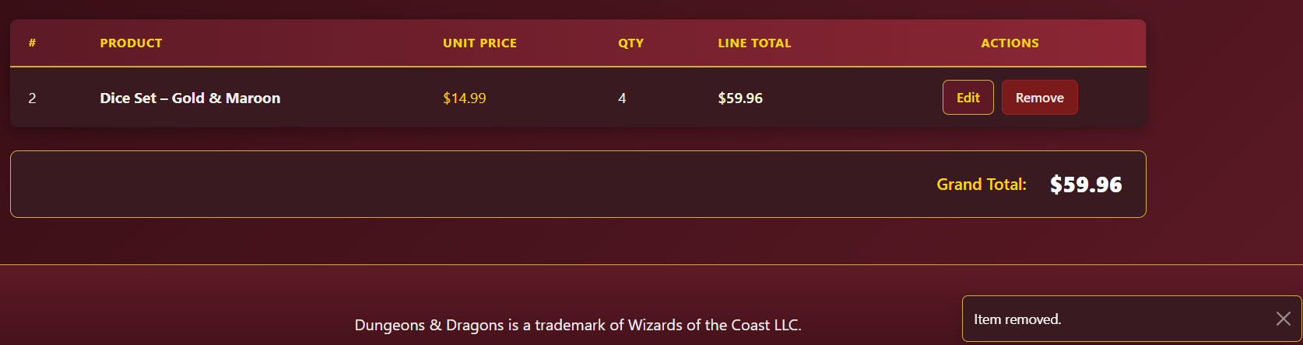
Figure 5 Toast notification after deleting item

Database Design
The database utilizes a relational schema to handle the one-to-many relationship between Products and Cart Items (Figure 6).
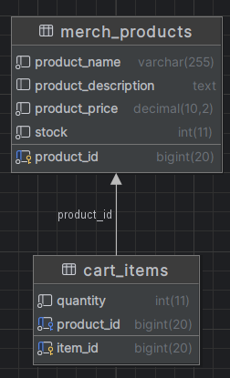
Figure 6 Schema Diagram showing relation between merch product and cart items
We used @Transactional services to ensure that when a product is deleted, its associated cart items are handled safely via cascading or constraints.

Repository Link
https://github.com/masifah-404/iste140-team4

