

**International Study Centre**

**Engineering, Science and Computing (ESC) Department**

**XFX1061 Software Design Module**

***Tutor Name: Kelly***

***Project Title: Hospital Management and Booking Application***

***Date of Submission: 2022***

|  |  |
| --- | --- |
| *Student Name:* | *Masif Muhammad Virk* |
| *Student ID. Number:* | *U2257131* |

**Contents**

**1.** **Project Introduction, Aim and Objectives** 2

1.1 Introduction 2

1.2 Aim and Objectives 2

**2. Methodology/Description** 2

• **Use Case:** 3

• **Class Diagram:** 4

• **Sequence Diagram:** 5

• **Activity Diagram:** 7

• **Flowchart:** 8

**3. Conclusion** 8

# **1.** **Project Introduction, Aim and Objectives**

## Introduction

In this module, we have been taught about UML (Unified Modelling Language) which is the visual modelling of real-world objects that are considered to be the first step in developing an object-oriented system. It shows how the system has been designed to work effectively and efficiently. The project I have choose is an appointment application and a management system for doctors and hospital management. In my program and design the patient can login or register and he can book an appointment easily while sitting from his home. However, the doctor can see who has booked the appointment with him and when. And lastly, the administration can have access to all of the data the admin can delete the patient can add patient manually can add doctor’s availability and can delete doctors if they have left or not available and also the administration can see all the appointment details of all the hospital departments.

I have learned a lot during this project from learning the real use of OOP and how to make a user-friendly program and also how to design the system what things should I consider before making an application. From my personal experience and what I’ve learnt I most important things are planning and then the requirement of the system.

## Aim and Objectives

The aim of the project is to design a software which can help people and also the main point is how can I design the software and what techniques I can use to make a good software.

- I have implemented the basics of software design to design my software coursework

And learned how can I make uml diagrams for any system.

# **2. Methodology/Description**

Here you can find all my UML diagrams and their explanation.

## **Use Case:**

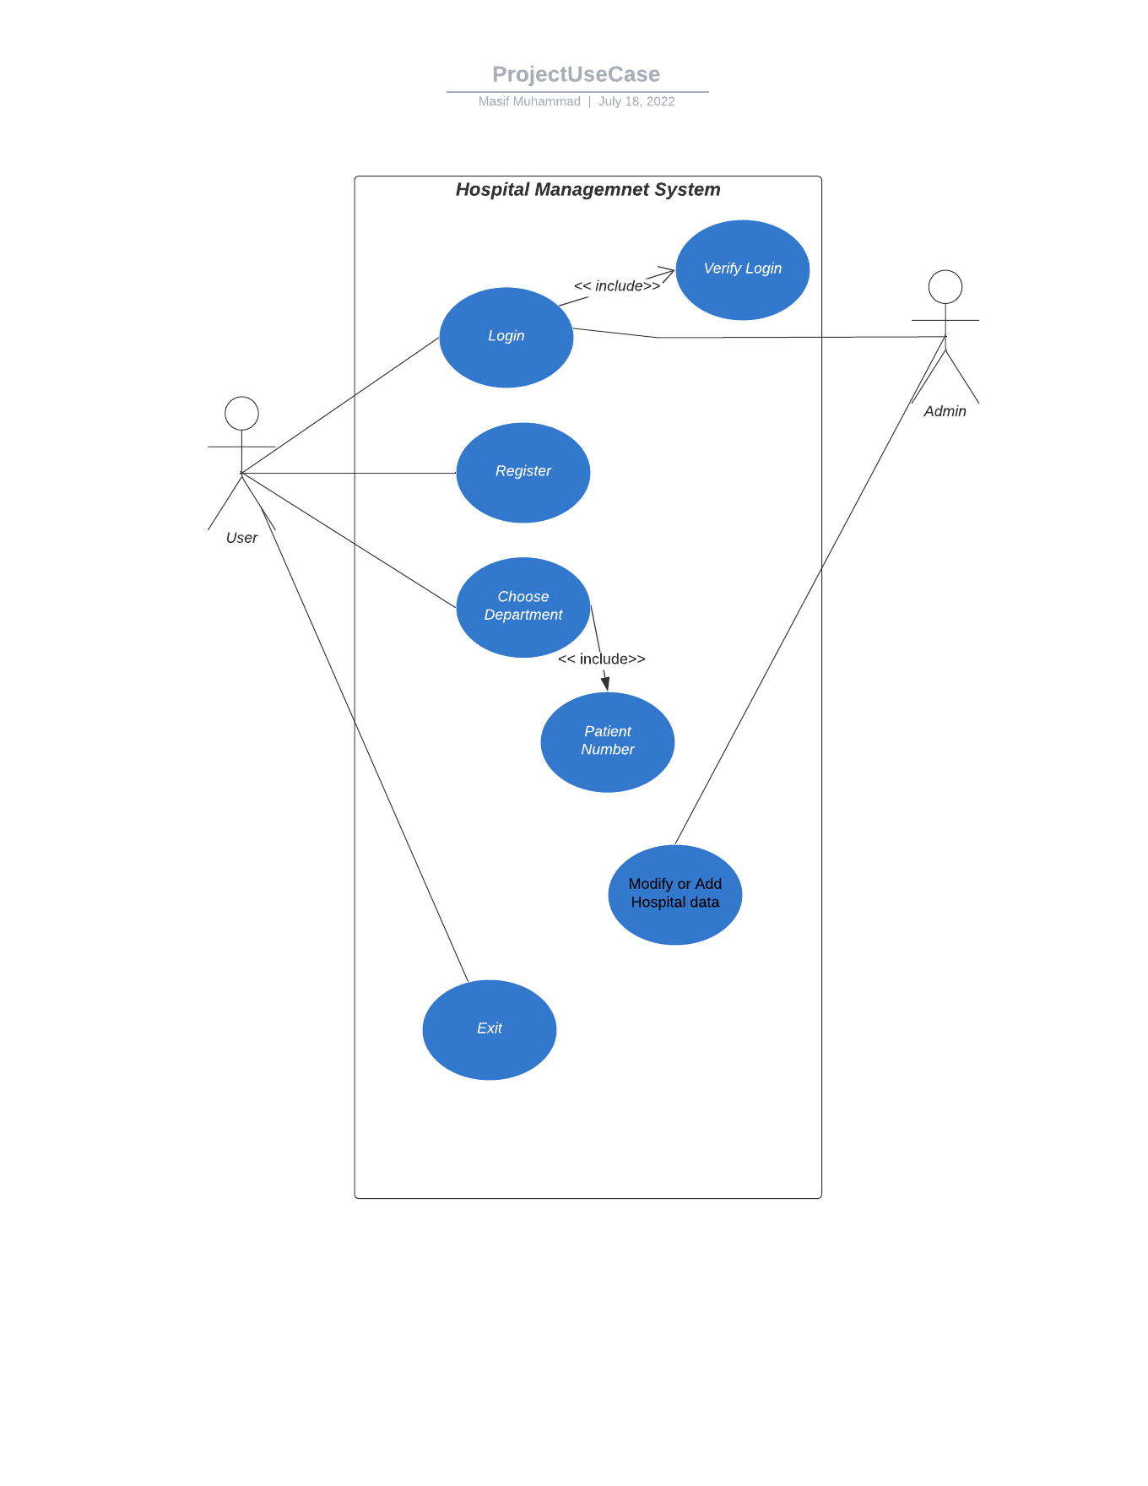

First of all, the diagram above is a use case diagram in which my program is described. Basically, a use case diagram is a type of UML diagram that analyses the functions of different system and how user can interact with those different types of systems. In my diagram I have two actors one is the user who will use the application and the other one is admin who will handle the application and can edit info in the application. The central part is the system which indicates my diagrams. First the person will login then the login details will be verified a new person can also register then he will have to choose a department of e.g. he can choose from Dental, Accident & Emergency, Orthopedics, Psychiatry, Physiotherapy then the system will generate a random number to the person so that he can go to the hospital and without being in any ques he can directly see the doctor.

## **Class Diagram:**

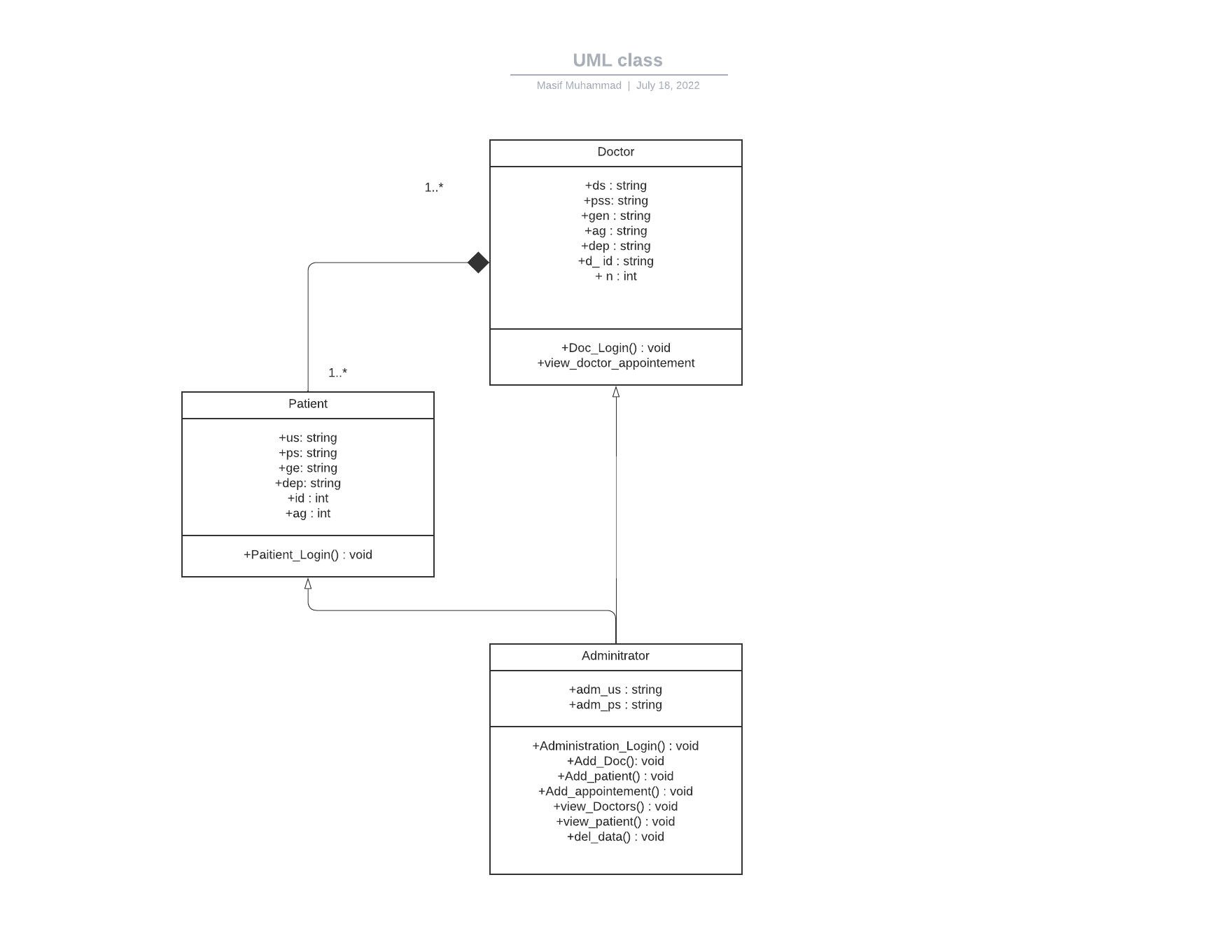

The diagram is a class diagram which shows the classes, attributes and then the methods. In the diagram above there are three classes one shows the doctor the second is patient and the third one is administrator the administrator class inherits from the doctor and patient classes. The patient class has composition with the doctor class. Then if we talk about the attributes we mostly have string and int attributes. Lastly at the bottom we have the methods which are also known as function in program.

## **Sequence Diagram:**

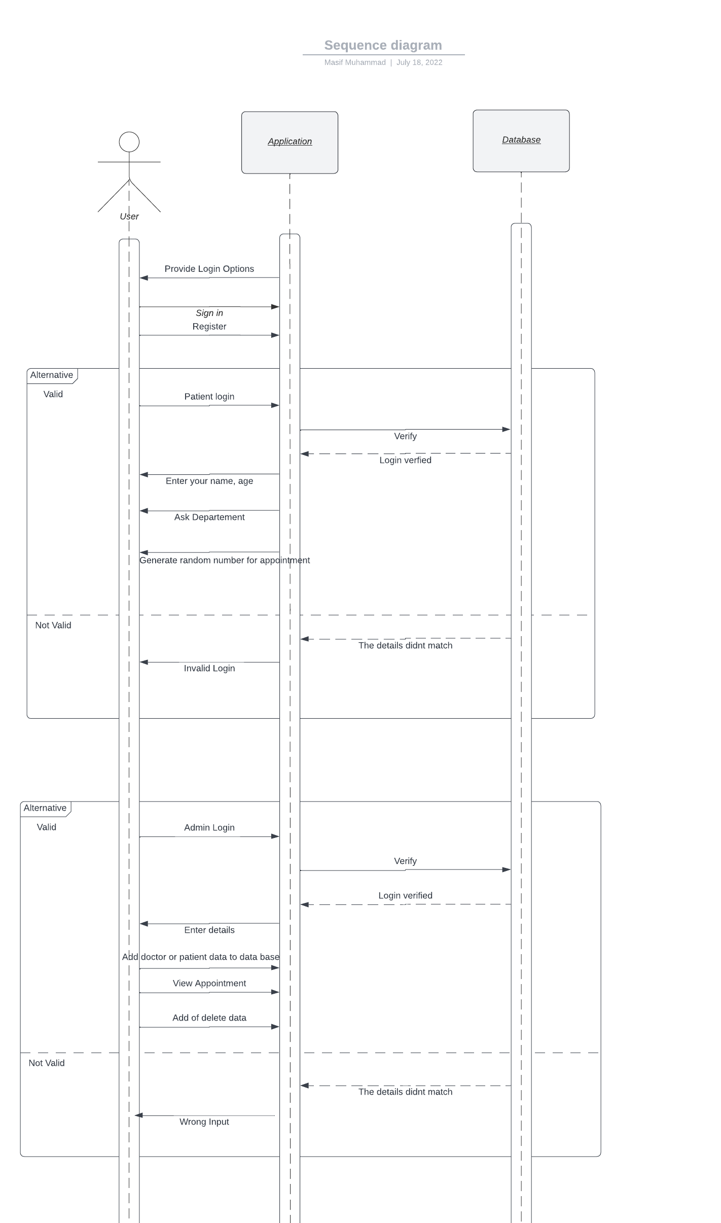

The diagram above is a sequence diagram in which I have an actor which is a user and two objects called application and database. First, the application will provide the user the login option then the user can login and he can also register. If the person logins as patient then his login details will be verified then the application will ask for the basic information of the person and then the application will generate a random number for the person so he can go the hospital to have his checkup and then there is another part if you login as admin you can make changes you can add data in the database and can remove the data from the database all according to the availability of the doctor. The admin can add or delete doctor and can see what patients have booked the appointments.

## **Activity Diagram:**

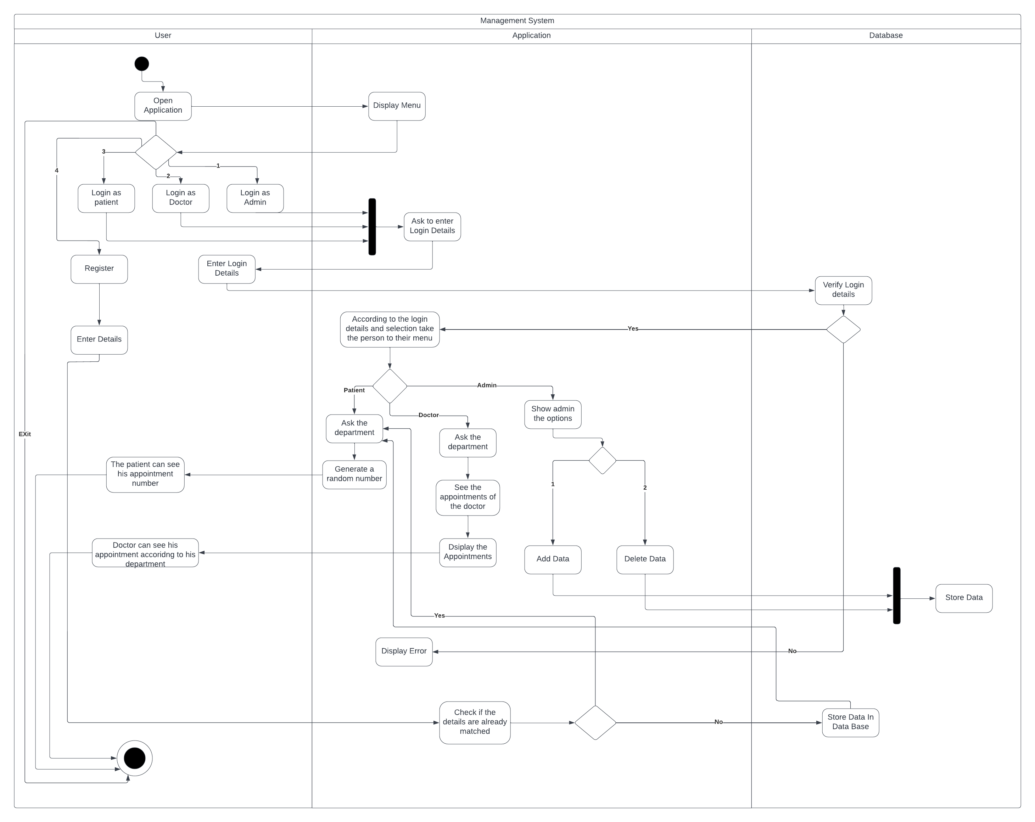

A UML activity diagram helps in providing a more in-depth visual representation of a particular use case. It is a behavioral diagram that depicts the movement of actions within a system. This is my activity uml diagram it has 3 actors user, application and database. First of all the user will open and he will have multiple opens which is the menu. In the menu there will be five options he will have the first option is login as administrator and the second option is login as doctor, the third option is login as patient, the fourth option is register and the last one is exit the program. After choosing the option all of them will enter their details which will be verified in the database if the options are correct they will go to their specific menu where the patient can choose the department and the application will generate a random number for him. The doctor can see what appointments he has and who has booked which appointment with him and lastly the admin as the most control he can see all the details, he can edit the details he can delete the details from the data base he can see all the appointments of the doctor and the patient and on the other hand if somehow the details are wrong then they will be revert back to login again.

## **Flowchart:**

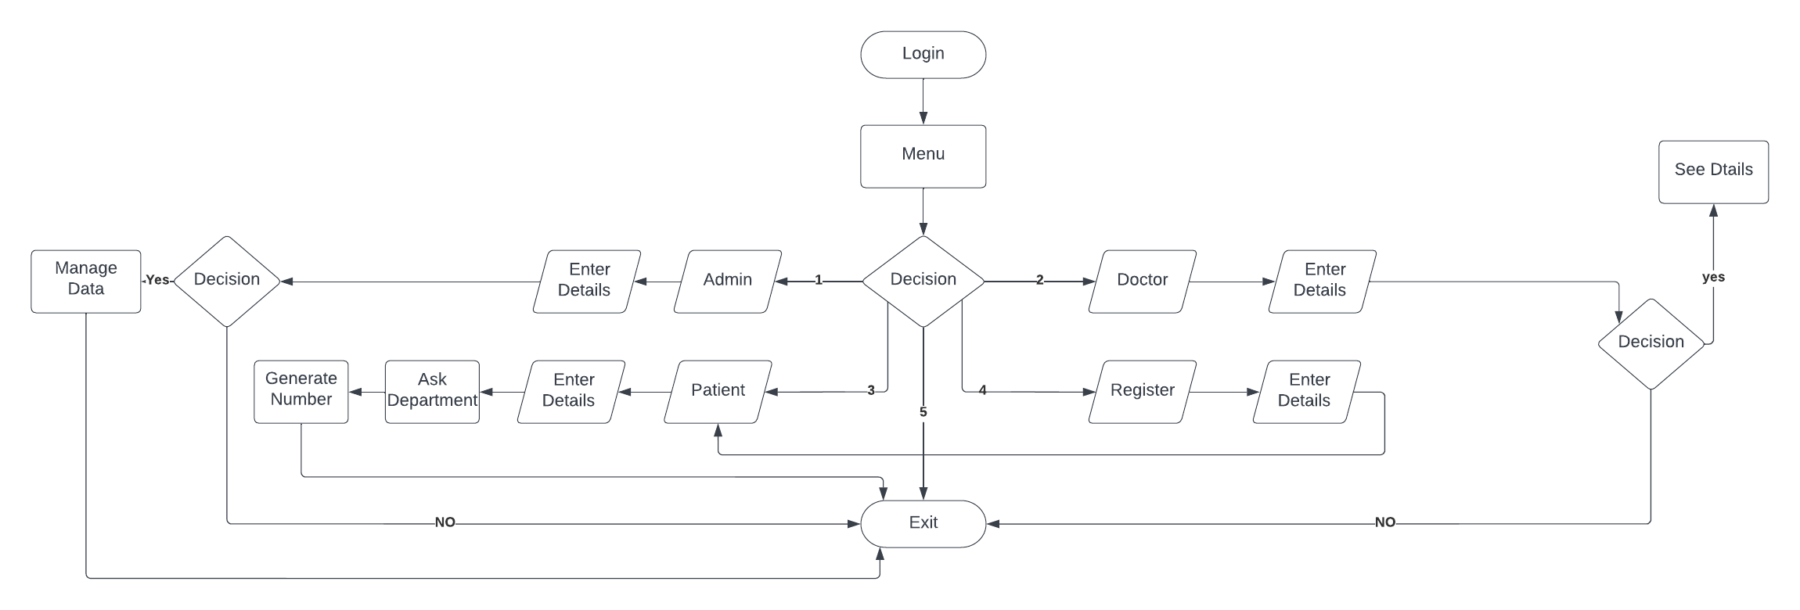

This is basically the flowchart of my program. This flowchart shows how my program is going to work so if a person login he will see the menu then he can make five decisions depending on his needs. He can login as Admin, Doctor or Patient and he can register if he registers as a new customer he will directly go to the patient menu. Every menu has its own functions so if someone login as patient he will enter details choose his desired department of need and a random number will be generated. Secondly, if the person login as doctor he will enter the details if the details are correct he can see his appointment otherwise the program will exit. Lastly, the admin can login and can manage all the data.

# **3. Conclusion**

In my conclusion, I would say that we have learned a lot about UML diagrams and have done 5 different types of diagrams which are Use case diagram, Activity Diagram, Sequence Diagram, Class Diagram, Flowcharts and at last we learned how to write a pseudo code. Furthermore, we learned the basic of Object Oriented Programming such as Abstraction, Encapsulation, Inheritance, and Polymorphism. These all concepts made programming easy for us as these are very useful in doing programming and we can learn a lot. If I compare myself to the last semester we did procedural programming which was easy to learn but tough to do because we had to repeat everything but now with classes and objects and the basic concepts of OOP we can do it easily.

In this project I have done a system for which I have written and explained everything above and have attached the code as well.