Question 1

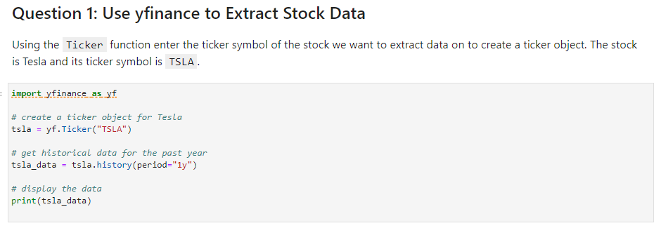

Result

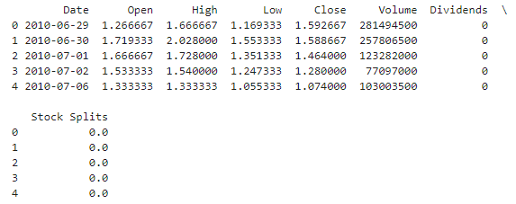

Question 2: Use Webscraping to Extract Tesla Revenue Data

Result

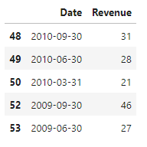

Question 3: Use yfinance to Extract Stock Data

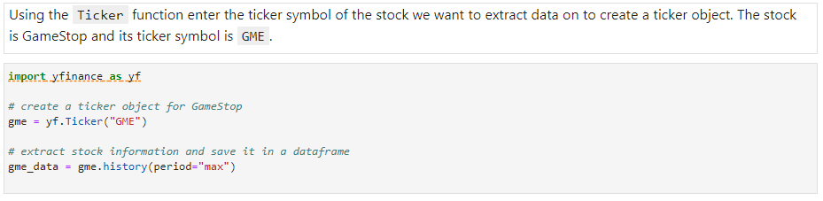

Result

Question 4: Use Webscraping to Extract GME Revenue Data

Result

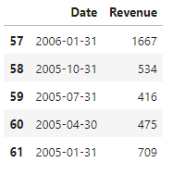

Question 5: Plot Tesla Stock Graph

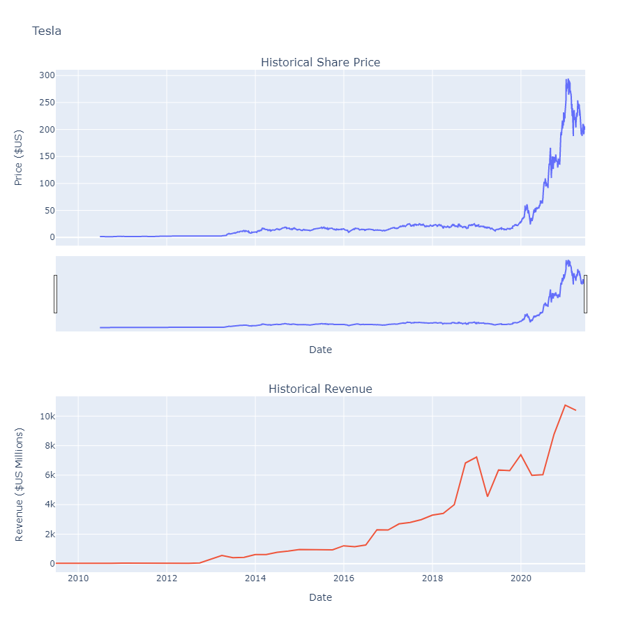

Question 6: Plot GameStop Stock Graph

Result

