Automated Alzheimer’s Disease Severity Classification

Team Member Names

Background and Objective
Alzheimer’s disease (AD) is neurodegenerative disease that displays progressively worsening features over time and affects nearly 7 million individuals in the United States, and an estimated 55 million world wide [citation here]. In addition to a clinical examination, the primary method of diagnosis is clinician review of radiographic imaging data (e.g., CT, MRI, or PET) scans [citation here]. Alzheimer’s disease can be difficult to diagnose, particularly at early stages, even with an expert neurological consult [citation here]. Additionally, it may be beneficial to evaluate disease progression through identification of longitudinal changes in radiographic imaging results. Such evaluation may be difficult as signs of progression may be subtle and variable across patients [citation here]. Finally, timely diagnosis may be constrained by the lack of sufficient availability of neurological specialists in a given healthcare system [citation here]. Therefore, a computational system that can automatically process radiographic data and diagnose Alzheimer’s disease and estimate disease severity would be highly beneficial to clinicians and patients. In this project, we will develop models for this purpose. Here, we provide exploratory data analysis to assess the data that will be used to develop our prediction models.

Dataset
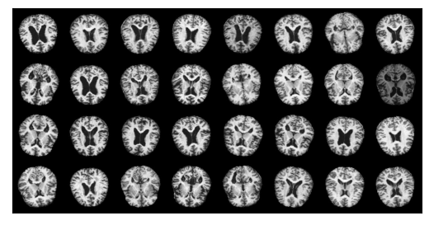
The dataset for this project is publicly available at https://www.kaggle.com/datasets/sachinkumar413/alzheimer-mri-dataset/data. It consists of 6400 unique greyscale images that were generated from magnetic resonance imaging (MRI) scans of individuals that either do not have Alzheimer’s disease or do have Alzheimer’s disease with disease state indicated by dementia severity . Each image is 128 X 128 pixels. An example of the dataset images is shown in Figure 1. Each image is labeled relative to disease severity with one of the following labels: mild Dementia (n=896), moderate dementia (n=64), no dementia (n=3200), and very mild dementia (n=2240). No additional information (e.g., demographics) was provided with this dataset.
Figure 1: Sample data for this project. Each image is a single slice of an MRI brain scan. Images were down sampled to 128 X 128 grey scale by the data provider.

Data cleaning
No data cleaning steps were required for this dataset as they were performed previously by the data provider. However, there is significant class imbalance for the samples labeled as “moderate dementia” for which there are only 64 samples compared to 896 in the next smallest sample group (“dementia”). Therefore, for our analyses, we have grouped the “dementia” and “moderate dementia” samples into a single group that we refer to as “moderate_to_severe_dementia”.

Key Predictors and Outcomes
We intend to treat our modeling as a classification problem for which we will consider different classification model types, all of which will be designed to predict the Alzheimer disease state of a patient. The outcome will be dementia_progression and will take one of three values from [no_dementia, mild_dementia, moderate_to_severe_dementia]. For our baseline model, we will consider a standard machine learning method (e.g., logistic regression) for which the inputs will be predictors extracted from the features. Specifically, we will extract the following features from each image: (1) peak pixel value; (2) sharpness; (3-6) power of top three Fourier spatial frequencies. As an initial assessment of these features, we conducted an ANOVA analysis to determine if there was a difference of means of the feature value when grouped by dementia label. The null hypothesis for these tests is that the mean of the feature is the same for each group. Based on the ANOVA test, all p-values were less than 0.01, and we therefore reject the null hypothesis and anticipate these features should be informative to our baseline model. For our alternative models, we intend to use a neural network architecture (e.g., an convolutional neural network) that will process the image directly without the need to engineer features.

