Automated Alzheimer’s Disease Severity Classification

Team Member Names

Background and Objective
In this project, we are developing a computational system that can automatically process radiographic data to estimate Alzheimer’s disease severity. Here, we detail the development and performance of our baseline model

Method Selection
We selected a feed-forward, fully connected neural network approach for our baseline model. We selected this method because, as with most neural network approaches, it is capable of learning latent features in the input images and does not require feature engineering. This is important for image data for which it is usually difficult to identify universally useful features for classification models. Additionally, our dataset consists of several thousand labeled images (n=6,400), which we anticipated would be sufficient for model training and evaluation. Finally, this model is capable of multi-class classification by adding a softmax calculation to the neural network output which aligns to our project objective.

Method Implementation

Data Preparation
Our input data includes only images, thus there are not missing data samples. Additionally, as we are using neural network approaches, feature engineering and selection are not required. However, to enhance the dataset and present more variation to the model during training, we did apply several data augmentation procedures. Specifically, we applied random rotation of up to 10 degrees and randomly flipped each image (horizontal and vertical) during training epochs. Note, that these approaches were applied separately for each training mini-batch during each training epoch (detailed below). Thus each image is presented to the model slightly differently (rotated, flipped) at each training epoch, which forces the model to learn the correct classification for different orientations of the image.

Data Splitting
We first split our data into a training set (80%) and a test set (20%). We then used k-fold cross-validation with k=3. This small value of k was selected to limit the number of model training and evaluation steps needed to obtain validation results as our dataset is reasonably large and it is infeasible to train and evaluate a large number of neural network models.

Hyperparameter Selection
For our base feed-forward model the only hyper-parameters to consider are the number of units in the hidden layer, the choice of activation function in the hidden layer, and if regularization should be applied. Due to our computational resource constraints, we elected to perform a limited grid search on the number of units in the hidden layer. Specifically, we considered hidden layer sizes of 32, 64, and 128. For the non-linear activation function we applied the rectified linear unit (ReLU) function as used in most neural network applications. We did not apply regularization. We selected the optimal number of hidden units based on the average cross-validation balanced accuracy score.

Evaluation Metrics
For our current baseline model, we evaluated the confusion matrix, the Receiver Operator Characteristic Curve, and standard point metrics including precision, recall, F1-score and accuracy. As indicated in the results, we computed these metrics only for the cross-validation folds. The test set will only be used after our alternative models (checkpoint 3) have been trained and evaluated through cross-validation from which we will pick the best overall model (i.e., the one with the best validation set performance) for evaluation on the test set.

Results
Here, we report the performance results of our baseline feed-forward neural network model. Through cross-validation, we found the optimal number of nodes in the hidden layer is 32 for which the average of balanced accuracy scores on the 3-cross validations folds was 0.29 (standard deviation of 0.05). We constructed a single confusion matrix by collecting the model predictions and actual labels of the validation samples for each iteration of the cross-validation procedure.
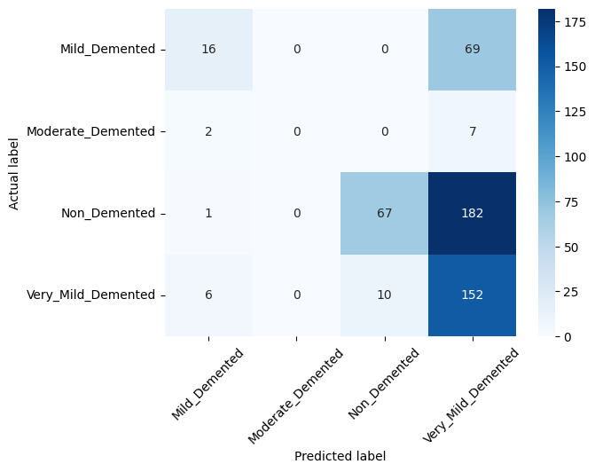
Figure 1: Confusion matrix over all cross-validation folds.
We also examined the Receiver Operating Characteristic curve (see Figure 2). Similar to the confusion matrix, we constructed the within class ROC curves by collecting the predicted class probabilities from the model for the validation samples in each iteration of the cross-validation procedure.
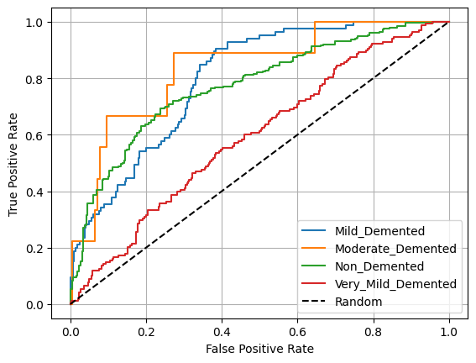
Figure 2: ROC curve over all cross-validation folds.
Finally, we considered standard point metric classification metrics. As with the previous results, we collected the model predictions over all of the validation folds to formulate a single set of point metrics.
Table 1 Cross-validation performance metrics.
Class | Precision | Recall | F1-Score
Mild | 0.67 | 0.16 | 0.26
Moderate | 0.0 | 0.0 | 0.0
Non-demented | 0.84 | 0.26 | 0.39
Very Mild | 0.36 | 0.89 | 0.51
Weighted Average | 0.64 | 0.44 | 0.40

Discussion
Overall, the feed-forward neural network baseline model did not perform particularly well. The confusion matrix (see Figure 1), indicates the model struggled to differentiate the non-demented and the very mild demented samples and to differentiate the mild demented from the very mild demented classes. Interestingly, it did not generate any false positives for the moderate demented class, though it also had zero sensitivity for this class, likely due to the small number of samples in that class. The ROC curves suggest that although the model performs better than random guessing, it does not perform well overall and particularly struggles with the very mild demented samples. Finally, as shown in Table 1, the model performance metrics were poor for all metrics except the non-demented precision (0.84) and the very mild recall (0.89), however these were largely offset by the low recall of the non-demented class (i.e., many false negatives) and the low precision for the very mild class (i.e., many false positives).
The primary limitation of our results is the limited number of samples. It is possible that with a larger number of training samples, the baseline model may have done better, though we caution that prior to collecting additional samples it would be necessary to perform a learning curve analysis to assess if over-fitting (variance) is present.
Our overall conclusion is that a simple feed-forward neural network model is insufficient for our task. In our subsequent modeling effort, we will consider two alternative architectures, specifically convolutional neural networks and image transformers.

