Automated Alzheimer’s Disease Severity Classification

Team Member Names

Background and Objective
In this project, we are developing a computational system that can automatically process radiographic data to estimate Alzheimer’s disease severity. Here, we detail the development and performance of our alternative model.

Method Selection
For our baseline model, we developed a a feed-forward, fully connected neural network to classify the severity of a patient’s dementia based on an input MRI brain scan. Although the model performed better than random guessing and indicated the feasibility of predicting dementia from an input MRI image, it struggled to differentiate very mild dementia from mild dementia classes. We hypothesize that the baseline model was not able to learn spatially invariant features that might be useful for this fine grane classification. For our alternative model, we are using a multilayer convolutional neural network (CNN). We have selected this approach because CNN models are specifically designed to learn important spatially invariant features that we hypothesize will improve classification performance. Similar to our baseline feed forward neural network model, the CNN model can learn latent features in the input images and does not require feature engineering. As noted in the previous report, our dataset consists of several thousand labeled images (n=6,400), which we anticipated would be sufficient for CNN model training and evaluation.

Method Implementation

Data Preparation
We did not need to alter our data pre-processing methods from the baseline model as both models work directly with image input data.

Data Splitting
We maintained the same data split used to train our baseline model. Specifically, the data was divided into a training set (80%) and a test set (20%). We again applied k-fold cross-validation with k=3 as detailed in the previous report.

Hyperparameter Selection
For our alternative CNN model, the hyper-parameters include the kernel size, the stride, the number of convolution layers, the choice of activation function in the hidden layer, and if regularization should be applied. Due to our computational resource constraints, we elected to perform a limited grid search on the kernel size and the number of convolution layers. First, we define a convolution layer as: a 2D convolution, max pooling, and ReLU activation. In our grid search, we considered kernel sizes of 3 and 5 and 1, 2, and 3 convolution layers. We did not apply regularization. We selected the optimal number hyperparameters based on the average cross-validation balanced accuracy score.

Evaluation Metrics
For our CNN model, we evaluated the confusion matrix, the Receiver Operator Characteristic Curve, and standard point metrics including precision, recall, F1-score and accuracy. As indicated in the results, we computed these metrics only for the cross-validation folds. The test set results will be presented in the final report.

Results
Here, we report the performance results of our alternative CNN model. Through cross-validation, we found the optimal kernel size was 3, and the optimal number of convolution layers was also 3, for which the average of balanced accuracy scores on the 3-cross validations folds was 0.62 (standard deviation of 0.04). We constructed a single confusion matrix by collecting the model predictions and actual labels of the validation samples for each iteration of the cross-validation procedure (Figure 1).
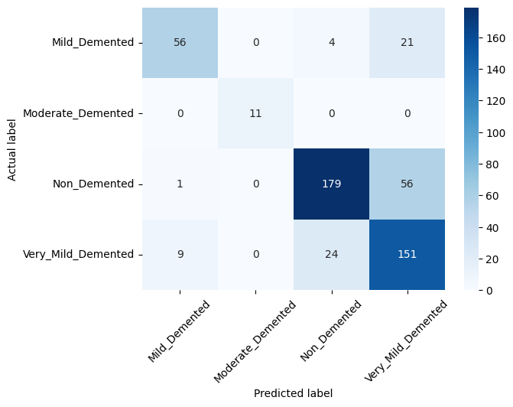
Figure 1: Confusion matrix over all cross-validation folds.
We also examined the Receiver Operating Characteristic curve (see Figure 2). Similar to the confusion matrix, we constructed the within class ROC curves by collecting the predicted class probabilities from the model for the validation samples in each iteration of the cross-validation procedure.
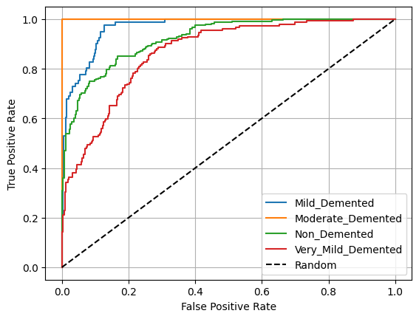
Figure 2: ROC curve over all cross-validation folds.
Finally, we considered standard point metric classification metrics. As with the previous results, we collected the model predictions over all of the validation folds to formulate a single set of point metrics.
Table 1 Cross-validation performance metrics.
Class | Precision | Recall | F1-Score
Mild | 0.86 | 0.74 | 0.79
Moderate | 1.0 | 0.91 | 0.95
Non-demented | 0.85 | 0.80 | 0.83
Very Mild | 0.7 | 0.79 | 0.75
Weighted Average | 0.80 | 0.79 | 0.79

Discussion
Overall, CNN model performed quite well and is substantially better than our baseline model (comparison to be provided in the final report). The confusion matrix (see Figure 1), indicates the model still has some difficulty distinguishing the non-demented and the very mild demented samples and to differentiate the mild demented from the very mild demented classes, but the result is much better than the baseline model. As with our baseline model, the CNN model did not generate any false positives for the moderate demented class, however unlike the baseline model it had high recall for this class. The ROC curves suggest that the model is a strong classifier, though it has some struggles with the very mild demented samples. Finally, as shown in Table 1, the model has very good performance metrics across all classes. The primary limitation of our results remains the limited number of samples. In a continuing study, we would recommend that a learning curve analysis be performed to determine if collecting additional training samples would be likely to improve model performance. Our overall conclusion is that a CNN model is likely to address our task given enough training data. Future work should include a detailed error analysis to determine if there are patterns that further indicate how to improve the model.

