Introduction
In class labs and take-home assignments for this course will be completed using Jupyter Python notebooks. For each assignment, learners will be provided with an existing Jupyter Python notebook file (designated by the .ipynb file extension). The .ipynb file may include both text response questions and programming problems to be completed using the Python programming language. Detailed instructions for each problem are included in the .ipynb file for each assignment. Learners should provide answers to both text response and programing problems directly in the .ipynb file. Once completed, learners should submit the .ipynb file on Canvas using the relevant Canvas Assignment interface (please reference the course syllabus for more details).
Learners may use any computing environment that supports Python and Jupyter to complete assignments. Options include: (1) Palmetto JupyterLab, (2) Google Colab and (3) your local machine. Options (1) and (2) are detailed in the following sections. Note, the Google Colab option eliminates the need to configure the Python environment and may be preferred for learners unfamiliar with Python environment management. For learners preferring to use Palmetto or their own computing environment, a requirements.txt file is provided.
For take-home assignments, after completing the assigned tasks and saving the changes, you will need to submit the assignment .ipynb file on Canvas. Please ensure that all outputs are visible in the saved notebook!

Google Colab
Google Colab is a web application that provides a free hosted Jupyter notebook environment and access to remote computing resources (including GPUs). The advantage of using this service for course assignments is that it eliminates the need to configure the Python environment. All you need is a Google account and any modern web browser (though Google Chrome is recommended). If you have an active Gmail account, then you should already have access to Google Colab and Google Drive. If you do not have a Google account, you will need to create one (see here) if you wish to use Google Collab for the course assignments.
Once you have a Google account, visit the link https://colab.research.google.com/. The page should look like the image below. Click on the Google Drive tab at the top (or left) of the dialog box to make sure you can access your Google Drive from Google Colab (this should happen automatically).
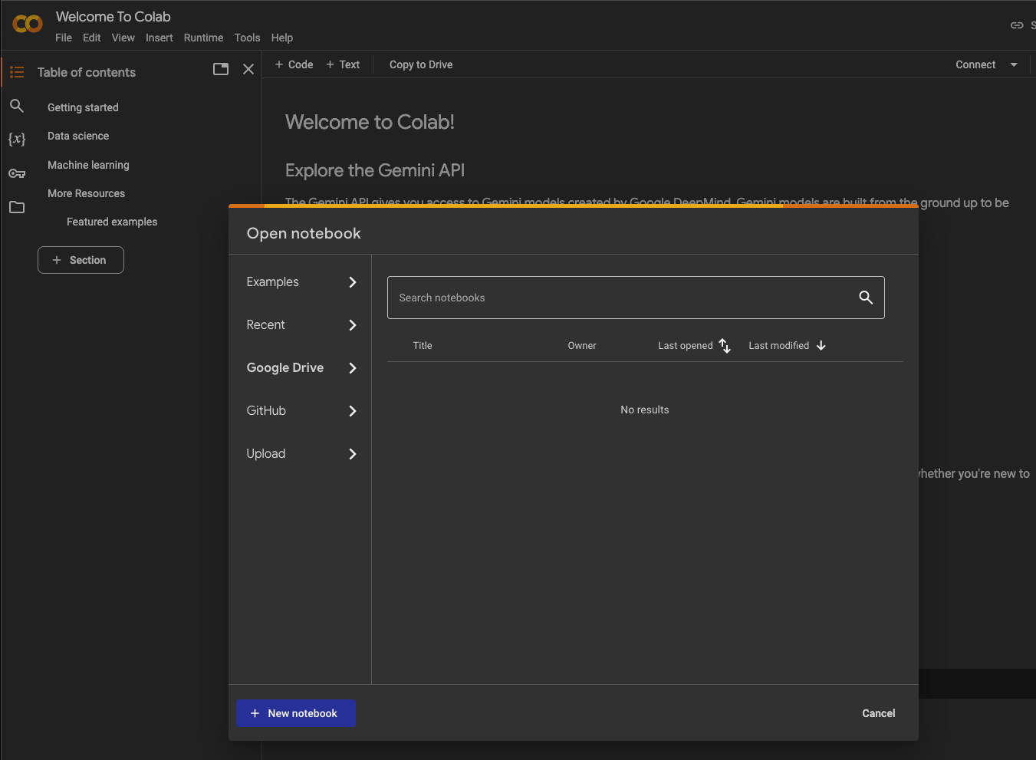

Next, click the “New notebook” button at the bottom left of the dialog box. Jupyter notebook files that you create using Google Colab are saved to your Google Drive account in the directory My Drive:Colab Notebooks. If you now go to your Google Drive, https://drive.google.com/drive/my-drive, you should see the Colab Notebooks folder as in the image below:
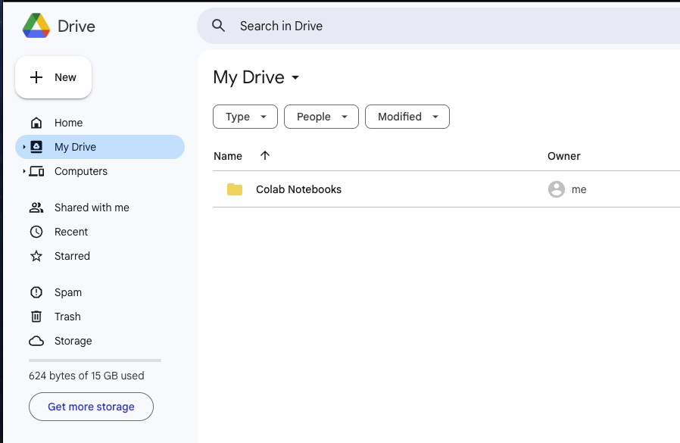
Some labs and homework assignments require additional resources (e.g., files containing data) that we will access from JupyterLab using Python programming commands. In such cases, it will be necessary to provide the Python code with the path to the required resource. In most cases, the lab or homework .ipynb file will be pre-populated with the code required to access these resources. However, for the code to work, you must store the resources in the expected location. For students using Google colab, the expected location is Colab Notebooks/cpsc-4300-6300/resources. To create these directories, double click on the Colab Notebooks folder in your Google Drive. Right click in the window and click the “New folder” menu item in the pop up dialog. Name the folder cpsc-4300-6300 in the new folder dialog and click “Create”. Now double click on the newly created cpsc-4300-6300 folder and repeat this process to create a folder called resources
You will need to download the .ipynb file for each course lab and homework assignment to your computer and then upload it to your Colab Notebooks directory on Google Drive. It is recommended that you store them in the directory Colab Notebooks/cpsc-4300-6300/labs and Colab Notebooks/cpsc-4300-6300/homeworks to keep things organized. You may add additional directories as needed. Once uploaded to your Google drive, if you now double click on an .ipynb file in your directory, it will be opened in a new tab in the Google Colab environment that looks similar to the image below. You are now ready to use Google Colab for the course labs and homework assignments.
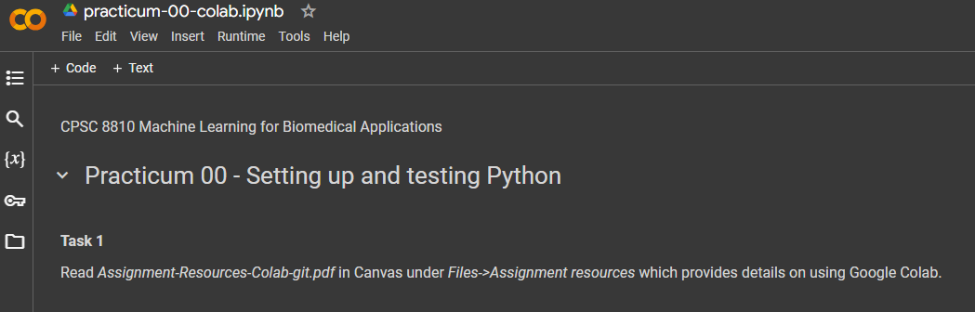
NOTE: Notebooks may not save automatically. To save updates to your .ipynb files, use the File->Save menu item.

Palmetto JupyterLab
Clemson University provides a number of graphical interfaces to access to the Palmetto high performance computing (HPC) cluster, including File Browser, terminal, and JupyterLab (see here for complete documentation). This section assumes you have an active Palmetto account. Please let me know if you do not have an account so that I may make a single request for everyone.

Accessing the Palmetto Graphical OnDemand Interfaces
To get started using the Palmetto JupyterLab environment for the course assignments, first visit the OnDemand service at https://ondemand.rcd.clemson.edu/pun/sys/dashboard. 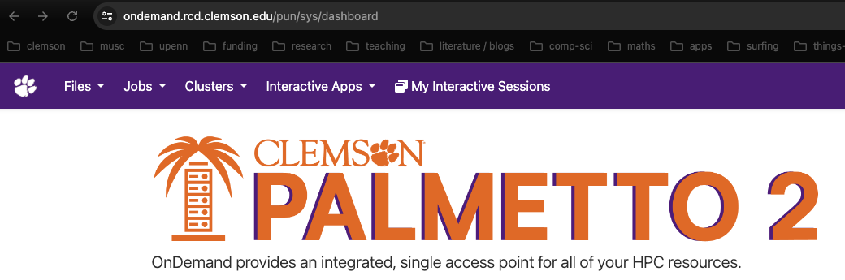

Access and Configure Palmetto JupyterLab
To launch a JupyterLab session select Interactive Apps | Jupyter Notebook from the OnDemand Dashboard:
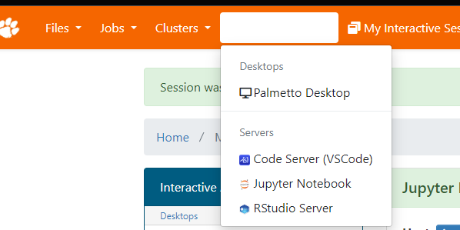
This will take you to a Jupyter Notebook Configuration Dialog. Unless otherwise specified in class or in the assignment file, the default options should be sufficient except:
- Walltime: Increase to at least 2 hours for labs and while working on homework.
- GPU: If required set the GPU field to 1 – this will be discussed in class when needed.
After clicking the Launch button at the bottom of the configuration dialog, you will be taken to your interactive Apps page. Your Jupyter environment may not be ready immediately. Once it is ready, you will see the Connect to Jupyter button as in the image below. Click that button launch the JupyterLab interface.
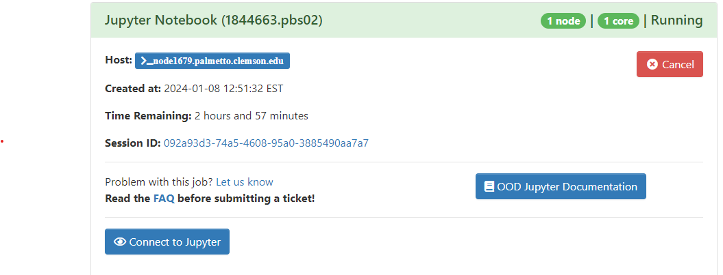

The JupyterLab interface includes a file directory (not shown) for which the root is set as the working directory you selected in the Jupyter Notebook configuration dialog (/home by default). The interface also contains a Launcher from which you can create new files and open a terminal.
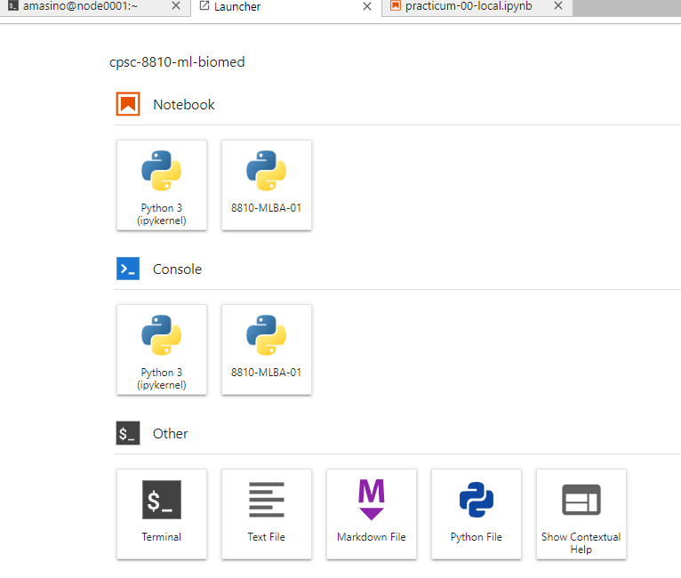
Configure Jupyter Kernel
To complete the in-class labs and homeworks, we first need to configure a new Python environment. From the JupyterLab Launcher, select the Terminal button which will open a Terminal tab in JupyterLab.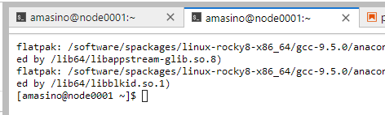

In the terminal execute the commands shown below to create, activate, and configure the Python Kernel:
conda create --name cpsc-4300 python=3.12
source activate cpsc-4300
conda install jupyter
python -m ipykernel install --user --name cpsc-4300 --display-name cpsc-4300
If you have downloaded the course requirements.txt file, copy it to Palmetto (drag and drop it onto the file explorer panel in Juypter) and then install the necessary Python libraries with the following command (this will be reviewed in class).
pip install -r requirements.txt
Some labs and homework assignments require additional resources (e.g., files containing data) that we will access from JupyterLab using Python programming commands. In such cases, it will be necessary to provide the Python code with the path to the required resource. In most cases, the lab or homework .ipynb file will be pre-populated with the code required to access these resources. However, for the code to work, you must store the resources in the expected location. For students using the Palmetto JupyterLab, the expected location is /home/YOUR-USER-NAME/cpsc-4300-6300/resources.
In the Palmetto Jupyter environment, you can create directories in your /home/username directory using the File Explorer panel on the left side (see image below). Right click in empty region of the file explorer window and click the “New Folder” menu item in the pop up dialog. Name the folder cpsc-4300-6300. Now double click on the newly created cpsc-4300-6300 folder and repeat this process to create three folders inside cpsc-4300-6300:
- resources
- homeworks
- labs
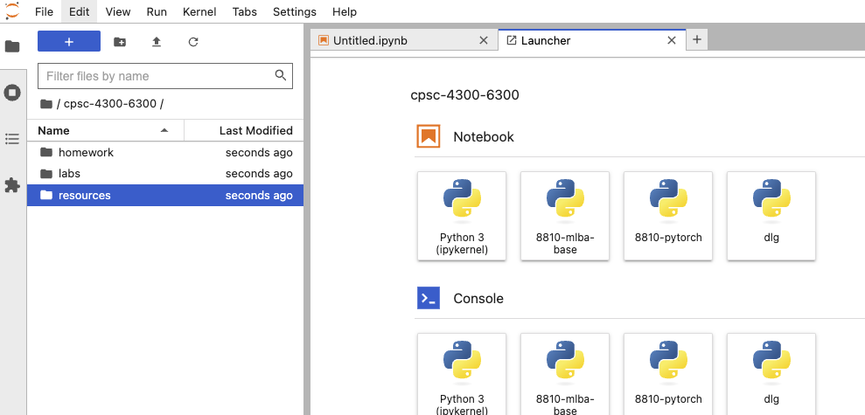
You can now copy course lab and homework files to your Palmetto home directory using the Jupyter lab upload file file explorer interface. Double clicking on a .ipynb file will open it in the Jupyter lab environment. You will need to change the Python kernel used by the notebook. To do so: At the top right of the notebook, click the “Python 3 (ipykernel)” text to open the Kernel selection dialog (shown below) and select “cpsc-ads-2024”.
