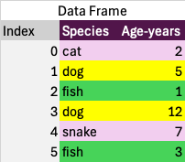
We’ve grouped the rows by the Species. The values of Age-years for each group are collected. We need to specify how to aggregate them before we can generate a result.
1,3
5,12

