**Abstract**

This construct of face-to-face communication is presented as a form of internal and external factors. A seven-item questionnaire we designed to measure communication. Two factors of face-to-face communication were investigated through the development and validation of the Interpersonal Communication Scale. External Perception defines an individual’s ability to interact with others, and Internal Disseverance refers to one’s desire to remove the distance between the individual, which they are communicating. The components of these two factors were explored in two studies using various measures of communication, self-deception, social desirability, and gender. External perception was shown to predict an individual’s perception ability, gender, and their ability to communicate with others. Internal disseverance was discovered to predicted an individual’s desire to communicate, and the strongest correlation to flexible and competence in regards to communication.

*Keywords:*  interpersonal communication, external perception, internal disseverance

**The Development of a Trait Measure of Face-To-Face Communication**

The question of how technology in society has affected the ability to communicate has been argued for years. Many observations have been made that individuals communicating via the web, texting, or using other technology appear to have inferior interpersonal skills than those using face-to-face (FtF) interaction (Hwang, 2011; Bakke, 2010). The use of computer-mediated communication is almost unavoidable, how well society utilizes technology in communication is becoming ever more important (Spitzberg, 2006). Being able to measure this observation is a challenge. In this research study, I developed a trait measure of FtF communication called the Interpersonal Communication Scale (ICS) based on factors that have been shown to control communication. With a baseline of FtF communication, it should be possible to manipulate different variables to formulate the effect of technology on communication.

Interpersonal communication is inescapable. Not communicating is not an option; even the act of not communicating communicates something. Verbal communication is only part of the act of communicating. Non-verbal communication is just as important and normally conveys more information than words alone. The use of technology to communicate, the telephone for instance, takes away the use of body language to communicate. The use of e-mail, texting, or instant messaging only further compounds the problem of communicating by taking away the ability to use tone or verbal cues in communication (Petric, Petrovcic, & Vehovar, 2011; Stephens, 2011; Stricker, 1982).

Interpersonal communication is also irreversible; once we utter a word, or say something it is impossible to take it back. While saying inappropriate things verbally is bad enough, having these communications written down or transferred via technology can make the severity of what was communicated magnified. Whereas something said to one person, is only heard by that one person, if it is recorded, the discourse can be shown to anyone.

Communication is also extremely complex (Algren & Eichhorn, 2011). Communication between two individuals involves six entities: Who you think you are, who you think the other person is, who you think the other person thinks you are, who the other person thinks they are, who the other person things you are, and who the other person thinks you think they are. In Being and Time, Martin Heidegger addresses this issue. It is his thought that without creating a language that both individuals completely and fully understand, it is impossible to communicate effectively (Heidegger, 1962). Proper use of language, and when to use it, is also an integral part of communication (Cegala, 2011). Communication is also complex because we use simulacrum in our day-to-day communication. Simulacrum is the use of symbols for words or ideas (Baudrillard, 1988). If you were to ask me how I was doing, and I responded ‘fair to midland’, would you understand that I just told you that even though I was doing OK, I could be better. Being able to use examples and symbolisms in language is critical in communication.

Finally, interpersonal communication is contextual (Duran, 1983& 1992; Hullman, 2007). Psychological, relational, situational, environmental, and cultural are important exoteric forms of context that communication can take place (Rubin & Martin, 1994). The order these different contexts are ordered will dictate how interactions between individuals will progress. This is due to each communicator having different value systems for these conceptualities (Martin, Anderson, & Thweatt, 1998; Martin & Anderson, 1998; Martin & Rubin 1995).

Where there are many different aspects of communication, having any two observers to agree on which factors are most important is difficult. Self-efficacy is a person’s belief in their own ability to successfully communicate with other individuals; and flexibility the ability to communicate in different ways (DeVito, 2001; Galvin, Bylund, & Brommel, 2012). Apprehension, assertiveness, anxiety, and confidence all relate to an individual’s active ability to successfully approach others and engage in communication (McCroskey & Richmond, 1991; DeVito, 2001). Listening and self-talk refer to how well an individual can communicate by actively focusing on the other communicator without changing the subject towards their self (Weaver II, 1993). Mindfulness, conflict resolution, perception, and empathy sum up the individual’s ability to be thoughtful of another while engaging in communication (Weaver II, 1993; DeVito, 2001; Galvin, Bylund, & Brommel, 2012). Metacommunication entails several aspects of communication. Non-verbal body language, verbal cues, language, and simulacrum were included in this sub-category as they all deal with internal ideas and thoughts about communication (Weaver II, 1993; DeVito, 2001). Openness towards others, as it relates to self-disclosure, owning feelings, and the willingness to communicate, was deemed another important aspect of communication (McCroskey & Richmond, 1991; Weaver II, 1993; DeVito, 2001). Supportiveness, positiveness, and reward when dealing with praise and criticism were grouped together as an individual who is more supporting and positive are much more likely to be approached by others and engage in communication (Weaver II, 1993). Equality, respect, and ethics were grouped together as all deal with how well we interact with others who are different from ourselves (DeVito, 2001). Finally, immediacy as it relates to liking and attraction was placed in a factor. How others view us will have an impact on how we are allowed to communicate with them (McCroskey, Larson, & Knapp, 1971).

The purpose of this article was to determine what factors of communication, both internally and externally, were most strongly attributed to FtF. In study one, I constructed the ICS from the above nine sub-categories of communication, and studied their reliability in relation to each other. The second study confirmed the dimensional structure of the ICS by using convergent, divergent, and predictive validity of the ICS.

**Item Selection and Reliability Study (study 1)**

**Method**

In initial set of 97 items was created. The items were evaluated and divided into nine sub-categories: Self-Efficacy & Flexibility; Apprehension, Assertiveness, Anxiety & Confidence; Listening and Self-Talk; Mindfulness, Conflict Resolution, Perception, & Empathy; Metacommunication; Openness; Supportiveness, Positiveness, & Reward; Equality, Respect, & Ethics; & Immediacy. After a face validity evaluation of the items, the list was reduced to 36 items. Each of the above factors was given four items. I then conducted an exploratory factor analysis of the questionnaire to verify the actual measurable structure.

**Participants**

One hundred ninety six individuals at Armstrong Atlantic State University participated in the initial reliability study. The participants consisted of undergrad and graduate students, faculty, and staff. In return for participating in this study, each individual was entered in a raffle. One participant of all combined studies was awarded $250.00. Thirty minutes of research time was awarded to twenty-three participants who signed up through SONA. The participants who received research time were students in psychology classes that had mandatory requirements for differing levels of research participation.

**Materials and Procedure**

The initial version of the ICP was administered to the participants in a casual setting outside of the psychology department in the Student Union building and library. The 36-item questionnaire was completed on campus during set testing times. An exploratory factor analysis was performed on the completed questionnaires and Cronbach’s alpha reliability coefficients were calculated.

**Results**

The 36-item version of the scale was keyed into SPSS and an initial exploratory principal analysis was performed. The analysis revealed that only one factor had an eigenvalue over 1.0 and a percent of Variance above 10%. After all but seven items were dropped a second factor analysis was performed and revealed that the 7-item scale consisted of two factors. Using Varamax rotation, the two factors had eigenvalues of 2.848 and 1.074 with percent of Variances of 40.693 and 15.339 respectively. The final rotation demonstrated simple structure with factor loadings of 0.40 or greater and none that double loaded in both of the factors (Spector, 1992). Four items loaded on the External Perception subscale and three loaded on the internal disseverance subscale (Table 1). The means, standard deviations, Cronbach’s Alpha, and intercorrelations can be seen in Table 2. Cronbach’s Alpha coefficient was calculated for the overall scale (ICS Scale α = .748) and both the sub-scales (External Perception α = .742, and Internal Disseverance α = .514). Both the overall ICS scale’s and the External Perception subscale’s Cronbach’s α were in the respectable rage according to DeVellis (2003), but the Internal Disseverance subscale’s α is considered unacceptable. Where I agree this value is low, I plan to investigate this further in the future and create additional items that will possibly bring this subscale’s α to a more acceptable range. Based on the correlations discovered in the validation process it is believed that this subscale has merit, and was retained for this study. It is also noted that the other published and well-known scales used in the validation of the ICS also reported low and unacceptable α scores.

In the first study, a one-way ANOVA was conducted to determine if there was a significant difference between gender for the ICS and the subscales. The results indicated that while there was significant difference for the ICS [F (1,187) =17.67, p<.001] and the External Perception subscale [F (1,189) =20.886, p<.001], there was no difference in the Internal Disseverance [F (1,187) =3.408, p>.05]. This indicates that females may be better at perception but both sexes are the same at desiring to communicate. See Figure 1 for the error bar graph, you will notice no overlap between genders.

In Figure 2, the outlier was included in the results as the individual was confirmed to have Asperger’s Syndrome (a high functioning form of Autism) and very poor communication skills associated with their disability. This strengthens the ICS’s validity as it shows it can accurately measure an individual’s communication ability whether high or low.

**Validity Study (study 2)**

**Method**

Study two was conducted in order to validate the simple structure discovered by the exploratory factor analysis in Study one and test the construct validity of the ICS by measuring the scale with other scales that measure related communication constructs (e.g. The Interpersonal Perception Task, Communication Flexibility Scale, and the Interpersonal Communication Competence Scale). Two additional scales were administered, one for divergent validity (Self-Deception Questionnaire), and another for external criteria (Social Desirability Scale).

**Measures.**

***Interpersonal perception task (IPT).***

The IPT (Archer & Costanzo, 1989) was created to measure an individual’s nonverbal communication and social perception. The video is 35 minutes long and contains 30 brief scenes. Each scene is paired with a question that has either two or three possible answers. For each scene, there is an objectively correct answer to the question asked. Each question is answered on a six point Likert scale. The scale has five subscales (Kinship, Lie, Competition, Status, and Intimacy). The internal reliability of the entire IPT during this study was respectable (Cronbach’s α = .724). Cronbach’s α for each subscale was Kinship α = .232, Lie α = .298, Competition α = .195, Status α= .469, and Intimacy α = .372. The same phenomenon seen in the other subscales was the same, the overall scale α falls in acceptable ranges but the subscales α do not.

***Self-deception questionnaire (SDQ).***

The SDQ (Gur & Sackeim, 1979) was created to measure self-deception in individuals. This 20-item questionnaire is set up to where if you answer one or two on a 7-point Likert scale you are deceiving yourself. The internal reliability of the SDQ during this study was very good (Cronbach’s α = .821).

***Interpersonal communication scale.***

This ICS was created to measure the FtF communication ability of individuals. The ICS is composed of two subscales, External Perception, and External Disseverance. The questionnaire is answered using a 7-item Likert scale. For the validity test, Cronbach’s Alpha coefficient was calculated for the overall scale (ICS Scale α = .729) and both sub-scales (External Perception α = .632, and Internal Disseverance α = .581). As mentioned above, the phenomenon of the subscales α’s are repeatedly lower than the overall scales.

***Communication flexibility scale (CFS).***

Rubin and Martin’s CFS (1995) was created to measure an individual’s flexibility in communication. Communication flexibility is defined by a person’s awareness that in any given situation there are options and alternatives available to them, their willingness to be adaptive in any given situation, and the belief that they have the ability to be flexible. The CFS is a 12-item scale answered by using a 6-item Likert scale. For the study the SFS had, an acceptable Cronbach’s Alpha coefficient of .729.

***Social desirability scale (SDS).***

The SDS (Crown & Marlowe, 1960) was created to identify the behaviors that are perceived by society to be acceptable. Sociology functionalists define this phenomenon as social networking. This phenomenon predicts that individuals behave in a biased manner depending on what society has deemed to be acceptable behavior. This 33-item questionnaire is answered using a 2-item Likert scale (True or False). For the second test, Cronbach’s Alpha coefficient for the SDS was calculated to be .811.

***Interpersonal communication competence scale (ICCS).***

The ICCS (Rubin & Martin, 1994) was created to measure the competence of an individual’s communication ability. The internal reliability of the SDQ during this study was minimally acceptable (Cronbach’s α = .652).

**Participants**

A new random sample of participants (N = 73) was used to determine if the initial exploratory factor analysis had merit. The data collected was entered into SPSS and a confirmatory factor analysis was performed.

**Materials and Procedure**

Questionnaire packets containing the above listed scales in the listed order were given to each participant. A pre-written instruction was verbally read to each participant and the test was administered beginning with the IPT video. A confirmatory factor analysis was performed on the completed questionnaires and Cronbach’s alpha reliability coefficients were calculated.

**Results**

The ICS was submitted to a confirmatory factor analysis, using maximum-likelihood solution to test the hypothesized factor structure found in study one. The resulting factor loadings are presented in Table 1. The means, standard deviations, Cronbach’s Alpha, and intercorrelations can be seen in Table 2. The Chi-Square goodness-of-fit was significant (.202); additionally I confirmed the result by using the x2/df ratio. The calculation was found to be 1.37 (10.991/8) which falls in the acceptable limits (Hatcher, 1994). Based on the information presented the ICS seems to be composed of the two hypothesized components: External Perception and Internal Disseverance. However, due to the flipping of items between factors in the validation study more research will be needed to determine if adding an additional item to the ICS subscale Internal Disseverance will cause the factor loadings to settle down and become more reliable.

A one-way ANOVA was conducted to determine if there was a significant difference between gender for the ICS and the subscales. The results indicated that there was no significant difference for the ICS [F (2, 70) =.003, p>.05], the External Perception subscale [F (2, 70) =.262, p>.05], or the Internal Disseverance subscale [F (2, 70) =.345, p>.05]. This indicates that there is no difference between the genders in regards to the ICS. Further investigation will need to be conducted as the results from study one and study two do not lead this researcher to the same conclusion. This may rectify itself after an additional item is added to the ICS subscale Internal Disseverance. See Figure 1 for the error bar graph, you will notice complete overlap between genders.

In Figure 2, the outlier was included in the results as the individual was confirmed to have a learning disability and very poor communication skills associated with their disability. This strengthens the ICS’s validity as it shows it can accurately measure an individual’s communication ability whether high or low.

**Construct Validation**

The intercorrelations for the ICS and the other scales selected for comparison are shown in Table 3. The pattern indicates that the ICS does indeed measure communication ability. The ICS is the only communication scale to correlate with all communication scales as predicted. The ICS also only correlates with the IPT that seems to indicate it has the ability to measure an individual’s perception ability. All communication scales except the IPT correlate with the SDS that seem to indicate uniformity between the scales regarding an individual’s desire to follow society norm by answering the way society has deemed appropriate. The ICS and subscale External Perception do not correlate with the SDQ as predicted, but the subscale Internal Disseverance does correlate on a one-tailed test and is significant at the .05 level. It is mentioned that on a two-tailed test the same subscale is not significant (p>.05).

**Discussion**

The ICS, as presented above, has shown to have possible merit as reliable and valid measure of FtF communication. Additional research will need to be performed to determine if additional items in the subscales will increase the Cronbach’s α to a more acceptable range and will cause the items to settle down and not move to another factor. One factor may have been the number of participants, as an acceptable random sample is deemed extremely accurate at the 95% confidence interval when approaching 384 respondents.

The ICS when fully validated will prove to be an effective tool as recoding a baseline for FtF communication and allow further research on the negative effect of technology in communication. Other applications could consist of commercial use in determining hiring practices and promotion opportunities. Measuring communication abilities of family members to help therapist and counselors guide their clients to a healthy communication with their significant other is also plausible. In fact, any area where FtF communication is vital would greatly benefit from a reliable and valid trait measure of FtF communication.

**Acknowledgements**

I would like to thank Wanda Goss and Lee Campbell for their help in completion of this project. Face validity was offered by Dr. Liz Colas and Dr. Allison Hatch. Statistical questions were answered by both Dr. [Greg Knofczynski](http://www.armstrong.edu/Science_and_Technology/mathematics/math_greg_knofczynski?AASUSTID=09bd39293fef2f7c6f35e423ac0486b9&AASUSTID=94e1a0a449155c4f92db5262d2329089) and Dr. Josh Lambert. Thanks also to Dr. Josh Lambert, Dr. Tony Morris, Dr. Liz Colas, and Orlando Montoya for their kinds words of encouragement and letters of recommendation to help me fund this project with community funds. Thanks to H&L Tire, and Molly MacPherson’s for their generous donations towards the completion of this project. I would most like to thank Dr. Vann Scott, whose insight and training has allowed me to complete this first step into scientific research.

**References**

Algren, M., & Eichhorn, K. C. (2011). Cognitive communication competence within public relations practitioners: Examining gender differences between technicians and managers. *Public Relations Review, 33*, 77-83.

Archer, D., & Costanzo, M. (Directors). (1989). *The Interpersonal Perception Task (IPT)* [Motion Picture].

Bakke, E. (2010). A model and measure of mobile communication competence. *Human Communication Research, 36*, 348-371.

Bargh, J. A. (1988). Automatic information processing: Implications for communication and affect. In L. Conohew, *Communication, social cognitinon, and affect* (pp. 9-32). Hillsdale, New Jersey: Lawrence Erlbaum Associates, Publishers.

Baudrillard, J. (1988). *Simulacra and Simulations.* (M. Poster, Ed.) Palo Alto, California: Stanford University Press.

Burman, D. D., Bitan, T., & Booth, J. R. (2008). Sex differences in neural processing of language among children. *Neuropsychologia, 46*, 1349-1362.

Cacioppo, J. T., Petty, R. E., & Tassinary, L. G. (1988). Communication, social cognition, and affect: A psychophysiological approach. In L. Donohew, *Communication, social cognition, and affect* (pp. 219-245). Hillsdale, New Jersey: lawrence Erlbaum Associates, Publishers.

Cegala, D. J. (2011). Interaction involvement: A cognitive dimension of communicative competence. *Communication Education, 30*, 109-121.

Clark, R. A. (1991). *Studying interpersonal communicaiton.* Newbury Park, California: Sage Publication.

Costanzo, M., & Archer, D. (1991). A method for teaching about verbal and nonverbal communication. *Teaching of Psychology, 18*(4), 223-226.

Crown, D. P., & Marlowe, D. (1960). A new scale of social desireability independent of psychopathology. *Journal of Consulting Psychology, 24*, 349-354.

DeVito, J. A. (2001). *The interpersonal communication book* (Ninth ed.). New York: Addison Wesley Longman, Inc.

Duran, R. L. (1983). Communicative adaptability: A measure of social communicative competence. *Communication Quarterly, 31*(4), 320-326.

Duran, R. L. (1992). Communication adaptability: A review of conceptualization and measurement. *Communication Quarterly, 40*(3), 253-268.

Galvin, K. M., Bylund, C. L., & Brommel, M. J. (2012). *Family communication: Cohesion and change* (Eighth ed.). Boston, Massachusetts: Pearson Education, Inc.

Gur, R. C., & Sackeim, H. A. (1979). Self-Deception: A concept in search of a phenomenon. *Journal of Personality and Social Psychology, 37*(2), 147-169.

Hatcher, L. (1994). *A step-by-step approach to using the SAR(R) system for factor analysis and structural equasion modeling.* Cary, North Carolina: SAS Institure.

Heidegger, M. (1962). *Being and time.* Hoboken, New Jersey: Wiley-Blackwell.

Hullman, G. A. (2007). Communicative adaptabitly scale: Evaluating its use as an 'other-report' measure. *Communication Reports, 20*(2), 51-74.

Hwang, Y. (2011). Is communicatino competence still good for interpersoanl media?: Mobile phone and instant messenger. *Computers in Human Behavior, 27*, 924-934.

Martin, M. M., & Anderson, C. M. (1998). The cognitive flexibility scale: Thee validity studies. *Communication Reports, 11*(1), 1-9.

Martin, M. M., & Rubin, R. B. (1995). A new measure of cognitive flexability. *Psycholigical Reports, 76*, 623-626.

Martin, M. M., & Rubin, R. B. (1995). A new measure of cognitive flexibiliyt. *Psychological Reports*, 623-626. doi:10.2466/pr0.1995.76.2.623

Martin, M. M., Anderson, C. M., & Thweatt, K. S. (1998). Aggressive communication traits and their relationships with the cognitive flexabiltiy scale and the communcation flexibiltiy scale. *Journal of Social Behavior and Personality, 13*(3), 531-540.

McCroskey, J. C., & Richmond, V. P. (1991). Willingness to communicate: A cognitive view. In M. Booth-Butterfield, *Communication, cognitino, and anxiety* (pp. 19-37). Newbury Park, California: Sage Publising, Inc.

McCroskey, J. C., Larson, C. E., & Knapp, M. L. (1971). *An introducation to interpersonal communication.* Englewood Cliffs, New Jersey: Prentice-Hall, Inc.

Petric, G., Petrovcic, A., & Vehovar, V. (2011). Social uses of interpersoanal communication technologies in a complex media environment. *European journal of Communication, 26*(2), 116-132.

Rubin, R. B., & Martin, M. M. (1994). Development of interpersonal communication competence. *Communication Research Reports, 11*(1), 33-34.

Spector, P. E. (1992). *Summated rating scale construciton. An introduction.* (M. S. Lewis-Beck, Ed.) Newbury Park, California: Sage Publications.

Spitzberg, G. H. (2006). Preliminary development of a model and measure of computer-mediated communicaiton (CMC) competence. *Journal of Computer-Mediated Communication, 11*, 629-666.

Stephens, K. K. (2011). Multiple conversations during organizational meetins: Development of the multicommunication scale. *Management Communicaiton Quarterly*. doi:10.1177/0893318911431802

Stricker, L. J. (1982). interpersoanl competence instrument: Development and preliminary finding. *Applied Psychological Measurement, 6*(1), 69-81.

Weaver II, R. L. (1993). *Understanding interpersonal communication* (Sixth ed.). New York: Harper Collins College Publishers.

**Table 1**

Factor loadings for the Interpersonal Communication Scale

Principal factor

ITEM External Perception Internal Disseverance

|  |  |  |
| --- | --- | --- |
| 1. I encourage others to tell me how they feel. | .654  (.794) | .279  (.167) |
| 1. People tell me that I am easy to talk to. | .856  (.505) | .091  (.549) |
| 1. Strangers often approach and start talking to me. | .645  (.170) | .147  (.640) |
| 1. People tell me I am a good listener. | .780  (-.041) | .100  (.779) |
| 1. I am honest with others about my thoughts and feelings. | .376  (.543) | .590  (.409) |
| 1. I believe that communication will be productive. | .238  (.886) | .675  (.003) |
| 1. I use examples to help me explain what I am talking about. | -.045  (.198) | .785  (.558) |

Note: First row of factor loadings are from the exploratory factor analysis, n = 193. The factor loadings in parentheses are the corresponding factor loadings from the confirmatory factor analysis, n = 73. There is movement of several of the items between factors; this may be due to the small sample taken during the validity study. More research will be needed to determine if adding an additional item to the Internal Disseverance ICS subscale will cause the factor loadings to settle down and become reliable.

**Table 2**

Means, standard deviations, intercorrelations, α reliability scores for the ICS and its subscales

M SD ICS Per Dis

|  |  |  |  |  |  |
| --- | --- | --- | --- | --- | --- |
| Reliability Study a |  |  |  |  |  |
| Interpersonal Communication | 37.70 | 5.89 | (.748) |  |  |
| External Perception | 20.78 | 4.32 | .925** | .(742) |  |
| Internal Disseverance | 16.92 | 2.50 | .753** | .445** | (.514) |
| Validation Study b |  |  |  |  |  |
| Interpersonal Communication | 38.40 | 5.87 | (.729) |  |  |
| External Perception | 21.79 | 3.86 | .906** | (.632) |  |
| Internal Disseverance | 16.60 | 2.88 | .824** | .507** | (.581) |

Note: an = 193; bn = 73.

** p<.001.

Cronbach’s α for each scale is in parentheses in diagonals.

Table 3

|  |  |  |  |  |  |  |  |  |  |  |
| --- | --- | --- | --- | --- | --- | --- | --- | --- | --- | --- |
| Intercorrelations among different questionnaire measures used in study 2 | | | | | | | | | | |
|  | | ICS | EXPER | INDIS | Gender | IPT | CFS | ICCS | SDQ | SDS |
| ICSTOT | Pearson Correlation | 1 | .906** | .824** | .007 | .327** | .562** | .714** | .188 | .387** |
| Sig. (1-tailed) |  | .000 | .000 | .478 | .003 | .000 | .000 | .057 | .000 |
| N | 73 | 73 | 73 | 73 | 72 | 72 | 70 | 72 | 73 |
| SUBICSEX | Pearson Correlation | .906** | 1 | .507** | .042 | .347** | .463** | .566** | .226* | .415** |
| Sig. (1-tailed) | .000 |  | .000 | .362 | .001 | .000 | .000 | .028 | .000 |
| N | 73 | 73 | 73 | 73 | 72 | 72 | 70 | 72 | 73 |
| SUBICSIN | Pearson Correlation | .824** | .507** | 1 | -.043 | .204* | .523** | .633** | .081 | .232* |
| Sig. (1-tailed) | .000 | .000 |  | .359 | .043 | .000 | .000 | .250 | .024 |
| N | 73 | 73 | 73 | 73 | 72 | 72 | 70 | 72 | 73 |
| Gender | Pearson Correlation | .007 | .042 | -.043 | 1 | -.134 | .011 | -.054 | .101 | .005 |
| Sig. (1-tailed) | .478 | .362 | .359 |  | .131 | .464 | .330 | .200 | .482 |
| N | 73 | 73 | 73 | 73 | 72 | 72 | 70 | 72 | 73 |
| IPTTOT | Pearson Correlation | .327** | .347** | .204* | -.134 | 1 | .142 | .138 | .064 | .180 |
| Sig. (1-tailed) | .003 | .001 | .043 | .131 |  | .119 | .130 | .298 | .065 |
| N | 72 | 72 | 72 | 72 | 72 | 71 | 69 | 71 | 72 |
| CFSTOT | Pearson Correlation | .562** | .463** | .523** | .011 | .142 | 1 | .619** | .155 | .442** |
| Sig. (1-tailed) | .000 | .000 | .000 | .464 | .119 |  | .000 | .098 | .000 |
| N | 72 | 72 | 72 | 72 | 71 | 72 | 69 | 71 | 72 |
| ICCSTOT | Pearson Correlation | .714** | .566** | .633** | -.054 | .138 | .619** | 1 | .206* | .235* |
| Sig. (1-tailed) | .000 | .000 | .000 | .330 | .130 | .000 |  | .045 | .025 |
| N | 70 | 70 | 70 | 70 | 69 | 69 | 70 | 69 | 70 |
| SDQTOT | Pearson Correlation | .188 | .226* | .081 | .101 | .064 | .155 | .206* | 1 | .585** |
| Sig. (1-tailed) | .057 | .028 | .250 | .200 | .298 | .098 | .045 |  | .000 |
| N | 72 | 72 | 72 | 72 | 71 | 71 | 69 | 72 | 72 |
| SDSTOT | Pearson Correlation | .387** | .415** | .232* | .005 | .180 | .442** | .235* | .585** | 1 |
| Sig. (1-tailed) | .000 | .000 | .024 | .482 | .065 | .000 | .025 | .000 |  |
| N | 73 | 73 | 73 | 73 | 72 | 72 | 70 | 72 | 73 |
| **. Correlation is significant at the 0.01 level (1-tailed).  *. Correlation is significant at the 0.05 level (1-tailed).  ICS = Interpersonal Communication Scale; EXPER = ICS subscale External Perception; INDIS = ICS subscale Internal Disseverance; IPT = Interpersonal Perception Task; CFS = Communication Flexibility Scale; ICCS = Interpersonal Communication Competence Scale; SDQ = Self-Deception Questionnaire; SDS = Social Desirability Scale | | | | | | | | | | |

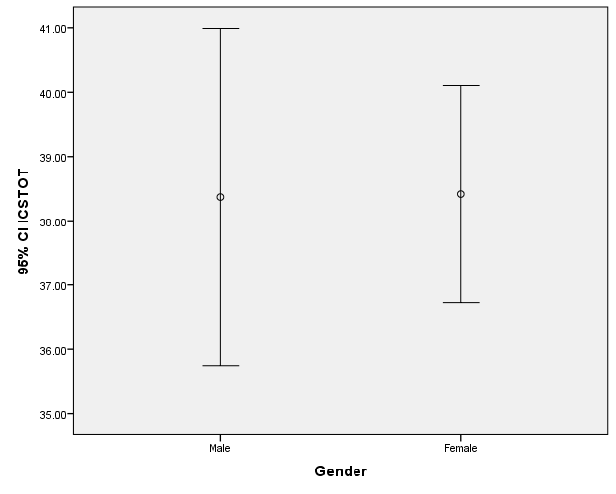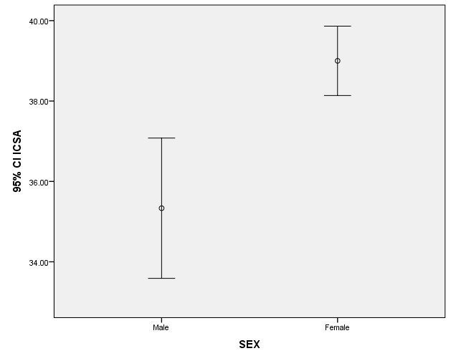Study One Study Two

Figure 1. It is not clear why there are different results from study one to study two. One reason may be the number of participants (study one n=193, study two n=73). Further research is needed to determine if adding an additional item to the ICS subscale Internal Disseverance will bull the means and standard deviation in the correct direction.

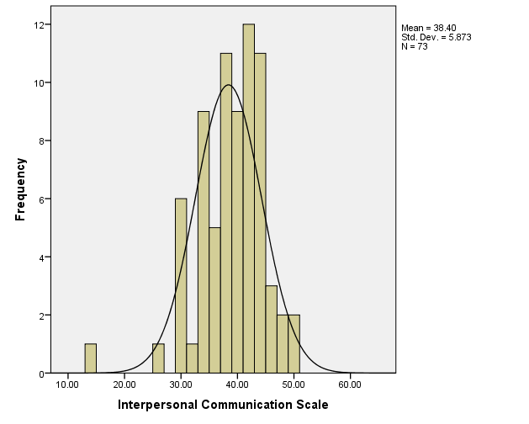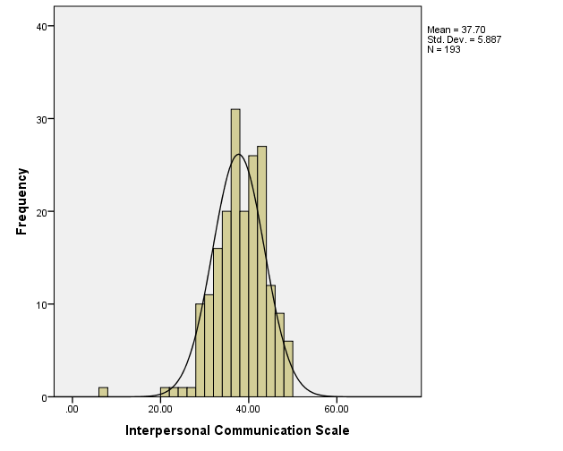Study 1 Study 2

Figure2. There is a nice bell curve developing in both studies. The outliers in both studies were included in the results as the individuals who participated in both were diagnosed as autistic (study one) and with a learning disability (study two). The predictability of the scale is shown to be able to measure all individual’s communication ability.