[https://www.radausa.lt/imontuojama-technika/gartraukiai/elica/kaitlentes-su-integruotu-gartraukiuhttps://academic.oup.com/jcem/article/98/3/973/2536592](https://www.radausa.lt/imontuojama-technika/gartraukiai/elica/kaitlentes-su-integruotu-gartraukiuhttps://academic.oup.com/jcem/article/98/3/973/2536592)

<https://assets.publishing.service.gov.uk/government/uploads/system/uploads/attachment_data/file/537616/SACN_Vitamin_D_and_Health_report.pdf>

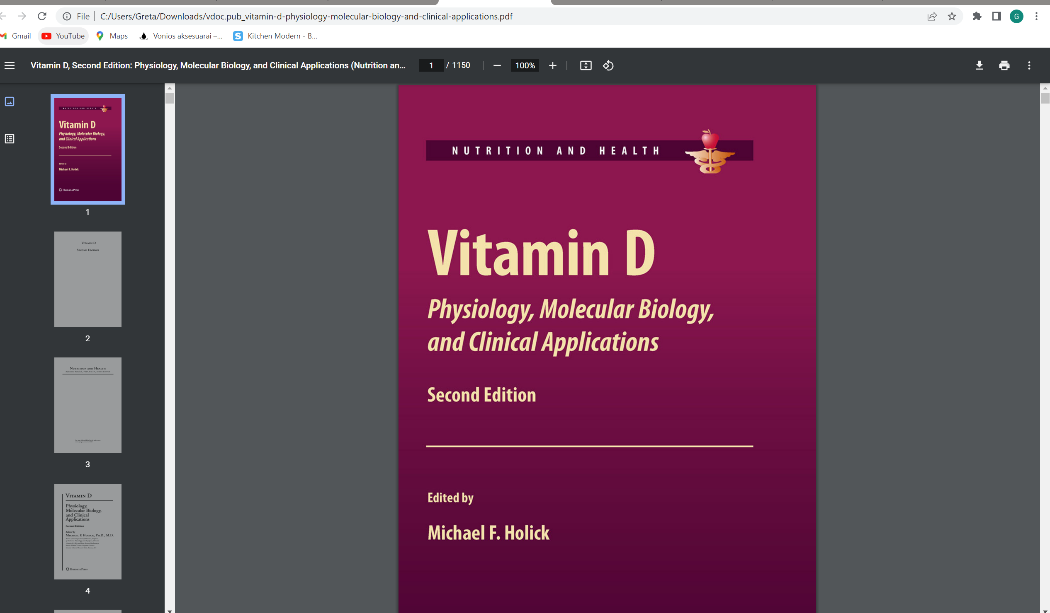

Vitamin D and Human Health Michal A. Zmijewski

