ERRORS =>
- Port already in use
Solution: Try to use other ports then run main to check either errors resolved OR Not.
Example: I was running an application on VueJs on port 3000, Apache Server was running on 80 & 443 Port, Laravel on 8000 Port, So I perfered to use 8080 Port for JAVA API. – It worked.
- Exception in thread "main" java.net.BindException
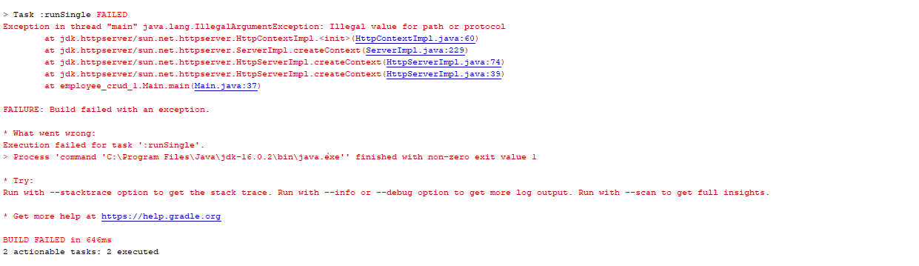
Solution 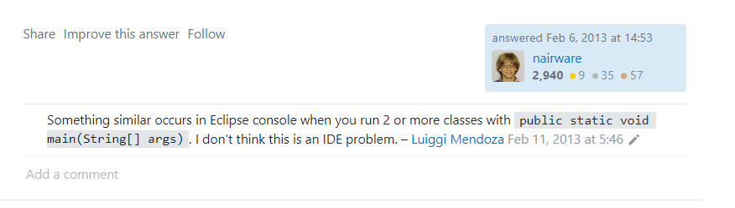
Example: I was using Routes Class to get API Routes from its Getter function, When I removed and used HardCoated Route String, It worked.
NOTE: From Console using [1] => “CURL localhost:8080/api/employees”
OR [2] => “CURL -X GET localhost:8080/api/employees”
It shos the response/message of API

