Rezultate raw - neprocesate
90 epoci
TEST RESULTS
===============================================================================================
Test Loss: 0.5795
-----------------------------------------------------------------------------------------------
Organ | Dice | IoU | Sens | Spec | Prec
-----------------------------------------------------------------------------------------------
artery | 0.0000 | 0.0000 | 0.0000 | 1.0000 | 0.0000
liver | 0.5665 | 0.4029 | 0.8093 | 0.9598 | 0.4483
stomach | 0.3282 | 0.2120 | 0.4256 | 0.9916 | 0.2841
vein | 0.4888 | 0.3296 | 0.7152 | 0.9939 | 0.3843
-----------------------------------------------------------------------------------------------
MACRO AVG | 0.3459
===============================================================================================

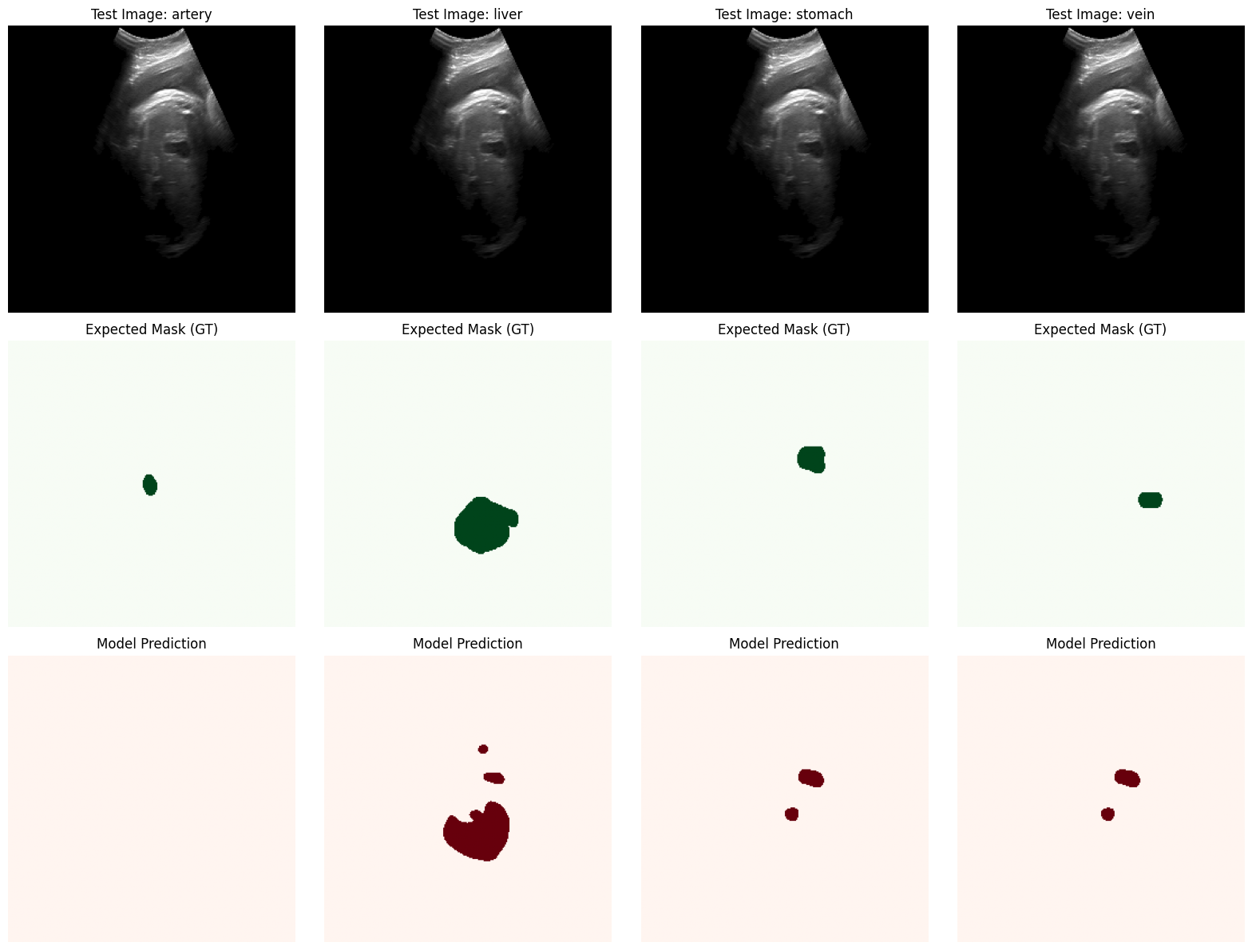

Rezultate raw - neprocesate
150 epoci
TEST RESULTS
===============================================================================================
Test Loss: 0.5773
-----------------------------------------------------------------------------------------------
Organ | Dice | IoU | Sens | Spec | Prec
-----------------------------------------------------------------------------------------------
artery | 0.0000 | 0.0000 | 0.0000 | 1.0000 | 0.0000
liver | 0.5739 | 0.4033 | 0.8369 | 0.9582 | 0.4377
stomach | 0.4825 | 0.3216 | 0.6657 | 0.9932 | 0.3844
vein | 0.4646 | 0.3044 | 0.6969 | 0.9930 | 0.3506
-----------------------------------------------------------------------------------------------
MACRO AVG | 0.3802
===============================================================================================
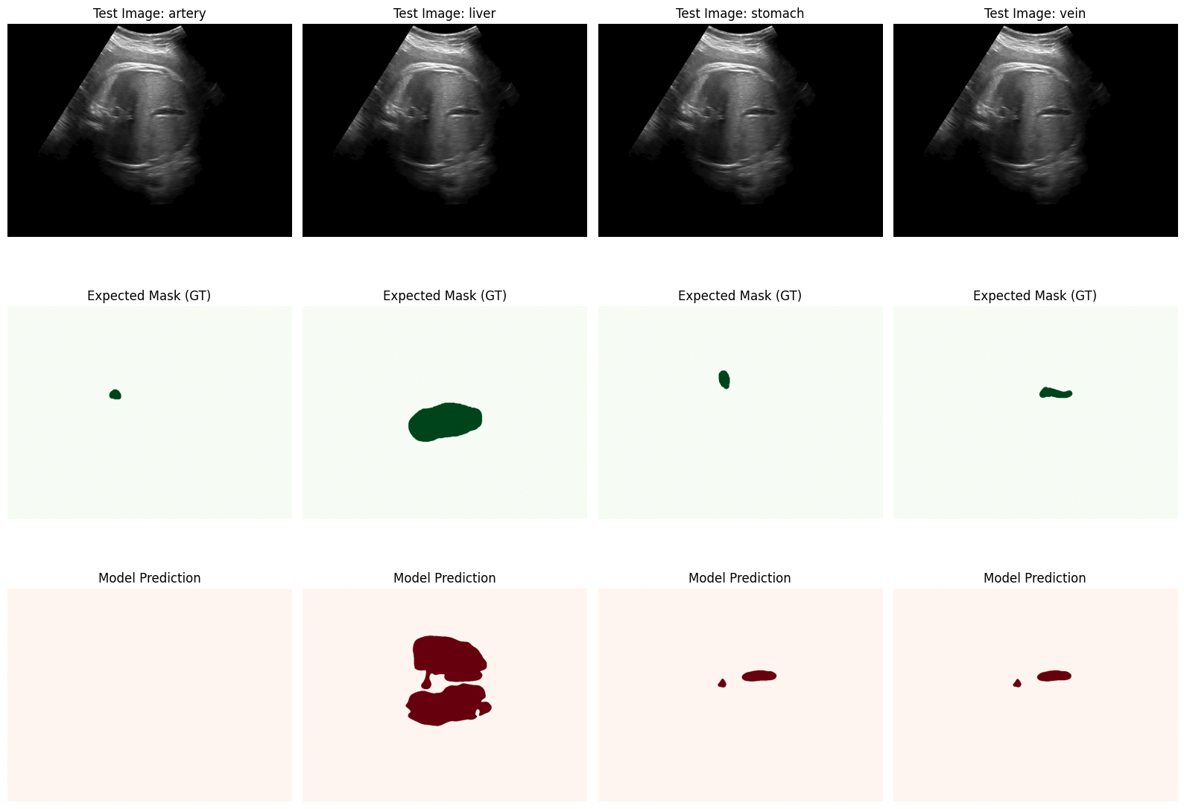

90 epoci
NO TEXT
✅ Loaded epoch 90, best val dice: 0.6242
Evaluating on Test Set: 100%|██████████| 30/30 [00:01<00:00, 21.65it/s]

===============================================================================================
TEST RESULTS
===============================================================================================
Test Loss: 0.4672
-----------------------------------------------------------------------------------------------
Organ | Dice | IoU | Sens | Spec | Prec
-----------------------------------------------------------------------------------------------
artery | 0.4943 | 0.3477 | 0.7241 | 0.9969 | 0.4108
liver | 0.6073 | 0.4450 | 0.8664 | 0.9610 | 0.4784
stomach | 0.5425 | 0.4086 | 0.6004 | 0.9967 | 0.5246
vein | 0.6469 | 0.4875 | 0.7416 | 0.9974 | 0.5997
-----------------------------------------------------------------------------------------------
MACRO AVG | 0.5727
===============================================================================================
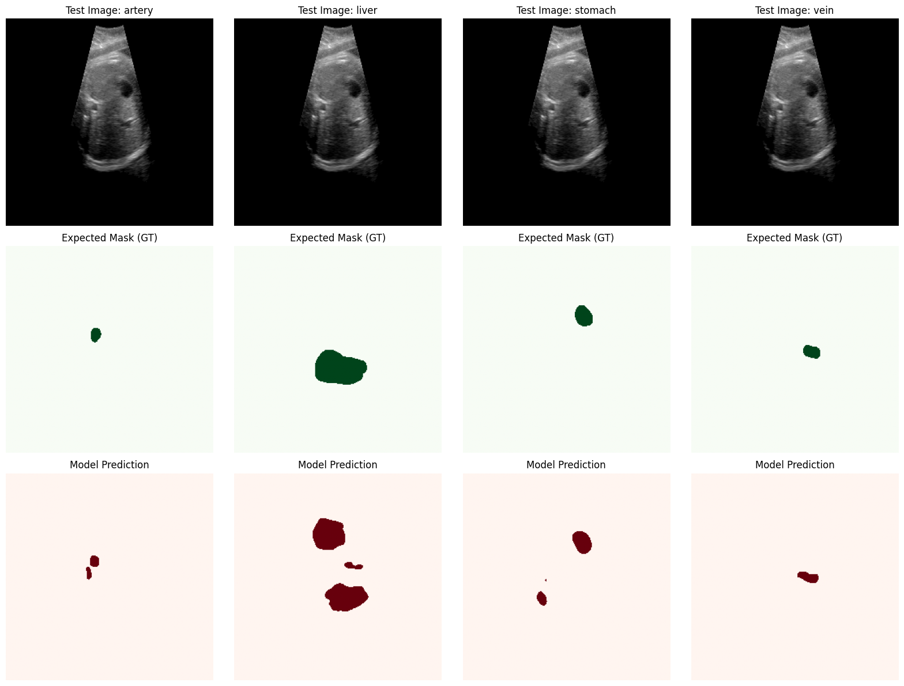

150 NO TEXT
✅ Loaded epoch 150, best val dice: 0.6525
Evaluating on Test Set: 100%|██████████| 30/30 [00:01<00:00, 22.25it/s]

===============================================================================================
TEST RESULTS
===============================================================================================
Test Loss: 0.4516
-----------------------------------------------------------------------------------------------
Organ | Dice | IoU | Sens | Spec | Prec
-----------------------------------------------------------------------------------------------
artery | 0.5634 | 0.4187 | 0.6835 | 0.9985 | 0.5156
liver | 0.6339 | 0.4739 | 0.8705 | 0.9653 | 0.5118
stomach | 0.5861 | 0.4500 | 0.6497 | 0.9966 | 0.5781
vein | 0.6852 | 0.5289 | 0.7580 | 0.9978 | 0.6451
-----------------------------------------------------------------------------------------------
MACRO AVG | 0.6172
===============================================================================================
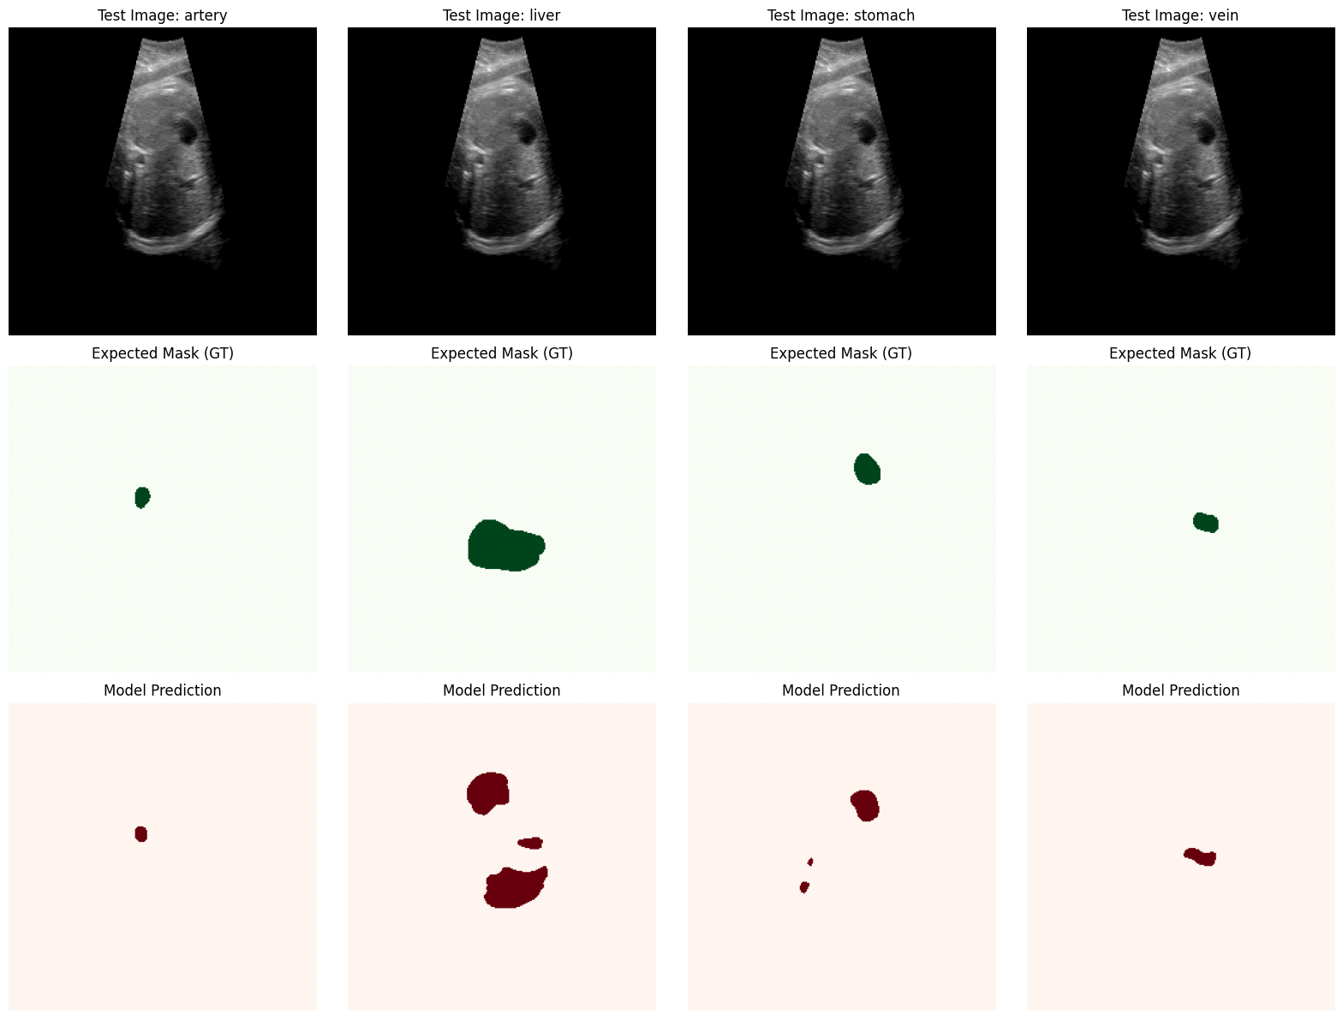

90 epoch cu noile ponderi(PONDERI + NO TEXT)
Loaded best model for evaluation.
Evaluating on Test Set: 100%|██████████| 30/30 [00:01<00:00, 22.95it/s]

===============================================================================================
TEST RESULTS
===============================================================================================
Test Loss: 0.6456
-----------------------------------------------------------------------------------------------
Organ | Dice | IoU | Sens | Spec | Prec
-----------------------------------------------------------------------------------------------
artery | 0.0994 | 0.0529 | 0.5048 | 0.9868 | 0.0568
liver | 0.4727 | 0.3168 | 0.6506 | 0.9589 | 0.3802
stomach | 0.1877 | 0.1115 | 0.2429 | 0.9904 | 0.1757
vein | 0.4332 | 0.2875 | 0.5014 | 0.9952 | 0.4389
-----------------------------------------------------------------------------------------------
MACRO AVG | 0.2983
===============================================================================================
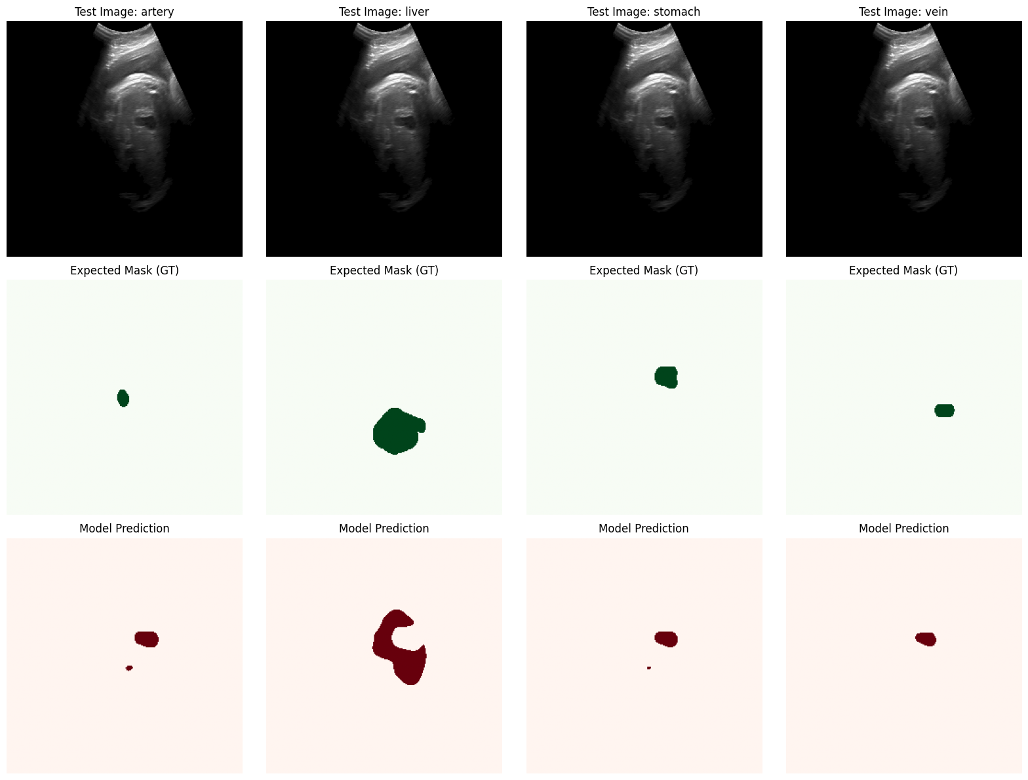

(PONDERI + NO TEXT)
dupa 150 epoci
TEST RESULTS
===============================================================================================
Test Loss: 0.4517
-----------------------------------------------------------------------------------------------
Organ | Dice | IoU | Sens | Spec | Prec
-----------------------------------------------------------------------------------------------
artery | 0.5827 | 0.4405 | 0.6715 | 0.9976 | 0.5623
liver | 0.6476 | 0.4902 | 0.8142 | 0.9723 | 0.5546
stomach | 0.6033 | 0.4673 | 0.6525 | 0.9969 | 0.6113
vein | 0.6872 | 0.5339 | 0.7387 | 0.9976 | 0.6791
-----------------------------------------------------------------------------------------------
MACRO AVG | 0.6302
===============================================================================================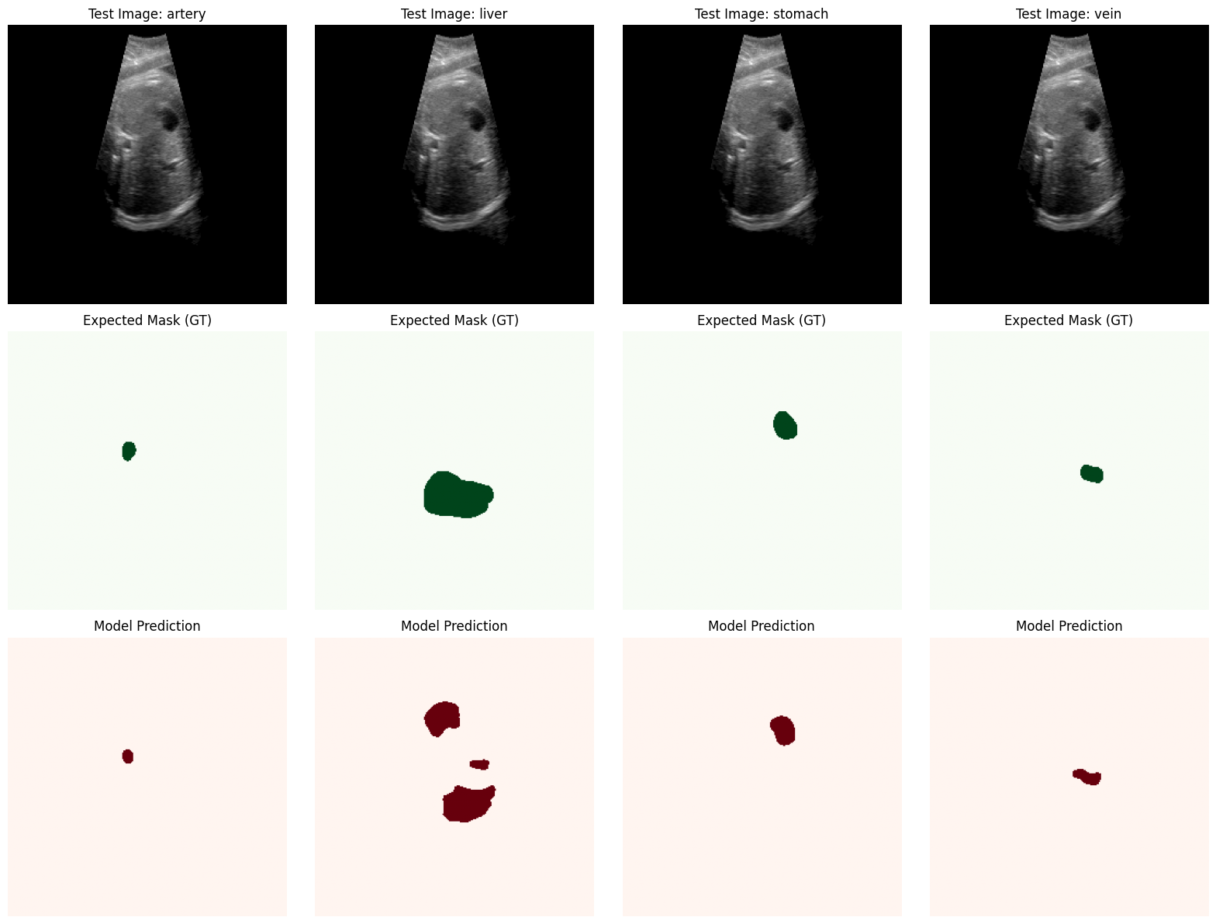

(90 epochs CLAHE)
Loaded best model for evaluation.
Evaluating on Test Set: 100%|██████████| 30/30 [00:14<00:00, 2.01it/s]

===============================================================================================
TEST RESULTS
===============================================================================================
Test Loss: 0.3124
-----------------------------------------------------------------------------------------------
Organ | Dice | IoU | Sens | Spec | Prec
-----------------------------------------------------------------------------------------------
artery | 0.3650 | 0.2232 | 0.4210 | 0.9950 | 0.3220
liver | 0.8512 | 0.7409 | 0.8805 | 0.9912 | 0.8237
stomach | 0.6540 | 0.4858 | 0.7120 | 0.9845 | 0.6047
vein | 0.5420 | 0.3717 | 0.6100 | 0.9880 | 0.4876
-----------------------------------------------------------------------------------------------
MACRO AVG | 0.6030
===============================================================================================

(150 CLAHE) + Ponderi + eliminare_text + wights schimbate
Loaded best model for evaluation.
Evaluating on Test Set: 100%|██████████| 30/30 [00:15<00:00, 1.99it/s]

===============================================================================================
TEST RESULTS
===============================================================================================
Test Loss: 0.1224
-----------------------------------------------------------------------------------------------
Organ | Dice | IoU | Sens | Spec | Prec
-----------------------------------------------------------------------------------------------
artery | 0.8355 | 0.7219 | 0.8642 | 0.9997 | 0.8113
liver | 0.8921 | 0.8055 | 0.9690 | 0.9921 | 0.8270
stomach | 0.8722 | 0.7755 | 0.9136 | 0.9989 | 0.8357
vein | 0.8552 | 0.7475 | 0.9010 | 0.9989 | 0.8148
-----------------------------------------------------------------------------------------------
MACRO AVG | 0.8637
===============================================================================================
