30 EPOCH RAW
Loaded best model for evaluation.
Evaluating on Test Set: 100%|██████████| 30/30 [00:14<00:00, 2.01it/s]

===============================================================================================
TEST RESULTS
===============================================================================================
Test Loss: 0.6824
-----------------------------------------------------------------------------------------------
Organ | Dice | IoU | Sens | Spec | Prec
-----------------------------------------------------------------------------------------------
artery | 0.0000 | 0.0000 | 0.0000 | 1.0000 | 0.0000
liver | 0.5551 | 0.3854 | 0.8163 | 0.9565 | 0.4226
stomach | 0.0847 | 0.0444 | 0.3991 | 0.9474 | 0.0478
vein | 0.0629 | 0.0325 | 0.3097 | 0.9556 | 0.0351
-----------------------------------------------------------------------------------------------
MACRO AVG | 0.1756
===============================================================================================
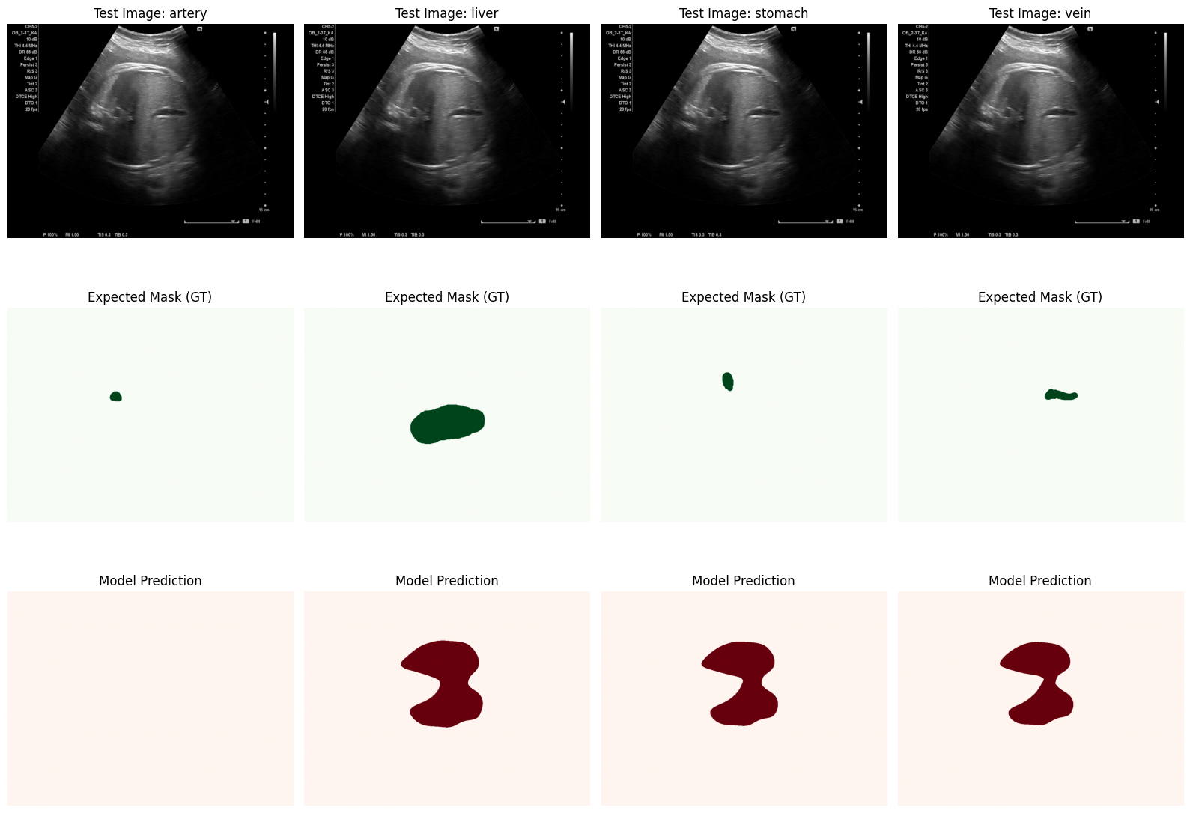

105 EPOCHS RAW
Loaded best model for evaluation.
Evaluating on Test Set: 100%|██████████| 30/30 [00:15<00:00, 1.99it/s]

===============================================================================================
TEST RESULTS
===============================================================================================
Test Loss: 0.1224
-----------------------------------------------------------------------------------------------
Organ | Dice | IoU | Sens | Spec | Prec
-----------------------------------------------------------------------------------------------
artery | 0.8355 | 0.7219 | 0.8642 | 0.9997 | 0.8113
liver | 0.8921 | 0.8055 | 0.9690 | 0.9921 | 0.8270
stomach | 0.8722 | 0.7755 | 0.9136 | 0.9989 | 0.8357
vein | 0.8552 | 0.7475 | 0.9010 | 0.9989 | 0.8148
-----------------------------------------------------------------------------------------------
MACRO AVG | 0.8637
===============================================================================================
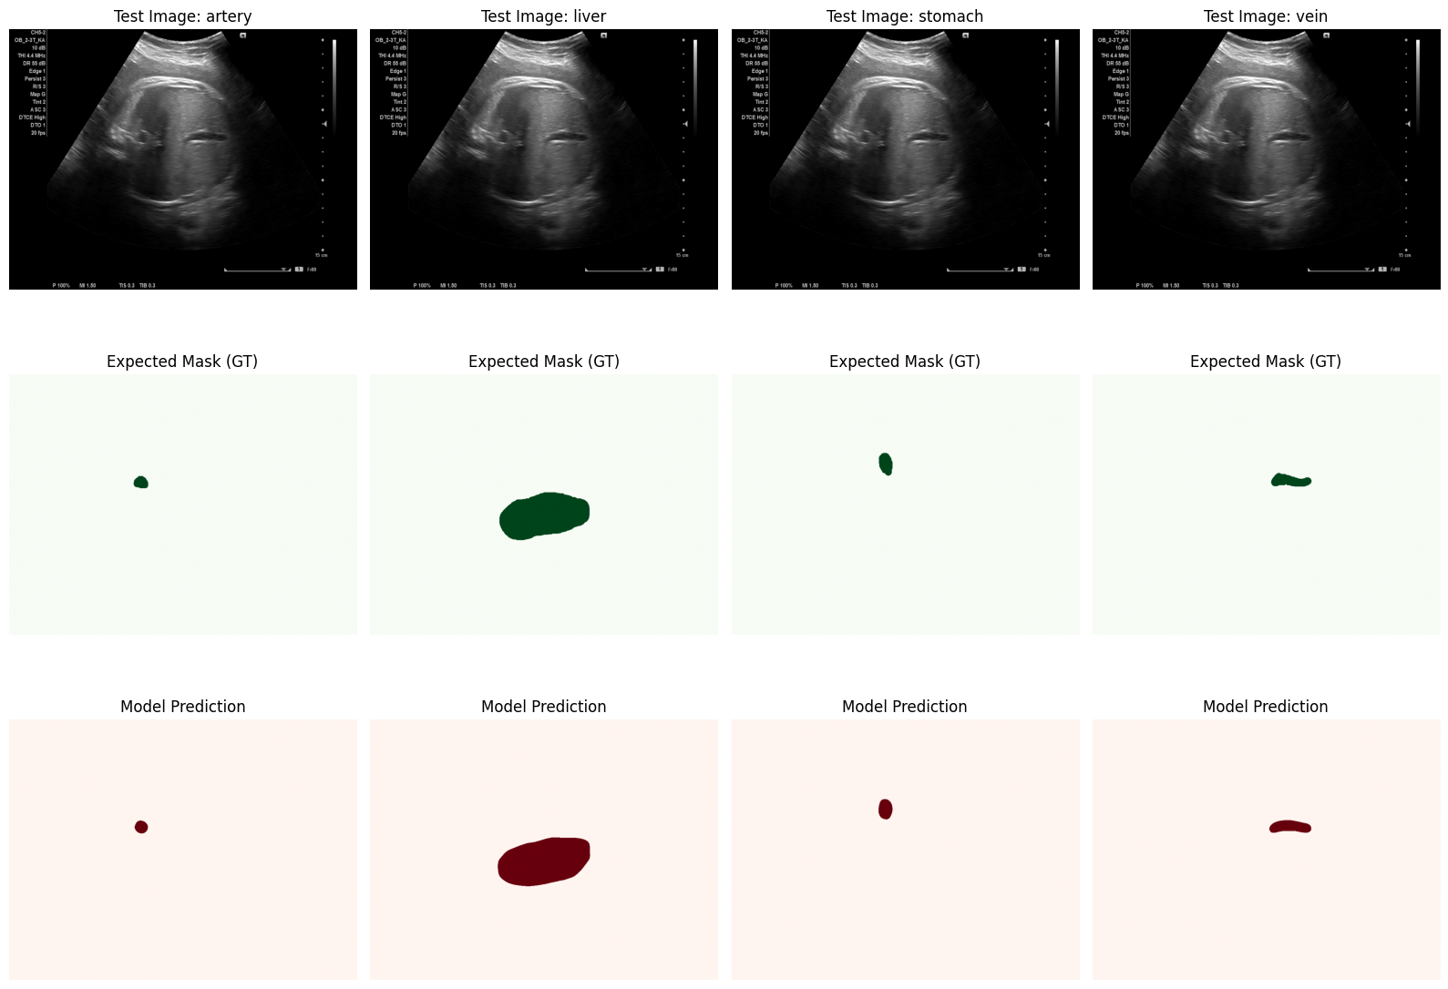

NO TEXT BEST OF 90 EPOCHS
Loaded best model for evaluation.
Evaluating on Test Set: 100%|██████████| 30/30 [00:05<00:00, 5.19it/s]

===============================================================================================
TEST RESULTS
===============================================================================================
Test Loss: 0.5773
-----------------------------------------------------------------------------------------------
Organ | Dice | IoU | Sens | Spec | Prec
-----------------------------------------------------------------------------------------------
artery | 0.0000 | 0.0000 | 0.0000 | 1.0000 | 0.0000
liver | 0.5739 | 0.4033 | 0.8369 | 0.9582 | 0.4377
stomach | 0.4825 | 0.3216 | 0.6657 | 0.9932 | 0.3844
vein | 0.4646 | 0.3044 | 0.6969 | 0.9930 | 0.3506
-----------------------------------------------------------------------------------------------
MACRO AVG | 0.3802
===============================================================================================
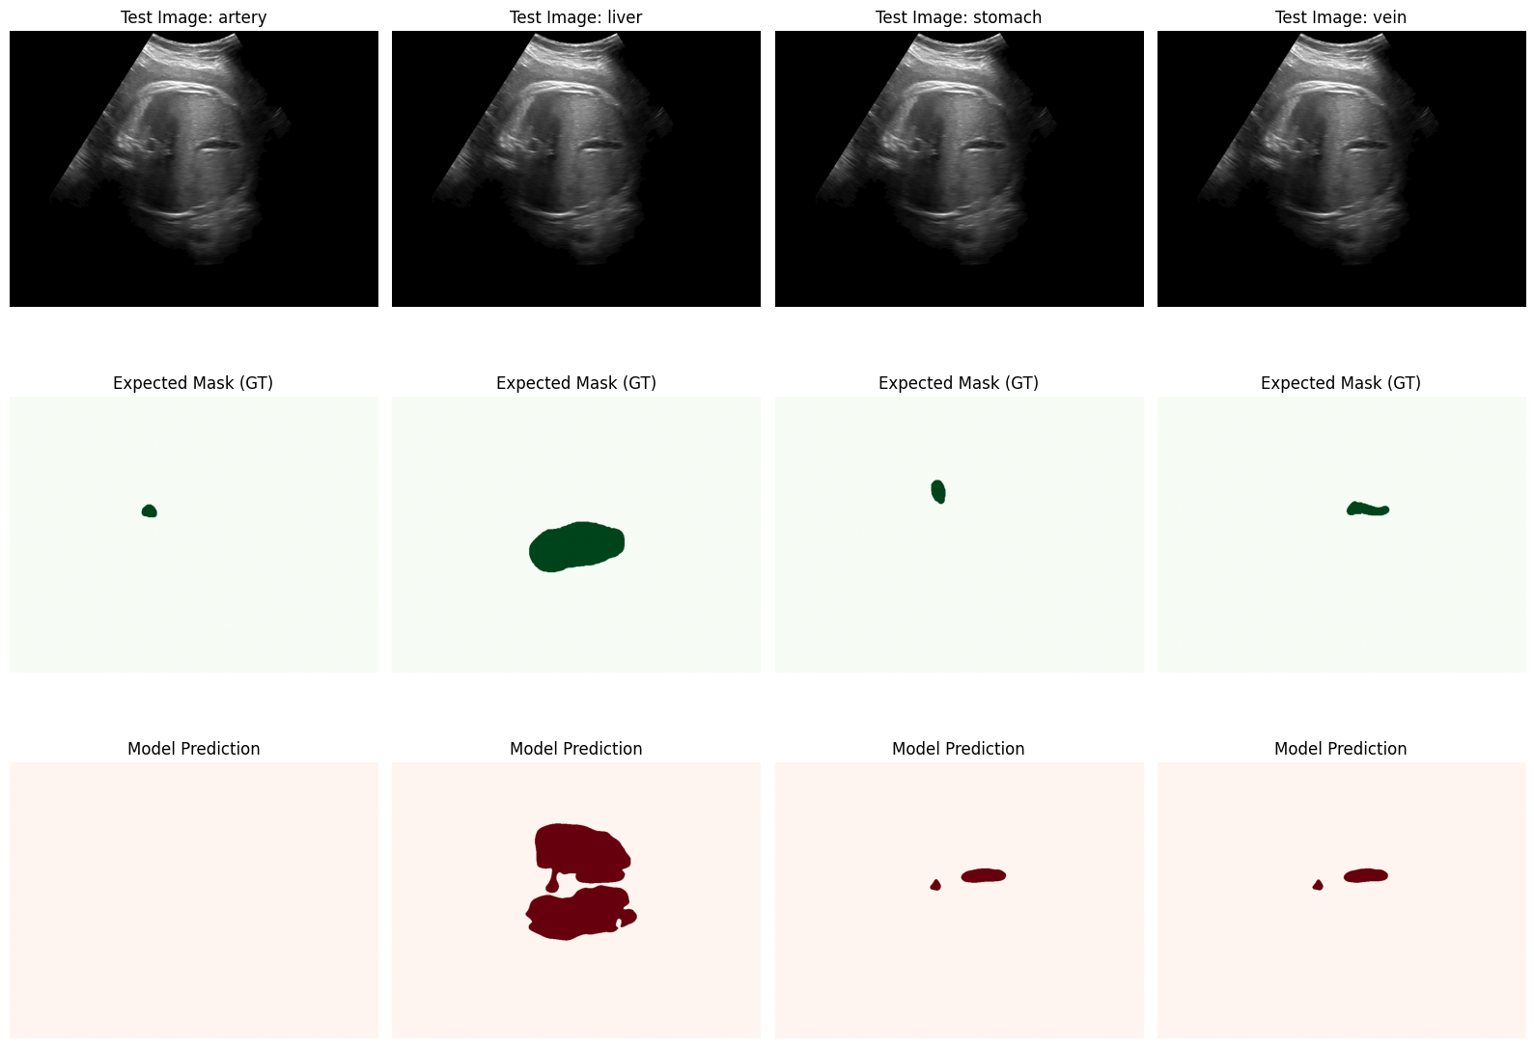

NO TEXTB BEST OF 111 EPOCHS:
AUTO STOP
Loaded best model for evaluation.
Evaluating on Test Set: 100%|██████████| 30/30 [00:07<00:00, 4.06it/s]

===============================================================================================
TEST RESULTS
===============================================================================================
Test Loss: 0.5795
-----------------------------------------------------------------------------------------------
Organ | Dice | IoU | Sens | Spec | Prec
-----------------------------------------------------------------------------------------------
artery | 0.0000 | 0.0000 | 0.0000 | 1.0000 | 0.0000
liver | 0.5665 | 0.4029 | 0.8093 | 0.9598 | 0.4483
stomach | 0.3282 | 0.2120 | 0.4256 | 0.9916 | 0.2841
vein | 0.4888 | 0.3296 | 0.7152 | 0.9939 | 0.3843
-----------------------------------------------------------------------------------------------
MACRO AVG | 0.3459
===============================================================================================
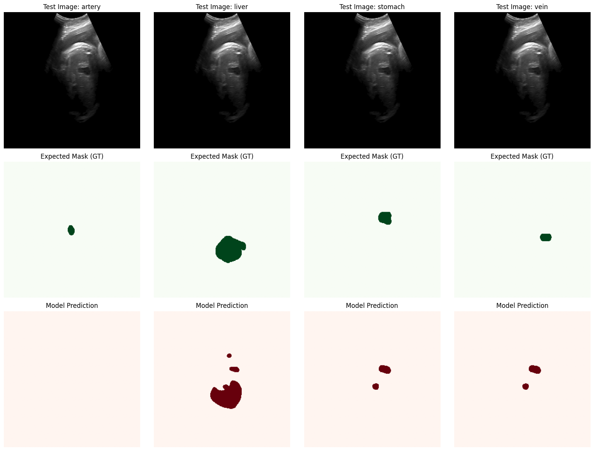

Gata. Încarc din nou în Colab și pornești antrenarea de la zero (RESUME_TRAINING = False).
Singura schimbare: pos_weight e acum un vector (1, 4, 1, 1) cu valori diferite per organ — artera primește 150 față de 25 cât aveau toate înainte. .view(1, -1, 1, 1) e important ca să se broadcast-uiască corect peste tensorii (B, C, H, W).
pos_weights = torch.tensor([150.0, 15.0, 20.0, 30.0]).view(1, -1, 1, 1).to(Config.DEVICE)
self.bce = nn.BCEWithLogitsLoss(pos_weight=pos_weights)

30 epoch cu noile ponderi
Loaded best model for evaluation.
Evaluating on Test Set: 100%|██████████| 30/30 [00:01<00:00, 22.95it/s]

===============================================================================================
TEST RESULTS
===============================================================================================
Test Loss: 0.6456
-----------------------------------------------------------------------------------------------
Organ | Dice | IoU | Sens | Spec | Prec
-----------------------------------------------------------------------------------------------
artery | 0.0994 | 0.0529 | 0.5048 | 0.9868 | 0.0568
liver | 0.4727 | 0.3168 | 0.6506 | 0.9589 | 0.3802
stomach | 0.1877 | 0.1115 | 0.2429 | 0.9904 | 0.1757
vein | 0.4332 | 0.2875 | 0.5014 | 0.9952 | 0.4389
-----------------------------------------------------------------------------------------------
MACRO AVG | 0.2983
===============================================================================================
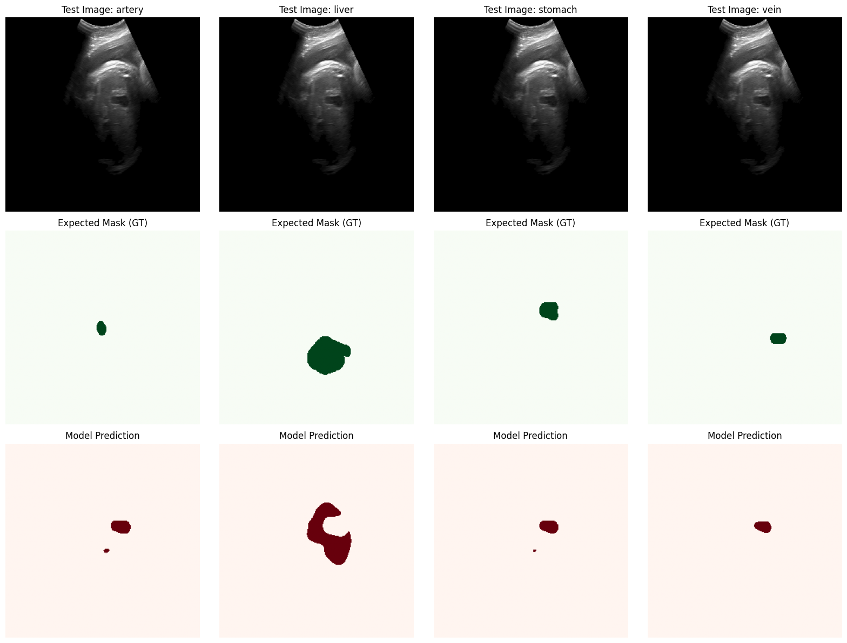

1. În celula de training, la inițializarea scheduler-ului (secțiunea # 3. Model...):
Înlocuiește:
scheduler = torch.optim.lr_scheduler.ReduceLROnPlateau(optimizer, mode='max',
factor=0.5, patience=5)
Cu:
scheduler = torch.optim.lr_scheduler.CosineAnnealingLR(optimizer, T_max=Config.NUM_EPOCHS)
Și mai jos, înlocuiește:
scheduler.step(avg_val_dice)
Cu:
scheduler.step()

2. În celula de Loss, schimbă:
pos_weights = torch.tensor([150.0, 15.0, 20.0, 30.0])
La:
pos_weights = torch.tensor([80.0, 15.0, 20.0, 30.0])

3. Resetează RESUME_TRAINING = False ca să înceapă de la zero cu noile setări.

Vedem ce o iesi
IESE BINESS BEST dupa 150 epoci
Loaded best model for evaluation.
Evaluating on Test Set: 100%|██████████| 30/30 [00:01<00:00, 23.22it/s]

===============================================================================================
TEST RESULTS
===============================================================================================
Test Loss: 0.4517
-----------------------------------------------------------------------------------------------
Organ | Dice | IoU | Sens | Spec | Prec
-----------------------------------------------------------------------------------------------
artery | 0.5827 | 0.4405 | 0.6715 | 0.9976 | 0.5623
liver | 0.6476 | 0.4902 | 0.8142 | 0.9723 | 0.5546
stomach | 0.6033 | 0.4673 | 0.6525 | 0.9969 | 0.6113
vein | 0.6872 | 0.5339 | 0.7387 | 0.9976 | 0.6791
-----------------------------------------------------------------------------------------------
MACRO AVG | 0.6302
===============================================================================================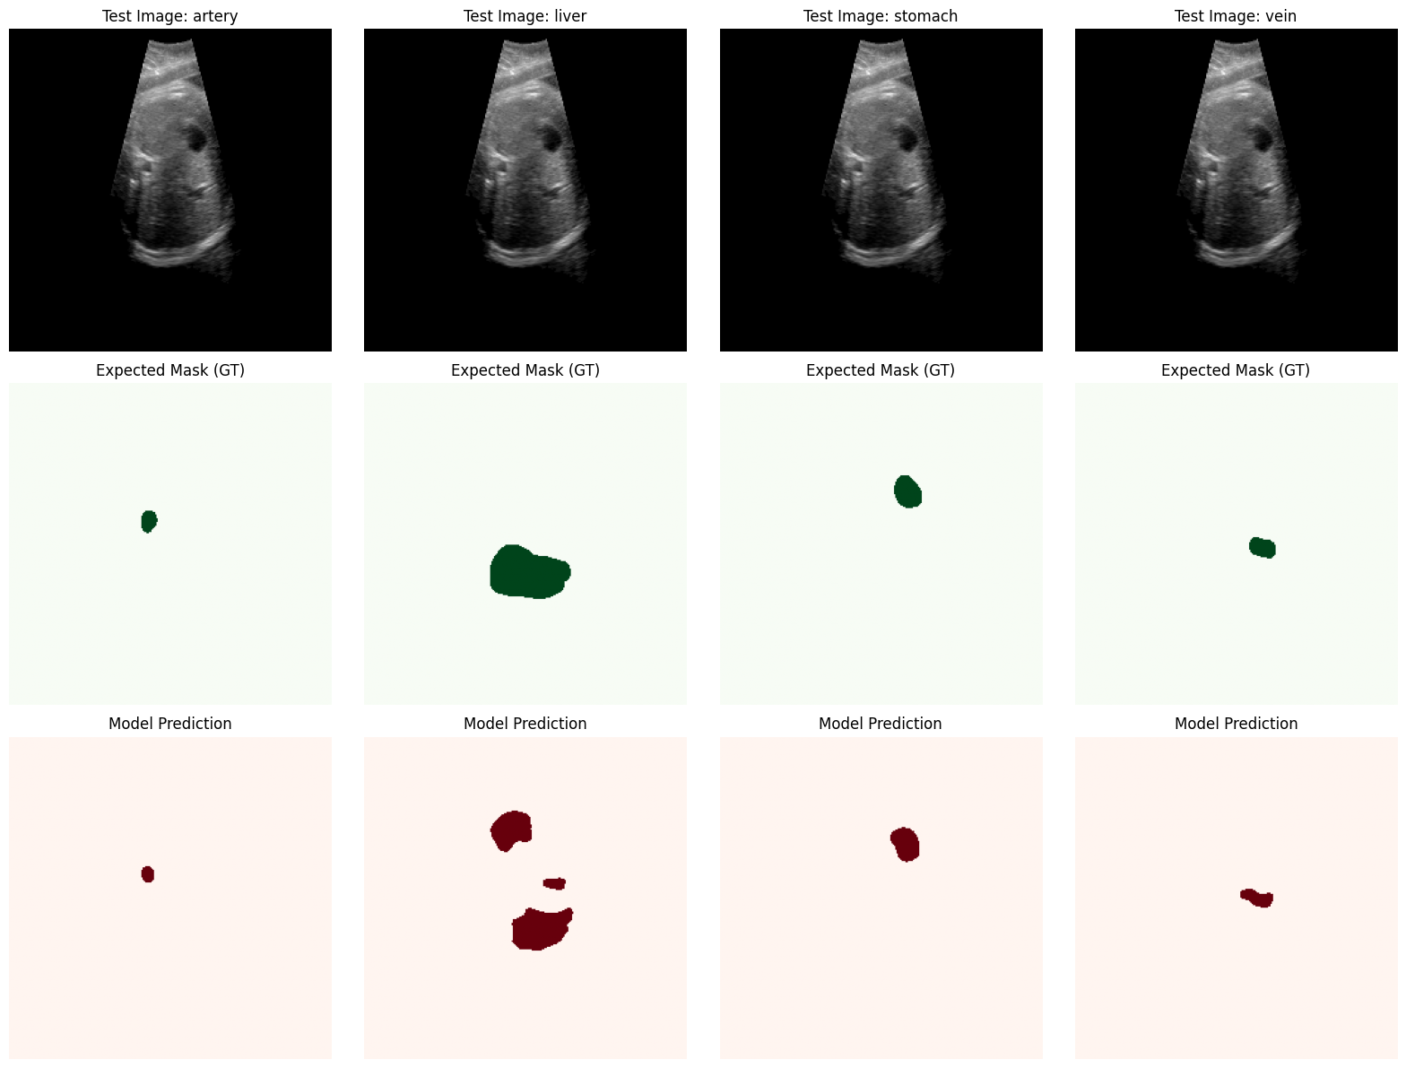

30
✅ Loaded epoch 30, best val dice: 0.3030
Evaluating on Test Set: 100%|██████████| 30/30 [00:01<00:00, 22.02it/s]

===============================================================================================
TEST RESULTS
===============================================================================================
Test Loss: 0.9139
-----------------------------------------------------------------------------------------------
Organ | Dice | IoU | Sens | Spec | Prec
-----------------------------------------------------------------------------------------------
artery | 0.0035 | 0.0018 | 0.0033 | 0.9988 | 0.0049
liver | 0.3146 | 0.2046 | 0.2359 | 0.9939 | 0.6103
stomach | 0.0066 | 0.0034 | 0.0054 | 0.9990 | 0.0224
vein | 0.0020 | 0.0010 | 0.0010 | 1.0000 | 0.0961
-----------------------------------------------------------------------------------------------
MACRO AVG | 0.0817
===============================================================================================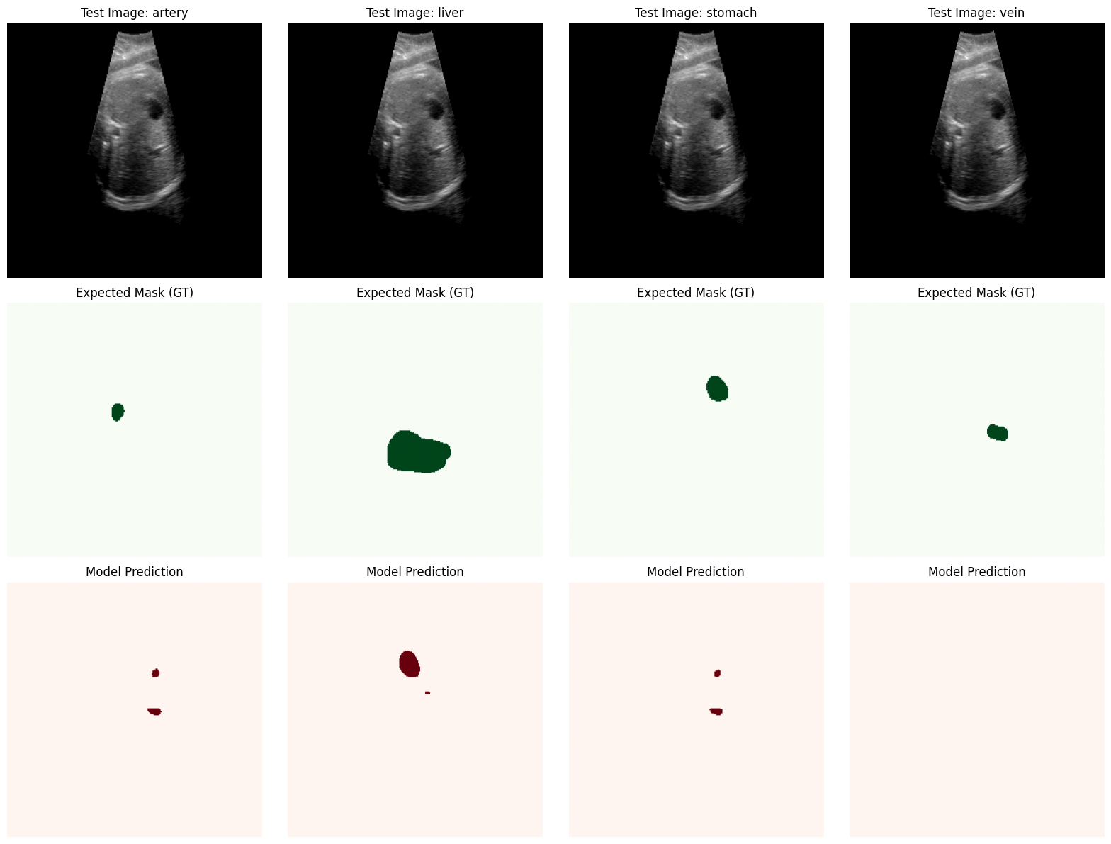
✅ Loaded epoch 60, best val dice: 0.4595
Evaluating on Test Set: 100%|██████████| 30/30 [00:01<00:00, 21.62it/s]

===============================================================================================
60
TEST RESULTS
===============================================================================================
Test Loss: 0.5151
-----------------------------------------------------------------------------------------------
Organ | Dice | IoU | Sens | Spec | Prec
-----------------------------------------------------------------------------------------------
artery | 0.1788 | 0.1013 | 0.8050 | 0.9876 | 0.1047
liver | 0.5324 | 0.3686 | 0.9137 | 0.9415 | 0.3821
stomach | 0.3899 | 0.2615 | 0.5722 | 0.9914 | 0.3081
vein | 0.5994 | 0.4347 | 0.7983 | 0.9951 | 0.5011
-----------------------------------------------------------------------------------------------
MACRO AVG | 0.4251
===============================================================================================
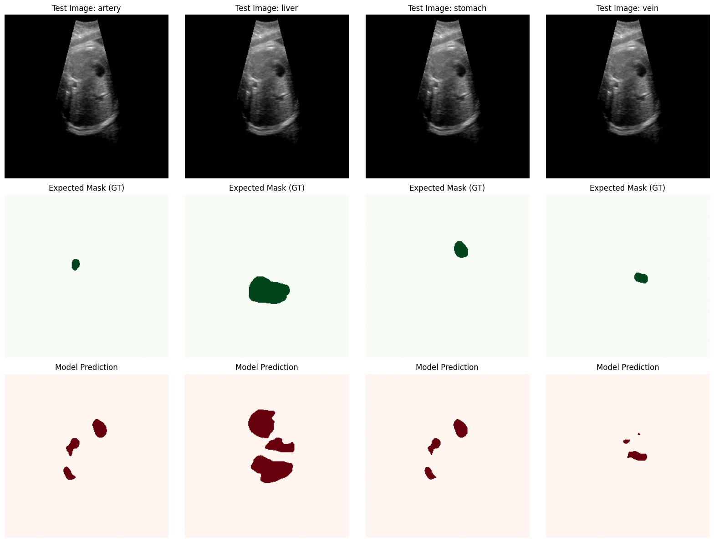

90
✅ Loaded epoch 90, best val dice: 0.6242
Evaluating on Test Set: 100%|██████████| 30/30 [00:01<00:00, 21.65it/s]

===============================================================================================
TEST RESULTS
===============================================================================================
Test Loss: 0.4672
-----------------------------------------------------------------------------------------------
Organ | Dice | IoU | Sens | Spec | Prec
-----------------------------------------------------------------------------------------------
artery | 0.4943 | 0.3477 | 0.7241 | 0.9969 | 0.4108
liver | 0.6073 | 0.4450 | 0.8664 | 0.9610 | 0.4784
stomach | 0.5425 | 0.4086 | 0.6004 | 0.9967 | 0.5246
vein | 0.6469 | 0.4875 | 0.7416 | 0.9974 | 0.5997
-----------------------------------------------------------------------------------------------
MACRO AVG | 0.5727
===============================================================================================
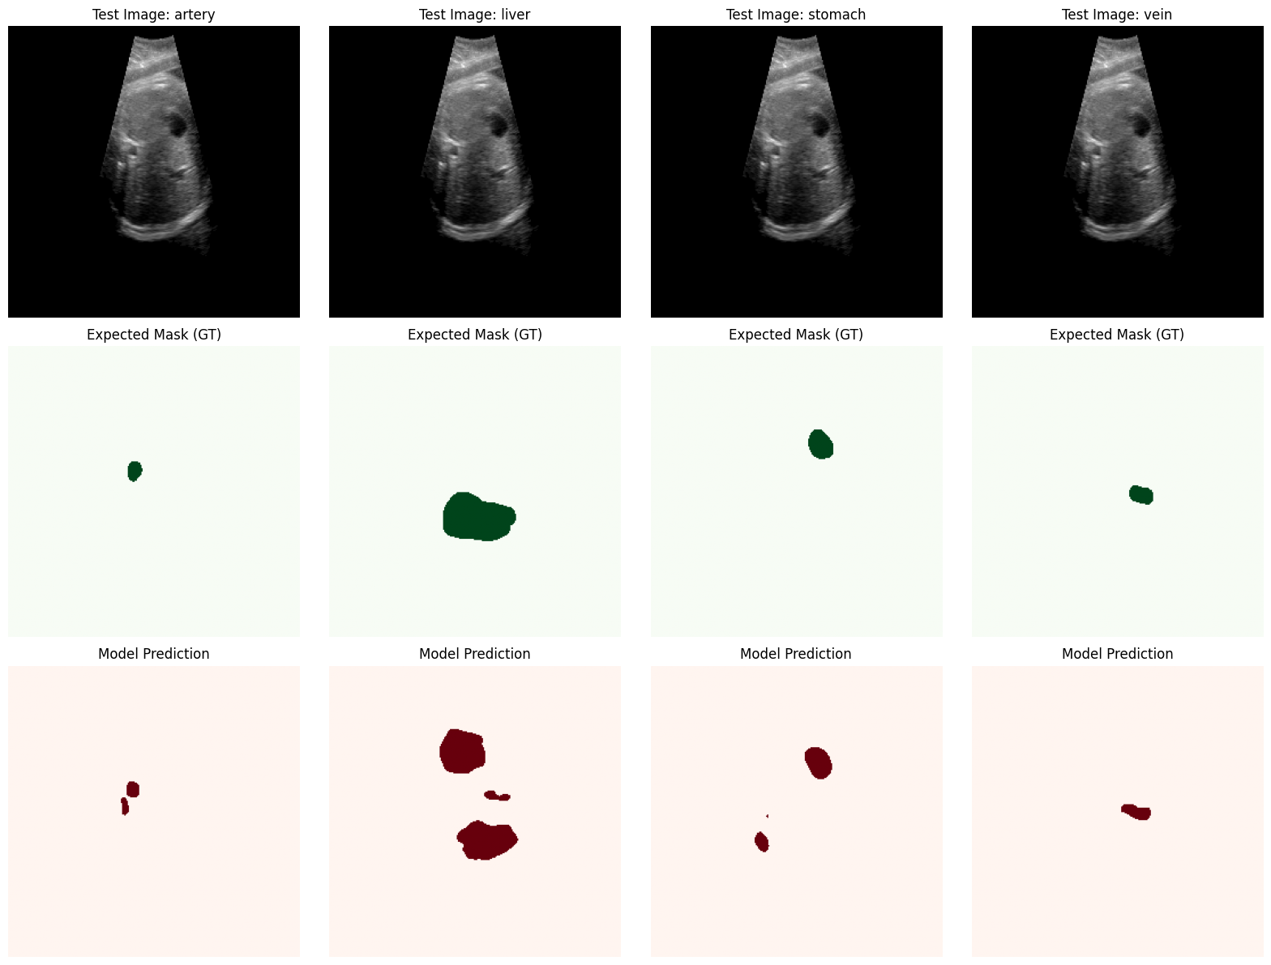
150
✅ Loaded epoch 150, best val dice: 0.6525
Evaluating on Test Set: 100%|██████████| 30/30 [00:01<00:00, 22.25it/s]

===============================================================================================
TEST RESULTS
===============================================================================================
Test Loss: 0.4516
-----------------------------------------------------------------------------------------------
Organ | Dice | IoU | Sens | Spec | Prec
-----------------------------------------------------------------------------------------------
artery | 0.5634 | 0.4187 | 0.6835 | 0.9985 | 0.5156
liver | 0.6339 | 0.4739 | 0.8705 | 0.9653 | 0.5118
stomach | 0.5861 | 0.4500 | 0.6497 | 0.9966 | 0.5781
vein | 0.6852 | 0.5289 | 0.7580 | 0.9978 | 0.6451
-----------------------------------------------------------------------------------------------
MACRO AVG | 0.6172
===============================================================================================
