To delete the profile:

Settings—communication and privacy

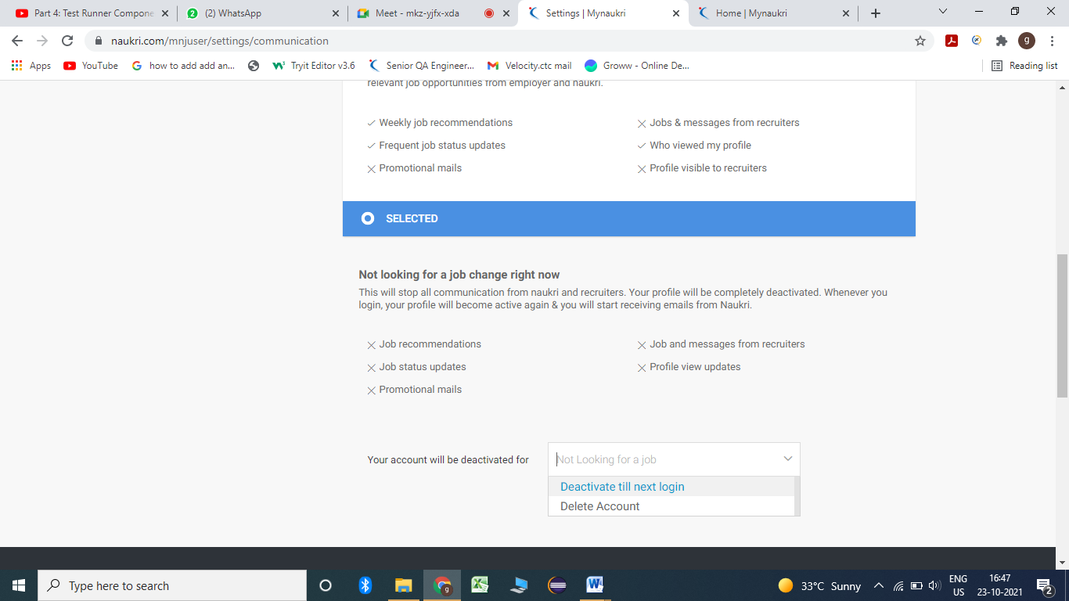

To create a profile:

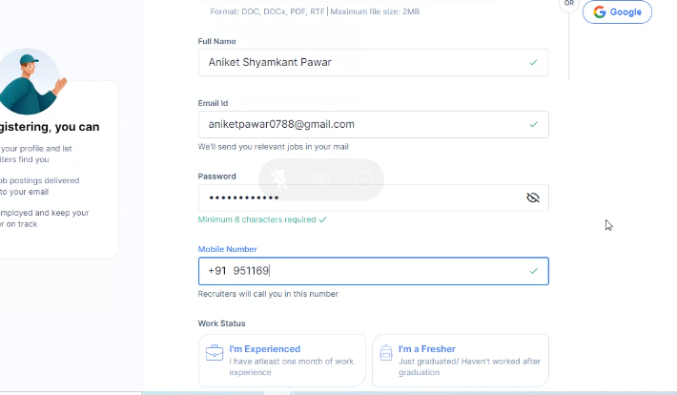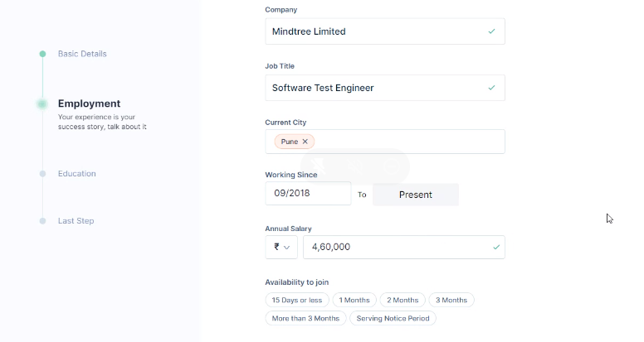

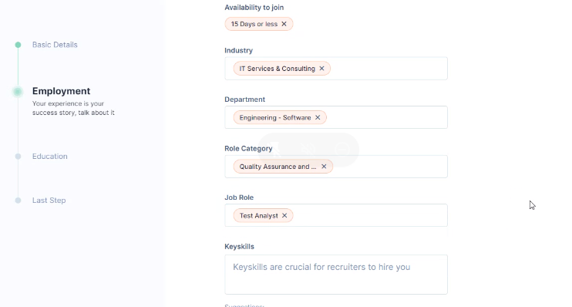

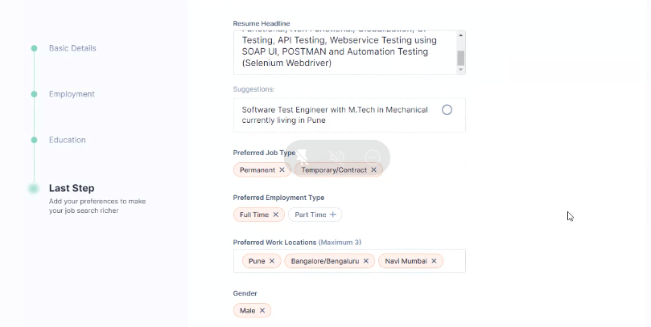

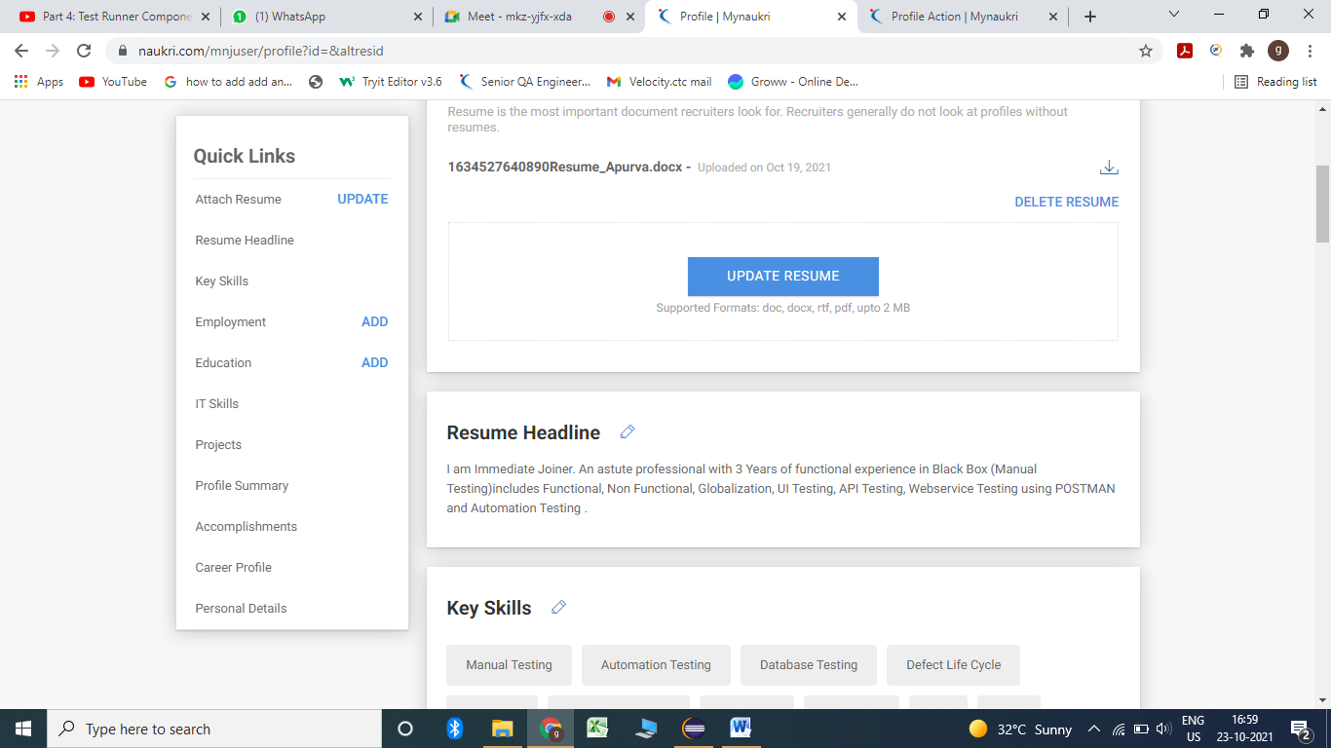

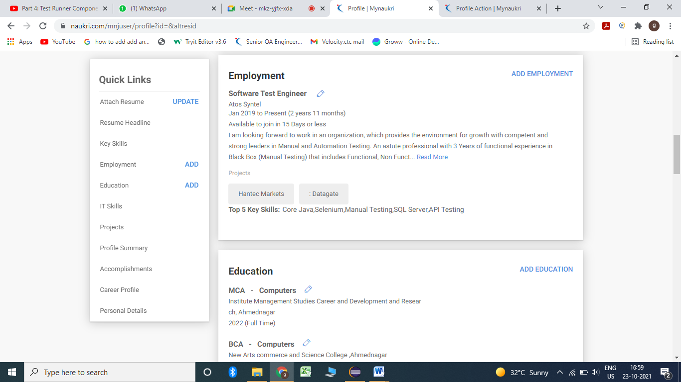

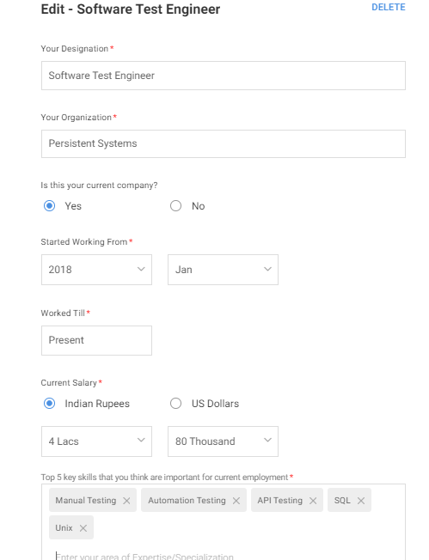

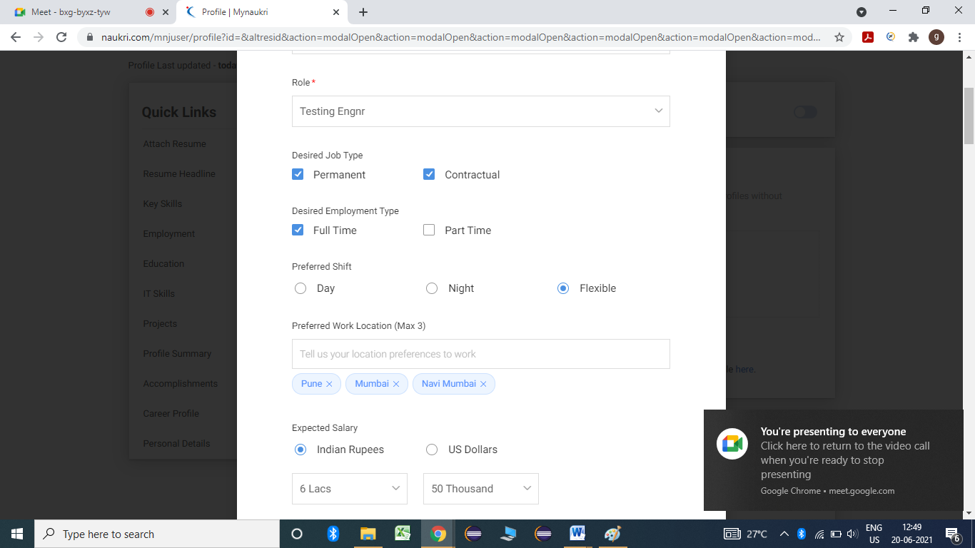

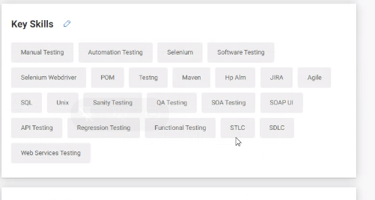

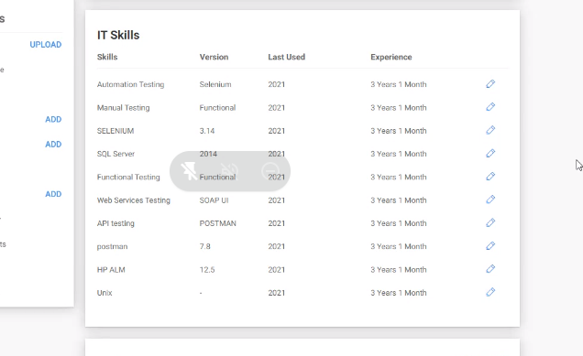

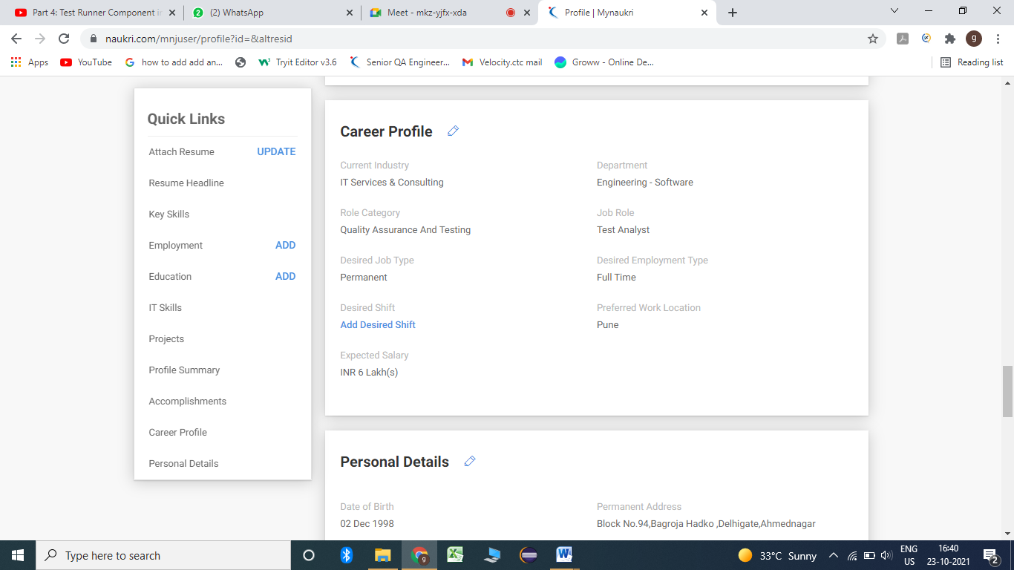

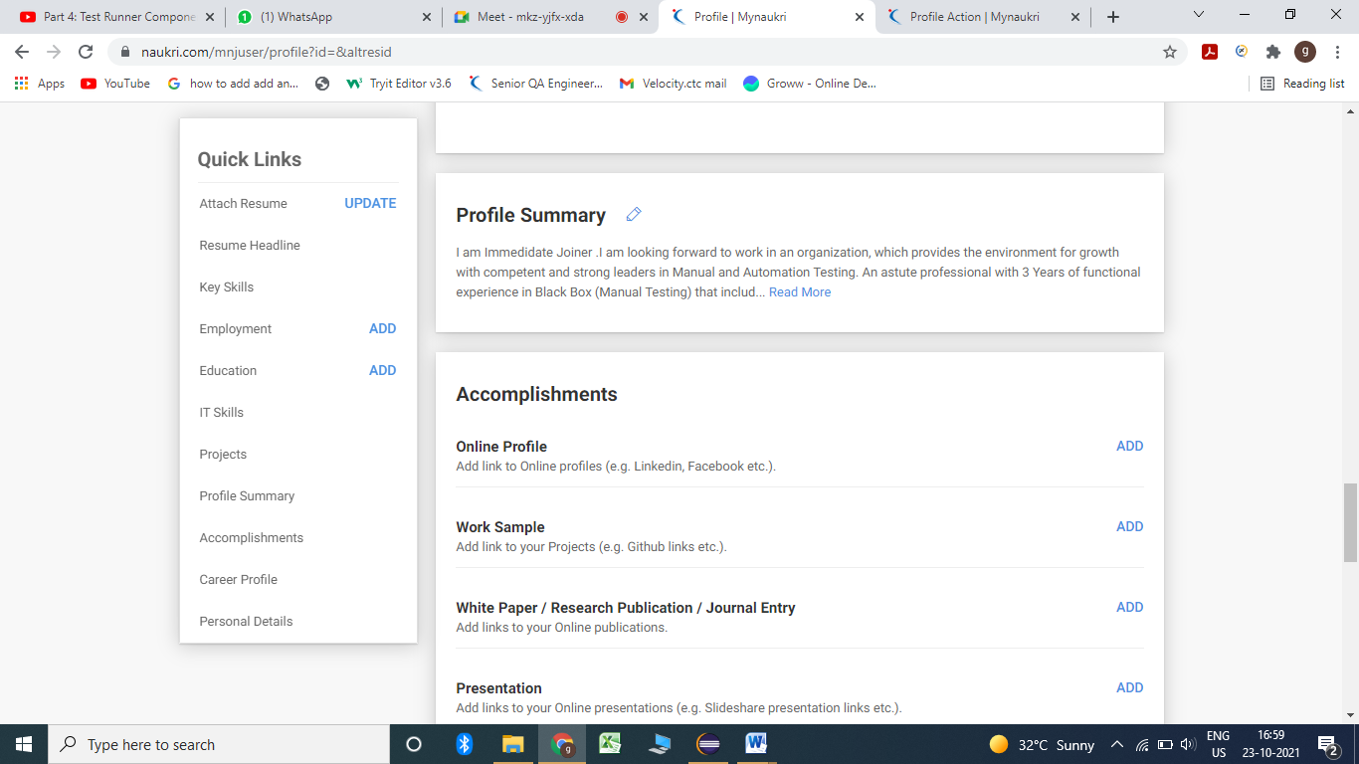

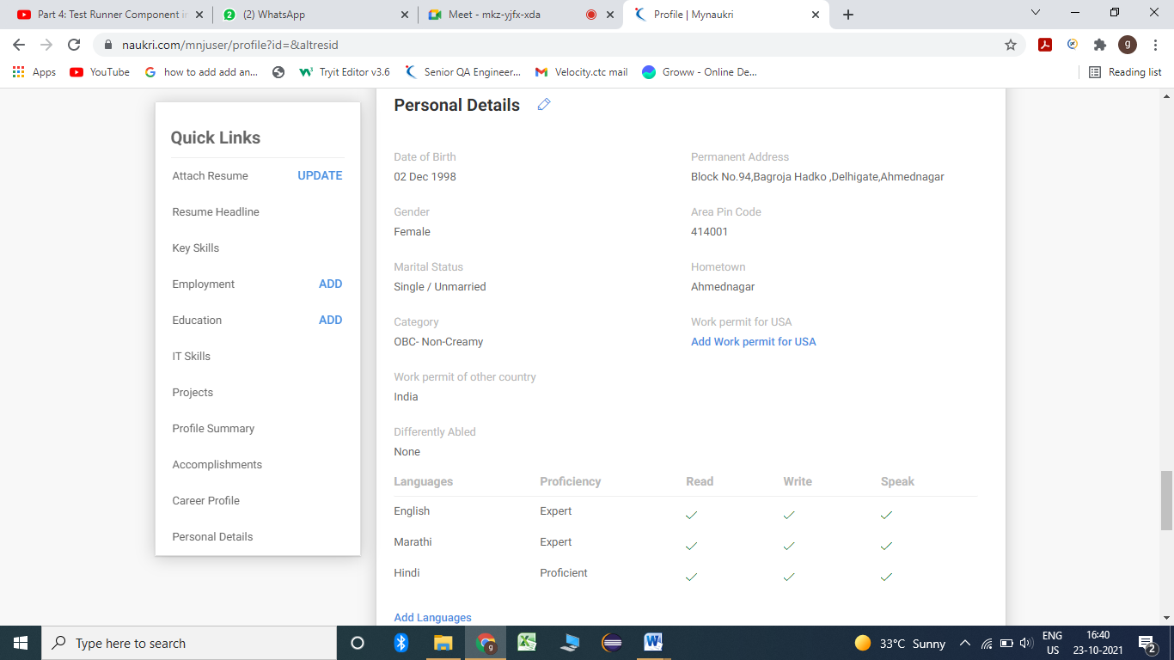

To check the recruiter messages go to My naukri--- recruiter messages

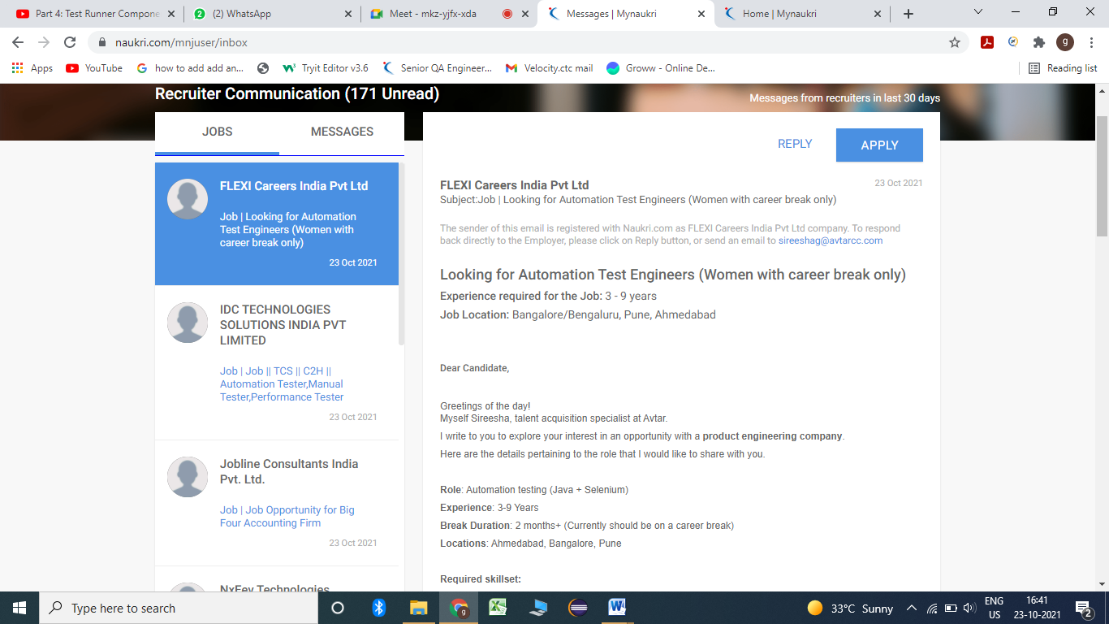

We have to do manage alerts in naukri.com which send the mail to student twice in a week.

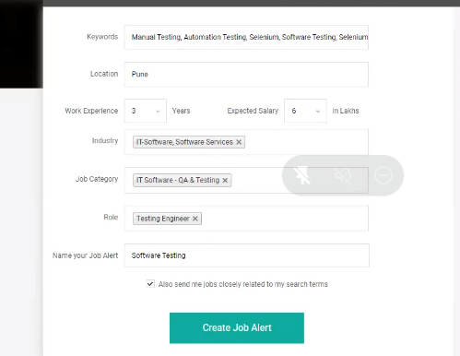

To block companies:

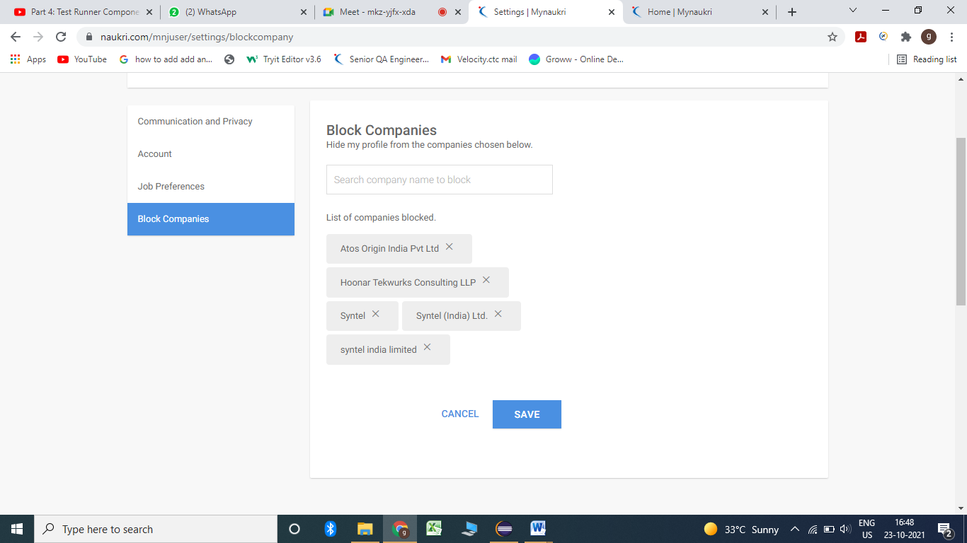

Experience:

Recruiter section:

Manual – 3.2 years

Automation – 3.2

480000 /12 = 40000 (Gross Salary) – 200(PT)-1000(Others) = 38800/-

PF – Yes (Recruiter).

Form 16 – Yes (Recruiter).

PAN card –

Expected salary:

20 to 30 % hike in the current but I am negotiable

MS Teams, Skype, Zoom meeting, Google meet

\*\*\*\*\*\*\*\*\*\*\*\*\*\*\*\*\*\*\*\*\*\*\*\*\*\*\*\*\*\*\*\*\*\*\*\*\*\*\*\*\*\*\*\*

R1 – Team member ---- Technical

R2- QA lead -- Technical

R3- Machine Test

R4- QA manager

R5- CEO

Submit the document

R6 – HR discussion Non technical – Salary discuss

Communication skills A, B, C D

Technical skills

Clarity of thoughts

Permanent –

Contractual position (Third party)-

Contract to hire-

1. Resume

2. Naukri profile deletion and creation.

3. Interview techniques and HR related questions and Q & A