Freescale MQX RTOS Example Guide
mutex example
This document explains the mutex example, what to expect from the example and a brief introduction to the API.

The example
The mutex example code is used to demonstrate how to use a mutex to synchronize two tasks. It creates a mutex and two tasks. Both tasks use STDOUT to print out messages. Each task will lock the mutex before printing and unlock it after printing to ensure that the outputs from tasks are not mixed together.

Running the example
Start HyperTerminal on the PC (Start menu->Programs->Accessories->Communications).
Make a connection to the serial port that is connected to the board (usually will be COM1).
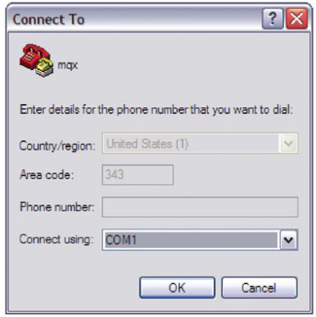
Set it for 115200 baud, no parity, 8 bits and click OK.
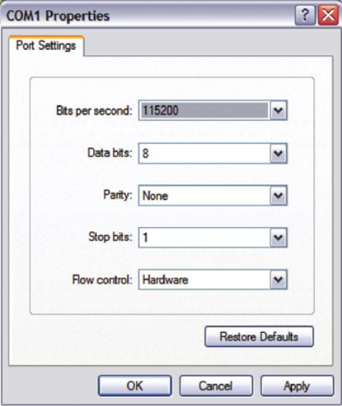

Then we compile the project mutex. When compiling there may be compiling error like this:

Error : preprocessor #error directive
main.c line 51 #error This application requires MQX_HAS_TIME_SLICE defined non-zero in user_config.h Please recompile kernel with this option.

In C:\Program Files\Freescale\Freescale MQX 3.x\config\common\small_ram_config.h please change
#define MQX_HAS_TIME_SLICE 0
to
#define MQX_HAS_TIME_SLICE 1

And rebuild the libraries bsp and psp. C:\Program Files\Freescale\Freescale MQX 3.7\mqx\build\cw10
This may take several minutes depending on the speed of the PC.

Then the mutex example can be compiled and downloaded to target board. We can see the running results displayed in the HyperTerminal:

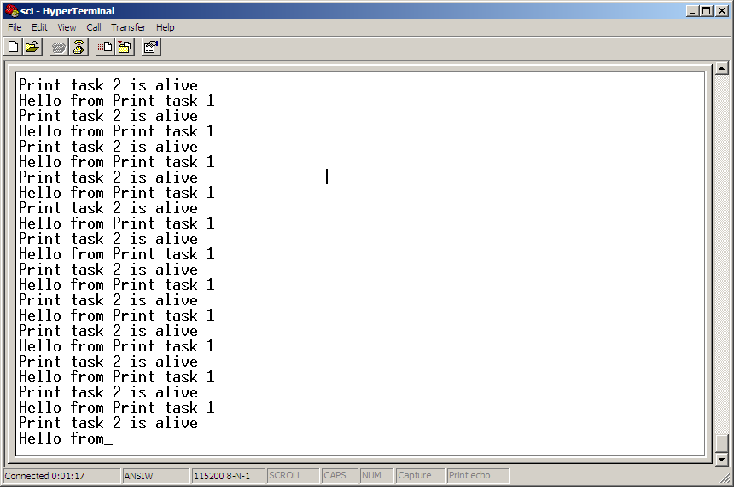

Explanation of the example
The application demo creates the main task first. The main task then creates two print tasks. The flows of the tasks are described in the next figure.

Initialize the mutex for print.
Main Task
Create a print task with string1, create another print task with string2.
Try to lock the print mutex
Print Task with string1
Block main task.
Success
?
Print string1 in STDOUT
Y
N
Unlock print mutex
Try to lock the print mutex
Print Task with string2
Success
?
Print string2 in STDOUT
Y
N
Unlock print mutex

The main task first initializes the mutex with the following line:
_mutex_init(&print_mutex, &mutexattr)

Then the main task creates a print task with parameter sting1, and creates a second print task with parameter strings withthe following line:
_task_create(0, PRINT_TASK, (uint_32)string1);
_task_create(0, PRINT_TASK, (uint_32)string2);
Then the main task blocks itself.

The two print tasks both use the STDOUT. If they used it in the same time, there would be conflicts, so a mutex is used to synchronize the two tasks.

Each print task will try to lock the mutex before printing the message; it will wait for the mutex as long as needed. Once the mutex is locked it prints the message and then unlocks the mutex so that the other task can lock it. This process is repeated indefinitely.

