Freescale MQX RTOS Example Guide
Timer example
This document explains the timer example, what to expect from the example and a brief introduction to the API.

The example
The timer example creates two timers, each timer has a 2 period seconds with an offset of 1 second between them. Task runs for 6 seconds.

Running the example
Run HyperTerminal on the PC (Start menu->Programs->Accessories->Communications).
Make a connection to the serial port which is connected to the board (usually will be COM1).
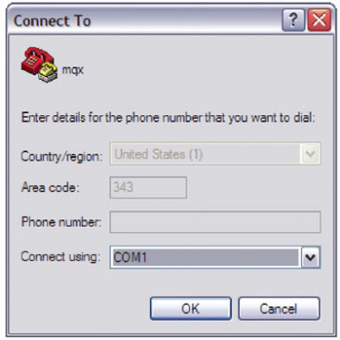
Set it with 115200 baud, no parity, 8 bits then click OK.
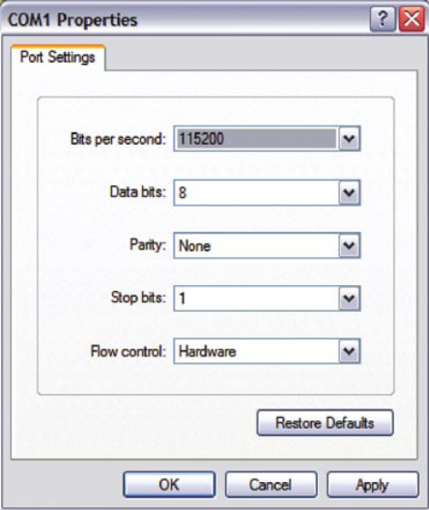

Run the code, then it can be seen from the terminal:
- Two timers are created;
- “ON” & “OFF” was printed at 1 second interval.
- 6 seconds later, timer task finished and both timers expired.
Comments: With 2 seconds period, the Serial terminal print “ON” & “OFF” three times in turn.
Below serial terminal snapshot shows timer example running info based on M52259EVB board:

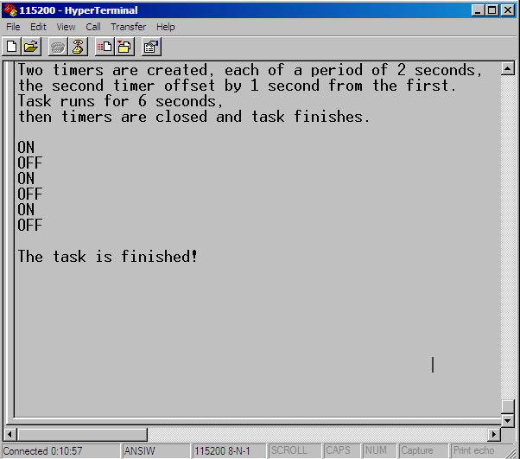

Explaining the example
The application example creates only one main task. The flow of the task is described in next figure.
Create timer component
Main Task
Start two periodic timers
(on_timer & off_timer)
Cancel two periodic timers
(on_timer & off_timer)
6 seconds pass
Set two tick variables
End of Example
LED_on or LED_off (2s)
N
Y
The main task starts to create timer component with more stack size in order to handle printf() requirements.

Two timers (on_timer and off_timer) are created with periodic timer type, which expire repeatedly at a specified interval. The code to do that is:
on_timer = _timer_start_periodic_at_ticks(LED_on, 0,
TIMER_ELAPSED_TIME_MODE, &ticks, &dticks);
_time_add_sec_to_ticks(&ticks, 1);
off_timer = _timer_start_periodic_at_ticks(LED_off, 0,
TIMER_ELAPSED_TIME_MODE, &ticks, &dticks);

Off_timer is 1 second offset with on_timer.

After 6 seconds delay time, the following code is used to cancel two created periodic timer (on_timer & off_timer).
_timer_cancel(on_timer);
_timer_cancel(off_timer);

