Freescale MQX RTOS Example Guide
USB Host HID Mouse Test
This document explains the USB Host HID Mouse test case, a brief introduce to the test objects , test steps and what to expect from the case.
The Test Objects
The Test case is used to test HID USB Mouse can be supported well by MQX USB stack. The case includes below test objects:
- USB mouse hotplug 10 times test.
- USB mouse multi-instance test.
- HID Class-level APIs test.
- USB mouse event test.
Running the example

Connection
Hub needed to support HID USB mouse Multi-instance test; connect USB mouse to Hub to begin the test cases

Test steps and Expected results :
- Building the test cases and loading the test image to board. Below information should be shown in debug console :
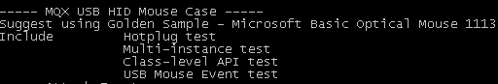
- Plugin USB mouse to the HUB port, below picture shows three USB mouses plugin :
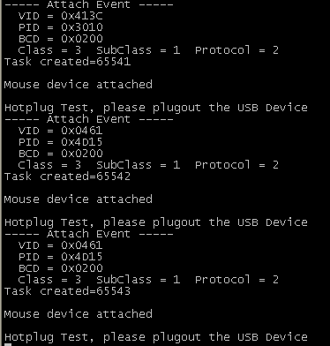
- Hotplug test is mandatory before HID Class APIs test and HID USB mouse event test, do hotplug test 10 times :
- After hotplug 10 times, case goes into HID Class APIs test branch, test result will be shown in the debug console as Passed or Failed :
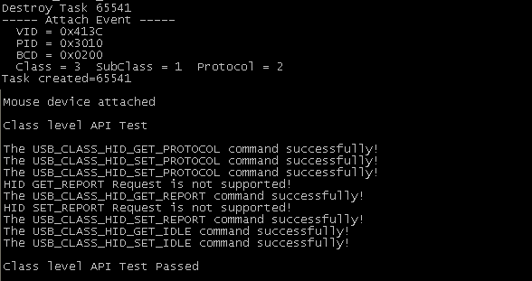
- USB event Test, move or click USB mouse, each USB mouse will get response in its own task :
