Freescale MQX RTOS Example Guide
USB Host MSD basic function Test
This document explains the MSD basic function test case, a brief introduce to the test objects , test steps and what to expect from the case.
The Test Objects
The Test case is used to verify USB MSD devcies can be supported well by MQX USB Host stack.
Two tasks will be created in this case. The first task is Shell Task in which we will perform some file operations to underneath USB disk. The other task is USB Task which installs USB disk on partiton, MFS and exposes USB disk to MFS.
The test case installs USB Disk with MQX MFS system. It supports to install the USB disk based on the raw disk or partition management if there is partition in the USB disk. If no partition the whole USB disk will be mounted on mount point name as c: or d:. If there is partition, the partition will be mounted on mount point name as c0:, c1 and as on. Multi-instance is supported in this case. But due to the limitation of MQX MFS subsystem, maximun 4 partitions/disks can be supported. The extra partition/disk can be recognized in USB stack level but will not be mounted in MFS and can not be accessed in MFS. The partition format must be Dos compatible format like FAT32, FAT16, FAT12 which is decided by MFS subsystem.

The case includes below test steps:
- USB disk hotplug 10 times test.
- USB disk multi-instance test.
- USB disk multi-partition test.
- USB disk write/read test.
- USB disk format test.
- USB disk hotplug test when transferring in progress.

Known issue
ENGR00272137 - USB disk can not be recoginized if connected by external Hub for EHCI controller
ENGR00272260 - Writetest failed if the write length equal or larger than 512 bytes
ENGR00272913 - mfs can not cd to other mounted partition/disk if the first mounted partion removed
ENGR00272365 - readtest command will not return to shell any more if plugout u-disk when readtest in progress
Running the Case

Connection
Hub is needed to support USB disk Multi-instance test; connect USB mouse to Hub to begin the test cases

Test steps and Expected results :
- Building the test cases and loading the test image to board. Shell prompt will be got and shown in debug console :
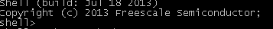
- Plugin USB two USB disks into the HUB port, below picture shows two USB disks plugin(one has partition, one do not) :
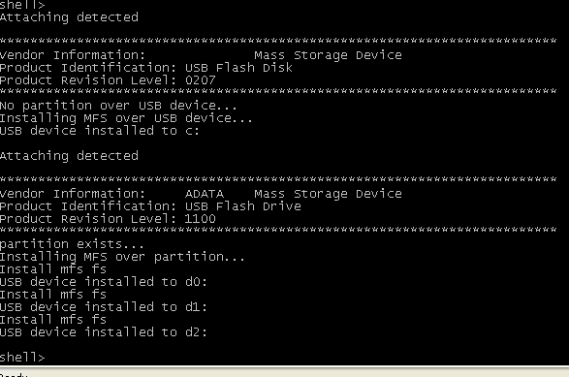
- Multi-partition test :
Using DiskGenius(download it from internet, it is a free tool) tool to generate 4 partitions to USB disk and format these partitions as FAT32.
Plugin the u-disk to hub , u-disk should be recognized and all 4 partitions should be mounted successfully like below :
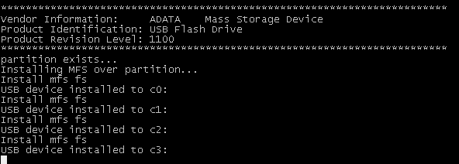
- Hotplug test
Do hotplug test 10 times, the u-disk should be recognized after each plugout&plugin.
- File operations test
  - In shell prompt, input help command to shell all supported shell command
  - Write operation
shell> write T1 5000
  - Read operation
shell> read T1
  - Readtest and writetest
shell> writetest T1
shell> readtest T1
  - Copy and compare test
shell> write T1 111
shell> copy T1 T2
shell> compare T1 T2
  - Format test(Here the mount point should be changed according to your test env)
shell> format d0:
- Hotplug when data transfer in progress
  - Do readtest in shell :
Shell> readtest
  - Plugout USB disk when the readtest in progress
  - Re-plugin the USB disk, the disk should be recognized succussfully

