Freescale MQX RTOS Example Guide
Lightweight event example
This document explains the lightweight event example, what to expect from the example and a brief introduction to the API.

The example
The lightweight event example code shows how a task waits for an event.
This event can be set by any other process or interrupt in the system that can set the variable lwevent. The example simulates an ISR event using another simple task.

Running the example
Connect a serial cable from the UART0 port of the board to the PC.

Start HyperTerminal on the PC (Start menu->Programs->Accessories->Communications).
Make a connection to the serial port that is connected to the board (usually will be COM1).
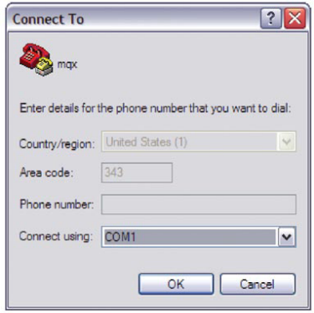
Set it for 115200 baud, no parity, 8 bits and click OK.
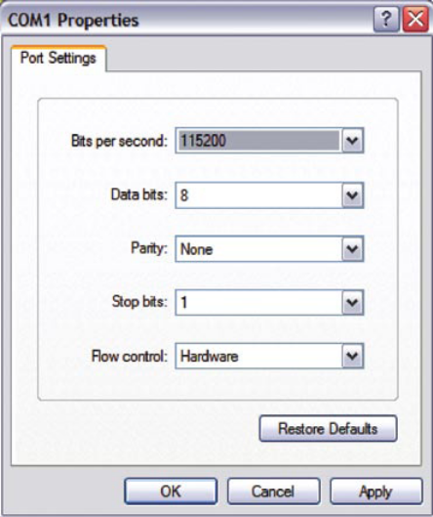

After the board is flashed the HyperTerminal will start printing the “Tick” message every certain time.
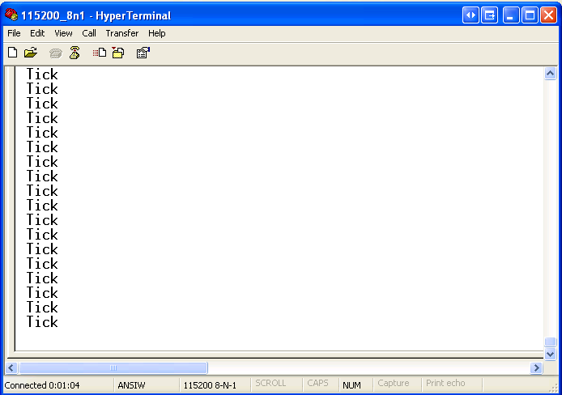

Explanation of the example
The example application creates two tasks. The service_task task creates a lightweight event group and enters a loop in which it waits for an event bit. When the appropriate lwevent bit is set, it clears it and prints "Tick.". The simulated_ISR_task task periodically sets the corresponding lwevent bit with a delay in between (no connection is opened to a lwevent group).

Create lwevent group
service_task

Clear lwevent 0x01
simulated_ISR_task user_fn()
Wait 200 msec
Set lwevent 0x01

Create simulated_ISR_task
wait lwevent 0x01
Print “Tick”

