Freescale MQX Example Guide
The lwmsgq example
This client/server model shows communication and task synchronization using message passing.

Server task initializes the message queues, creates three client tasks, and then waits for a message.

After receiving a message, the task returns the message to the sender.

Client task sends a message to the server_task and then waits for a reply.

Running the example
Start HyperTerminal on the PC (Start menu->Programs->Accessories->Communications).
Make a connection to the serial port that is connected to the board (usually will be COM1).
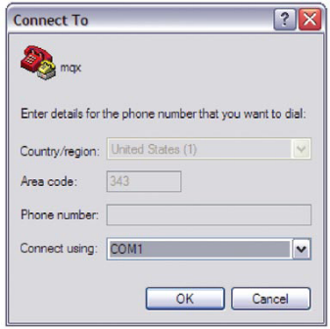
Set it for 115200 baud, no parity, 8 bits and click OK.
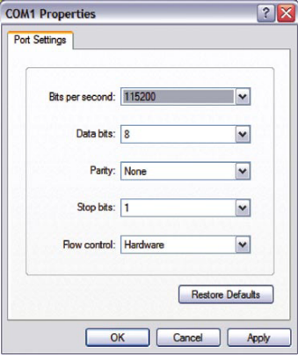
After running the MCU, you will see the printed message as the following picture.

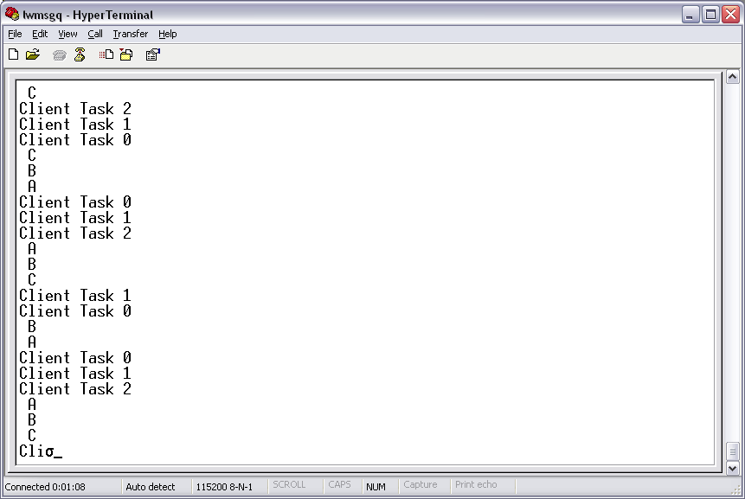

Explanation of the example
The flow of the tasks is described in the next figure. There is a server task that receives all the incoming data and responds to them. There are three client tasks. Each client sends a message to the server and receives the answer back from it.

No
Yes
Sever task
create server messages queue
create client messages queue
Client task n
Send message to server queue
Receive message

Response to sender
message received?

