Freescale MQX Example Guide
The msg example
This client/server model shows communication and task synchronization using message passing.

Server task blocks waiting for a request message from Client task. When Server receives the request, it executes the request and returns the message to Client. Two-way message exchange is used, in order to block Client while Server runs.

Server opens an input message queue that it will use to receive requests from Client tasks and creates a message pool, from which it allocates request messages. Server then creates a number of Client tasks. In a real application, the Client tasks most likely would not be created by Server.

When Server has opened its message queue and created its message pool, it enters a loop, receiving messages from the message queue, acting on them (in this case, printing the data), and returning the message to Client.

Client also opens a message queue. It allocates a message from the message pool, fills in the message field, sends the message to Server, and waits for a response from Server.

Running the example
Start HyperTerminal on the PC (Start menu->Programs->Accessories->Communications).
Make a connection to the serial port that is connected to the board (usually will be COM1).
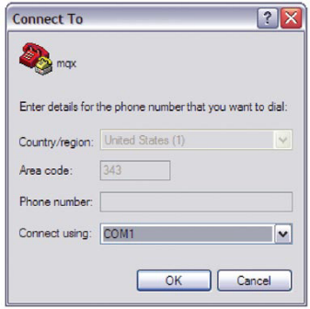
Set it for 115200 baud, no parity, 8 bits and click OK.
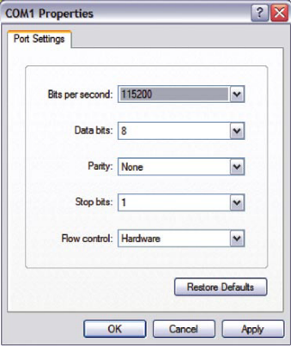
After running the MCU, you will see the printed message as the following picture.

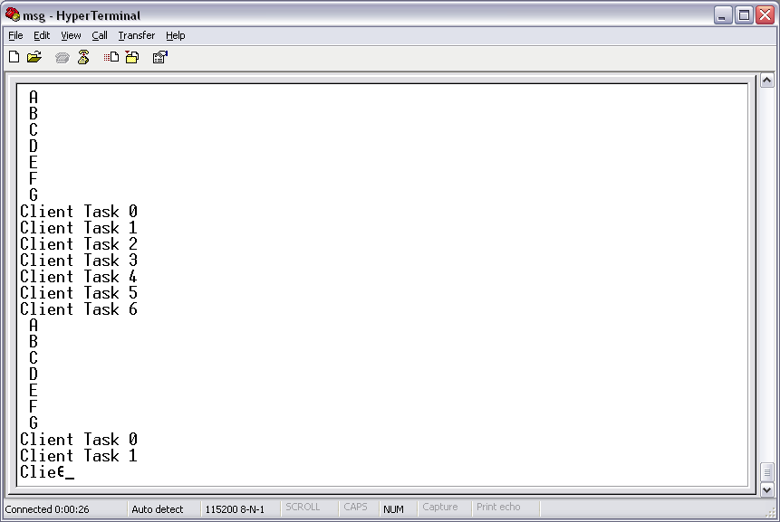

Explanation of the example
The flow of the tasks is described in the next figure. There is a server task that receives all the incoming data and responds to them. There are seven client tasks. Each client sends a message to the server and receives the answer back from it.

No
Yes
Opens a message queue
Sever task
create a message pool
create the client tasks
allocate a message
Client task n
wait for a return message
free the message

Response to sender
message received?
Opens a message queue

