Freescale MQX RTOS Example Guide
watchdog example
This document explains the watchdog example, what to expect from the example and a brief introduction to the API.

The example
The watchdog example code is used to demonstrate how to use a software watchdog for a task. It creates a soft watchdog for the task which restarts it in a loop. The loop time is increased each time until the watchdog timer expires.

Running the example
Start HyperTerminal on the PC (Start menu->Programs->Accessories->Communications).
Make a connection to the serial port that is connected to the board (usually will be COM1).
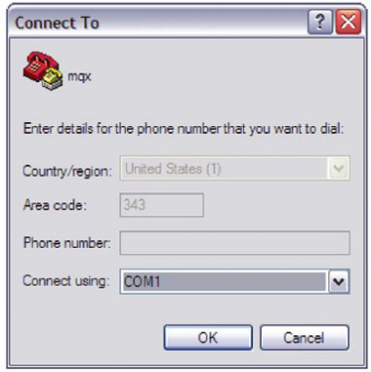
Set it for 115200 baud, no parity, 8 bits and click OK.
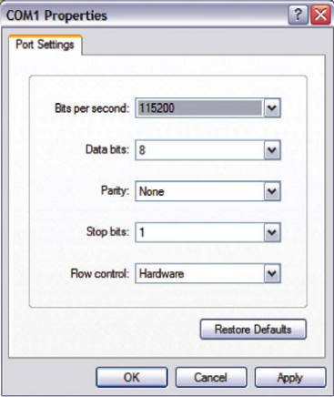

Then compile the project watchdog.

Note:This example requires MQX_USE_SW_WATCHDOGS to 1. In case this configuration option is not enabled in MQX kernel add
#define MQX_USE_SW_WATCHDOGS 1
to user_config.h and recompile MQX libraries.

There can be seen the following result in the HyperTerminal:

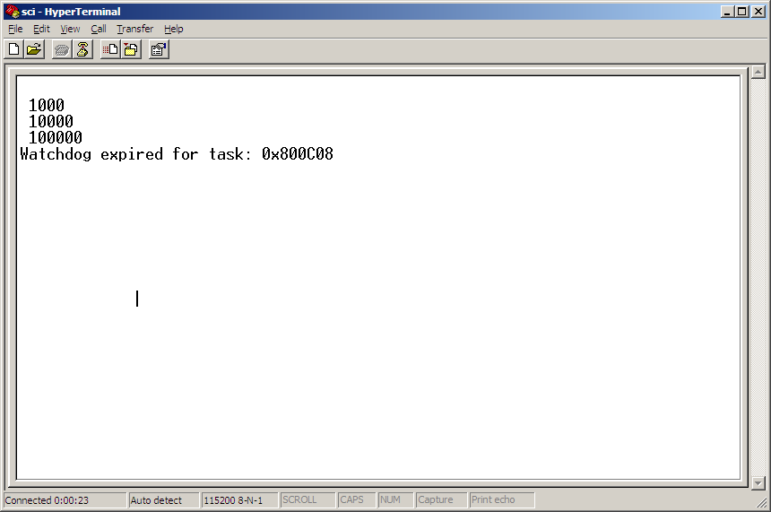

Explanation of the example
The application demo creates only one main task. The flow of the task is described in the next figure.

Create a watchdog component.
Main Task
Restart the watchdog
Waste time n ticks.
n=n*10

Exit MQX
Print watchdog expire message in STDOUT
handle_watchdog_expiry ()
Print n in STDOUT.

The main task first initializes a MQX_TICK_STRUCT using the following line:
_time_init_ticks(&ticks, 10);
The value 10 is used to initialize struct ticks, and the struct ticks will be used to restart the watchdog later in the main loop.

Then the main task creates a watchdog component using the following line:
result = _watchdog_create_component(BSP_TIMER_INTERRUPT_VECTOR,
handle_watchdog_expiry);
By this a software watchdog is created for the task and the handler for watchdog expiry is assigned. When the watchdog is not restarted in time, the watchdog will expire and handle_watchdog_expiry() will be called automatically.

Then main task enters a loop, in the loop it first restarts the watchdog with the parameter ticks which was initialized in previous steps. And then it wastes some time - the time will be increased 10 times every loop. Then it stops the watchdog and prints the elapsed time and continues with the next loop.

When the value exceeds the watchdog expiration period, handle_watchdog_expiry will be called, and watchdog expiry message along with the task number will be printed to STDOUT.

