Freescale MQX RTOS Example Guide
USB Host CDC basic function Test
This document explains the MSD basic function test case, a brief introduce to the test objects , test steps and what to expect from the case.
The Test Objects
The Test case is used to verify USB CDC ACM devcies can be supported well by MQX USB Host stack.
Three tasks will be created in this case. The first task is Main_Task which initializes USB Host Driver and creates two sub tasks – UART2USB and USB2UART. After that it monitors CDC Device register event, opens the CDC devices and triggers the two sub tasks running.
UART2USB sub task receives input from stdin usually which is the UART console. Then the received characters will be sent to CDC Device by USB port and after that this task will set event to trigger USB2UART subtask. The CDC Device is performed by MQX USB OOBE case usb4 which will save the received characters into its sending buffer.
Once USB2UART task is activated, it will try to read characters from CDC Device sending buffer by USB port. After that it will compare the received characters and sending characters in UART2USB task to do data integration test. When data matched, the received data will be print out to standout usually it is UART console. After that it task will set event to prepare UART2USB task and halt itself to next transfer.
The case includes below test steps:
- USB CDC device hotplug 10 times test.
- USB CDC basic function test
- USB CDC stress test by transferring text file

Known issue and limitation
ENGR00274464 - CDC COM: If interrupt tty enable, Virtual CDC device failed to work when transfer more than 4 characters one time from CDC host.
Limitation – The CDC sending and receiving buffer size is 200 bytes. When sending one line extra 200 characters(including the new line character), only the first 200 characters can be transferred.
Running the Case

Connection
Two boards are needed. One board acts as CDC device by OOBE case usb4. And connect the CDC device board with CDC Host board by USB port.

Test steps and Expected results :
- Building the test cases and loading the test image to board. Shell prompt will be got and shown in debug console :
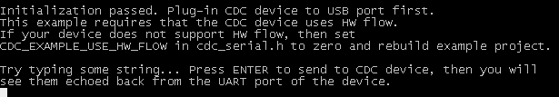
- Plugin CDC Device board with CDC Host board by USB port then UART console input is available. Try to input some characters in the console:
- Check the output in Device board Uart console, the input in Host board should be noticed :
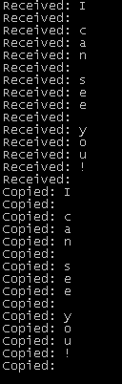
- Hotplug test
Do hotplug test 10 times, the CDC Device should be recognized and work normally after each plugout&plugin.
- Transfer text file
  - Prepare a text file in Window PC
  - Try to transfer this file by console by click Transfer->Send Text File menu in HyperTerminal and select the text file
  - No Error should be encountered during file transferring and the context of this text file should be recieved and print out correctly in Device board.

