What's in the Box

- Mold(s) of large or small size, with or without walls
- Glass substrate: molds are printed onto a glass substrate. This substrate can be easily removed or kept for convenient handling. If the mold delaminates from the glass, it can be glued back on or arranged and glued onto a different substrate, if desired.
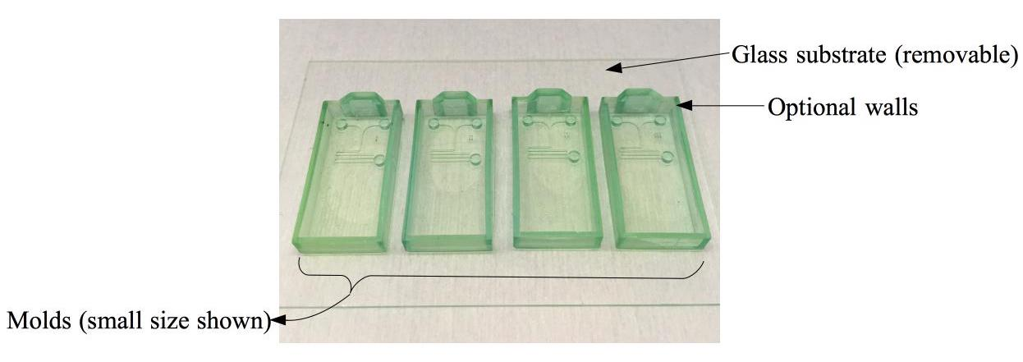
Maskless Instructions

- Remove Maskless mold from packaging. Place mold in a petri dish or aluminum foil dish to prevent spilling of PDMS throughout the process below.
- Dry mold at 80 ºC for 30 to 60 minutes prior to first use. Allow mold to return to room temperature.
- Prepare PDMS precursor according to desired protocol. A recommended procedure is as follows:
  - Weigh Sylgard 184 parts A and B in a 10:1 ratio by weight and mix thoroughly.
  - Degass the PDMS precursor under vacuum until all visible bubbles disappear.
- For molds with walls: pour the PDMS precursor into the mold. The volume of PDMS precursor may be weighed in order to keep the thickness of the device consistent: use up to 0.9 mL for the small sized molds and up to 4 mL for the large sized molds. For molds without walls, place mold in a plastic or aluminum foil petri dish and pour PDMS on top of the mold.
- Degass the PDMS for a second time in the mold.
- Cure the PDMS in the mold. Oven curing at 80 ºC for 15 – 40 minutes is recommended. Remove the mold from heat and allow to cool to room temperature.
- Use a flat tweezer or other small, flat edge to dislodge PDMS from mold on one end of the mold. Use the tweezers to pull the PDMS out of the mold.
- Finish processing the PDMS replica by treating the surface (such as with reactive ion etching), adhering to glass, and inserting tubing according to desired procedure.
- Mold can be reused without additional treatment. If needed, mold can be rinsed with water or isopropyl alcohol and dried at 80 ºC, taking care not to abrade the fine features in the mold.

