Apigee-2 Way SSL Target Connection

Document Summary

|  |  |  |  |
| --- | --- | --- | --- |
| Document Owner | APIM Team | Date Issued: | 04-11-2019 |
| Document Status |  | Version: | Draft |

# Deployment Guide

## Introduction

This document address steps to create key store , trust store , references and wiring to target server .

Reference Documents

| Document Title | Author | Version | Date |
| --- | --- | --- | --- |
| Apigee 2 way SSL Target Connection | Dwitikrushna Pattanaik | 1.0 | 04-11-2019 |
|  |  |  |  |

Below is the list of steps required to configure 2way SSL of target connection using Edge UI.

## Key Store

Step1- Environment-> TLS Key stores

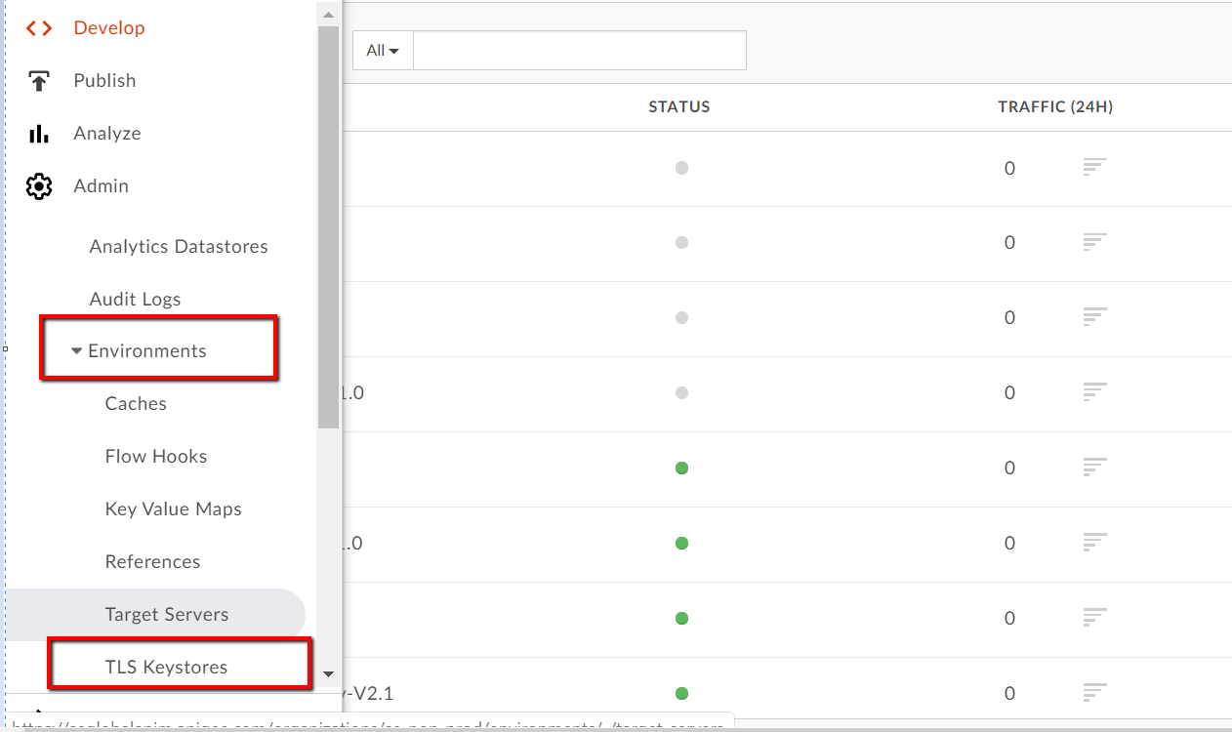

Step -2 Plus Key Store - > Give Key store name -> Add KeyStore

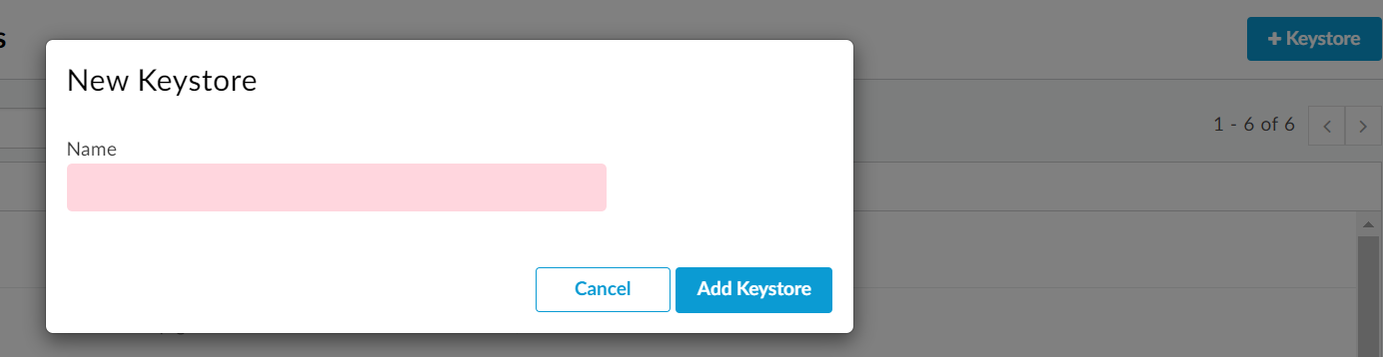

Step-3 – Select the Key store and click on + button to create an alias .



Step-4 – Create Alias by selecting certificate and key

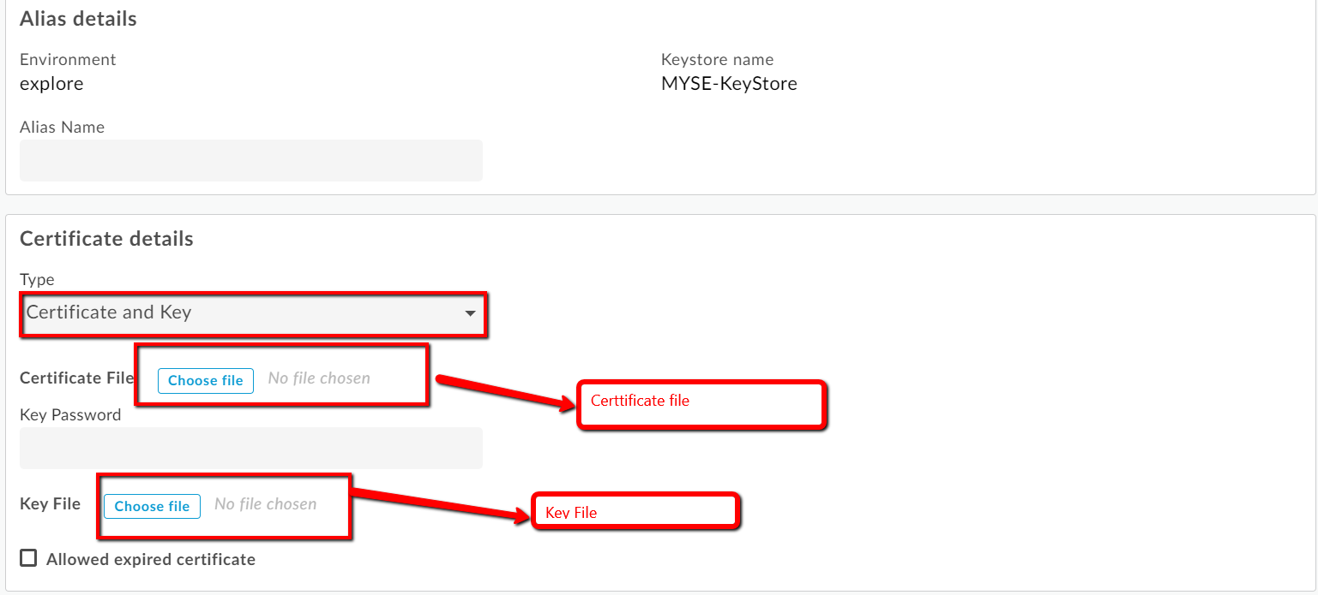

Step -5 – Click Save button .

## Trust Store

Step1- Environment-> TLS Key stores



Step -2 Plus Key Store - > Give Trust store name -> Add KeyStore



Step-3 – Select the Trust store and click on + button to create an alias .



Step -4 - Create Alias by selecting Certificate Only

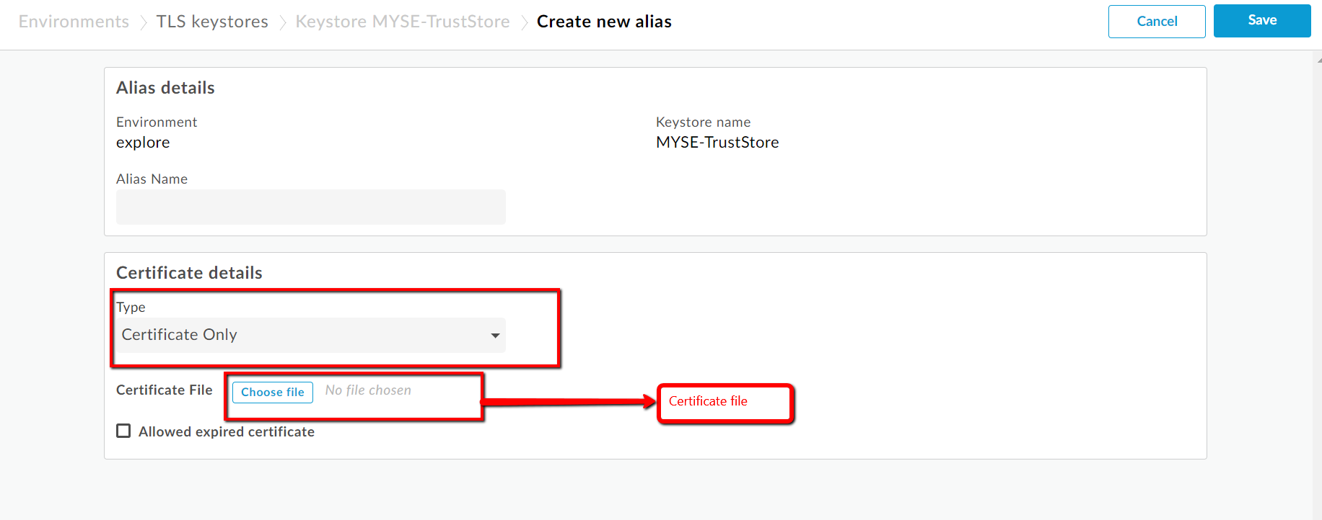

Step -5 – Click Save button .

## Reference

Step-1- Environment – References

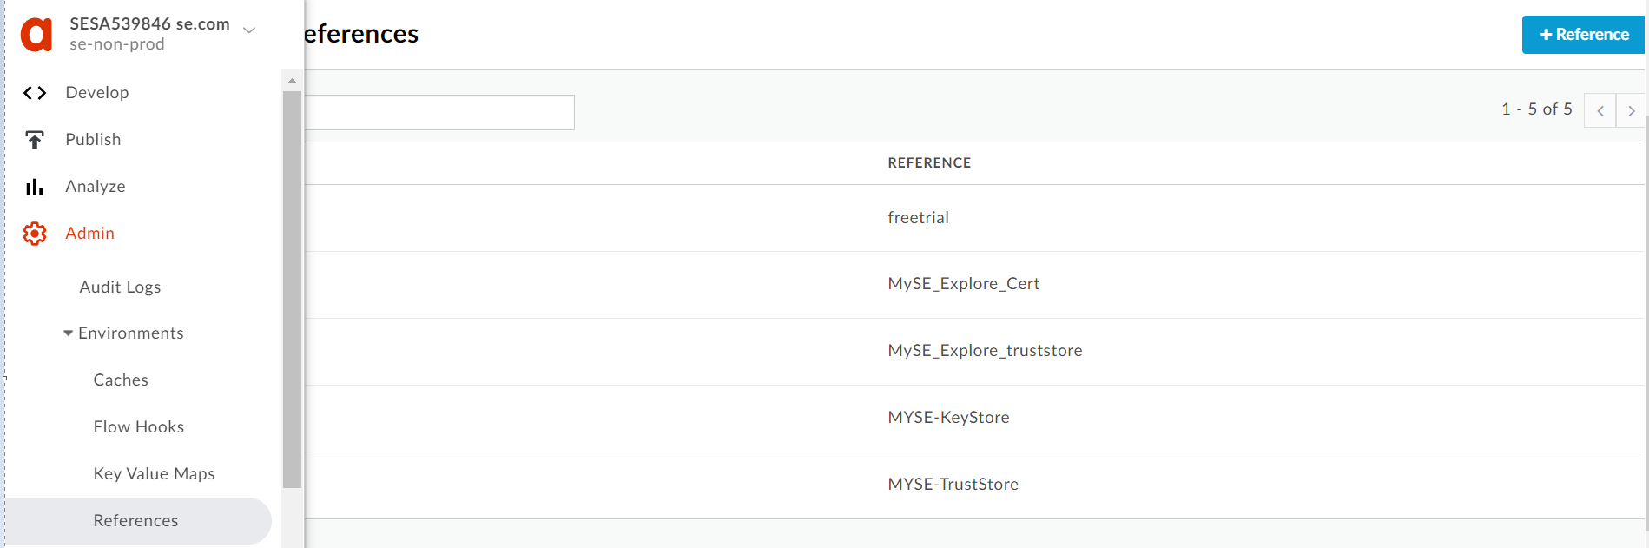

Step-2 – Click on Plus Reference - > Give Reference name -> Select the KeyStore/Trust Store from the drop down - > Click on Add Reference

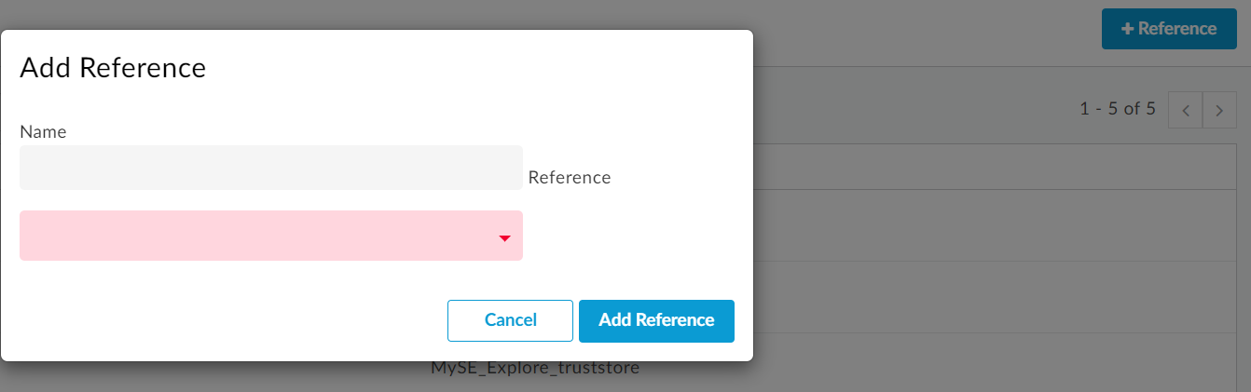

## Target Server-Config

Step -1 – update the target server config with key store and alias . Below is example of MYSE-Server

{

"name": "MYSE-Server",

"host": "mysewebservice-int.btsec.dev.schneider-electric.com",

"isEnabled": true,

"port": 443,

"sSLInfo": {

"enabled": "true",

"clientAuthEnabled": "true",

"keyStore": "ref://Myse-Explore-Cert",

"trustStore": " ref://Myse-Explore-Trust",

"keyAlias": "Alias name given while creating key store",

"ignoreValidationErrors": "false"

}

}

Step -2 – Mandatory Attribute in target server config for 2way SSL. clientAuthEnabled must be true to enable 2 way SSL.KeyStore and keyAlias are the tow other mandatory attribute for 2 way SSL.

"clientAuthEnabled": "true",

"keyStore": "ref://Myse-Explore-Cert",

"keyAlias": "Alias name given while creating key store",

Step -3 – Deploy the target server job from the jenkins

## Target Server-Edge UI – 2way SSL

Step-1 - Environment – Target Server – Edit Server – check enable 2way SSL- select key store and alias name- save

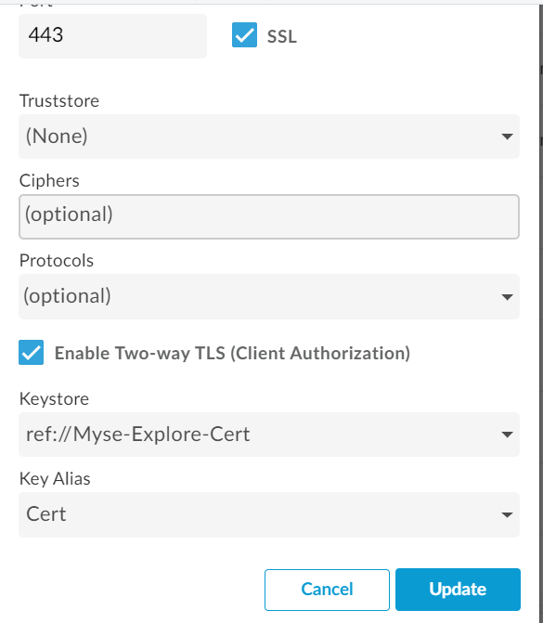

Reference:

<https://docs.apigee.com/api-platform/system-administration/configuring-ssl-edge-backend-service>