# Token Generation

## AR Token Generation:

### Steps:

* Import the below attached postman collection:



Note : Postman collection is pointing to UAT env(10.236.129.130:8243). Change the endpoint and Authorization token accordingly.

* Trigger - Authentication/init
  + Response would be the url. Sample given below:

"https://uatbfo19-secommunities.cs17.force.com/identity/services/apexrest/App/AssetRegistration/services/oauth2/authorize?response_type=code&client_id=3MVG9ahGHqp.k2_z.lHI3jkn3Z2zqaOuJdjqPGR7RPR28evPNlSoKzdGL4YM2hRdUQI_7mHi_Y8BLfbzMT5g1&redirect_uri=https://localhost/auth"

* Take that url and open in browser, home page will get displayed.

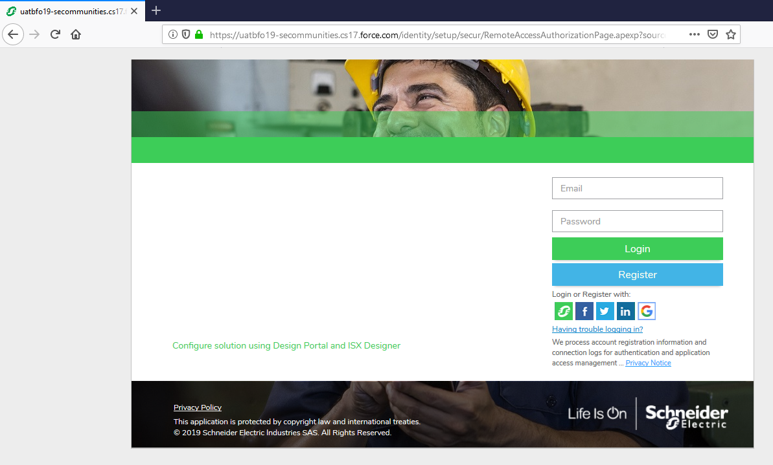

* Enter username and password, click on login.
  + Login: XXXXXXX
  + Password: XXXX
* auth code will get generate in the url.( https://localhost/auth?code=aPrxSwqB0mdEnqet4Ix4arJUdlVZs5omtm1dlcxXYILbVVohqzWBIm3K7Cs1pUff3kVV5.qECw%3D%3D&sfdc_community_url=https%3A%2F%2Fuatbfo19-secommunities.cs17.force.com%2Fidentity&sfdc_community_id=0DB12000000CaVnGAK)

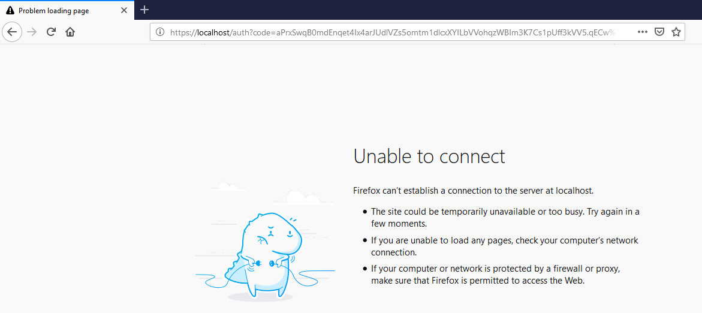

* use auth code value in the authentication/accessToken resource.

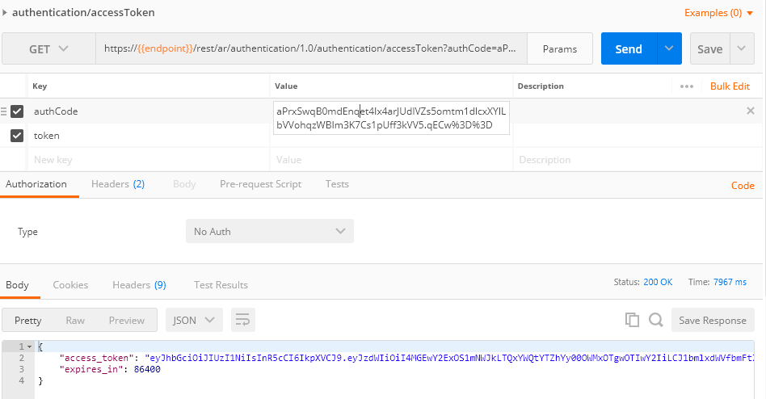

* access_token will get generate in the response.

## BFO-Token

### Steps:

* Import the below attached postman pack



Note : Postman collection is pointing to UAT env(10.236.129.130:8243).

* Update below field/param value:
  + client_id
  + client_secret
  + username
  + password
* Response :

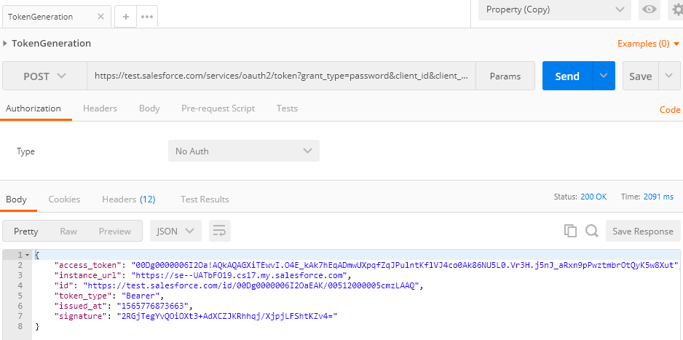

## SR-Token

### Steps:

* Import the below attached postman pack and updated Login (username) and password in the request body.



Note : Postman collection is pointing to UAT env(10.236.129.130:8243). Change the endpoint and Authorization token accordingly.

* Response :

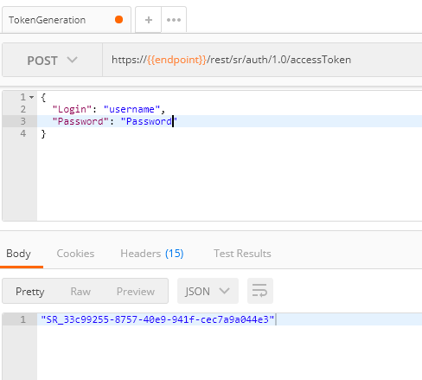

## IDMS User Token Generation

### Token generation steps for Global user

#### Steps:

* Use the below URL as per work / home user
  + https://uatbfo19-secommunities.cs17.force.com/identity/idp/login?app=0spg0000000CalK -- Work
  + https://uatbfo19-secommunities.cs17.force.com/identity/idp/login?app=0spg0000000CalJ – Home
* Enter the user's email & password for which we are trying to generate the session token.
* Once the user is successfully loged-in open the below URL in the next tab(with client id)

https:// uatbfo19-secommunities.cs17.force.com /identity/services/oauth2/authorize?response_type=token&client_id={client_id}&redirect_uri=https://test.salesforce.com/services/oauth2/callback

* Once the URL is loaded, copy the link which contains the param : access token.
* In the obtained value of access token replace %21 with shift+1 [!]

### Token generation steps for China user

#### Steps:

* Open the identity login page, enter the mobile no. & click on forgotPassword? option.

Login page [old]

<https://identity-int.schneider-electric.com/ui/#!/login?app=oauthSampleApp>

New URL for token generation:

<https://identity-int.schneider-electric.com/ui/#!/login?app=AutomationWork>

* The page will re-direct to Re-set Password Page, enter the Mobile no and select re-set password
* Another OTP will be sent to mobileNo@mailinator. Use this PIN in the Password re-set page and enter the New password.
* Once the user is activated and Password is set, open the login URL [old/new as above] and enter the mobile no and the password set.
* Once Logged-in the session token will be displayed in the home page.

## MySE Token Generation

### Steps

* Open the Login URL provided below with client_id(user/account specific)

[https://uatbfo19-secommunities.cs17.force.com/identity/services/apexrest/App/mySchneider/services/oauth2/authorize?response_type=token&client_id={client_Id}&redirect_uri=myschneider%3A%2F%2Foauth](https://uatbfo19-secommunities.cs17.force.com/identity/services/apexrest/App/mySchneider/services/oauth2/authorize?response_type=token&client_id=%7bclient_Id%7d&redirect_uri=myschneider%3A%2F%2Foauth)

* Enter username and password to login.
* After login, next page URL will contain the access_token
* Replace %3D with “=” in access token