**Case API- High Level Design**

Contents

API Meta Data 1

API Specification 2

Proxy-High Level Flow 2

Proxy-Pre-flow Diagram 2

Flows 3

Proxy-Post -Flow 3

Target-Pre-Flow 3

Target-Post-Flow 4

List of generic Policy (Proxy Endpoint) 4

List of generic Policy (Target Endpoint) 4

Mapping/Mash (Extension Policy Used) 4

Additional Policy 4

Validation 4

Reference Config 5

Error Codes 5

Others 5

**Authors: API Management Team**

**Digital Architecture**

|  |  |  |  |
| --- | --- | --- | --- |
| **Version & Date** | **Created/Changed by** | **Change details** | **Reviewed/Approved By** |
| **1.1/April 08,2020** | **Dwiti Pattanaik** | **Updated version** |  |

## API Meta Data

|  |  |  |
| --- | --- | --- |
| **Name** | **Value** | **Comment** |
| API Name | Case-V1 |  |
| API Version | 1.0 |  |
| Spec Name | Case_1_0 |  |

## API Specification

|  |  |  |
| --- | --- | --- |
| **Category** | **Value** | **Comments** |
| APIM Requirement | <https://schneider-electric.app.box.com/folder/107935280126> |  |
| Avid Link | <https://next.stoplight.io/se-avid/external-case-api/version%2F1.0/Case.oas2.yml?view=%2F> |  |

## Proxy-High Level Flow

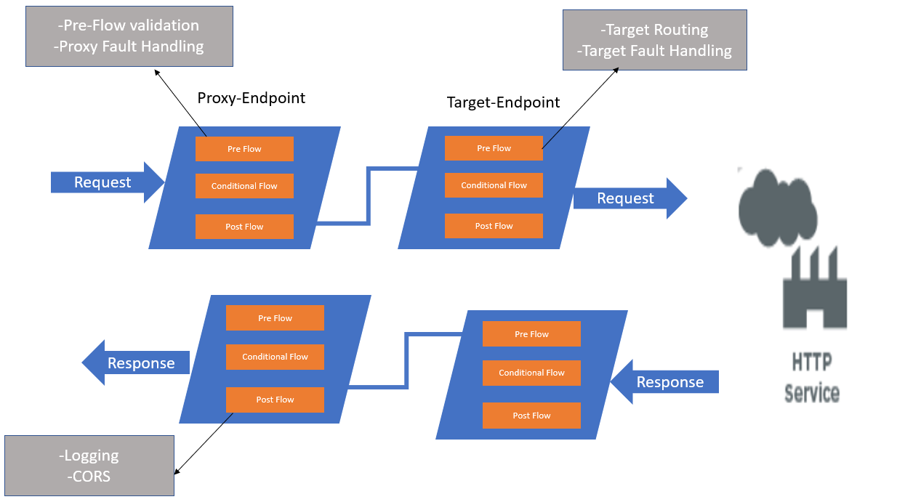

## 

## Proxy-Pre-flow Diagram

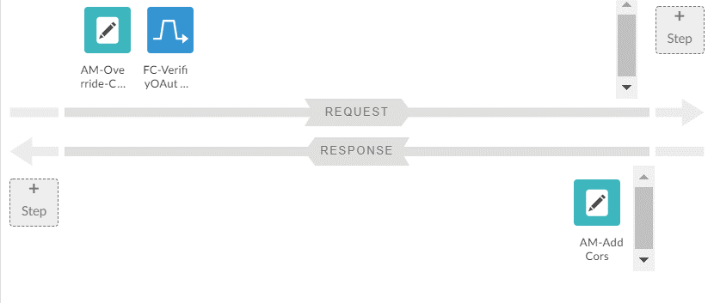

## Flows

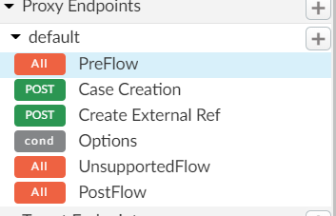

## Proxy-Post -Flow

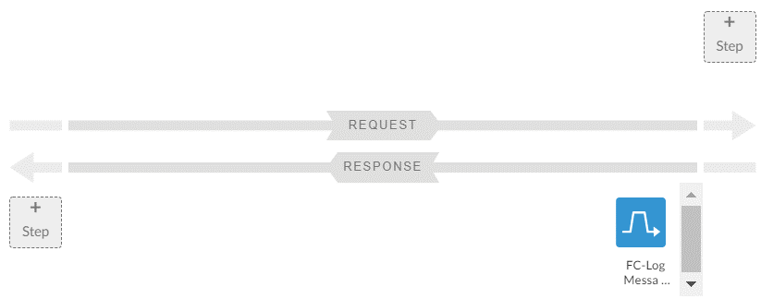

## Target-Pre-Flow

NA

## Target-Post-Flow

NA

## List of generic Policy (Proxy Endpoint)

|  |  |  |
| --- | --- | --- |
| **Name** | **Step** | **Description** |
| AM-403-Forbidden | Pre-Flow-Request | Assign Message to set error message for 404,405 and 403 |
| AM-AddCors | Pre-Flow-Request/Response | Assign Message to allow headers for CORS |
| AM-Override-Config | Pre-Flow-Request | Assign message to override default config like spike, quota and content type support |
| FC-LogMessage | Pre-Flow-Response | Flow call out to call the log shared flow |
| FC-VerifiyOAuth-LimitTraffic | Pre-Flow-Request | Flow call out to call the shared flow for pre flow validation like ouath, quota etc |
| RF-403-Forbidden | Pre-Flow-Request | Raise fault for 403,404 and 405 |

## List of generic Policy (Target Endpoint)

|  |  |  |
| --- | --- | --- |
| **Name** | **Step** | **Description** |
| EV-ExtractCustomError | Target-Fault | Extract variable to parse target backend error |
| FC-ProxyErrorHandling | Proxy-Fault | Flow call out to handle proxy error handling |
| FC-TargetErrorHandling | Target-Fault | Flow call out to handle target error handling |
| AM-AddCors | Target-fault | Assign Message to allow headers for CORS |

## Mapping/Mash (Extension Policy Used)

|  |  |  |
| --- | --- | --- |
| **Name** | **Description** | **Comments** |
| Header, Path variable, Query Parameter | NA |  |
| Request / Response - success | NA |  |
| Response – Error | Error structure is same as SEAPIM structure. message and code is extracted and overridden |  |

## Additional Policy

|  |  |  |
| --- | --- | --- |
| **Name** | **Step** | **Description** |
| KVM-Case-Config | Pre-Flow-Request | KVM to read configuration |
| KVM-External-Case-Config | Pre-Flow-Request | KVM to read configuration |

## Validation

|  |  |  |
| --- | --- | --- |
| **Type** | **Description** | **Status** |
| Mandatory Validation – (Header, Query Parameter) | NA |  |
| Request Payload schema validation | NA |  |
| Payload limit validation | NA |  |

## Reference Config

|  |  |  |
| --- | --- | --- |
| **Name** | **Reference** | **Comments** |
| Target Server | BFO-Server |  |
| KVM | BFO-Service-KVM |  |
| Cache | NA |  |

## Error Codes

|  |  |  |
| --- | --- | --- |
| **HTTP status** | **SEAPIM Code** | **Comments** |
| 400 |  |  |
| 401 |  |  |
| 405 |  |  |
| 415 |  |  |
| 429 |  |  |
| 500 |  |  |
| 500 |  |  |
|  |  |  |
|  |  |  |

## Others

|  |  |  |
| --- | --- | --- |
| **Type** | **Value** | **Comments** |
| Shared Flow design | Location -<https://schneider-electric.app.box.com/folder/79384989886> |  |
| Streaming | Default |  |
| Connection time out | Default |  |
| IO time out | Default |  |
|  |  |  |