Name: Maskur Al Shal Sabil
ID: IT18021
Topic : Mininet Basic

1. Native Installation from Source
To install natively from source, first we need to get the source code:
git clone git://github.com/mininet/mininet
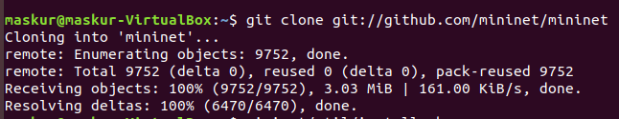
Note that the above git command will check out the latest and greatest Mininet . If we want to run the last tagged/released version of Mininet - or any other version - we may check that version out explicitly:
cd mininet
git tag # list available versions
git checkout -b 2.2.1 2.2.1 # or whatever version we wish to install
cd ..
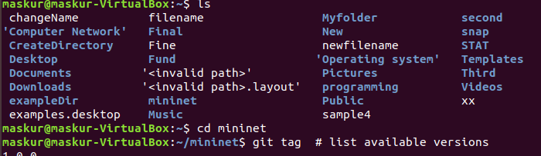

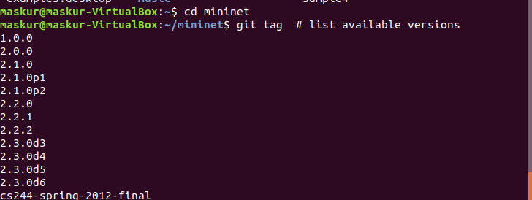

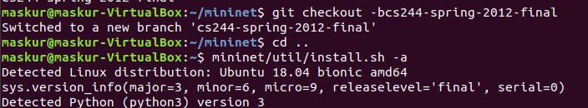

Once we have the source tree, the command to install Mininet is:
mininet/util/install.sh [options]
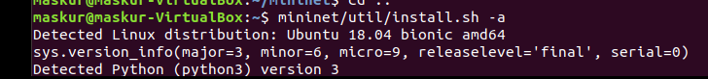

Typical install.sh options include:
- -a: install everything that is included in the Mininet VM, including dependencies like Open vSwitch as well the additions like the OpenFlow wireshark dissector and POX. By default these tools will be built in directories created in our home directory.
- -nfv: install Mininet, the OpenFlow reference switch, and Open vSwitch
- -s mydir: use this option before other options to place source/build trees in a specified directory rather than in our home directory.
So, we will probably wish to use one (and only one) of the following commands:
To install everything (using your home directory): install.sh -a
To install everything (using another directory for build): install.sh -s mydir -a
To install Mininet + user switch + OVS (using your home dir): install.sh -nfv
To install Mininet + user switch + OVS (using another dir:) install.sh -s mydir -nfv

Now this is time to check is it successfully installed

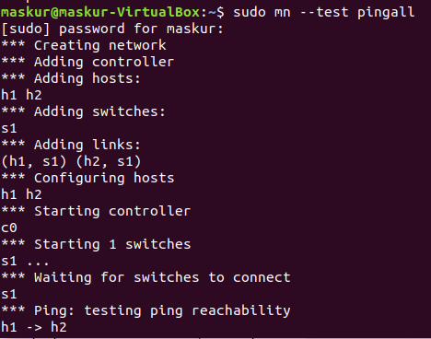

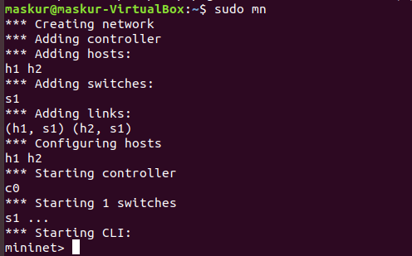

Walk through mininet
Part 1 Basic commands

Display Startup Options
So now we start with the help commands in mininet . Type : sudo mn -h in our terminal
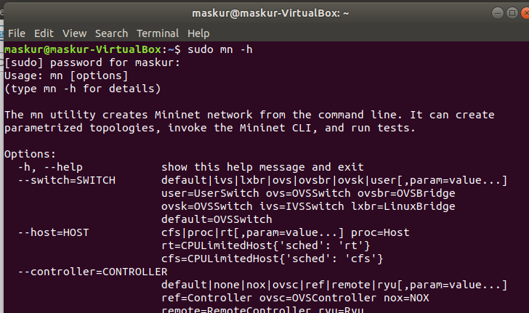

Start Wireshark
To view control traffic using the OpenFlow Wireshark dissector, first open wireshark in the background:
$ sudo wireshark &
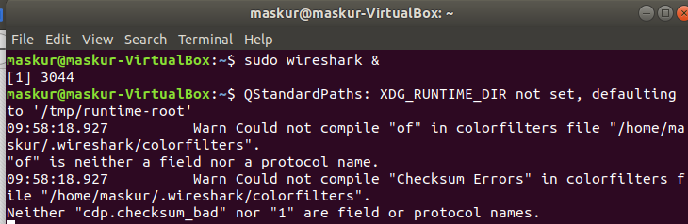

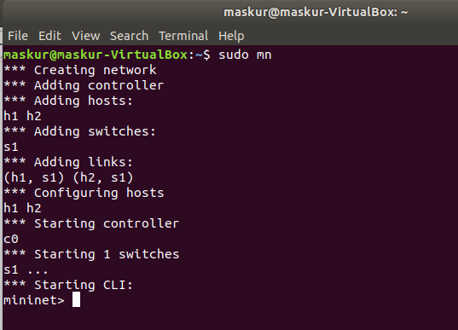

Interact with Hosts and Switches
Now in the command line we use command $ sudo mn
which provides the minimal topology having two hosts process, one switches and additionally a controller.If no specific test is passed as a parameter, the Mininet CLI comes up.
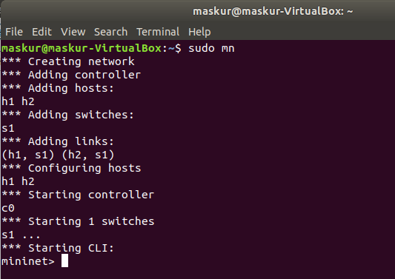
Help command
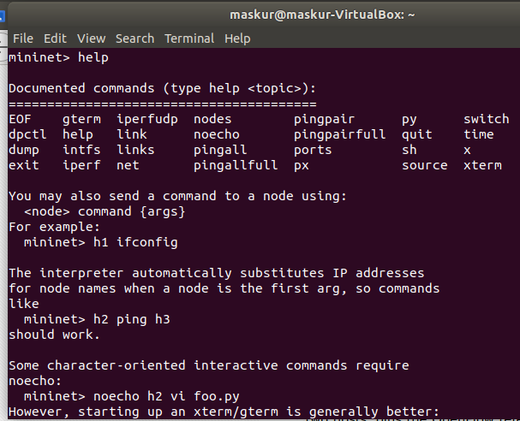

Display nodes:
Here everything is considered as node
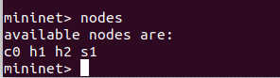

To know more details about the nodes we can use : dump
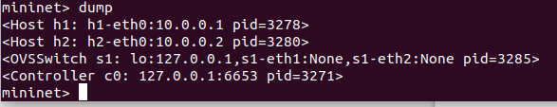

Display links:
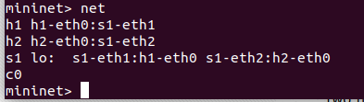

Simple commands within a node:
If the first string typed into the Mininet CLI is a host, switch or controller name, the corresponding
command is executed on that node. For example, run the following command on host h1 to show its
network interfaces.

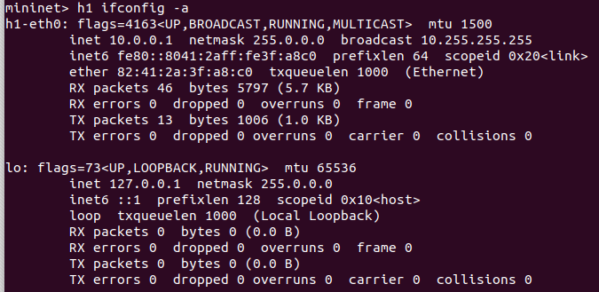

In the above command, we can replace h1 with s1 to see the details of the switch’s interfaces.

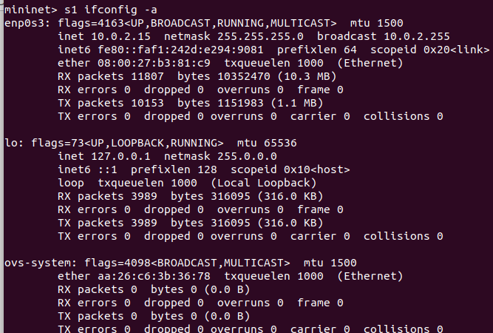

Also,for a list of processes in a host we can run h1 ps –a.
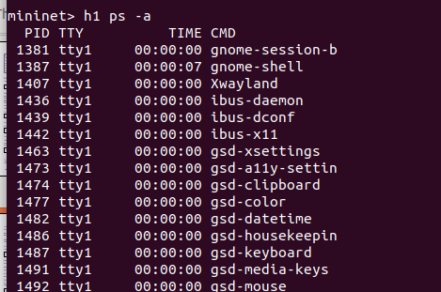

Test connectivity between hosts:
In order to ping host 1 from host 2, run the following command:
mininet> h1 ping -c 1 h2

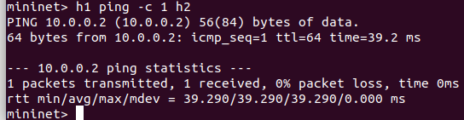
If a string appears later in the command with a node name, that node name is replaced by its IP address; this happened for h2.
We should see OpenFlow control traffic. The first host ARPs for the MAC address of the second, which causes a packet_in message to go to the controller. The controller then sends a packet_out message to flood the broadcast packet to other ports on the switch (in this example, the only other data port). The second host sees the ARP request and sends a reply. This reply goes to the controller, which sends it to the first host and pushes down a flow entry.
Now the first host knows the MAC address of the second, and can send its ping via an ICMP Echo Request. This request, along with its corresponding reply from the second host, both go the controller and result in a flow entry pushed down (along with the actual packets getting sent out).
A simple way to test the connectivity of all nodes in the Mininet CLI is to run the pingall command,
which does an all-pairs ping.
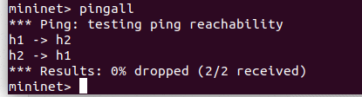

Run a simple web server and client
Remember that ping isn’t the only command we can run on a host! Mininet hosts can run any command or application that is available to the underlying Linux system (or VM) and its file system. We can also enter any bash command, including job control (&, jobs, kill, etc..)
Next, we starting a simple HTTP server on h1, making a request from h2, then shutting down the web server:
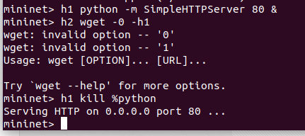

Exit the CLI:
mininet> exit
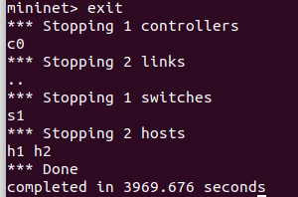

Cleanup
If Mininet crashes for some reason, clean it up:
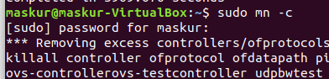

Part 2: Advanced Startup Options

Run a Regression Test
We don’t need to drop into the CLI; Mininet can also be used to run self-contained regression tests.
Run a regression test : $ sudo mn --test pingpair
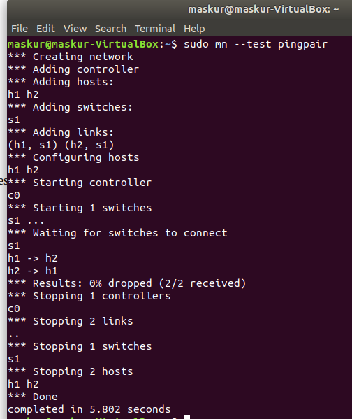

This command created a minimal topology, started up the OpenFlow reference controller, ran an all-pairs-ping test, and tore down both the topology and the controller.
Another useful test is iperf (give it about 10 seconds to complete):
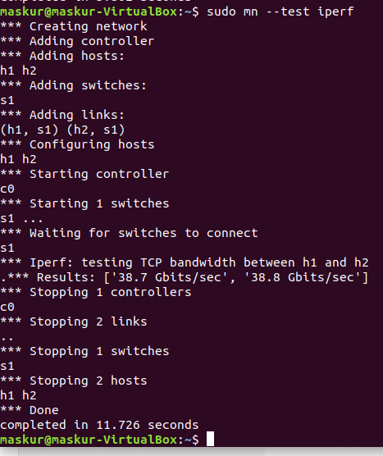

This command created the same Mininet, ran an iperf server on one host, ran an iperf client on the second host, and parsed the bandwidth achieved.

Changing Topology Size and Type
The default topology is a single switch connected to two hosts. We could change this to a different topo with --topo, and pass parameters for that topology’s creation. For example, to verify all-pairs ping connectivity with one switch and three hosts:
Run a regression test:
$ sudo mn --test pingall --topo single,3

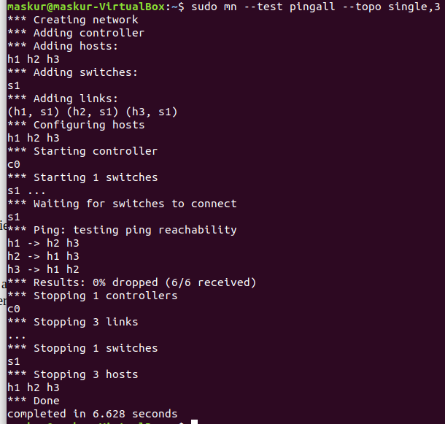
Another example, with a linear topology (where each switch has one host, and all switches connect in a line):
$ sudo mn --test pingall --topo linear,4
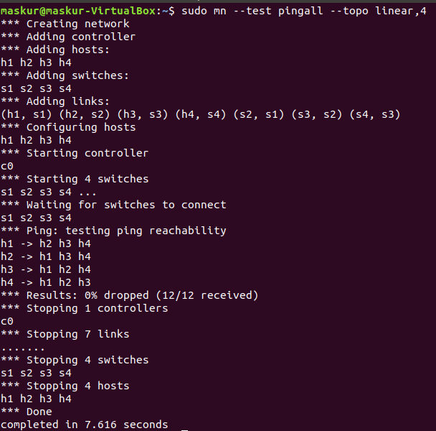

Link variations
Mininet 2.0 allows you to set link parameters, and these can even be set automatially from the command line:
$ sudo mn --link tc,bw=10,delay=10ms
mininet> iperf
...
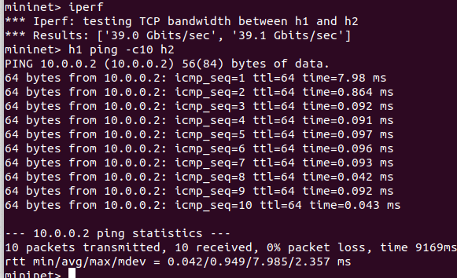
mininet> h1 ping -c10 h2

Adjustable Verbosity
The default verbosity level is info, which prints what Mininet is doing during startup and teardown. Compare this with the full debug output with the -v param:
$ sudo mn -v debug
...
mininet> exit
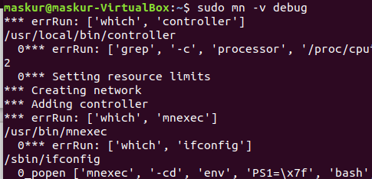

Lots of extra detail will print out. Now try output, a setting that prints CLI output and little else:
$ sudo mn -v output
mininet> exit

Custom Topologies
We can easily defined a custom topology using a simple Python API, To do this : In our mininet we directory we have
custom/topo-2sw-2host.py. This example connects two switches directly, with a single host off each switch:
"""Custom topology example

Two directly connected switches plus a host for each switch:

host --- switch --- switch --- host

Adding the 'topos' dict with a key/value pair to generate our newly defined
topology enables one to pass in '--topo=mytopo' from the command line.
"""

from mininet.topo import Topo

class MyTopo( Topo ):
"Simple topology example."

def __init__( self ):
"Create custom topo."

# Initialize topology
Topo.__init__( self )

# Add hosts and switches
leftHost = self.addHost( 'h1' )
rightHost = self.addHost( 'h2' )
leftSwitch = self.addSwitch( 's3' )
rightSwitch = self.addSwitch( 's4' )

# Add links
self.addLink( leftHost, leftSwitch )
self.addLink( leftSwitch, rightSwitch )
self.addLink( rightSwitch, rightHost )

topos = { 'mytopo': ( lambda: MyTopo() ) }
Now we can test this custom topology using the following commands in the terminal :
$ sudo mn --custom ~/mininet/custom/topo-2sw-2host.py --topo mytopo --test pingall

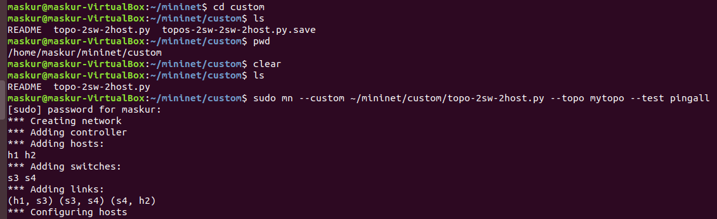
MAC ID:
By default, hosts start with randomly assigned MAC addresses. This can make debugging tough, because every time the Mininet is created, the MACs change, so correlating control traffic with specific hosts is tough.
The --mac option is super-useful, and sets the host MAC and IP addrs to small, unique, easy-to-read IDs.
So first check :
$ sudo mn
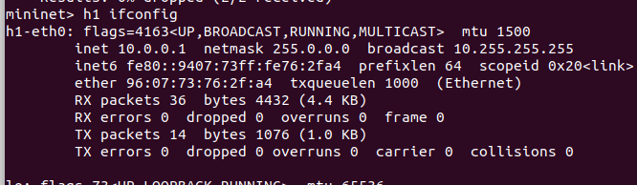
mininet > h1 ifconfig

And then ,
$sudo mn - - mac
mininet> h1 ifconfig
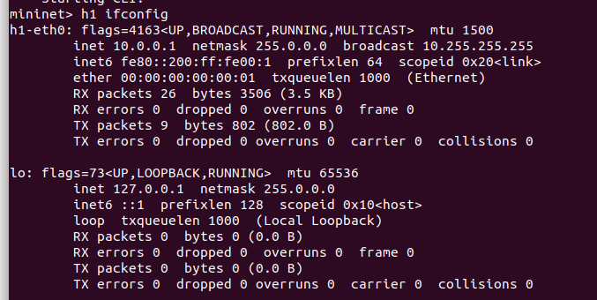

Xterm display:
For more complex debugging, we can start Mininet so that it spawns one or more xterms.
To start an xterm for every host and switch, pass the -x option:
$sudo mn -x
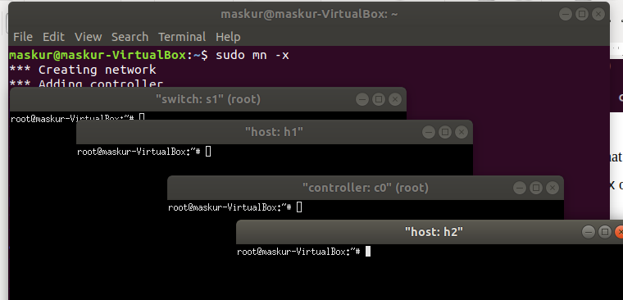

After a second, the xterms will pop up, with automatically set window names.
Alternately, we can bring up additional xterms as shown below.
By default, only the hosts are put in a separate namespace; the window for each switch is unnecessary (that is, equivalent to a regular terminal), but can be a convenient place to run and leave up switch debug commands, such as flow counter dumps.
Xterms are also useful for running interactive commands that we may need to cancel, for which we’d like to see the output.
For example:
In the xterm labeled “switch: s1 (root)”, run:
dpctl dump-flows tcp:127.0.0.1:6634
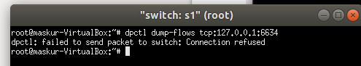

Nothing will print out; the switch has no flows added. To use dpctl with other switches, start up mininet in verbose mode and look at the passive listening ports for the switches when they’re created.
Now, in the xterm labeled “host: h1”, run:

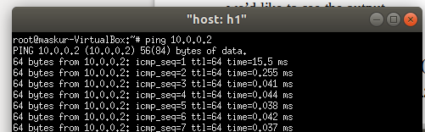

Other Switch Types
Other switch types can be used. For example, to run the user-space switch:
$ sudo mn --switch user --test iperf
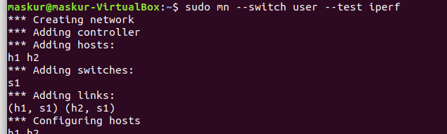
Note the much lower TCP iperf-reported bandwidth compared to that seen earlier with the kernel switch.
If we do the ping test shown earlier, we should notice a much higher delay, since now packets must endure additional kernel-to-user-space transitions. The ping time will be more variable, as the user-space process representing the host may be scheduled in and out by the OS.
On the other hand, the user-space switch can be a great starting point for implementing new functionality, especially where software performance is not critical.
Another example switch type is Open vSwitch (OVS), which comes preinstalled on the Mininet VM. The iperf-reported TCP bandwidth should be similar to the OpenFlow kernel module, and possibly faster:
$ sudo mn --switch ovsk --test iperf
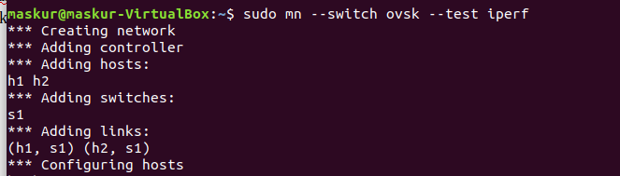

Mininet Benchmark
To record the time to set up and tear down a topology, use test ‘none’:
$ sudo mn --test none
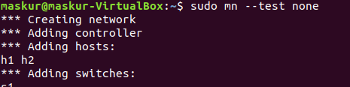

Everything in its own Namespace (user switch only)
By default, the hosts are put in their own namespace, while switches and the controller are in the root namespace. To put switches in their own namespace, pass the --innamespace option:
$ sudo mn --innamespace --switch user
Instead of using loopback, the switches will talk to the controller through a separately bridged control connection. By itself, this option is not terribly useful, but it does provide an example of how to isolate different switches.
Note that this option does not (as of 11/19/12) work with Open vSwitch.
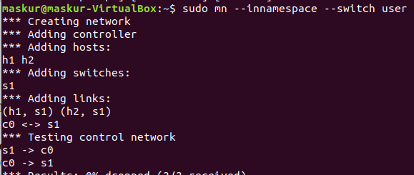

Part 3: Mininet Command-Line Interface (CLI) Commands

Display Options
To see the list of Command-Line Interface (CLI) options, start up a minimal topology and leave it running. Build the Mininet:
$ sudo mn
mininet> help
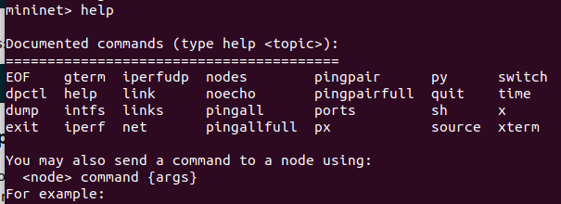

Python Interpreter
If the first phrase on the Mininiet command line is py, then that command is executed with Python. This might be useful for extending Mininet, as well as probing its inner workings. Each host, switch, and controller has an associated Node object.
At the Mininet CLI, run:
mininet> py 'hello ' + 'world'
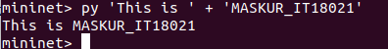

Print the accessible local variables:
mininet> py locals()
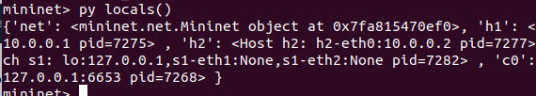
Next, see the methods and properties available for a node, using the dir() function:
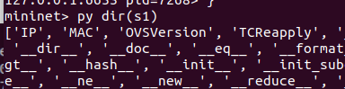
mininet> py dir(s1)

We can read the on-line documentation for methods available on a node by using the help() function: mininet> py help(h1) (Press "q" to quit reading the documentation.)
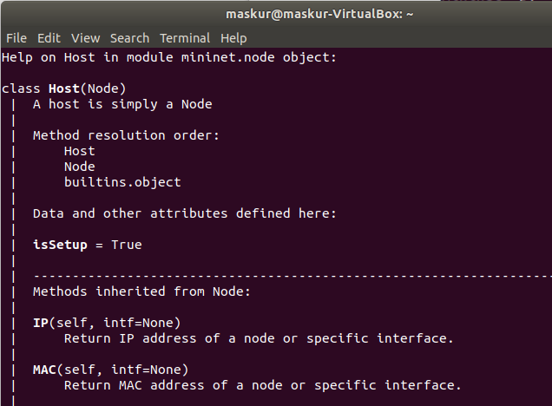
We can also evaluate methods of variables:
mininet> py h1.IP()
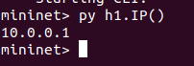

Link Up/Down
For fault tolerance testing, it can be helpful to bring links up and down.
To disable both halves of a virtual ethernet pair:
mininet> link s1 h1 down
To bring the link back up:
mininet> link s1 h1 up

XTerm Display
To display an xterm for h1 and h2:
mininet> xterm h1 h2

Part 4: Python API Examples

SSH daemon per host
One example that may be particularly useful runs an SSH daemon on every host:
$ sudo ~/mininet/examples/sshd.py
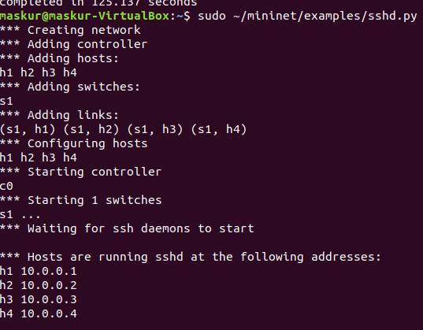
Exit SSH example mininet:
$ exit
Conclusion: Few days ago I was downloaded and try to run some basic command in mininet and today Alhamdulillah I have fully completed the walkthrough using mininet taking help from mininet.org

