Data Visualization: Assignment 4

Student 1: Bartosz Maślanka. 144091

Student 2: Kajetan Kubik. 145451

**Design**

**Dashboard name and purpose**

Stock-App

Displaying information about cryptocurrencies, and crypto-market.

**Tasks solved using the dashboard**

1. Comparing how different cryptocurrencies contribute to different markets.
2. Checking how cryptocurrencies change value during different periods of times.
3. Checking how smaller crypto looks against Bitcoin.

**Sketches**

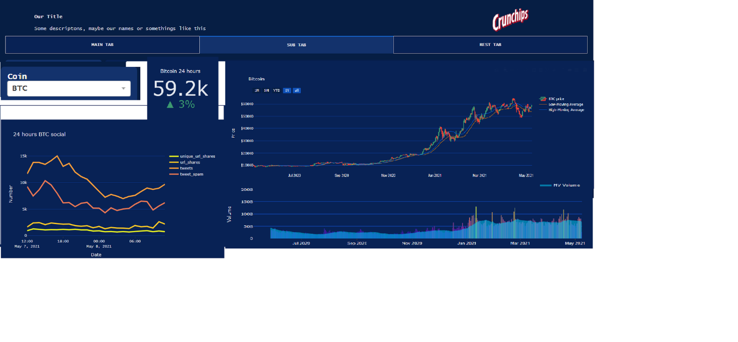

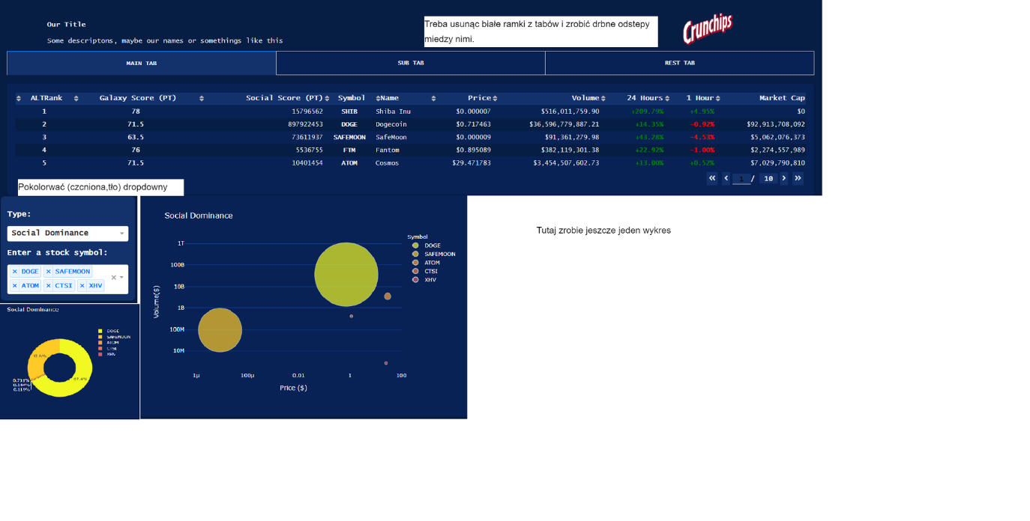

**Implementation**

**Screenshots**

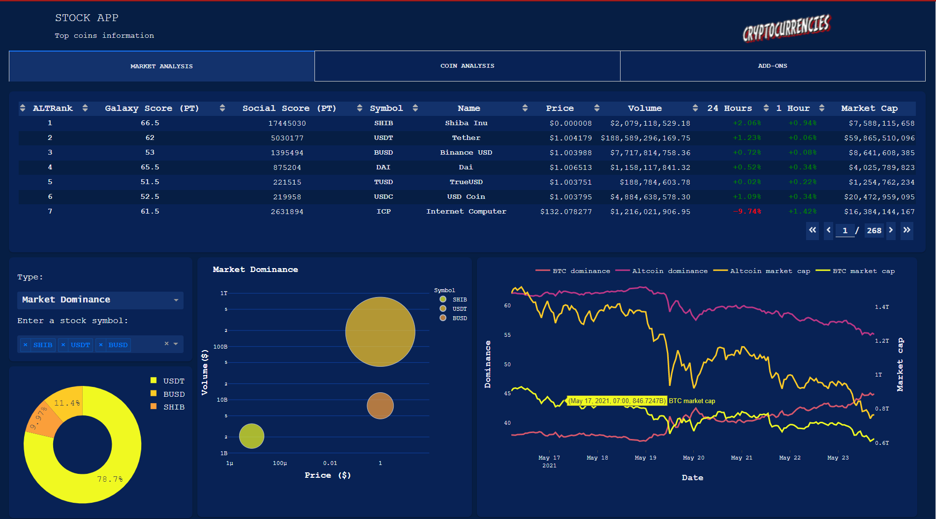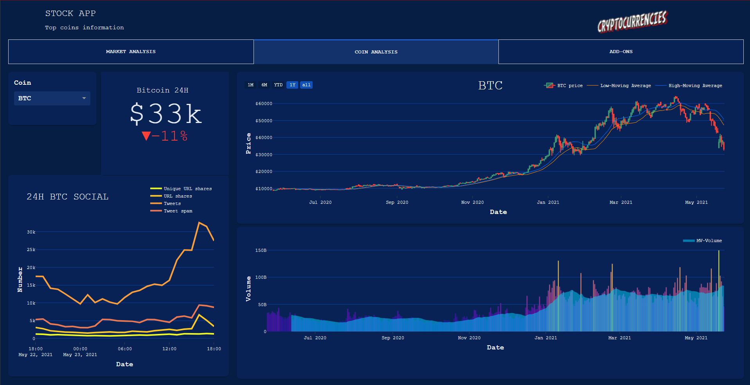

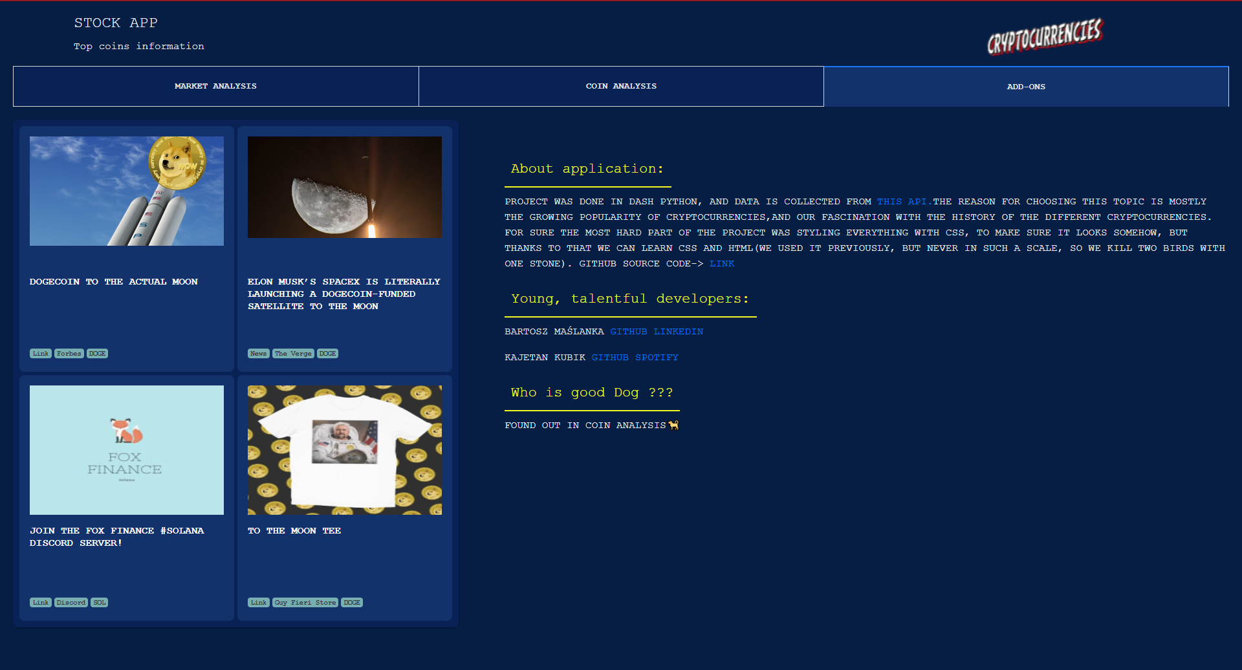

**Github**

<https://github.com/maslana146/StockApp>

**Link to live demo**

<https://crypto-stock-app.herokuapp.com/?fbclid=IwAR20Wt6Tb96YXfpjw7FirShBEvWaXsWSe0oVT5r5X-WxDZAxsBHQemLy5pI>