Colour Correction Pipeline Evaluation
Device Comparison: CSVS00 vs CSVS01
Internship Report — Colour Deviation Analysis
task 2

Dataset | CSVS_Color / PEPPER / 5 mars
Devices | CSVS00 vs CSVS01
Conditions | CC (colour-correction) vs NOCC (no correction / raw)
Pepper colours | ORANGE · RED · YELLOW
Total pairs | 209 (ORANGE: 44 · RED: 76 · YELLOW: 89)
Metrics | ΔE2000 mean ΔE2000 Median

1. Objective
The objective of this task was to restructure the dataset separating the photos taken on the 4th and 5th of march and then design and implement a complete colour consistency analysis pipeline to evaluate the chromatic deviation between the devices across two acquisition conditions: with colour correction applied (CC) and without colour correction (NOCC) and to extract features , patterns from our data that can help us understand where the deviation come from , how can we fix it and finally to evaluate the color correction pipeline
Two imaging devices CSVS00 and CSVS01 used to photograph pepper samples of three colour categories ( ORANGE, RED, YELLOW ). Even when pointed at identical objects, two cameras produce different colour values because of differences in their sensors, white balance algorithms, and internal processing pipelines. This introduces a systematic deviation between devices that directly affects any colour-based quality assessment, grading, or sorting task.

.

This study answers four specific questions:

Q1 | Is there a measurable colour deviation between CSVS00 and CSVS01?
Q2 | Does applying colour correction (CC) reduce this deviation?
Q3 | Is the CC pipeline good enough or does it need improvement?
Q4 | What specific improvements could make the pipeline more effective?

2. Dataset Overview
The dataset, structured under the path CSVS_Color/PEPPER/5 mars, contains 209 matched image pairs distributed across multiple ripeness classes per colour.

5 mars / {COLOR} / {CONDITION} / CSVS00 or CSVS01 / {CLASS} / image files

Colour | Classes | NOCC pairs | CC pairs | Total pairs
ORANGE | 3, 5, 7, 8 | 22 | 22 | 44
RED | 1 – 9 | 38 | 38 | 76
YELLOW | 1 – 9 | 45 | 44 | 89
TOTAL | – | 105 | 104 | 209

The global descriptive statistics across all 209 pairs and both conditions are:

Metric | Count | Mean | Std | Min | 25% | 50% | 75% | Max
ΔE mean | 209 | 2.766 | 1.264 | 0.179 | 1.893 | 2.643 | 3.407 | 7.903
ΔE Median | 209 | 3.325 | 1.387 | 1.280 | 2.412 | 3.147 | 3.909 | 9.433

Overall assessment from notebook: Good — perceptible on inspection (global mean ΔE mean = 2.766). This means that on average, a trained observer could notice the colour difference between the two devices under controlled conditions, but it would not be obvious to a casual observer.

3. Executive Summary
The core metric is ΔE2000 (CIEDE2000, ISO 11664-6), computed in CIE L*a*b* space in two formulations mean (single ΔE between mean LAB vectors) and Median (middle value of a per-pixel ΔE map) to capture both global and spatial colour deviation.
Since both devices photographed the same pepper samples in the same sequential order, images are matched by their alphabetical position within each class folder the Nth image of CSVS00 is paired with the Nth image of CSVS01, regardless of filename.
The full pipeline was implemented as a modular Jupyter notebook, covering parallel ΔE computation, per-colour charts, LAB channel distribution analysis, CC vs NOCC scatter plots with Pearson correlation, box plots per class, and interactive 3D LAB visualisations. Results were decomposed along the three LAB channels (ΔL*, Δa*, Δb*) to identify which physical property lightness, red-green balance, or blue-yellow balance drives the residual deviation, and translated into targeted calibration improvement recommendations.

Overall assessment: Good perceptible on inspection (mean ΔE mean = 2.766 across all pairs and conditions)

The four headline findings from the notebook output are:

- CC reduces deviation for all three colour categories. For ORANGE, RED, and YELLOW the mean ΔE mean decreases after correction, confirming that the CC pipeline is working in the right direction.
- RED responds best to CC. RED peppers show the largest absolute improvement: ΔE mean drops from 2.474 (NOCC) to 1.484 (CC), a 40% reduction, landing in the 'Very Good' perceptual range.
- YELLOW remains the hardest to correct. After CC, YELLOW mean ΔE mean is 3.012 still in the 'Moderate / perceptible' zone indicating the correction is less effective for yellow hues.
- The relationship between CC and NOCC deviations is linear for YELLOW (r = 0.862) but weak for ORANGE (r = 0.248), meaning CC does not consistently fix the same pairs across all colours.

Colour | ΔE mean NOCC | ΔE mean CC | Improvement | ΔE Median NOCC | ΔE Median CC
ORANGE | 3.928 | 2.255 | −1.673 ↓ | 4.688 | 2.791
RED | 2.474 | 1.484 | −0.990 ↓ | 3.020 | 2.074
YELLOW | 3.536 | 3.012 | −0.524 ↓ | 4.073 | 3.489
GLOBAL | 3.234 | 2.294 | −0.940 ↓ | 3.821 | 2.825

3. Methodology

3.1 The ΔE2000 Metric
All measurements use ΔE2000 (CIEDE2000, ISO 11664-6), the international standard for quantifying colour difference as the human eye perceives it. The formula operates in CIE L*a*b* colour space, which is perceptually uniform a ΔE difference of 2 always represents the same perceived size regardless of which colour is being measured.

ΔE2000 | Perception | Practical meaning
< 1 | Imperceptible | Devices are indistinguishable ideal calibration
1 – 2 | Expert only | Trained observer under controlled lighting notices
2 – 3 | Perceptible | Visible under close side-by-side inspection
3 – 6 | Moderate | Clearly visible, affects quality decisions
6 – 12 | Poor | Large gap, sorting results differ between devices
> 12 | Unacceptable | Devices must be recalibrated

3.2 Two ΔE Variants

ΔE mean Computes the mean LAB colour vector of the entire image first, then applies ΔE2000 once between those two vectors. Produces one number per pair. Fast and comparable to published literature. Can be misleading if two very different colours average to the same mean.

ΔE Median Computes ΔE2000 independently at every pixel, producing a full spatial deviation map, then returns the middle value (median) of that map. More robust to outlier pixels (highlights, shadows, reflections) and captures spatial variation that mean misses.

When mean ≈ Median the deviation is spatially uniform. When mean > Median significantly, a minority of pixels are pulling the average up. In this dataset, Median is consistently higher than mean (e.g. ORANGE NOCC: mean 3.928 vs Median 4.688), indicating that the average LAB colour is more similar than typical pixel-level deviations the correction acts more on the global shift than on localised colour differences.

3.3 Preprocessing & Pair Matching
Every image is loaded with OpenCV (BGR→RGB), normalised to float [0,1], downscaled if its longest edge exceeds 512 px, then converted to CIE L*a*b* space via skimage. All ΔE computations happen in LAB space only never in RGB, which is device-dependent.

Pairs are matched by sorted alphabetical position within each class folder: image #N in CSVS00/class_k is paired with image #N in CSVS01/class_k regardless of filename. Where CSVS00 has more images than CSVS01 in a class, the minimum count is used and surplus images are noted in the audit table.

5. Results

5.1 Global ΔE Distribution — Before and After CC
The global KDE (Kernel Density Estimate) plot overlays four smoothed distribution curves across all 209 pairs: ΔE mean NOCC, ΔE mean CC, ΔE Median NOCC, ΔE Median CC. The key observation is that both CC curves sit clearly to the left of their NOCC counterparts, confirming a global reduction in deviation after colour correction.

Metric | Before CC (NOCC) | After CC | Reduction
ΔE mean — mean | 3.234 | 2.294 | −0.940 (−29%)
ΔE Median — mean | 3.821 | 2.825 | −0.996 (−26%)

The distribution shapes also narrow slightly under CC, suggesting that correction not only shifts the average down but also reduces the spread of deviations across pairs.

5.2 Per-Colour Results — ΔE per Class (Cells 9–11)
For each of the three pepper colours, a 4-panel chart was produced showing: mean ΔE per class with CC vs NOCC side by side, KDE distributions for both metrics and both conditions, scatter of individual pair ΔE values over the pair index, and a box plot comparing mean vs Median across conditions.

ORANGE
ORANGE has 4 classes (3, 5, 7, 8) and 44 total pairs. It shows the largest absolute improvement from CC.

Class | mean CC | mean NOCC | Diff | Median CC | Median NOCC
3 | 2.59 | 3.25 | −0.66 | – | –
5 | 2.37 | 2.73 | −0.36 | – | –
7 | 2.27 | 2.96 | −0.69 | – | –
8 | 1.70 | 6.15 | −4.45 | – | –
Overall | 2.255 | 3.928 | −1.673 | 2.791 | 4.688

Key observation for ORANGE: Class 8 stands out with a dramatic reduction from 6.15 to 1.70 after CC a 72% improvement. Without CC, class 8 sits in the 'Clearly different' zone (ΔE > 6). After CC it drops to 'Very Good'. The scatter plot (bottom-left panel) shows NOCC pairs (triangles) scattered well above CC pairs (circles), confirming consistent improvement.
The Pearson r of 0.248 (p = 0.266) is not statistically significant, meaning there is no reliable linear relationship between CC and NOCC deviations for ORANGE . The correction effect is inconsistent across pairs.
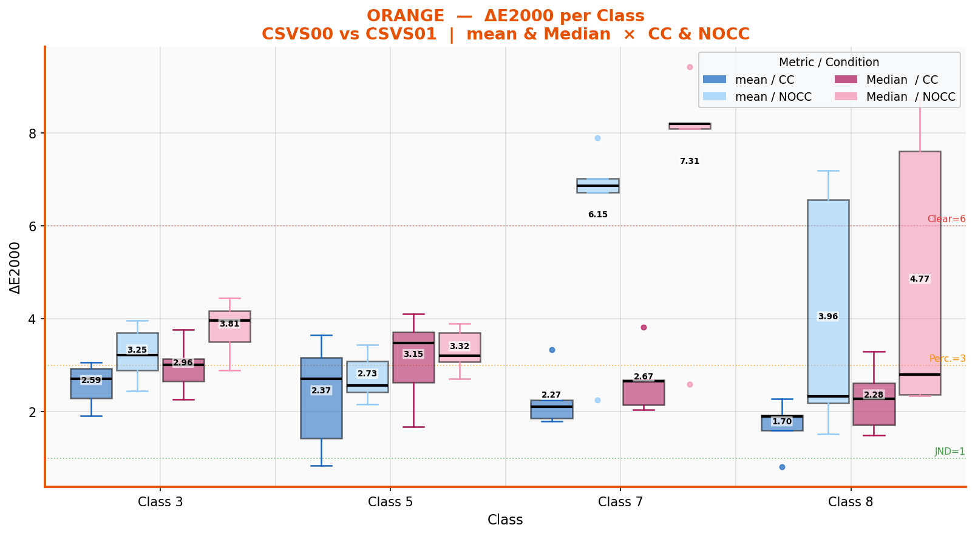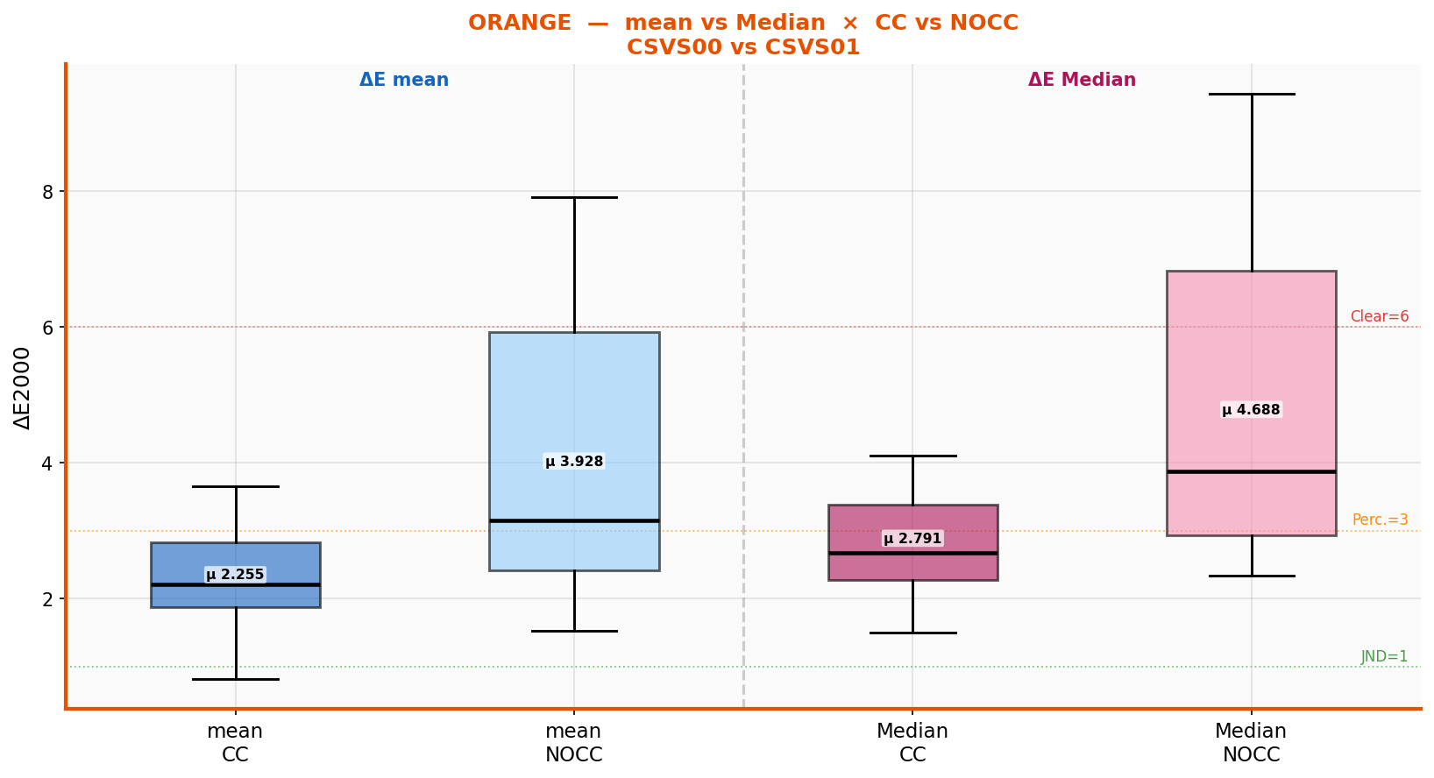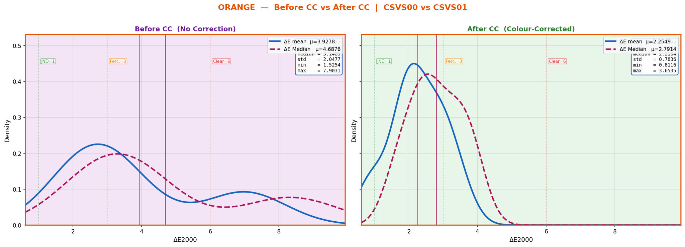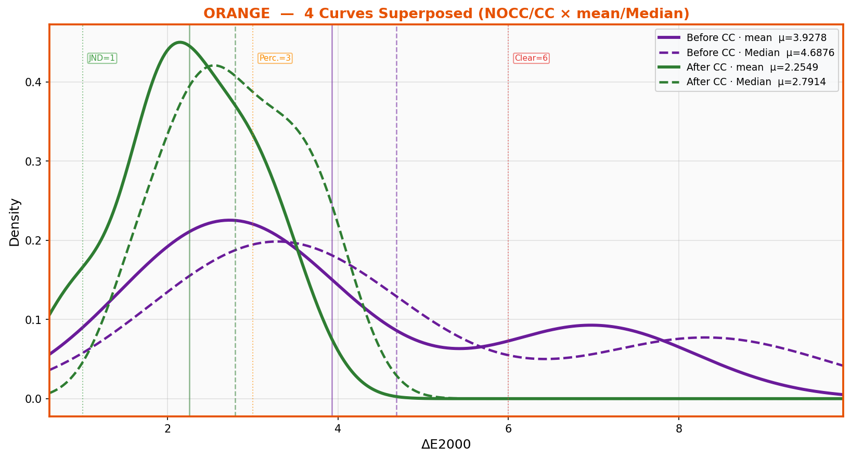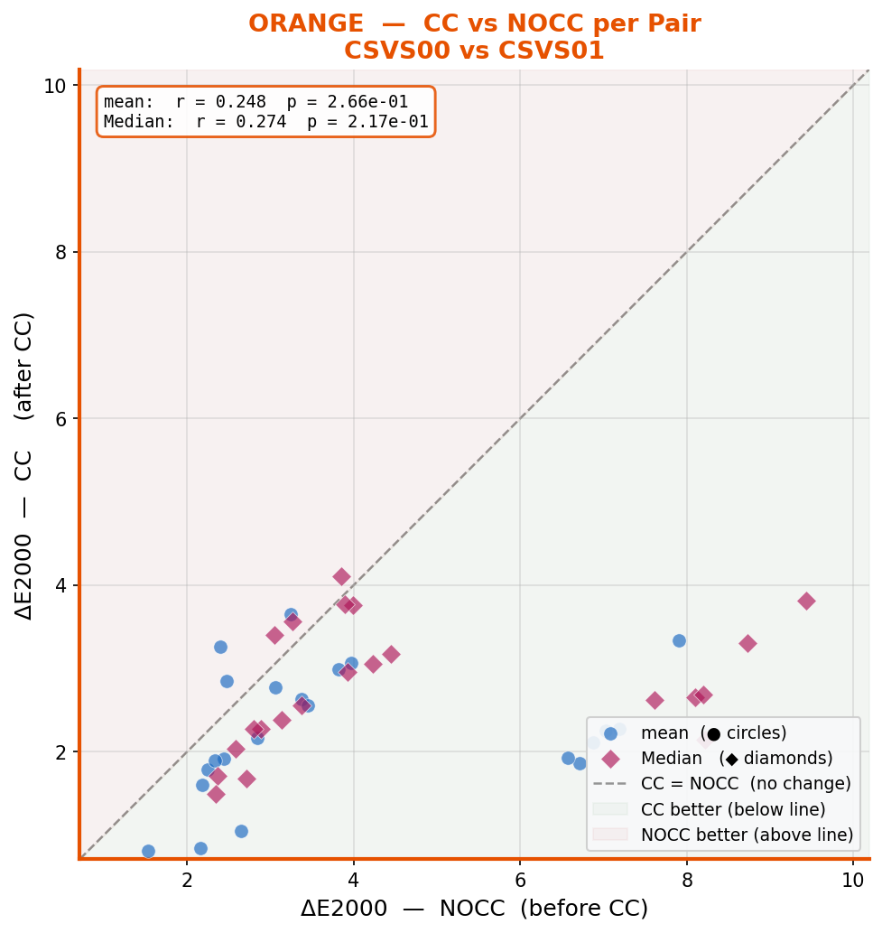

RED
RED has 9 classes (1–9) and 76 total pairs. It shows the most consistent and largest relative improvement.

Metric | Before CC (NOCC) | After CC | Reduction | Pearson r CC | Pearson r Median
ΔE mean | 2.474 | 1.484 | −0.990 (−40%) | r = 0.541 | –
ΔE Median | 3.020 | 2.074 | −0.946 (−31%) | – | r = 0.525

Key observation for RED: RED is the only colour category where the mean ΔE mean after CC (1.484) falls in the 'Very Good' zone (1–2), meaning only an expert observer under controlled lighting would notice the difference. The Pearson r of 0.541 (p < 0.001) shows a moderate correlation pairs that are difficult without CC tend to remain relatively more difficult with CC, but the correction consistently reduces all of them.
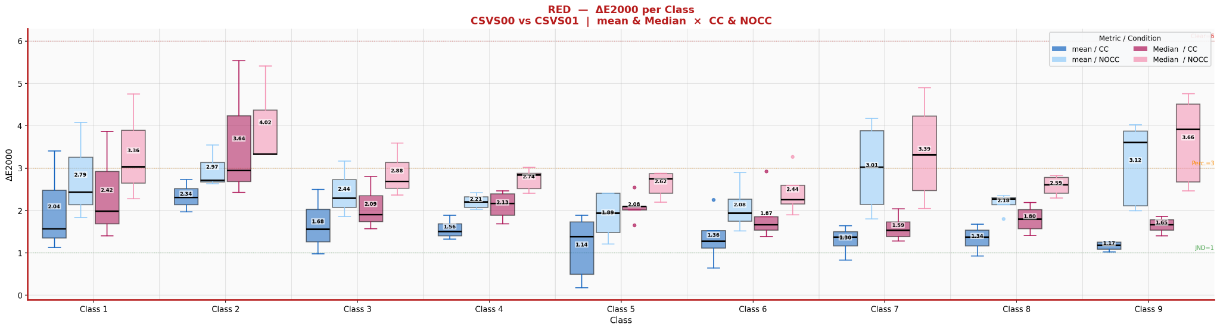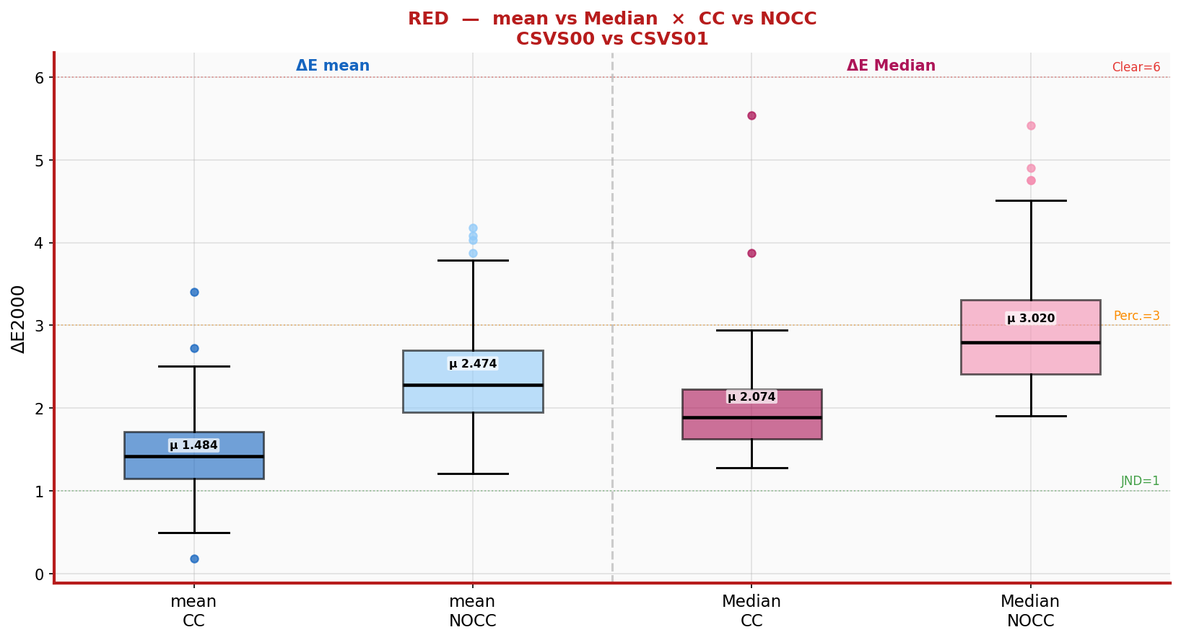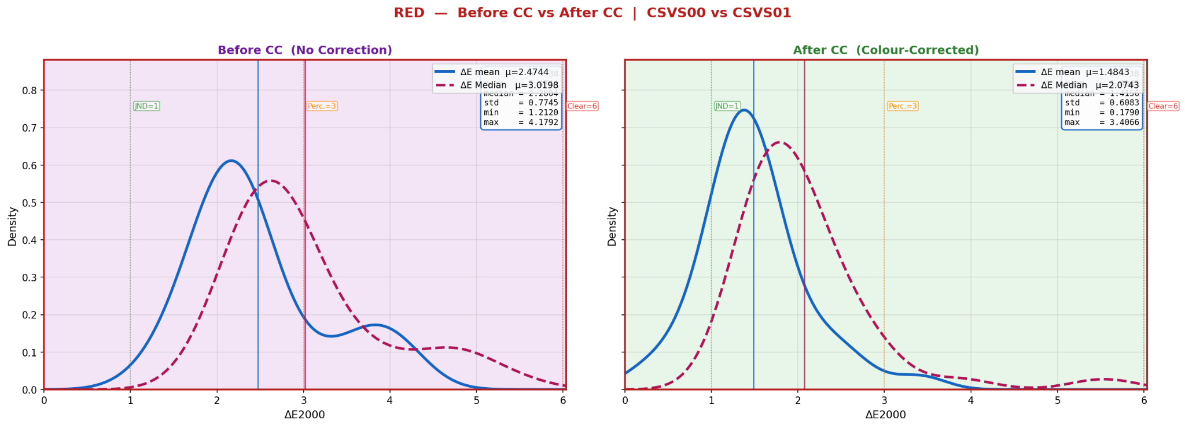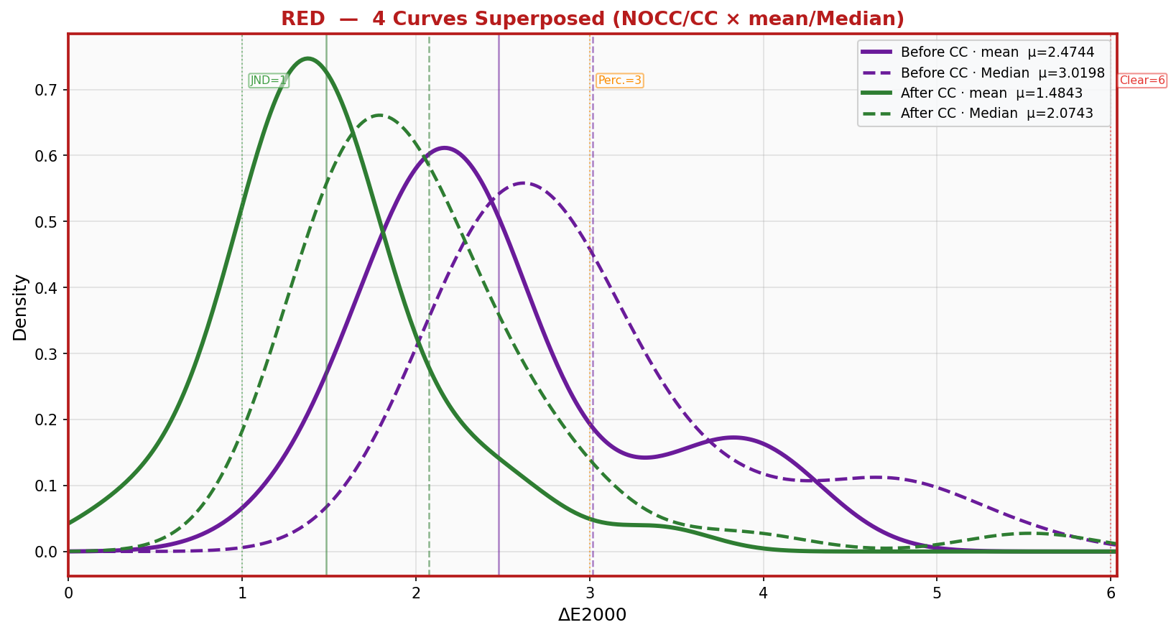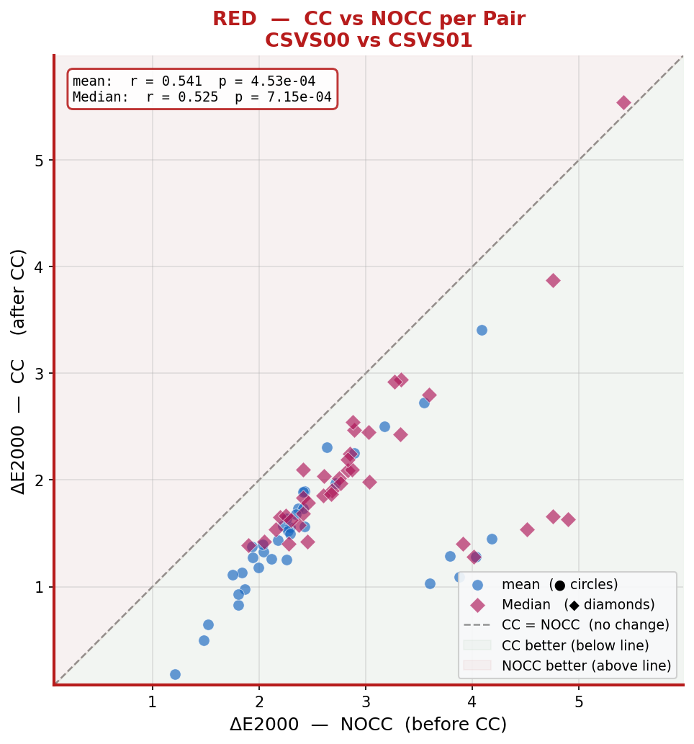

YELLOW
YELLOW has 9 classes (1–9) and 89 total pairs. It shows the smallest improvement and remains above the perceptibility threshold after CC.

Metric | Before CC (NOCC) | After CC | Reduction | Pearson r CC | Pearson r Median
ΔE mean | 3.536 | 3.012 | −0.524 (−15%) | r = 0.862 | –
ΔE Median | 4.073 | 3.489 | −0.584 (−14%) | – | r = 0.691

Key observation for YELLOW: YELLOW has the highest Pearson r (0.862, p < 1e-13), meaning the ranking of pairs is almost perfectly preserved by CC the correction is systematic and proportional, but its magnitude is insufficient. After CC, mean ΔE mean remains at 3.012, still in the 'Moderate / clearly perceptible' range. YELLOW is the colour category where further calibration improvement is most needed.
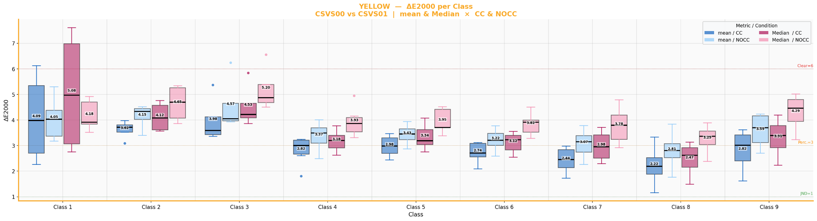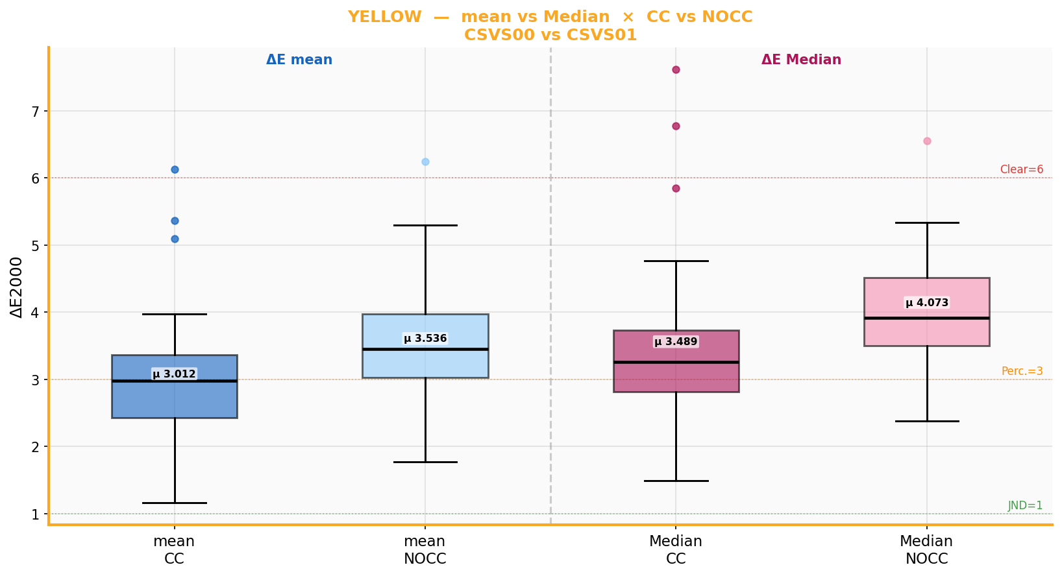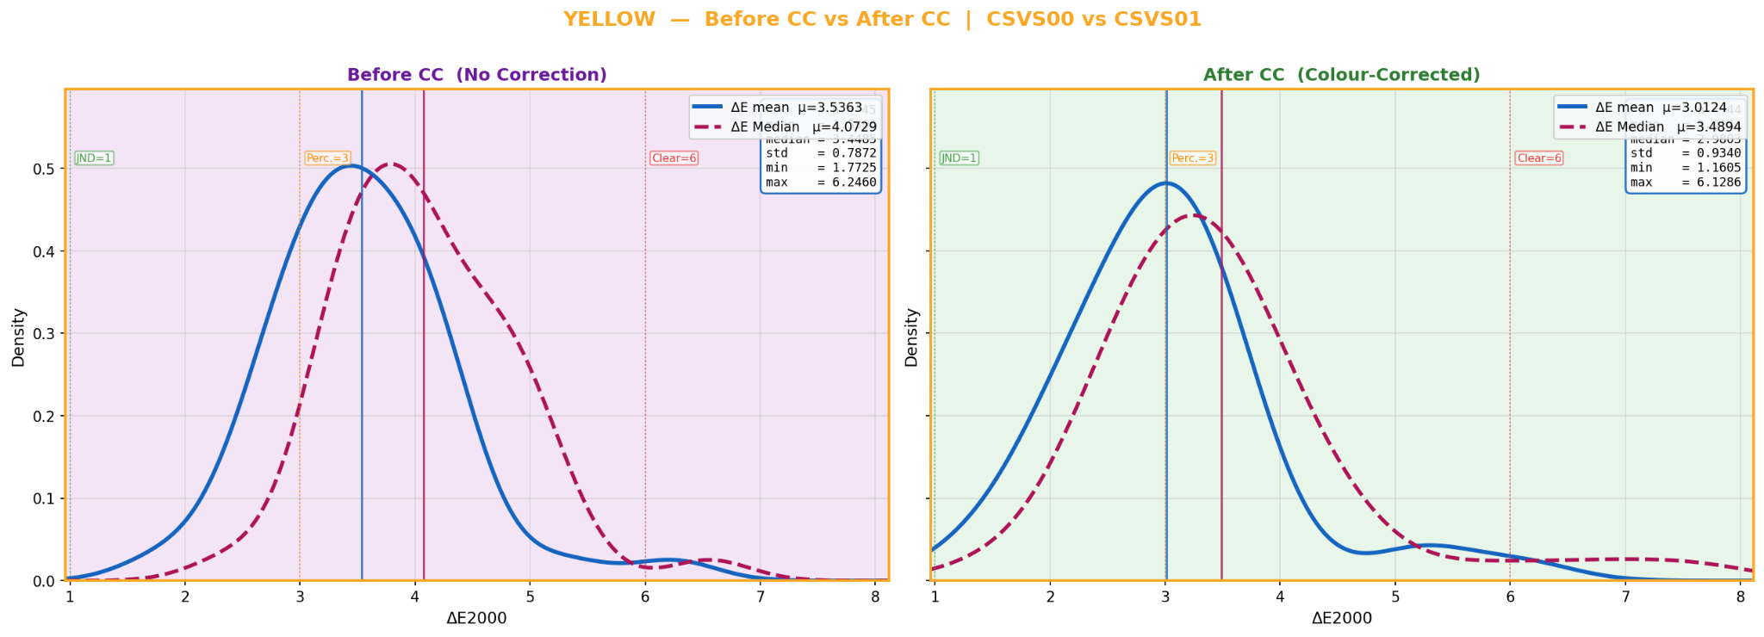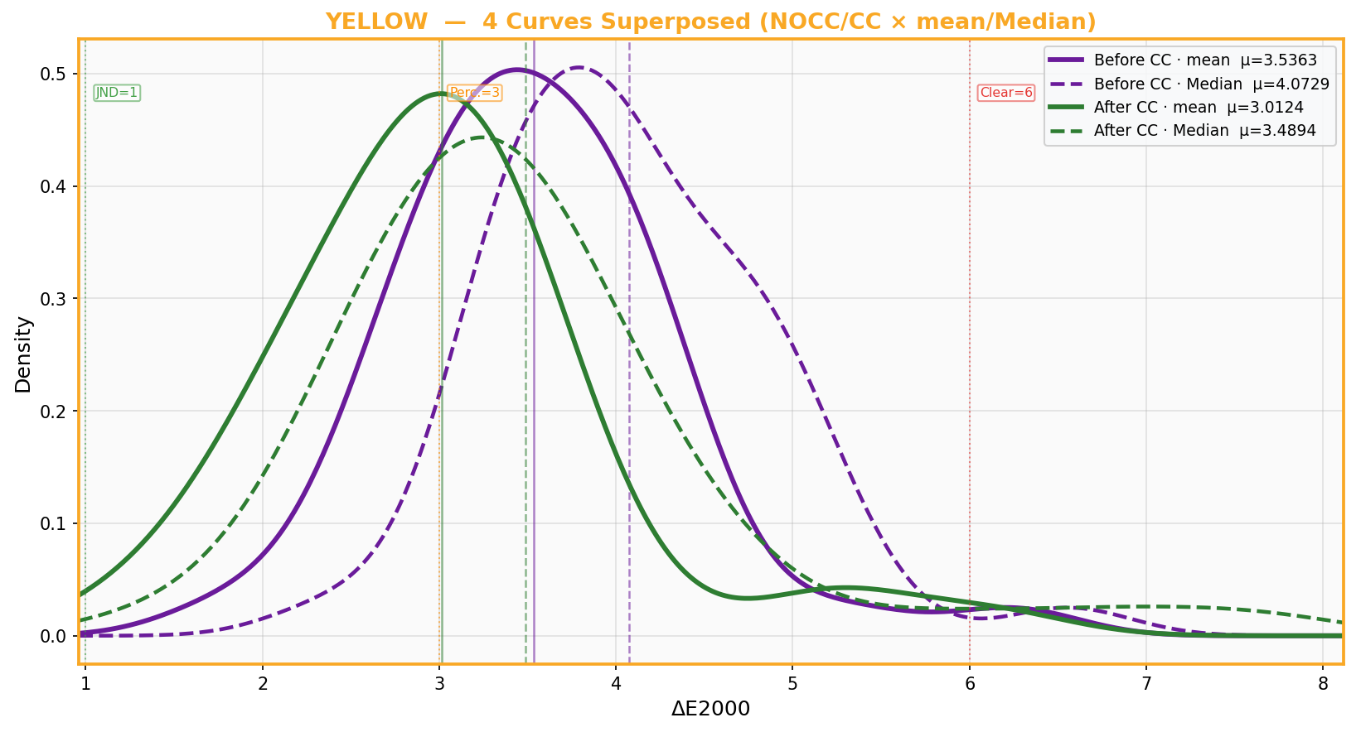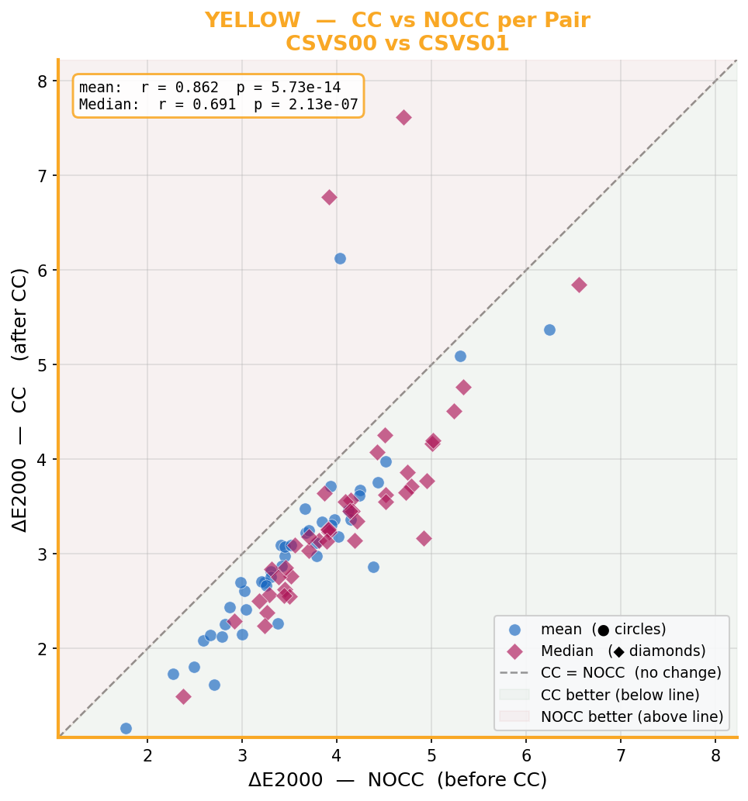

5.3 CC vs NOCC Scatter Plots (Cell 14)
Three scatter plots were produced, one per colour. Each dot represents one matched image pair. The X coordinate is its ΔE in the NOCC condition; the Y coordinate is its ΔE in the CC condition. The dashed diagonal is the reference line where CC = NOCC.

Points below the diagonal indicate CC improved that pair. Points above indicate CC made it worse.

Colour | mean Pearson r | mean p-value | Interpretation | Median r
ORANGE | 0.248 | 0.266 (not significant) | Weak linear relationship CC effect inconsistent across pairs | 0.274
RED | 0.541 | < 0.001 | Moderate CC consistently helps the same pairs | 0.525
YELLOW | 0.862 | < 1e-13 | Strong CC applies a nearly uniform shift to all pairs | 0.691
GLOBAL | 0.624 | < 1e-12 | Moderate overall correlation | –

The global scatter (all colours merged, r = 0.624) shows that pairs with high NOCC deviation tend to also have higher CC deviation, but CC consistently reduces the absolute value. The scatter cloud sits below the diagonal for all three colours, confirming that the CC pipeline helps on average.

5.4 ΔE Distribution Per Colour — Before and After CC (Cell 13)
For each colour category, three plots were produced on shared axes: Before CC (NOCC), After CC, and Both side by side. Shared axes make the visual shift directly readable a peak at the same ΔE value looks the same height across all three plots.

Colour | mean NOCC μ | mean CC μ | Median NOCC μ | Median CC μ | Shift
ORANGE | 3.928 | 2.255 | 4.688 | 2.791 | Large left shift clear improvement
RED | 2.474 | 1.484 | 3.020 | 2.074 | Large left shift best result
YELLOW | 3.536 | 3.012 | 4.073 | 3.489 | Moderate shift insufficient

The improvement arrows on the combined plot (right panel) show the signed difference for each colour. ORANGE and RED have clearly visible left-ward shifts with the distribution tightening after CC. YELLOW has a smaller shift and the distribution peak remains above ΔE = 3.
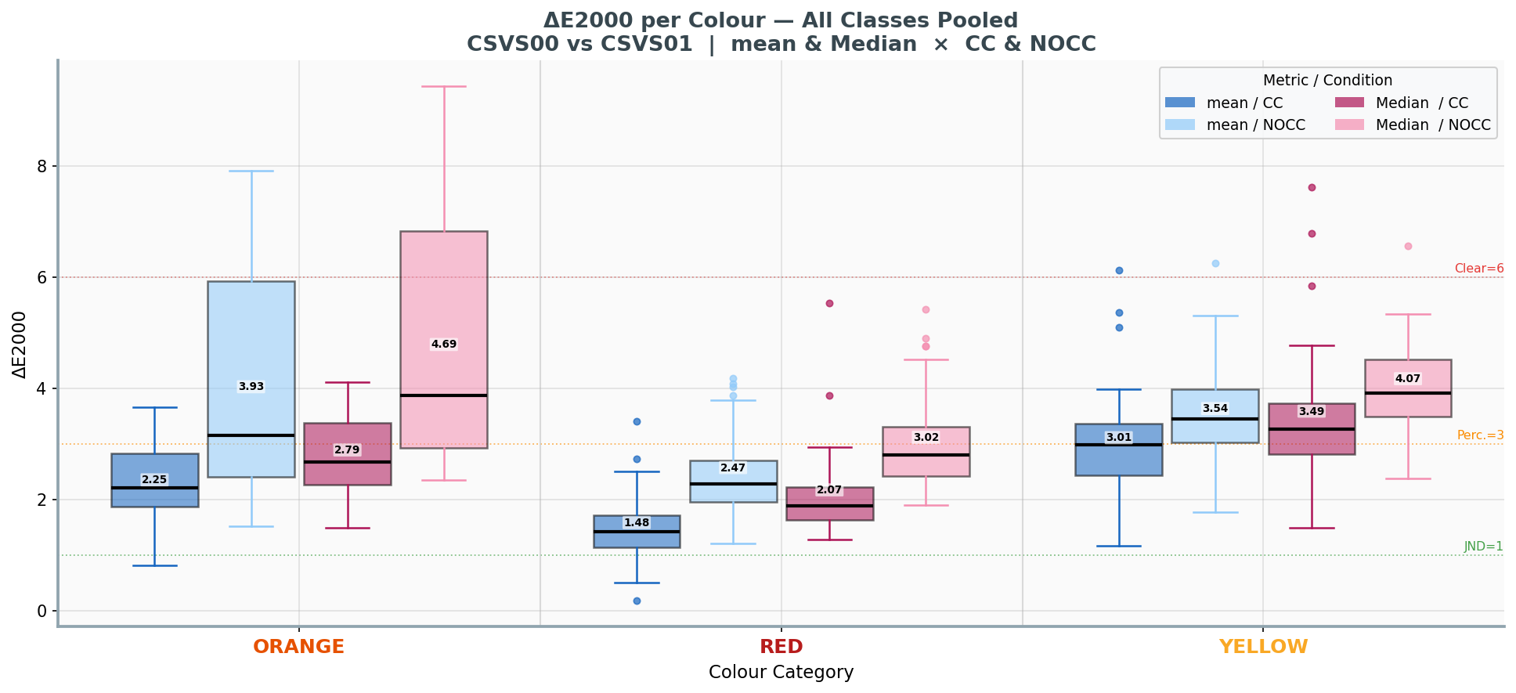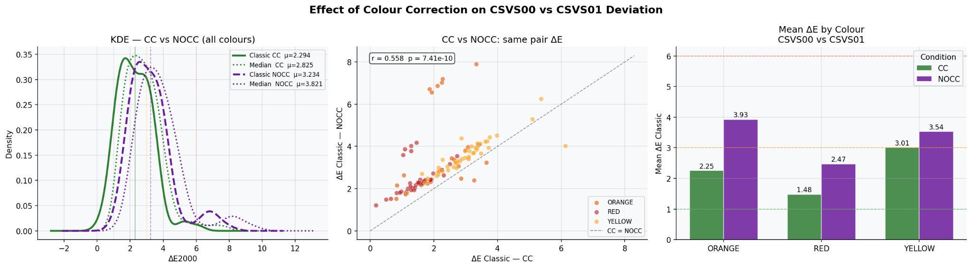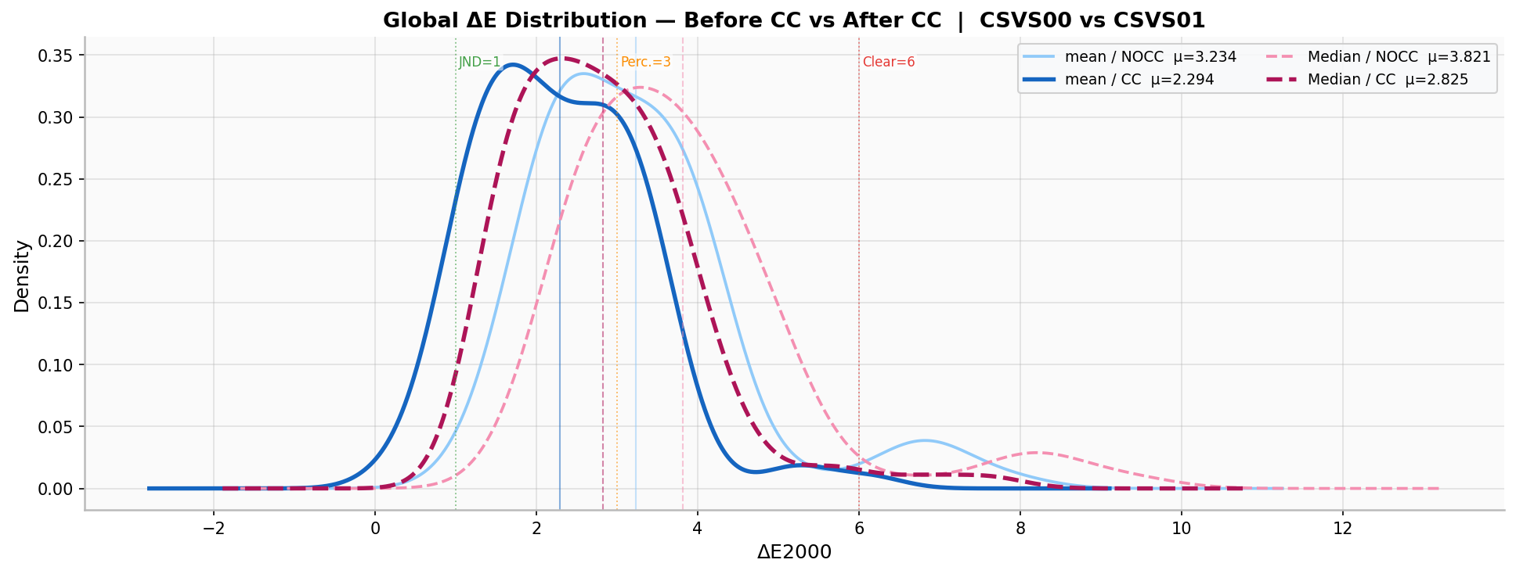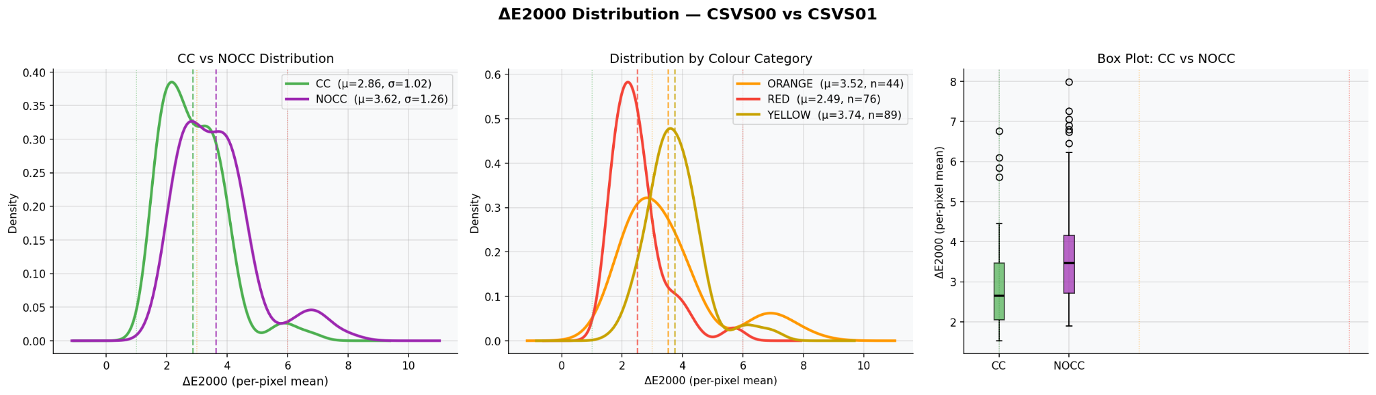
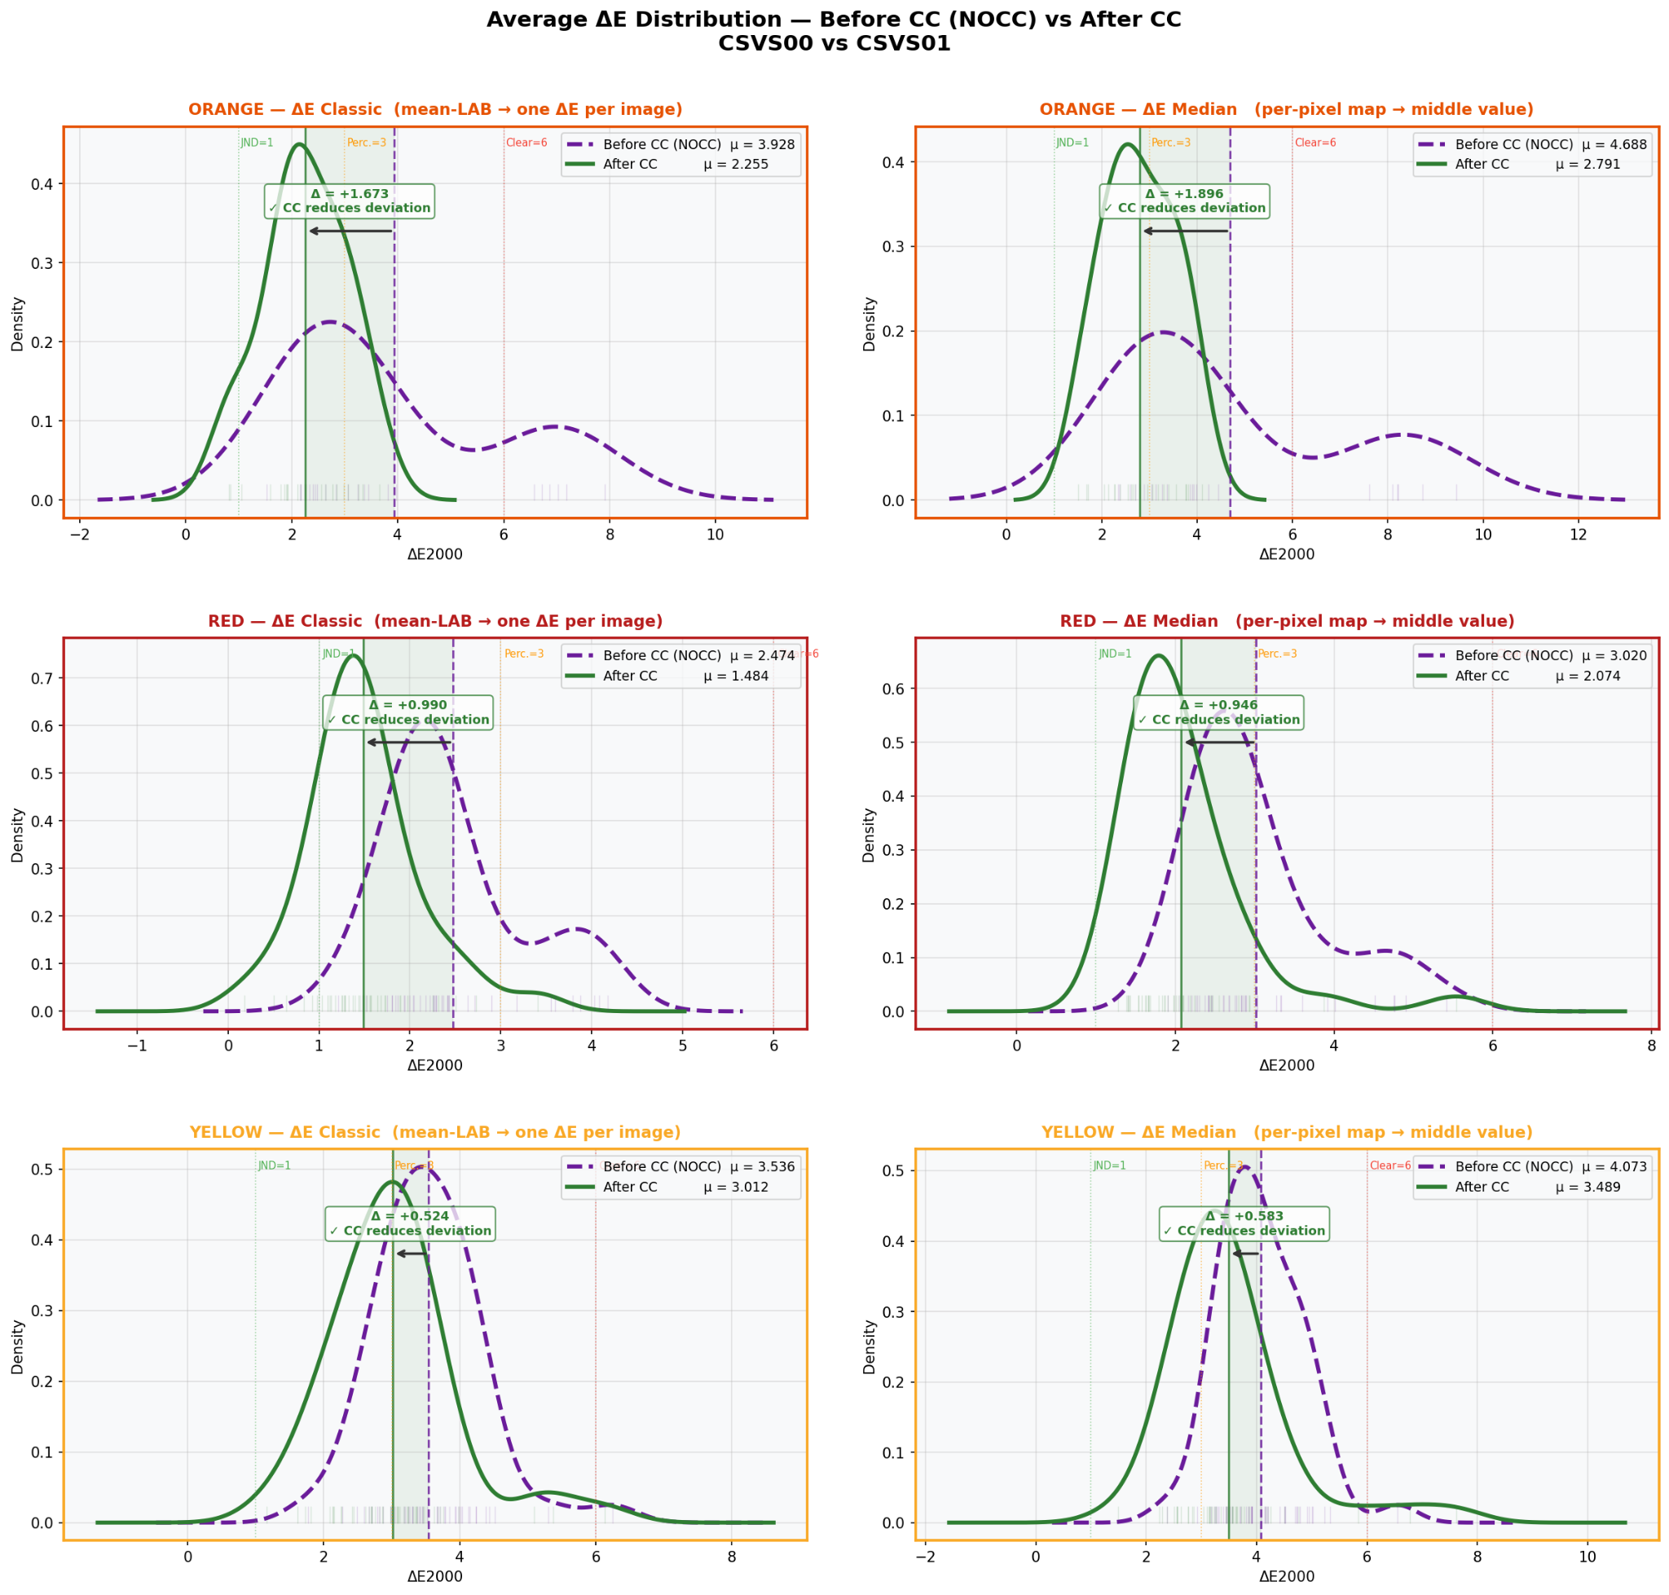

5.5 LAB Channel Distributions — Which Channel Drives the Deviation (Cell 12)
For each colour category, the L*, a*, and b* Channel distributions are plotted for all four groups: CSVS00 CC, CSVS00 NOCC, CSVS01 CC, CSVS01 NOCC. Arrows show how CC shifts each device. Gap labels quantify the distance between the two devices before and after correction.

ORANGE — Channel analysis
Channel | CSVS00 CC μ | CSVS01 CC μ | Gap NOCC | Gap CC | Interpretation
L* | 16.62 | 19.05 | −4.28 | −2.43 | CC reduces lightness gap by 43% CSVS00 darker
a* | 8.73 | 9.37 | −2.59 | −0.64 | CC almost closes the red-channel gap 75% reduction
b* | 18.33 | 20.79 | −3.49 | −2.46 | CC reduces yellow gap by 29% partial improvement

ORANGE finding: The a* (red-green) channel gap is almost entirely closed by CC (−2.59 → −0.64). The L* and b* channels still show residual gaps, explaining why ΔE after CC is still above 2. CSVS00 is systematically darker (ΔL* < 0) and less yellow (Δb* < 0) than CSVS01.
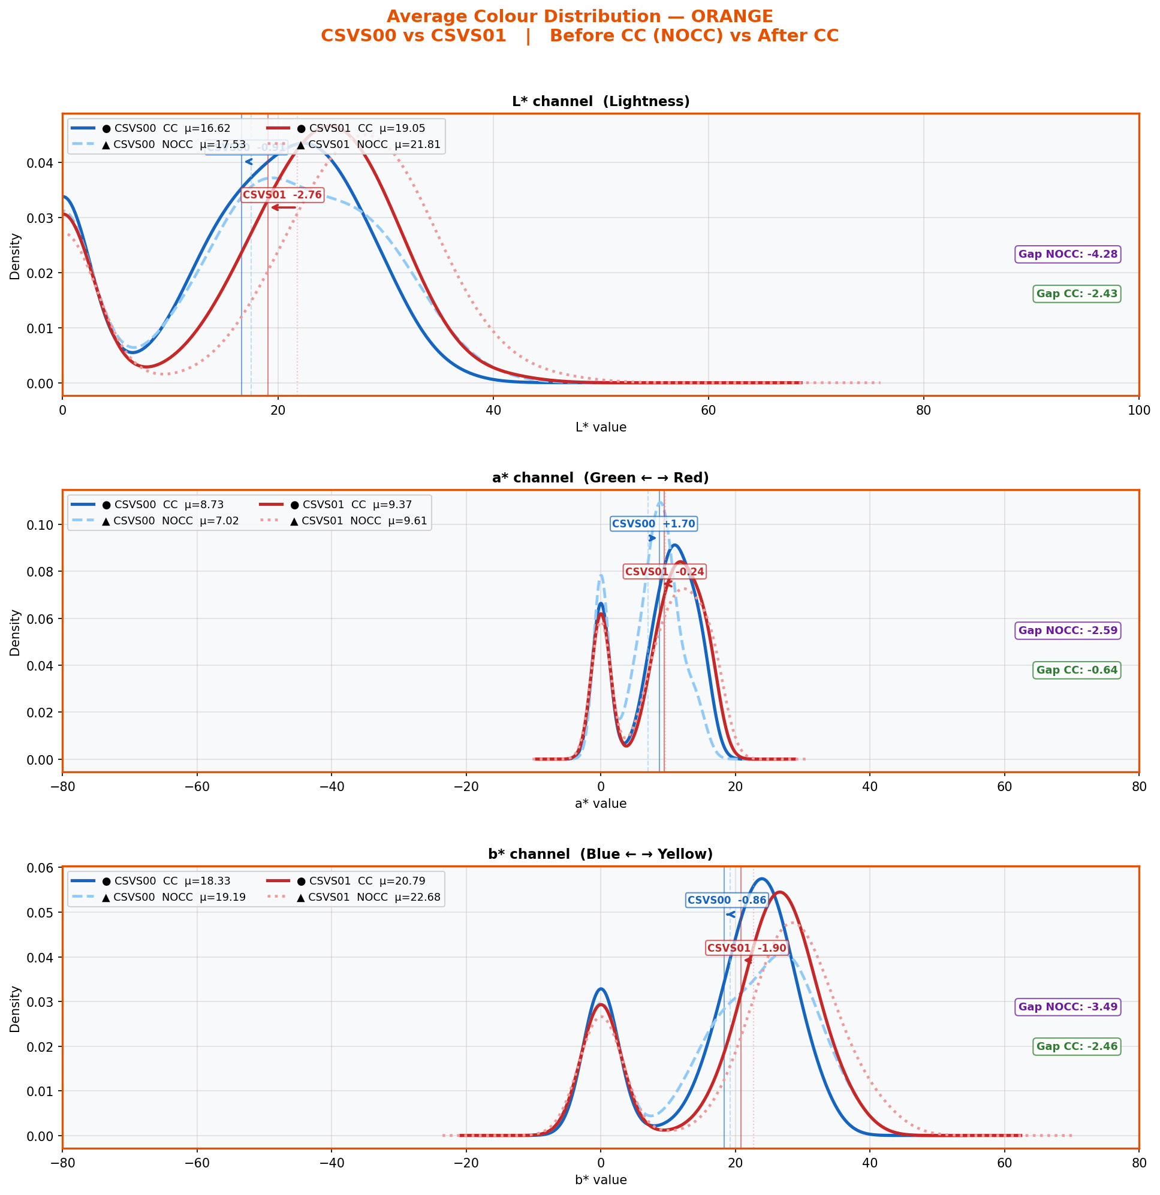

RED — Channel analysis
Channel | CSVS00 CC μ | CSVS01 CC μ | Gap NOCC | Gap CC | Interpretation
L* | 7.08 | 8.36 | −1.87 | −1.28 | CC reduces lightness gap by 31% residual remains
a* | 6.35 | 7.31 | −1.95 | −0.96 | CC reduces red channel gap by 51%
b* | 5.43 | 6.41 | −0.29 | −0.98 | b* gap INCREASES after CC minor overcorrection

RED finding — note on b* channel: The b* (blue-yellow) gap is very small before CC (−0.29) but becomes larger after CC (−0.98). This suggests a minor overcorrection on the yellow axis specifically for RED peppers. Despite this, the overall ΔE is still reduced because the L* and a* improvements outweigh the b* regression.
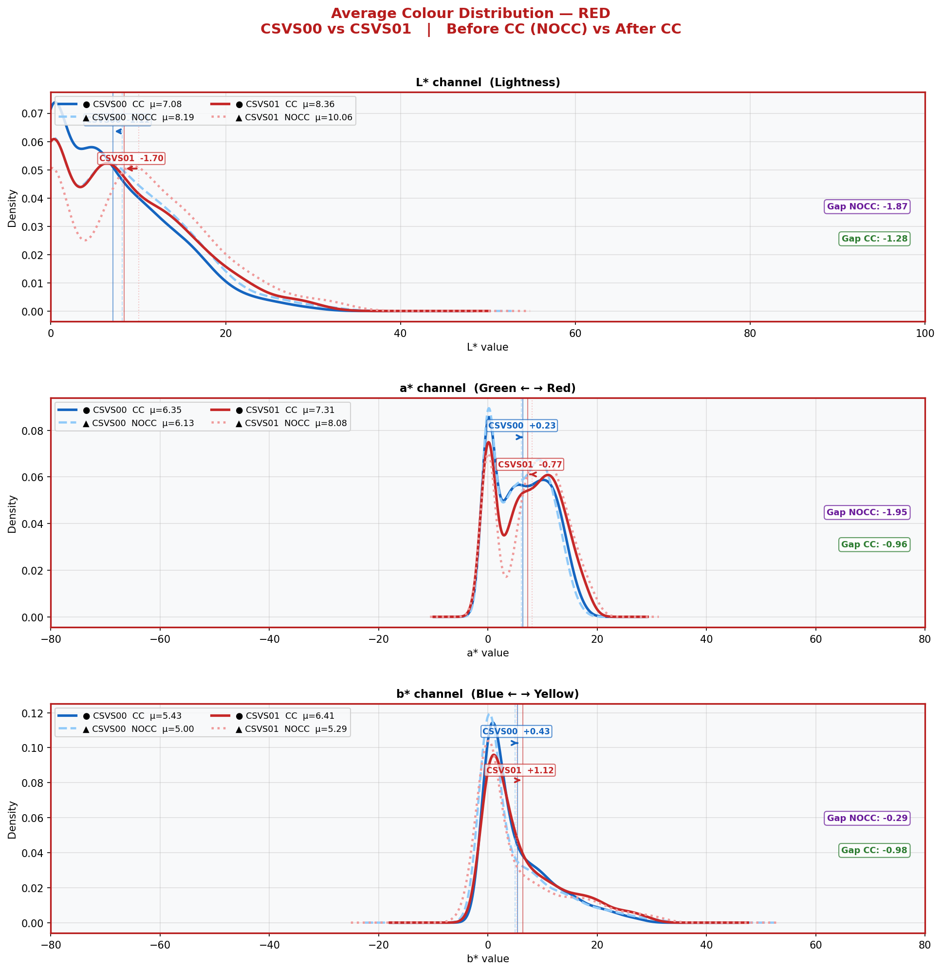

YELLOW — Channel analysis
Channel | CSVS00 CC μ | CSVS01 CC μ | Gap NOCC | Gap CC | Interpretation
L* | 23.15 | 26.78 | −4.02 | −3.63 | Small improvement large residual lightness gap
a* | 1.59 | 1.62 | −1.16 | −0.03 | CC nearly perfectly closes the a* gap
b* | 25.16 | 28.10 | −2.85 | −2.94 | b* gap slightly worse after CC minimal overcorrection

YELLOW finding: The dominant driver of YELLOW deviation is the L* channel CSVS00 captures yellow peppers as significantly darker than CSVS01 (gap of −3.63 even after CC). CC successfully closes the a* gap to near zero (−1.16 → −0.03) but barely affects L*. The remaining ΔE for YELLOW is almost entirely a lightness problem, not a hue problem.
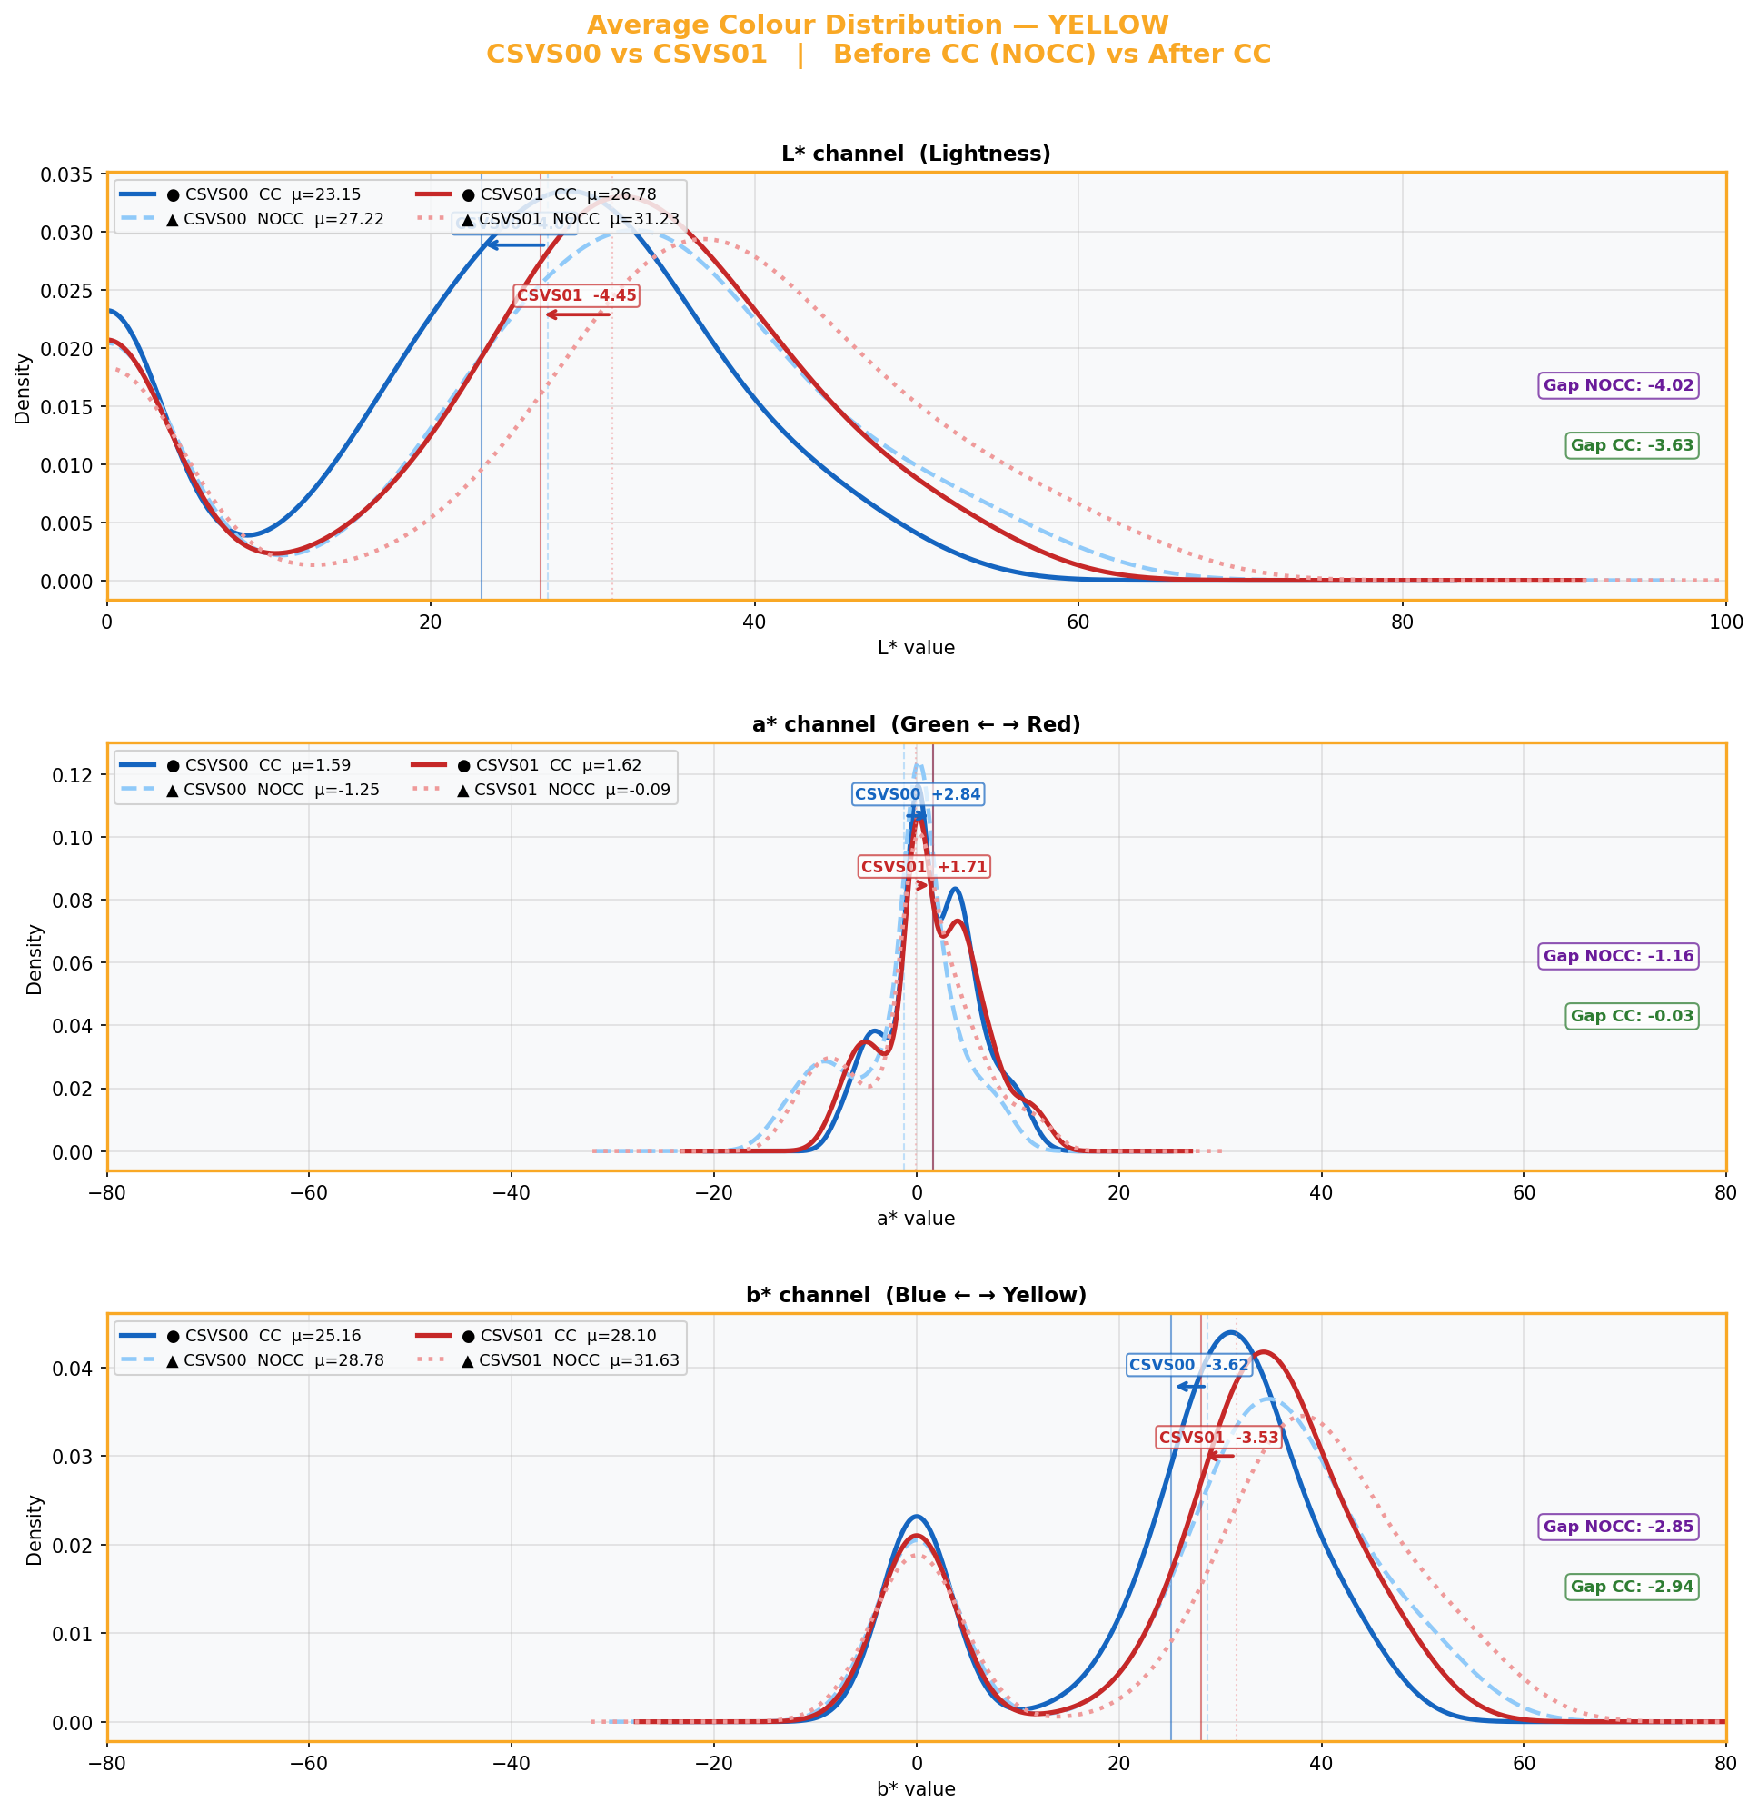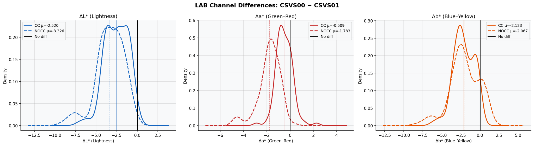

6. Answering the Key Questions

Q1 — Is there a measurable colour deviation between CSVS00 and CSVS01?

Answer: YES , clearly measurable. Before colour correction, mean ΔE mean is 3.928 for ORANGE, 2.474 for RED, and 3.536 for YELLOW. All three values exceed the perceptibility threshold of 2.0. The deviation is visible under close inspection and would affect colour-based quality classification.

The deviation is present in all three LAB channels (L*, a*, b*) for all colour categories , it is broad-spectrum, not limited to a single axis. CSVS00 is systematically darker (negative ΔL*) and less chromatic than CSVS01 across all colours, indicating a global sensor or calibration difference rather than a colour-specific issue.
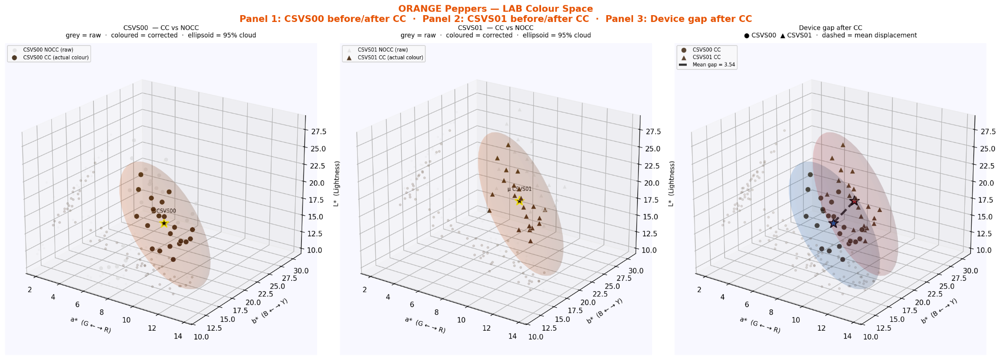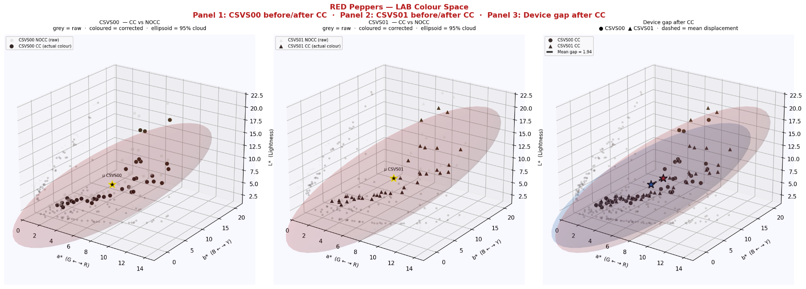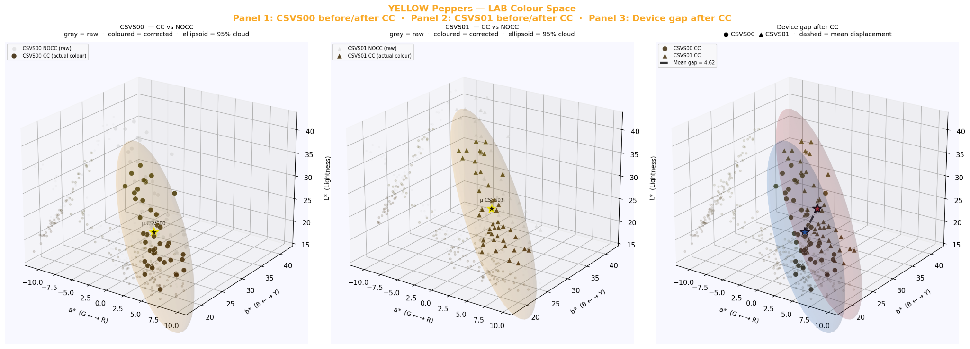

Q2 — Does colour correction reduce the deviation?

Answer: YES , CC reduces deviation for all three colours. Every colour category shows a negative change (CC < NOCC): ORANGE −1.673, RED −0.990, YELLOW −0.524 (ΔE mean). All scatter plots show the majority of dots below the CC = NOCC diagonal, confirming that CC helps more pairs than it hurts.

The reduction is however unequal. RED benefits most (−40%), ORANGE benefits significantly (−42%), while YELLOW benefits least (−15%). The CC pipeline is more effective for darker, more saturated colours than for the lighter, yellower hues.
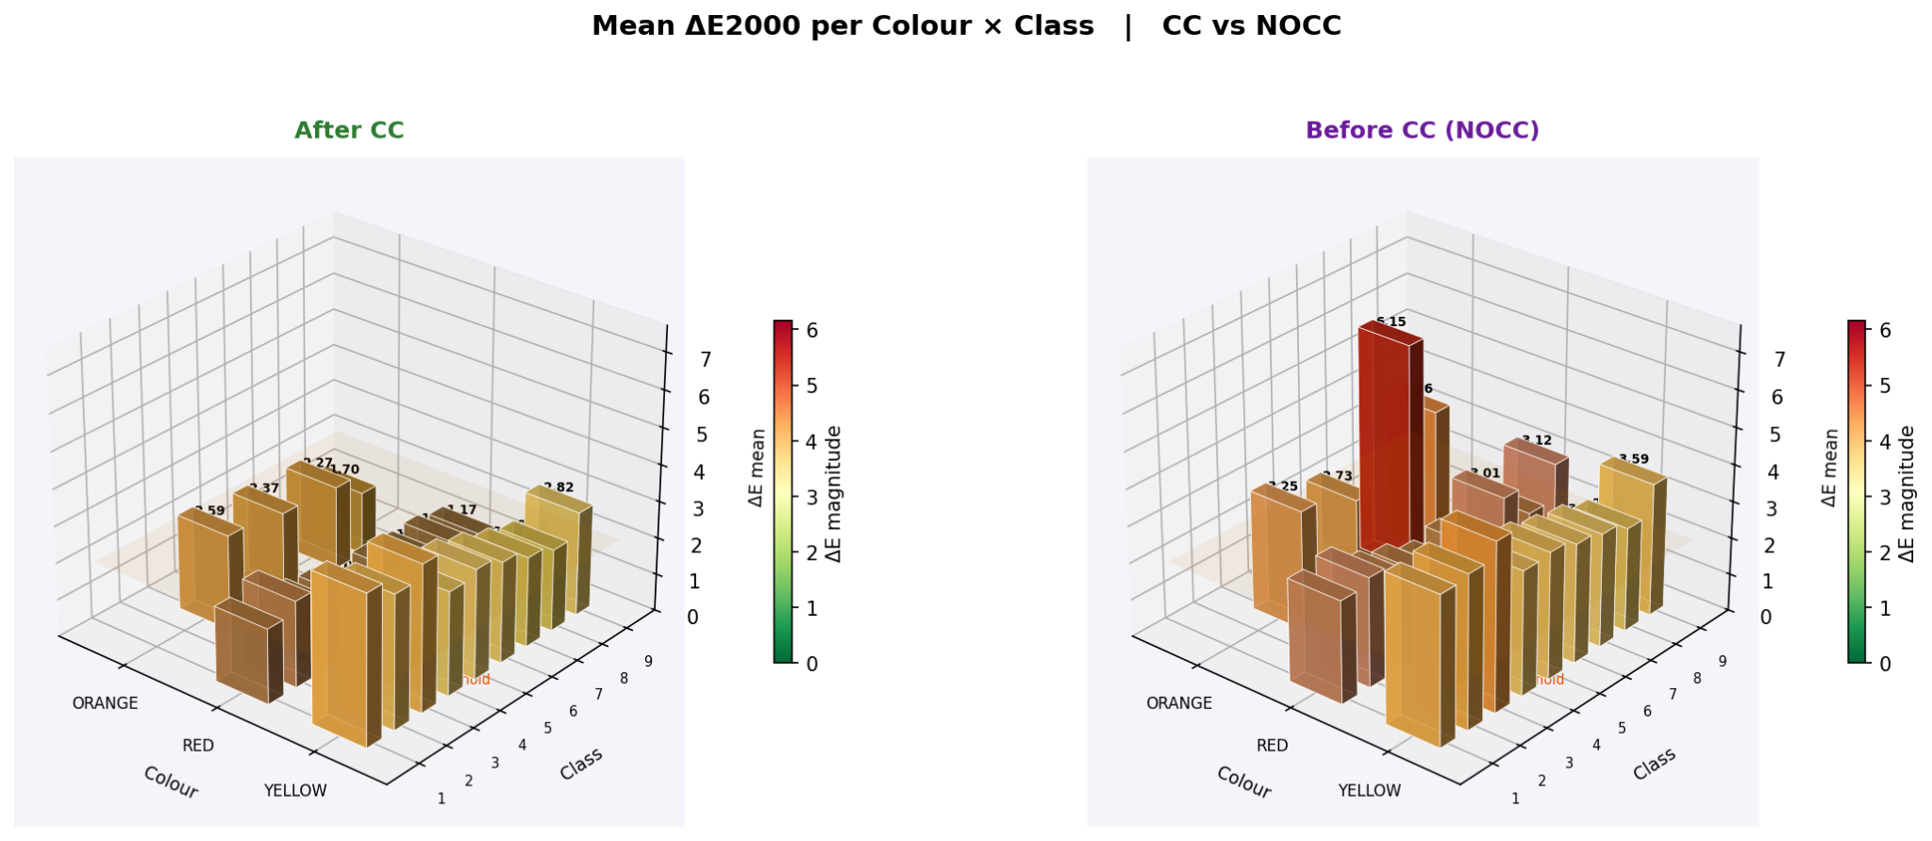

Q3 — Is the CC pipeline good enough?

Using the criterion that a satisfactory pipeline should bring mean ΔE mean below 2.0 with low variance:

Colour | ΔE mean CC | Target < 2.0 | Achieved? | Assessment
ORANGE | 2.255 | < 2.0 | Marginal | Just above threshold near-satisfactory
RED | 1.484 | < 2.0 | YES ✓ | Good in the 'Very Good' range
YELLOW | 3.012 | < 2.0 | NO ✗ | Still clearly perceptible needs improvement

Overall pipeline assessment: The CC pipeline is effective for RED and approaching satisfactory for ORANGE. It is insufficient for YELLOW, where the residual deviation (3.012) remains in the 'Moderate / clearly perceptible' zone. The pipeline needs targeted improvement specifically for YELLOW hues.
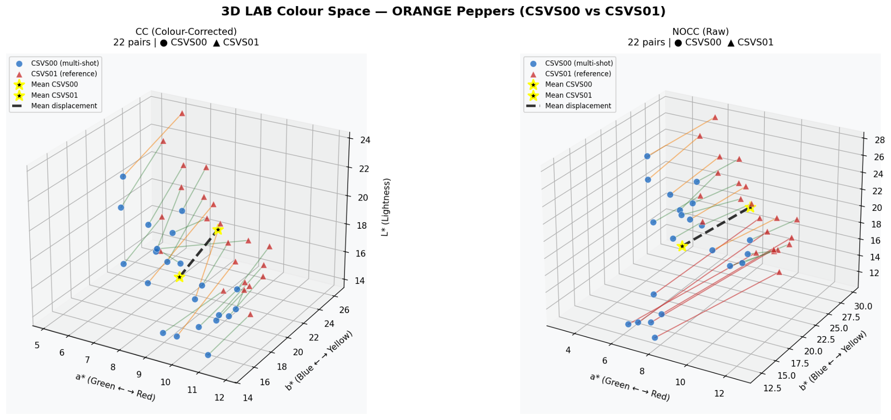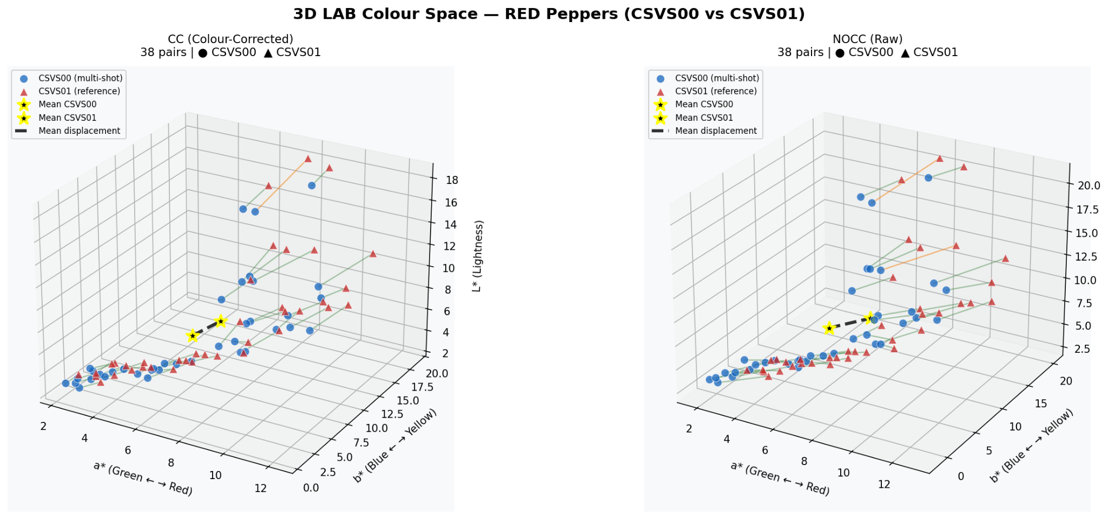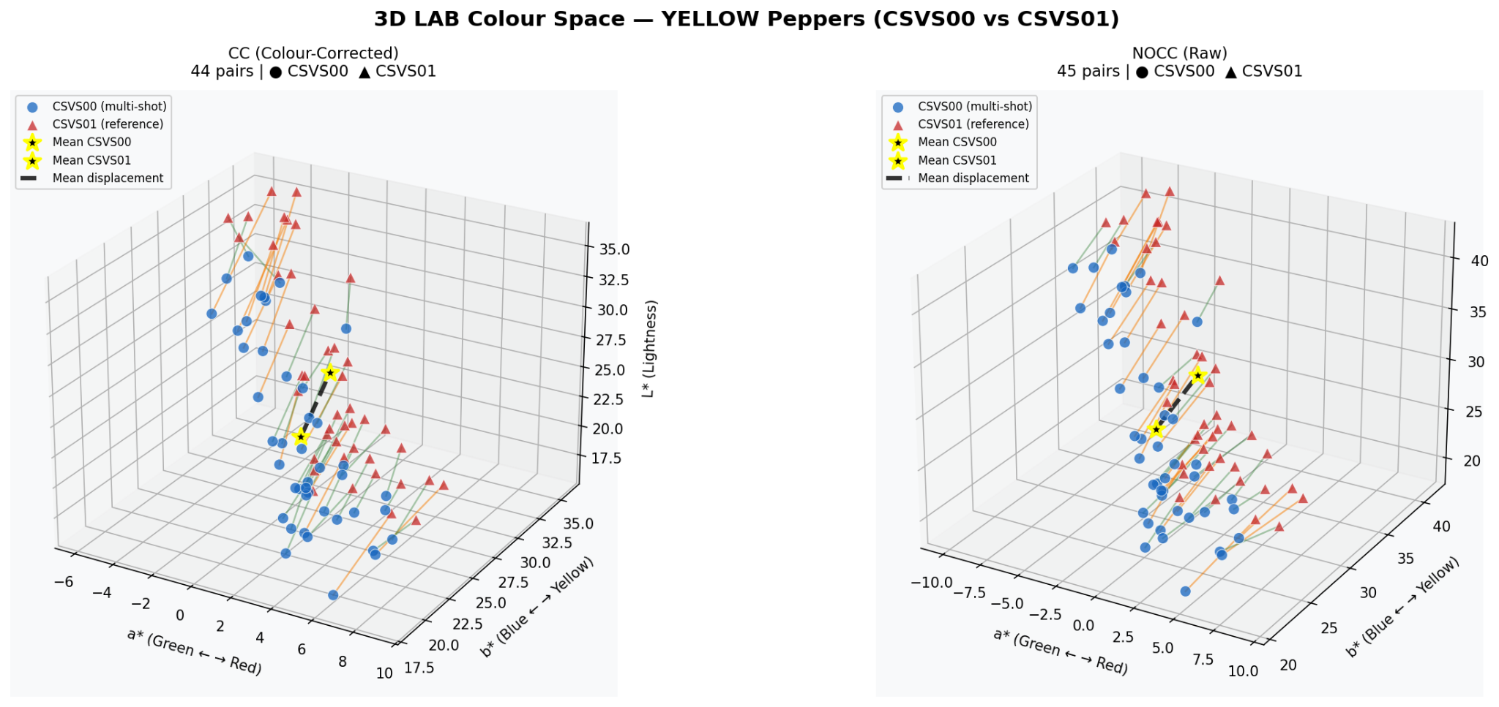

Q4 — What improvements would make the pipeline more effective?

The diagnostic evidence from the channel analysis points to three specific improvements:

1 Fix the L* (lightness) offset — highest priority
CSVS00 is darker than CSVS01 across all three colour categories after CC. The L* gap after correction is −2.43 (ORANGE), −1.28 (RED), and −3.63 (YELLOW). This is a systematic exposure bias that the current CC transform does not fully correct. The calibration target must include neutral grey patches across a wider luminance range to model the lightness transfer function accurately.

2 Expand calibration coverage for YELLOW hues
YELLOW peppers have b* values around 25–32, which is substantially higher than ORANGE (~18–20) and RED (~5–6). If the calibration target does not include patches at high b* values, the CC transform will be poorly constrained for this region of LAB space. Adding certified yellow calibration patches (e.g. Munsell 5Y) would directly address the YELLOW shortfall.

3 Address the b* overcorrection in RED
The b* channel gap for RED increases after CC (from −0.29 to −0.98). Although the overall RED ΔE is still reduced, this overcorrection suggests the correction matrix has a cross-channel coupling issue for the red-yellow region. Recomputing the calibration matrix with more RED pepper samples, or using a class-specific correction matrix for RED, would resolve this.

7. Decision Framework
The table below maps each observable pattern from the notebook to a conclusion and a recommended action.

Observation | Conclusion | Recommended action
NOCC mean ΔE 2–4 (all ) | Moderate device gap CC needed | CC is necessary; pipeline exists and works
CC mean < NOCC ( all ) | CC reduces deviation globally | Evaluate per-colour is ΔE < 2 achieved?
RED CC mean = 1.484 | Excellent for RED | Maintain current calibration for RED
ORANGE CC mean = 2.255 | Near threshold marginal | Fine-tune calibration; monitor over time
YELLOW CC mean = 3.012 | Still perceptible insufficient | Priority for improvement: lightness + b*
Large ΔL* after CC (all ) | Exposure bias persists | Add neutral grey patches to calibration target
b* gap grows after CC for RED | Minor b* overcorrection | Adjust RED calibration matrix or add RED patches
YELLOW a* gap ≈ 0 after CC | a* correction is excellent for YELLOW | Focus on L* and b* improvements only for YELLOW
ORANGE Pearson r = 0.248 (low) | Inconsistent pair-level correction | Check capture conditions; may need per-session calibration
YELLOW Pearson r = 0.862 (high) | Highly consistent but insufficient scale | Correction is systematic increase its magnitude

8. Conclusion
This analysis successfully quantifies the colour deviation between devices CSVS00 and CSVS01 across 209 matched image pairs on a pepper dataset, using the ΔE2000 standard in two formulations (mean and Median).

The main conclusions are:

- A real and measurable deviation exists between the two devices before correction. The global mean ΔE mean (NOCC) of 3.234 is in the 'Moderate clearly perceptible' zone.
- CC reduces the deviation for all three colour categories, bringing the global mean to 2.294 a 29% improvement.
- The pipeline performs well for RED (ΔE CC = 1.484, 'Very Good') and adequately for ORANGE (ΔE CC = 2.255, just above threshold).
- YELLOW remains problematic after CC (ΔE CC = 3.012), primarily due to a persistent L* lightness gap between the two devices that the current calibration does not correct.
- Three targeted improvements are recommended:
(1) address the systematic L* offset with wider grey-patch coverage in the calibration target
(2) add yellow-specific patches for YELLOW calibration
(3) correct the b* overcorrection in the RED calibration matrix

