**How Web Works?**

By: Masoud Rahman

## [**Clients and servers**](https://developer.mozilla.org/en-US/docs/Learn/Getting_started_with_the_web/How_the_Web_works#clients_and_servers)

Computers connected to the web are called **clients** and **servers**. A simplified diagram of how they interact might look like this:

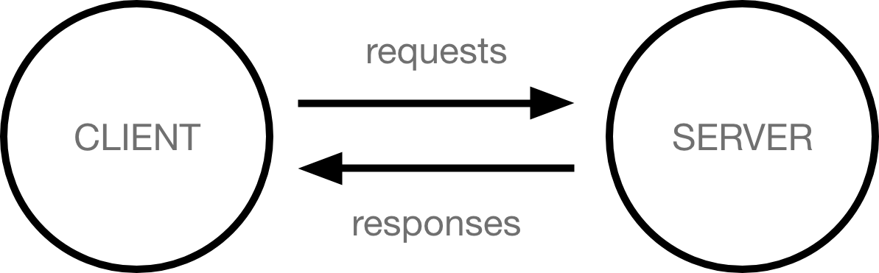

* Clients are the typical web user's internet-connected devices (for example, your computer connected to your Wi-Fi, or your phone connected to your mobile network) and web-accessing software available on those devices (usually a web browser like Firefox or Chrome).
* Servers are computers that store webpages, sites, or apps. When a client device wants to access a webpage, a copy of the webpage is downloaded from the server onto the client machine to be displayed in the user's web browser.

## [**The other parts of the toolbox**](https://developer.mozilla.org/en-US/docs/Learn/Getting_started_with_the_web/How_the_Web_works#the_other_parts_of_the_toolbox)

The client and server we've described above don't tell the whole story. There are many other parts involved, and we'll describe them below.

For now, let's imagine that the web is a road. On one end of the road is the client, which is like your house. On the other end of the road is the server, which is a shop you want to buy something from.



In addition to the client and the server, we also need to say hello to:

* **Your internet connection**: Allows you to send and receive data on the web. It's basically like the street between your house and the shop.
* **TCP/IP**: Transmission Control Protocol and Internet Protocol are communication protocols that define how data should travel across the internet. This is like the transport mechanisms that let you place an order, go to the shop, and buy your goods. In our example, this is like a car or a bike (or however else you might get around).
* **DNS**: Domain Name System is like an
* **DNS**: Domain Name System is like an address book for websites. When you type a web address in your browser, the browser looks at the DNS to find the website's IP address before it can retrieve the website. The browser needs to find out which server the website lives on, so it can send HTTP messages to the right place (see below). This is like looking up the address of the shop so you can access it.
* **HTTP**: Hypertext Transfer Protocol is an application [protocol](https://developer.mozilla.org/en-US/docs/Glossary/Protocol) that defines a language for clients and servers to speak to each other. This is like the language you use to order your goods.
* **Component files**: A website is made up of many different files, which are like the different parts of the goods you buy from the shop. These files come in two main types:
  + **Code files**: Websites are built primarily from HTML, CSS, and JavaScript, though you'll meet other technologies a bit later.
  + **Assets**: This is a collective name for all the other stuff that makes up a website, such as images, music, video, Word documents, and PDFs.

## [**So what happens, exactly?**](https://developer.mozilla.org/en-US/docs/Learn/Getting_started_with_the_web/How_the_Web_works#so_what_happens_exactly)

When you type a web address into your browser (for our analogy that's like walking to the shop):

1. The browser goes to the DNS server, and finds the real address of the server that the website lives on (you find the address of the shop).
2. The browser sends an HTTP request message to the server, asking it to send a copy of the website to the client (you go to the shop and order your goods). This message, and all other data sent between the client and the server, is sent across your internet connection using TCP/IP.
3. If the server approves the client's request, the server sends the client a "200 OK" message, which means "Of course you can look at that website! Here it is", and then starts sending the website's files to the browser as a series of small chunks called data packets (the shop gives you your goods, and you bring them back to your house).
4. The browser assembles the small chunks into a complete web page and displays it to you (the goods arrive at your door — new shiny stuff,

## **How the Web Works?**

When you enter something like [Google.com](http://www.google.com/) the request goes to one of many special computers on the Internet known as *Domain Name Servers* **(DNS)**. All these requests are routed through various routers and switches. The domain name servers keep tables of machine names and their IP addresses, so when you type in [Google.com](http://www.google.com/) it gets translated into a number, which identifies the computers that serve the Google Website to you.

When you want to view any page on the Web, you must initiate the activity by requesting a page using your browser. The browser asks a domain name server to translate the domain name you requested into an IP address. The browser then sends a request to that server for the page you want, using a standard called Hypertext Transfer Protocol or HTTP.

The server should constantly be connected to the Internet, ready to serve pages to visitors. When it receives a request, it looks for the requested document and returns it to the Web browser. When a request is made, the server usually logs the client's IP address, the document requested, and the date and time it was requested. This information varies server to server.

An average Web page actually requires the Web browser to request more than one file from the Web server and not just the HTML / XHTML page, but also any images, style sheets, and other resources used in the web page. Each of these files including the main page needs a URL to identify each item. Then each item is sent by the Web server to the Web browser and Web browser collects all this information and displays them in the form of Web page.

## **In Short**

We have seen how a Web client - server interaction happens. We can summarize these steps as follows −

A user enters a URL into a browser (for example, [Google.com](http://www.google.com/). This request is passed to a domain name server.

The domain name server returns an IP address for the server that hosts the Website (for example, 68.178.157.132).

The browser requests the page from the Web server using the IP address specified by the domain name server.

The Web server returns the page to the IP address specified by the browser requesting the page. The page may also contain links to other files on the same server, such as images, which the browser will also request.

The browser collects all the information and displays to your computer in the form of Web page

**What is request and response in web?**

Web clients and servers communicate by using a request/response protocol called HTTP, which is an acronym for Hypertext Transfer Protocol. HTTP includes two methods for retrieving and manipulating data: GET and POST. GET. Retrieves data from the server

## **What is HTML?**

* HTML stands for Hyper Text Mark-up Language
* HTML is the standard mark-up language for creating Web pages
* HTML describes the structure of a Web page
* HTML consists of a series of elements
* HTML elements tell the browser how to display the content
* HTML elements label pieces of content such as "this is a heading", "this is a paragraph", "this is a link", etc.

## **What is an HTML Element?**

An HTML element is defined by a start tag, some content, and an end tag:

<tagname> Content goes here... </tagname>

The HTML **element** is everything from the start tag to the end tag:

<h1>My First Heading</h1>

<p>my first paragraph. </p>

**Uses of Html**

1. It is the core technology used in World Wide Web.

2. Html elements are the basic building blocks of a webpage. With CSS and JavaScript, it forms a triad of cornerstone technologies for the World Wide Web.

3. It is used to show the content on Webpages. Web browsers reads an html file in background, understands the code written in file and displays the webpage accordingly.

**HTML was invented by Tim Berners-Lee in 1990.He led the foundation of Web.**

**Fun Fact about Html**:Html was developed for the purpose of making it simpler for Scientists at different Universities to gain access to each other's research paper.

**Hope you got your answer!**

## **What is CSS?**

* CSS stands for Cascading Style Sheets
* CSS describes how HTML elements are to be displayed on screen, paper, or in other media
* CSS saves a lot of work. It can control the layout of multiple web pages all at once
* External stylesheets are stored in CSS files

### Uses of CSS

* We can add unique styles to our old documents of HTML.
* We can change the overall look and feel of our website by following some changes in the CSS code.
* A cascading style sheet can be used with JavaScript and HTML in most of the websites to develop user interfaces for a lot of mobile applications and user interfaces for various web applications

### Features of CSS

* **Opportunity in Web designing:**If anyone wants to begin a career in web designing professionally, it is essential to have knowledge of CSS and HTML.
* **Website Design:**With the use of CSS, we can control various styles, such as the text color, the font style, the spacing among paragraphs, column size and layout, background color and images, design of the layout, display variations for distinct screens and device sizes, and many other effects as well.
* **Web Control:**CSS has controlling power on the documents of HTML, so it is easy to learn. It is integrated with the HTML and the XHTML markup languages.
* **Other Languages:**Once we have knowledge of some basics of CSS and HTML, other associated technologies like Angular, PHP, and JavaScript are become clearer to understand.

## What is DNS?

The Domain Name System (DNS) is the phonebook of the Internet. Humans access information online through [domain names](https://www.cloudflare.com/learning/dns/glossary/what-is-a-domain-name/), like nytimes.com or espn.com. Web browsers interact through [Internet Protocol (IP)](https://www.cloudflare.com/learning/network-layer/internet-protocol/) addresses. DNS translates domain names to [IP addresses](https://www.cloudflare.com/learning/dns/glossary/what-is-my-ip-address/) so browsers can load Internet resources.

Each device connected to the Internet has a unique IP address which other machines use to find the device. DNS servers eliminate the need for humans to memorize IP addresses such as 192.168.1.1 (in IPv4), or more complex newer alphanumeric IP addresses such as 2400:cb00:2048:1: c629:d7a2 (in IPv6).

## How does DNS work?

The process of DNS resolution involves converting a hostname (such as www.example.com) into a computer-friendly IP address (such as 192.168.1.1). An IP address is given to each device on the Internet, and that address is necessary to find the appropriate Internet device - like a street address is used to find a particular home. When a user wants to load a webpage, a translation must occur between what a user types into their web browser (example.com) and the machine-friendly address necessary to locate the example.com webpage.

In order to understand the process behind the DNS resolution, it’s important to learn about the different hardware components a DNS query must pass between. For the web browser, the DNS lookup occurs "behind the scenes" and requires no interaction from the user’s computer apart from the initial request