Alfa

Use Case Model

Usage note: There is procedural guidance within this template that appears in a style named InfoBlue. This style has a hidden font attribute allowing you to toggle whether it is visible or hidden in this template. Use the Word menu Tools🡪Options🡪View🡪Hidden Text checkbox to toggle this setting. A similar option exists for printing Tools🡪Options🡪Print.

# Introduction

# Overview

…

# Use Case Diagram

…

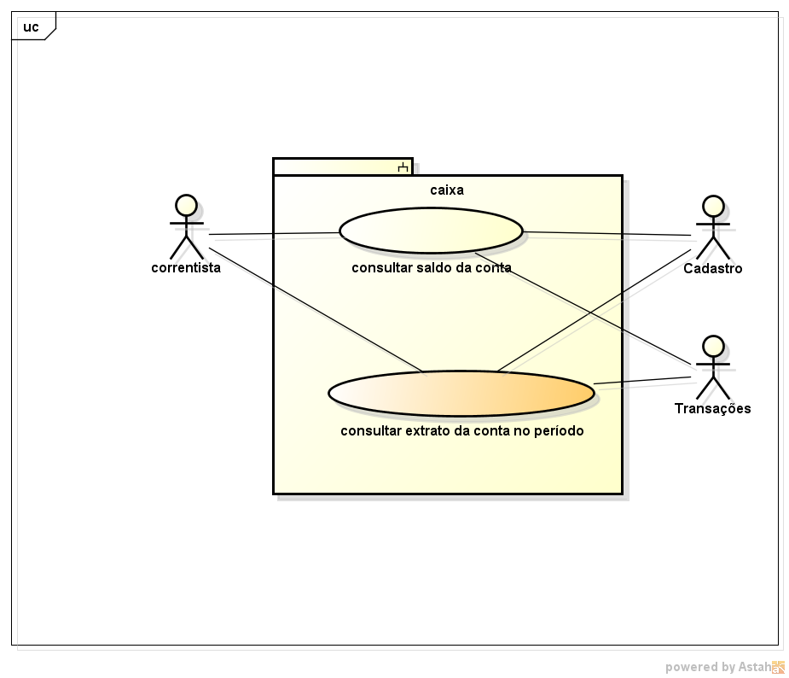

Figura 3‑1

# Product Overview

## Correntista

## Cadastro

## Transações

…

# Use Cases

## Consultar saldo da conta

## Consultar extrato da conta no período

…