* **name student: masoud Ghanim .**

**Create a calculator with any design you want.**

Must have:

* Main div. (All the buttons / divs will be inside that div).
* All the buttons as it appears in the picture.
* Background-color and design to each button.

[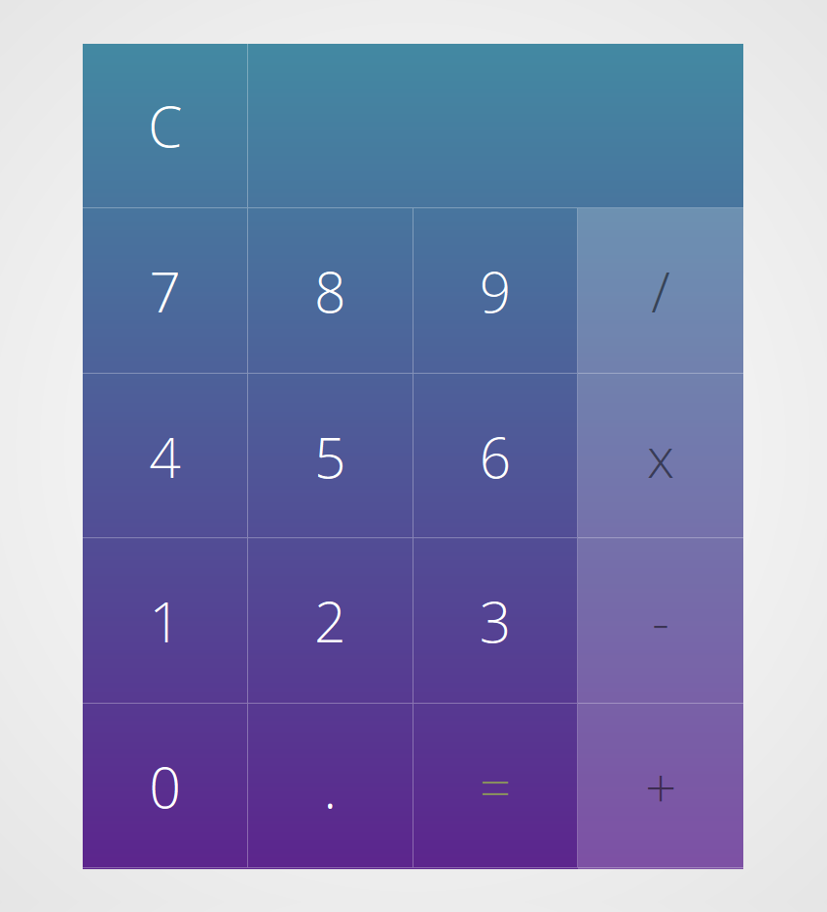](https://camo.githubusercontent.com/ca977a2b2f81c3b5af7e77b6f05213df67608887/68747470733a2f2f692e70696e696d672e636f6d2f6f726967696e616c732f34622f33642f63332f34623364633332383365656166343436633861653866333563306334333530642e706e67)

**Html :**

<!DOCTYPE html>

<html lang="en">

<head>

    <meta charset="UTF-8">

    <meta name="viewport" content="width=device-width, initial-scale=1.0">

    <title>Document</title>

    <link rel="stylesheet" href="calculator.css">

</head>

<body>

    <div id="out">

  <div> <button id="space">0</button> </div>

        <button class="Arithmeticoperations2">AC</button>

        <button class="Arithmeticoperations2">±</button>

        <button class="Arithmeticoperations2">%</button>

        <button class="Arithmeticoperations">÷</button>

        <button id="7">7</button>

        <button id="8">8</button>

        <button id="9">9</button>

        <button class="Arithmeticoperations" id="X">X</button>

        <button id="4">4</button>

        <button id="5">5</button>

        <button id="6">6</button>

        <button class="Arithmeticoperations" id="-">-</button>

        <button id="1">1</button>

        <button id="2">2</button>

        <button id="3">3</button>

        <button class="Arithmeticoperations" id="+">+</button>

        <button id="s0">0</button>

        <button id=".">.</button>

        <button class="Arithmeticoperations" id="=">=</button>

    </div>

</body>

</html>

**CSS:**

body{

    background-color: black;

}

button{

cursor: pointer;

width: 97px;

height: 95.9px;

margin-bottom: 4.7px;

font-size: 40px;

background-color: rgb(51, 50, 50);

border:black solid 10px;

border-top-left-radius: 50%;

border-top-right-radius: 50%;

border-bottom-left-radius: 50%;

border-bottom-right-radius: 50%;

color: white ;

z-index: 2;

}

#out{

    border:black solid 2px;

    border-radius: 1px;

    height: 600px;

    width: 400px;

    margin: 300px;

    background: linear-gradient(to bottom, whblack );

    z-index: 1;

}

#space{

width:400px;

border-radius: 0%;

cursor: wait;

text-align: left;

}

.Arithmeticoperations{

    color: blanchedalmond;

    background-color: orange;

}

.Arithmeticoperations2{

    background-color: rgb(161, 161, 161);

    color: black;

}

#s0{

color: white;

width: 197px;

border-radius: 45%;

}

