Tack My Health is a medical app designed to allow diabetics to store and track their glucose reading, weight, and blood pressure data. The apps will provide statistics such as the average, high, and low for each category as well as for the last seven logs. The data will also be displayed graphically as well.

The main purpose of Track My Health is to replace hand written log books that most doctors require their patients to keep. By utilizing cloud storage, the patient can access his or her data from any device that runs the app. Therefore, the app renders potential devastating issues like lost or destroyed log books impossible. The app will also automatically clean out old data that is older than 120 days; therefore, the log will never be cluttered as handwritten log books are with useless data.

The system will consist of a Cordova app that utilizes the following frontend technologies such as HTML5, CSS3, JavaScript, AngularJS, jQuery, and PlottyJS. The backend will be written in PHP with a MySQL database that is hosted in the cloud. The app will be developed primarily for Android.

Wire Frame:

The app will consist of ten total screens. The main screen will allow navigation to the weight, blood sugar, and blood pressure menus. From the menus the user will be able to navigate to the input screen or display the data. The app will be a single page application.

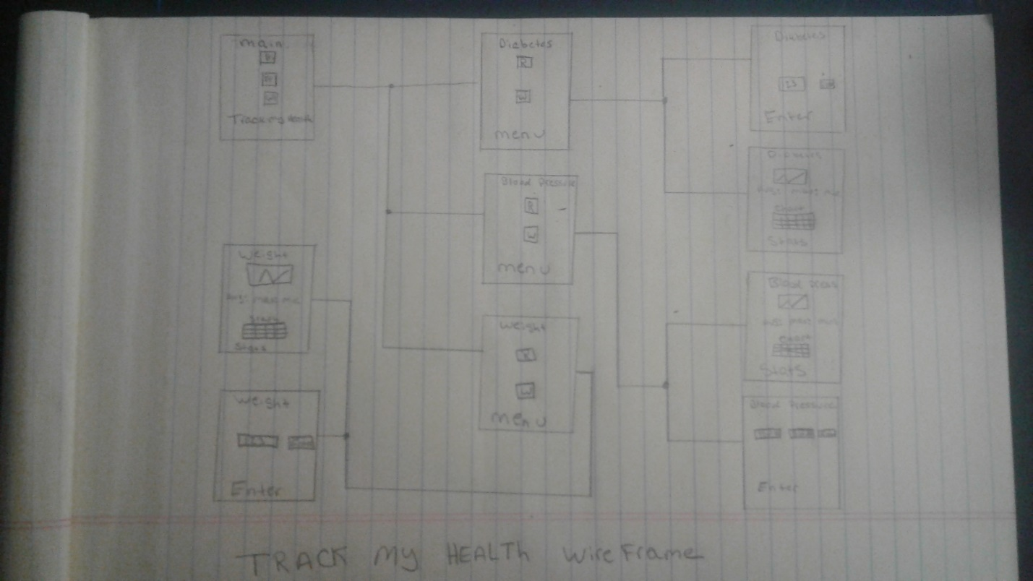

Front-end:

The front-end will consist of HTML5, CSS3, JavaScript, jQuery, and AngularJS. The front-end will be installed on the mobile device and allow the user to upload data, retrieve data, display data, display statistics, and navigate to submenus. The front-end logic will be governed by the following UML,

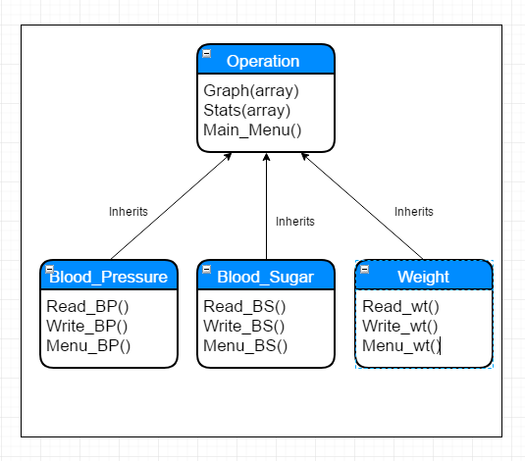

Backend

The backend will utilize a factory pattern that is responsible for inserting and retrieving data from the database. The PHP will be hosted in the cloud.

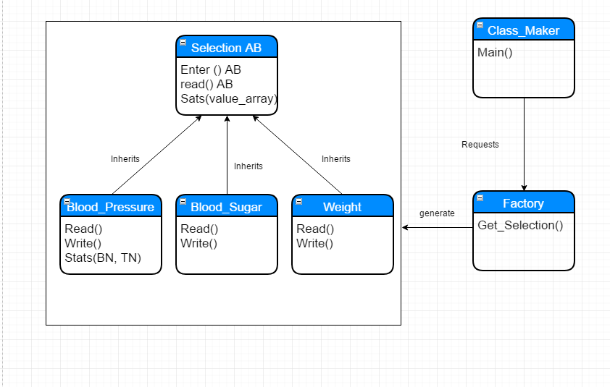

Classes or methods that are denoted with AB denote an abstract method or class.

Database:

A MySQL database will be used to store the data on a cloud server. The data will be stored for a total of 120 day or approximately four months. The database will be used to satisfy the following business requirements,

A patient can have many blood sugar readings.

A blood sugar reading can have one patient.

A patient can have many blood pressure readings.

A blood pressure reading can have one patient.

A patient can have many weight readings.

A weight reading can only have one patient.

