**Figures**

Figures should be submitted in the following formats for accepted manuscripts:

* TIFF
* JPEG
* EPS (vector graphics)
* PDF (with fonts embedded)
* PPT/PPTX
* DOC/DOCX
* AI

Files should adhere to the following resolution requirements:

* 600 dpi for black and white or color line art (bar graphs, charts, etc.)
* 300 dpi for photographs
* 600 dpi for combination images (photographs that also contain line art, text, or thin lines)

General Appearance:

* Do not embed figures in the body of your article document. Number each figure with Arabic numerals in order of their citation in text. Label multipart figures with consecutive letters of the alphabet, using a lowercase letter (a, b, c, etc.). Place this letter in the upper left corner of the figure, outside the figure itself (not in the figure).
* Because this journal is published online only beginning in 2018, color figures incur no additional charge and are encouraged for your submission. We suggest using a colorblind-friendly palette.
* Grayscale patterns do not reproduce as well as solid colors or lines. Avoid small dotted lines, thin lines, multiple levels of gray shading, and stippling. For bar graphs, use black, white, striped, hatched, or colored designs, but only if they are sufficiently widely spaced to appear distinct from one another.
* If no important information will be lost, consider placing fewer numbers on the axes to achieve an uncluttered look. Define abbreviations in the figure legend, not on the figure itself. Symbol keys and scale bars should appear on the figures, not in the figure legends. Make figures as simple as possible; avoid gridlines and boxes.
* Maps generally should include longitude and latitude, an indication of compass direction, and a thin outer line as a border. Make lines on maps bold and distinct while eliminating information not pertinent to the subject.

Size and Proportion:

* Figure sizes should be no more than 6 inches wide and 7 inches high. When possible, submit figures in the size you wish to have them appear in the journal. Most illustrations, except some maps and very wide graphs, should be 1-column width (3 inches) at a resolution of 600 dpi.
* The font size of the *x*- and *y*-axis numbers should be slightly smaller than the axis label. A consistent font (Helvetica is preferred) should be used throughout. Use boldface type only if required for journal style. Use sentence case (i.e., only capitalize the first word) for axis titles, labels, and legends.
* For symbols and lines, avoid very small sizes and line thicknesses (1 point width stroke or greater is preferable).  All elements of a figure should appear with the same degree of intensity. If different degrees of intensity need to be conveyed, lines should differ by 1 point width for clarity.

Image quality will be drastically reduced, possibly impacting readability, if you do not supply your images in the preferred formats and resolutions.

**Figure Preparation Guidelines for Peer Review Submission**

* Are all figures included in your submission as separate files or in an inclusive PDF/Word document/LaTeX suite?
* Do all figures have an accompanying legend that describes the content and explains any abbreviations or symbols?
* Are all figures cited in the main text of your article in numeric order?
* Are all words or symbols appearing in your figures large enough for easy reading?
* Is each individual figure file less than 10 MB?

**Figure Preparation Guidelines for Post-Acceptance**

* Are all figures included in your submission as separate files or in an inclusive PDF/Word document/LaTeX suite? Single, original, unconverted files are best.
* Do all figures have an accompanying legend that describes the content and explains any abbreviations or symbols?  Include your figure legends as a separate section in your main text file.
* Are all figures cited in the main text of your article?  Ensure all figures are numbered in the order in which they are mentioned in the manuscript.
* Are all words or symbols appearing in your figures large enough for easy reading? Closely follow the preferred resolution guidelines for best presentation.
* Use the preferred file types for best image quality.
* Is each individual figure file less than 10 MBs? Remove excess white space surrounding figures for lower file size.  Use the LZW compression option when saving TIFF files to reduce file size without affecting image quality. Save black and white images as grayscale instead of RGB or CMYK.
* Were figures created between 80 and 180 mm in width and using 300 to 600 DPI (larger for line art)?  Higher quality figures are more useful to readers.
* Are all figure files named with their appropriate figure number?  Tip! Use only figure numbers in the file names to ensure correct typesetting (i.e.,Figure 1).

**- Overall main message (if this was an article for a journal, what would the (potential) main message be?)**

Carrion decomposition modulates seed banks and vegetation recovery.

**Conceptual sketches of your figures (photos/pictures are fine), with variables / components in each figure (ideally this is based on the data you have) and the message of each figure.**

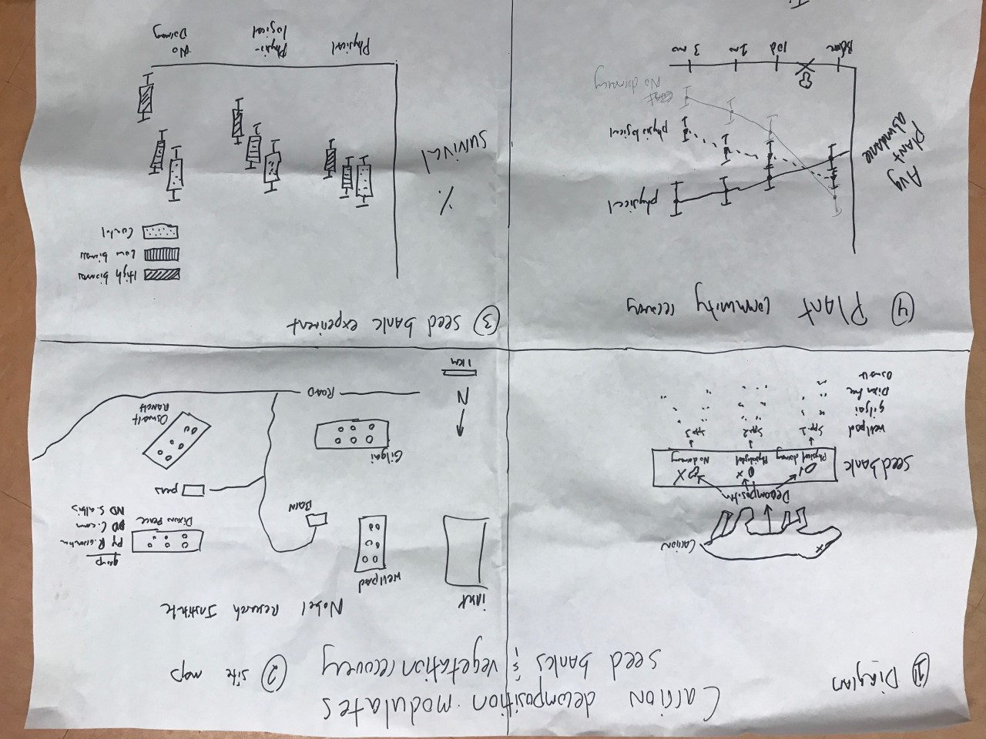

**Part 1 [Diagram]**. Carrion decomposition should affect seeds differently depending on seed characteristics. To explore this hypothesis, we chose four species from each of three functional groups (physiological dormancy, physical dormancy, and no dormancy)



**Part 2 [Map]**. Each group of species is assigned to one of four experimental sites. Sites are in similar prairie assemblages, which are interspersed with gulleys that support woody vegetation. The six subplots in each replicate reflect our experimental design, which crosses two levels of carrion biomass (normal background mortality and mass mortality events) with scavenger and herbivore exclusion as well as no exclusion, which mimics animal die-offs of different functional groups. There is also a reference plot outside of each site, with no carrion (control).



**group = biomass**

**x = seed functional group**

**y = % survival**

**Part 3 [Figure]**. This will show the percent survival for each functional group across all sites. For now, I imagined representing these result simply, which hides all the variation that may be occurring within the factorial design. In reality, I will probably end up with a box and whisker for each treatment (scavenger-low, scavenger-high, herbivore-low, herbivore-high, etc).



**group = seed functional group**

**x = sampling event (time series)**

**y = average plant abundance**

**Part 4 [Figure]**. This is where the rubber meets the road. We have vegetation data in those subplots from before the carrion deployment, throughout the growing season, and toward the end of the growing season. If carrion decomposition is important, I expect the returning vegetation community to reflect which seed functional groups faired best under the decomposing carrion. On the other hand, I also collected seed rain data. It is possible that this process is as important, or even more or less important, than the seed bank— I don’t know. If I can, I may try to incorporate this information as well, which will likely come at the cost of the map. I will also have to factor that into the diagram. I had just wanted to keep it simple to start out.