Dow

Last Draft: 3/23/25

MT DEQ Air Research and Monitoring

2023-2025 Modulair PM2.5 collocation, Analysis and Modeling

DRAFT – Format V2

Table of Contents

Terms, Acronyms and Abbreviations 3

Executive Summary 4

Background 5

use 5

introduction 5

mt DEQ Air research and monitoring overview 5

UMt msba captsone 6

# Terms, Acronyms and Abbreviations

|  |  |
| --- | --- |
| MT | Montana |
| DEQ | Department of Environmental Quality |
| AQB | Air Quality Bureau |
| ARMS | Air Research and Monitoring Section |
| EPA | Environmental Protection Agency |
| PM2.5 | Particulate matter of 2.5 microns or less in diameter |
| PM10 | Particulate matter of 2.5 microns or less in diameter |
| UG/M3 | Micrograms per cubic meter |
| BAM | Beta attenuation monitor |
| FEM | Federal Equivalency Method |
| AQI | Air Quality Index |
| CAA | Clean Air Act |
| NAAQS | National Ambient Air Quality Standards |
| Ambient air monitors | May be referred to as “monitors”, “samplers”, “sensors,” or “BAMs” (context dependent) |
| UM | University of Montana |
| MSBA | Master of Science of Business Analytics |

# Executive Summary

To be completed at end

# Background

## USE

This report is intended for internal use by MT DEQ Air Quality Bureau staff. It is intended to serve as both a high-level summary of analysis and findings, as well as a technical document assuring quality control of processes described within.

All additional questions, comments and concerns can be forwarded to the project’s author, Mason Dow: [mason.dow@mt.gov](mailto:mason.dow@mt.gov)

## INTRODUCTION

This report summarizes the purpose, methods, analysis, modeling and correction of Montana Department of Environmental Quality Air Research and Monitoring Section operated QuantAQ Modulair PM2.5 air quality sensors, collocated with regulatory-grade FEM PM2.5 ambient air monitors. All findings herein are preliminary and meant for internal use only.

## MT DEQ AIR RESEARCH AND MONITORING OVERVIEW

The Air Research and Monitoring Section (ARMS) operates an ambient air monitoring network across the state of Montana. The purpose of Montana’s ambient air monitoring network is to monitor, assess and provide information on statewide air quality conditions and trends as specified by the Montana and Federal Clean Air Acts. The Air Quality Monitoring Program works in conjunction with local air pollution agencies and some industries, measuring air quality throughout Montana. This data provides the factual basis for regulatory decisions as well as provides air quality information to our local counterparts and the public.

In additional to its regulatory ambient air monitors, ARMS operates several informational air monitors for a variety of purposes related to its overall mission. This includes public information and ancillary scientific studies. Some of these samplers are regulatory-quality instruments modified to exist as special purpose monitors (SPMs). Others are light-scattering sensors. (need more + transition here)

PM2.5, or particulate matter of 2.5 microns or less in diameters, is Montana’s “pollutant of concern”, or a key focus of the ambient air monitoring network. Wood smoke, from wildfires and wood stoves, is the chief source of PM2.5 across the state. Monitoring this pollutant is of great important to ARMS. Increased focus on recent impactful wildfire smoke seasons (primarily the summer months, from May to September), coupled with recently lowered national ambient air quality standards for PM2.5, citizens and local governments and seeking expanded PM2.5 monitoring and information for making sound decisions for the benefit of public health. Both regulatory and non-regulatory monitors are employed to provide the public with PM2.5 concentrations for airsheds across the state.

ARMS seeks to provide the public with air quality information in real-time. Hourly measurements of PM2.5 are recorded by the monitors and reported out. Data is available on the DEQ-hosted [Today’s Air dashboard](https://todaysair.mtdeq.us/), as well as the [EPA’s AirNow](https://www.airnow.gov/) air quality portal and various tools. This data is communicated to the public using two key units; UG/M3 (micrograms per cubic meter), which is a concentration (mass per volume), and the Air Quality Index (AQI). The U.S AQI was developed by the EPA for communicating information about outdoor air quality and health. The AQI includes six color-coded categories, each corresponding to a range of index values. The higher the AQI value, the greater the level of air pollution and the greater the health concern. For example, an AQI value of 50 or below represents good air quality, while an AQI value over 300 represents hazardous air quality, while 100 generally corresponds to an ambient air concentration that equals the level of the short-term national ambient air quality standard (NAAQS) for protection of public health. Each category corresponds to a different level of health concern and has a specific color, making it easy for people to quickly determine whether air quality is reaching unhealthy levels in their communities. There exist AQI values for five of the major air pollutants regulated by the Clean Air Act (CAA). For purposes of this report, all AQI values refer to those corresponding to PM2.5 concentrations.

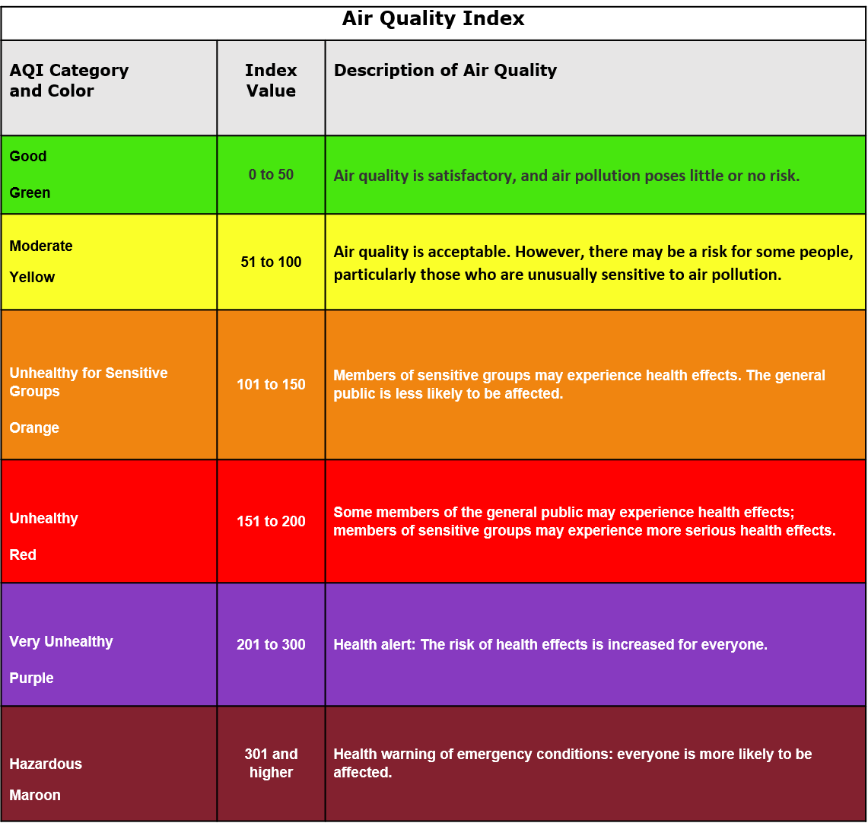

Figure A: EPA Air Quality Index Table (source: AirNow.gov)

An additional note: The EPA also calculates an [AQI NowCast value](https://www.epa.gov/sites/default/files/2018-01/documents/nowcastfactsheet.pdf), which uses a weighted averaging system of concentrations to estimate a more “current” air quality value. This report and it’s analysis does not use the NowCast averaging system, instead opting to use the traditional static AQI values for simplicity.

## UMT MSBA CAPTSONE

This project has been completed as part of my Capstone, completing my Master of Science of Business Analytics. All products and processes have been operated and built with the client’s needs, the ARMS section, as the priority of the effort.