Website Documentation Folder
Project Title: Full-Stack Web Application
Group Members: Jadie Mason, Brandon Grant, Dashawn Lynch, Jahiem Davis, Reon Gordon
Date: 25/02/2026

1. Site Map
The website structure is organized as follows:
• Home
• Login
• Register
• Dashboard
• Products
• Cart
• Checkout
• Emergency Contacts (if applicable)
• Admin Panel
• Contact Us
• Privacy Policy

[ SITE MAP SCREENSHOT HERE ]
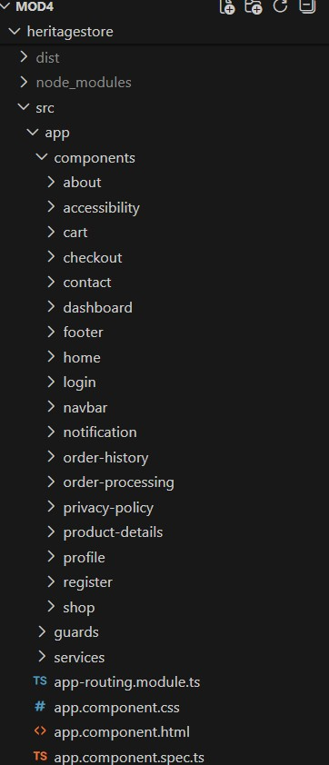

2. Database Schema
The database is designed using a relational structure. Below are the main tables:
Users Table:
- id (Primary Key)
- name
- email (Unique)
- password (Encrypted)
- role
- created_at
Products Table:
- id (Primary Key)
- name
- description
- price
- image
- stock
Orders Table:
- id (Primary Key)
- user_id (Foreign Key)
- total_amount
- status
- created_at
Order_Items Table:
- id (Primary Key)
- order_id (Foreign Key)
- product_id (Foreign Key)
- quantity
- price

[ DATABASE SCHEMA DIAGRAM HERE ]
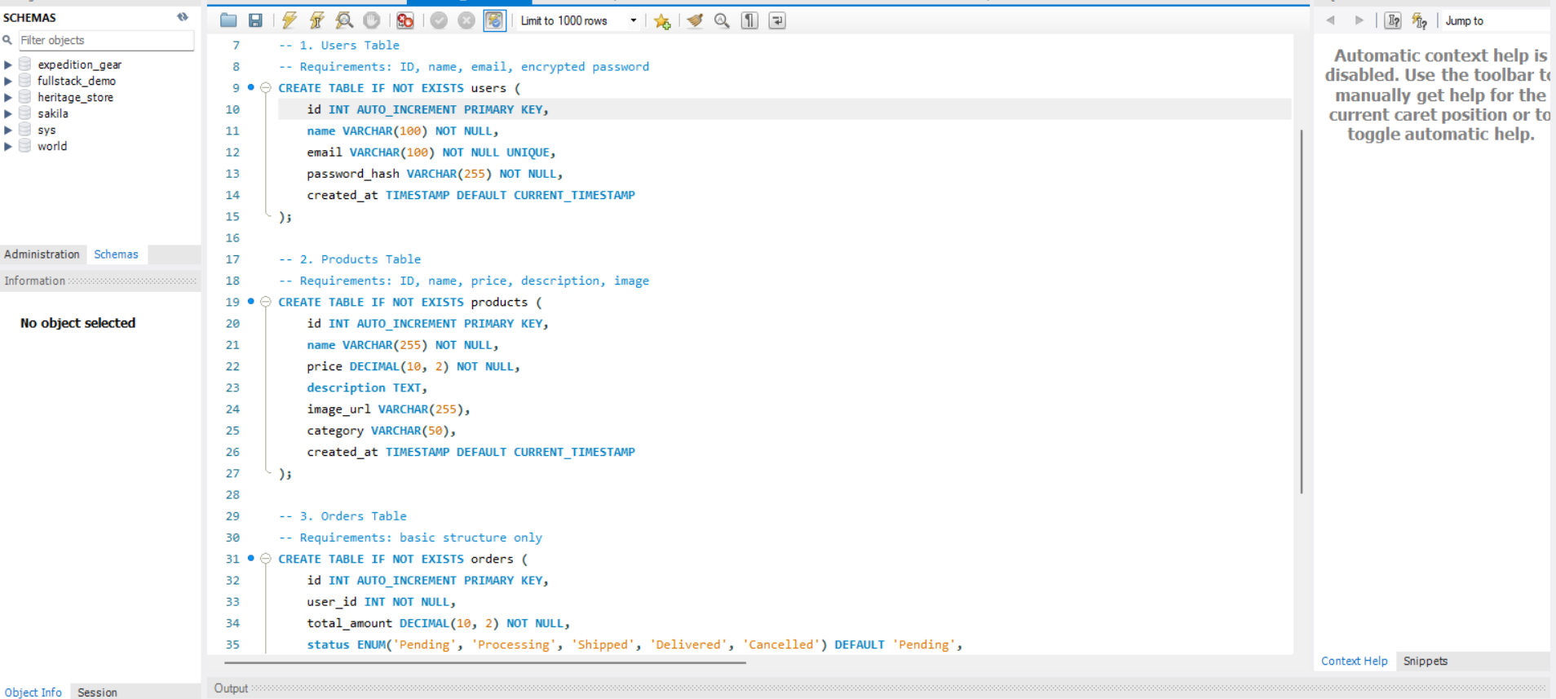

3. Security Explanation (Password Encryption)
Passwords are never stored in plain text. The system uses secure hashing algorithms such as bcrypt to encrypt passwords before storing them in the database. When a user registers, the password is hashed with a salt. During login, the entered password is hashed again and compared to the stored hash.
Additional Security Measures:
• JWT authentication for secure session management
• HTTPS for encrypted data transmission
• Input validation to prevent SQL injection
• Role-based access control for admin features

4. Privacy Policy
This website collects personal information such as name and email address for account creation and order processing purposes only. We do not sell or share user data with third parties.
Data Protection:
• All passwords are encrypted.
• User data is stored securely in the database.
• Users can request account deletion.
• Cookies are used only for authentication and session management.

5. Accessibility Checklist
The website follows accessibility best practices to support elderly and disabled users:
• High contrast color scheme
• Large readable fonts
• Alt text for all images
• Keyboard navigation support
• ARIA labels for screen readers
• Responsive design for different devices
• Clear buttons and navigation structure
Screenshot Placeholder: Insert Accessibility Features Screenshot Below
[ ACCESSIBILITY SCREENSHOT HERE ]
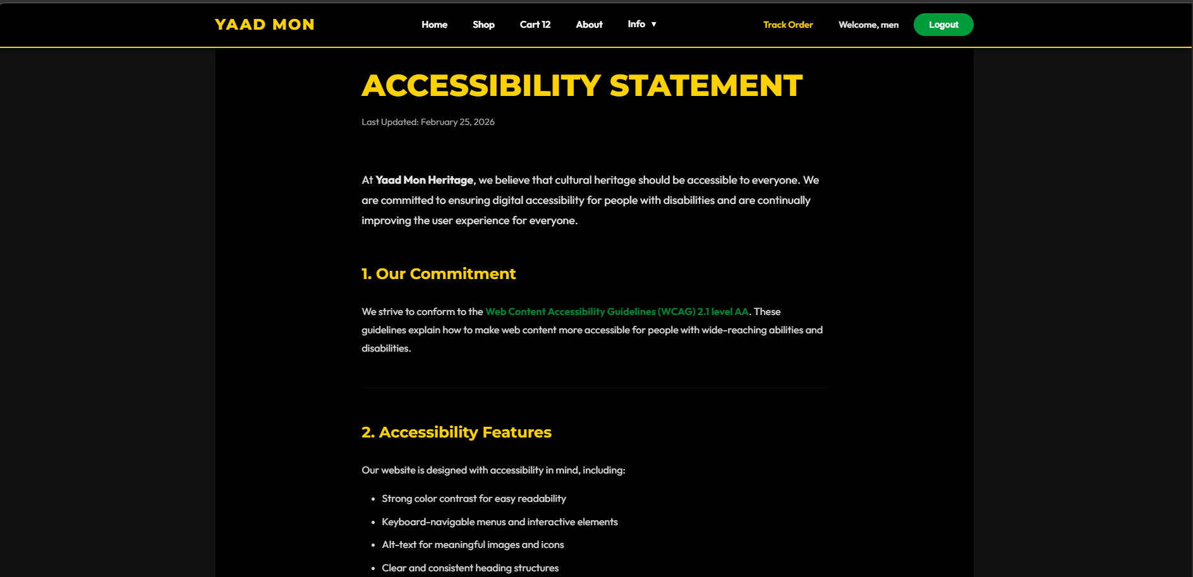

6. Test Report
Testing was conducted to ensure system functionality, usability, and security.
Functional Testing:
• User Registration – Passed
• User Login – Passed
• Add to Cart – Passed
• Checkout Process – Passed
• Admin Product Management – Passed
Performance Testing:
• Page load speed tested using browser tools
• No major performance issues detected
Security Testing:
• Password encryption verified
• Unauthorized access blocked
• Form validation tested

7. Lighthouse Performance Report
The website was tested using Google Lighthouse to measure performance, accessibility, best practices, and SEO compliance.
Lighthouse Categories:
• Performance Score
• Accessibility Score
• Best Practices Score
• SEO Score
Insert Lighthouse Screenshot Below:
[ LIGHTHOUSE REPORT SCREENSHOT HERE ]
