Data Acquisition System
Project Overview & Status

1. Project Overview

This document provides a technical overview of a real-time Data Acquisition (DAQ) system designed to collect, validate, process, and store high-frequency sensor data.

2. Problem Statement

The collection of performance and operational data during aeroderivative gas turbine test runs is critical for validating engine health and performance prior to customer shipment. However, direct sensor placement within the engine is not feasible due to the extreme operating temperatures and harsh environmental conditions, which exceed sensor operating limits and can result in sensor damage, inaccurate measurements, and unreliable data acquisition.

3. Design Process

I began by drafting several design concepts, then evaluated each option against system requirements, environmental constraints, ease of assembly, and long-term usability.
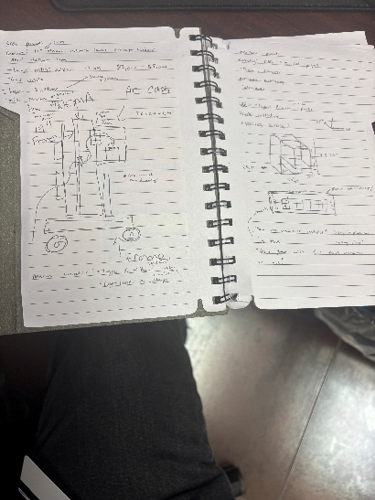
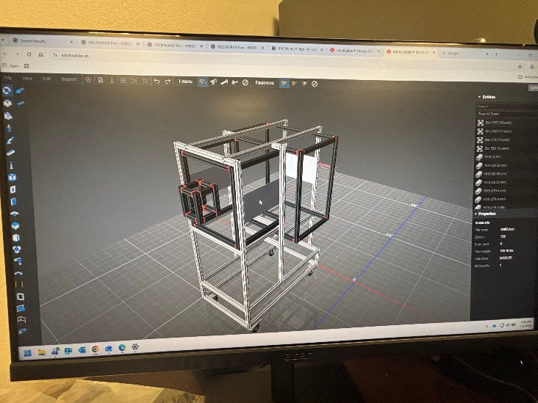

After multiple CAD revisions and design iterations, I developed a viable system model and ordered the components required to assemble the configuration, including:
- 80/20 aluminum extrusions and connectors to create a modular, rigid support frame.
- NEMA 4-rated 19-inch rack to protect the system in outdoor conditions and support strip panels for organized wiring.
- AC enclosure to help maintain the Keyence data system within its required operating temperature range.
- K-type and U-type connectors to collect temperature and simplify field wiring.
- 19-inch strip panels to improve cable routing, labeling, and maintenance access.
- Pressure transmitters and mounts to capture pressure measurements while maintaining secure sensor placement.

4. Assembly

Once the primary components arrived, I began assembling the system by building the support structure, positioning the rack and enclosure, and planning the wiring layout for accessibility and serviceability.
During assembly, I focused on secure mounting, organizing cable routing, and component placement that would allow the DAQ system to be maintained and operated efficiently during test activity.
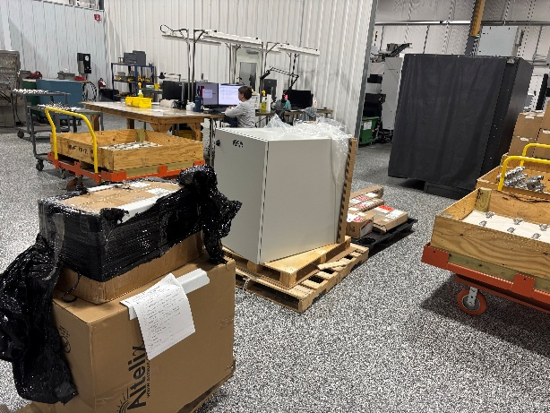
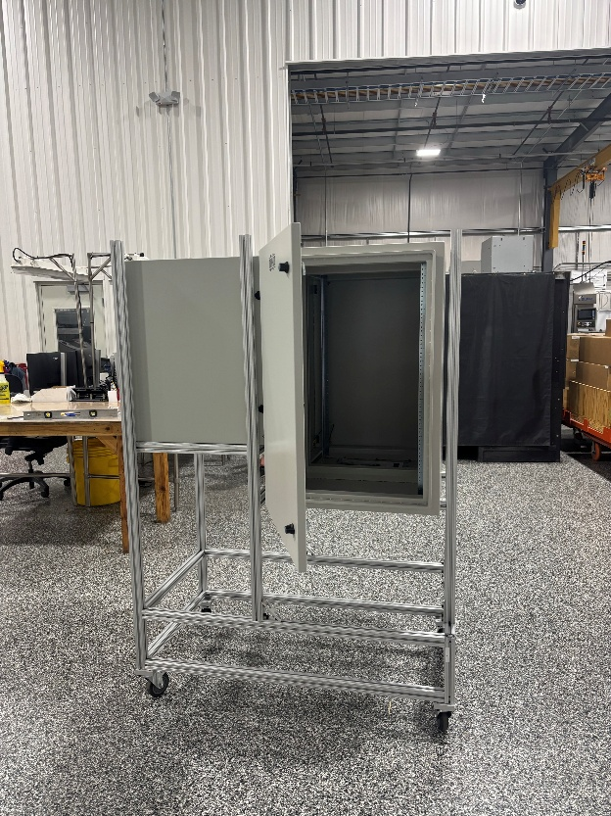

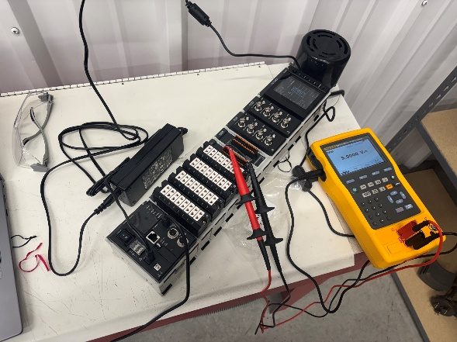

The final product converted the CAD concept into a functional DAQ support system with organized hardware, protected components, and a layout designed for practical use in the test environment.

5. Conclusion

This project strengthened my understanding of the engineering design process by requiring me to turn an initial concept into a functional, usable system. It also provided hands-on experience with CAD iteration, component selection, system organization, assembly planning, and practical decision-making for a real test environment.

