bhttps://drive.google.com/file/d/1sqzv_wFxpV3kxPEhMYe48tVey_bc_zwp/view?usp=sharing Resources:
Here's the initial paper Chris G led on the mathematical formulation of the synthetic (artificial) market:
https://arxiv.org/pdf/2101.01787

Here's a short paper explaining the markets applied to replication prediction (it was a "demo" paper at AAAI, so there is a video too):
https://arxiv.org/pdf/2201.06924

Here is a paper that talks about human experiences in our hybrid markets:
https://arxiv.org/pdf/2303.00866

Datasets:
- SMPD: https://smp-challenge.com/download_image.html
Download :
train folder: https://drive.google.com/file/d/1NaUG2pAF5AY-o6fXHoWfhwyqzXD4vcm2/view?usp=sharing
train_allmetadata_json folder: https://drive.google.com/file/d/1sqzv_wFxpV3kxPEhMYe48tVey_bc_zwp/view?usp=sharing
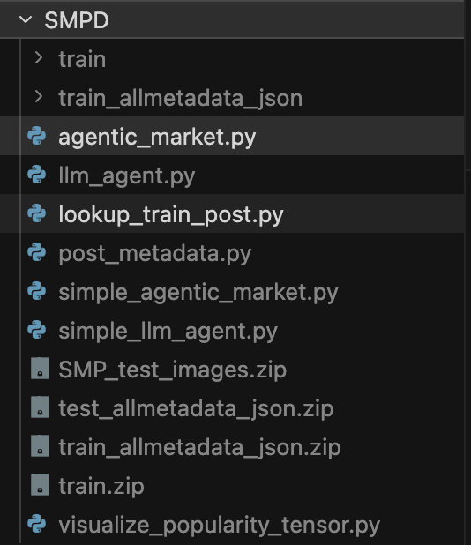

Gemini Models:
Kind | Example model ids
Fast / cheap (good default for your script) | gemini-2.0-flash, gemini-2.5-flash
Lighter / cheaper | gemini-2.0-flash-lite, gemini-2.0-flash-lite-001, gemini-2.5-flash-lite
Stronger reasoning | gemini-2.5-pro

Use case | Example model values
Cheap, fast, multimodal | gpt-4o-mini
Stronger multimodal | gpt-4o,
Older / still seen in docs | gpt-4-turbo, gpt-3.5-turbo
Reasoning-focused families | o1, o1-mini, o3-mini

Post_IDs :
- train/1@N18/1075.jpg
- train/3175@N73/30916.jpg
- train/11830@N28/84816.jpg
- train/15687@N16/135435.jpg
- train/21369@N1/146385.jpg
- train/108435@N35/1118334.jpg
- train/108298@N52/1115777.jpg
- train/24371@N3/167451.jpg
- train/4352@N69/167902.jpg
- train/106547@N67/1077111.jpg
- train/22350@N26/146974.jpg
- train/105714@N10/1059544.jpg
- train/108150@N2/1112850.jpg
- train/101864@N54/982761.jpg
- train/21568@N10/156250.jpg

Gemini

Notes:
Gemini-2.0-flash-lite-001 will be retired on June 1, 2026. As of March 6, 2026, gemini-2.0-flash-001 and gemini-2.0-flash-lite-001 are only available for existing customers.
Post_ID | Category | Log_view | Model | Temp. | Output_ZS | Output_FS
train/1@N18/1075.jpg | Travel&Active&Sports | 15.15 | gemini-2.0-flash | 0.2 | 3
“ | “ | “ | “ | 0.3 | 3
“ | “ | “ | “ | 0.4 | 3
“ | “ | “ | gemini-2.5-pro | 0.4 | 1
“ | “ | “ | “ | 0.2 | 1
“ | “ | “ | gemini-2.5-flash | 0.2 | 4
 |  |  | gemini-2.0-flash | 0 | 3
 |  |  | gemini-2.5-flash | 0 | 4
 |  |  | gemini-2.0-flash-lite | 0 | 3
 |  |  | gemini-2.0-flash-lite-001 | 0
 |  |  | gemini-2.5-flash-lite | 0 | 3
 |  |  | gemini-2.5-pro | 0 | 1
train/3175@N73/30916.jpg | Entertainment | 3.7 | “ | “ | 4
“ | “ | “ | gemini-2.5-pro | “ | 2

 |  |  | gemini-2.0-flash | 0 | 3
 |  |  | gemini-2.5-flash | 0 | 4
 |  |  | gemini-2.0-flash-lite | 0 | 3
 |  |  | gemini-2.0-flash-lite-001 | 0
 |  |  | gemini-2.5-flash-lite | 0 | 3
 |  |  | gemini-2.5-pro | 0 | 1
train/11830@N28/84816.jpg | Urban | 8.37 | gemini-2.0-flash | 0 | 3
 |  |  | gemini-2.5-flash | 0 | 4
 |  |  | gemini-2.0-flash-lite | 0 | 4
 |  |  | gemini-2.0-flash-lite-001 | 0
 |  |  | gemini-2.5-flash-lite | 0 | 3
 |  |  | gemini-2.5-pro | 0 | 4
train/15687@N16/135435.jpg | Fashion | 14.15 | gemini-2.0-flash | 0 | 3
 |  |  | gemini-2.5-flash | 0 | 4
 |  |  | gemini-2.0-flash-lite | 0 | 4
 |  |  | gemini-2.0-flash-lite-001 | 0
 |  |  | gemini-2.5-flash-lite | 0 | 3
 |  |  | gemini-2.5-pro | 0 | 4
train/21369@N1/146385.jpg | Holiday&Celebrations | 5.43 | gemini-2.0-flash | 0 | 3
 |  |  | gemini-2.5-flash | 0 | 2
 |  |  | gemini-2.0-flash-lite | 0 | 3
 |  |  | gemini-2.0-flash-lite-001 | 0
 |  |  | gemini-2.5-flash-lite | 0 | 3
 |  |  | gemini-2.5-pro | 0 | 1
train/108435@N35/1118334.jpg | Social&People | 1.0 | gemini-2.0-flash | 0 | 4
 |  |  | gemini-2.5-flash | 0 | 5
 |  |  | gemini-2.0-flash-lite | 0 | 4
 |  |  | gemini-2.0-flash-lite-001 | 0
 |  |  | gemini-2.5-flash-lite | 0 | 3
 |  |  | gemini-2.5-pro | 0 | 5
train/108298@N52/1115777.jpg | Holiday&Celebrations | 2.0 | gemini-2.0-flash | 0 | 3
 |  |  | gemini-2.5-flash | 0 | 3
 |  |  | gemini-2.0-flash-lite | 0 | 3
 |  |  | gemini-2.0-flash-lite-001 | 0
 |  |  | gemini-2.5-flash-lite | 0 | 3
 |  |  | gemini-2.5-pro | 0 | 4
train/24371@N3/167451.jpg | Food | 6.07 | gemini-2.0-flash | 0 | 3
 |  |  | gemini-2.5-flash | 0 | 2
 |  |  | gemini-2.0-flash-lite | 0 | 3
 |  |  | gemini-2.0-flash-lite-001 | 0
 |  |  | gemini-2.5-flash-lite | 0 | 3
 |  |  | gemini-2.5-pro | 0 | 2
train/4352@N69/167902.jpg | Fashion | 11.1 | gemini-2.0-flash | 0 | 3
 |  |  | gemini-2.5-flash | 0 | 2
 |  |  | gemini-2.0-flash-lite | 0 | 3
 |  |  | gemini-2.0-flash-lite-001 | 0
 |  |  | gemini-2.5-flash-lite | 0 | 3
 |  |  | gemini-2.5-pro | 0 | 1
train/106547@N67/1077111.jpg | Whether&Season | 2.32 | gemini-2.0-flash | 0 | 3
 |  |  | gemini-2.5-flash | 0 | 4
 |  |  | gemini-2.0-flash-lite | 0 | 3
 |  |  | gemini-2.0-flash-lite-001 | 0
 |  |  | gemini-2.5-flash-lite | 0 | 3
 |  |  | gemini-2.5-pro | 0 | 4
train/22350@N26/146974.jpg | Entertainment | 4.91 | gemini-2.0-flash | 0 | 2
 |  |  | gemini-2.5-flash | 0 | 2
 |  |  | gemini-2.0-flash-lite | 0 | 3
 |  |  | gemini-2.0-flash-lite-001 | 0
 |  |  | gemini-2.5-flash-lite | 0 | 2
 |  |  | gemini-2.5-pro | 0 | 1
train/105714@N10/1059544.jpg | Travel&Active&Sports | 2.32 | gemini-2.0-flash | 0 | 3
 |  |  | gemini-2.5-flash | 0 | 2
 |  |  | gemini-2.0-flash-lite | 0 | 3
 |  |  | gemini-2.0-flash-lite-001 | 0
 |  |  | gemini-2.5-flash-lite | 0 | 3
 |  |  | gemini-2.5-pro | 0 | 1
train/108150@N2/1112850.jpg | Urban | 5.39 | gemini-2.0-flash | 0 | 2
 |  |  | gemini-2.5-flash | 0 | 2
 |  |  | gemini-2.0-flash-lite | 0 | 2
 |  |  | gemini-2.0-flash-lite-001 | 0
 |  |  | gemini-2.5-flash-lite | 0 | 2
 |  |  | gemini-2.5-pro | 0 | 1
train/101864@N54/982761.jpg | Whether&Season | 12.53 | gemini-2.0-flash | 0 | 4
 |  |  | gemini-2.5-flash | 0 | 4
 |  |  | gemini-2.0-flash-lite | 0 | 4
 |  |  | gemini-2.0-flash-lite-001 | 0
 |  |  | gemini-2.5-flash-lite | 0 | 3
 |  |  | gemini-2.5-pro | 0 | 5
train/21568@N10/156250.jpg | Electronics | 5.75 | gemini-2.0-flash | 0 | 3
 |  |  | gemini-2.5-flash | 0 | 4
 |  |  | gemini-2.0-flash-lite | 0 | 3
 |  |  | gemini-2.0-flash-lite-001 | 0
 |  |  | gemini-2.5-flash-lite | 0 | 3
 |  |  | gemini-2.5-pro | 0 | 2

OpenAI
Post_ID | Category | Log_view | Model | Temp. | Output_ZS | Output_FS
train/1@N18/1075.jpg | Travel&Active&Sports | 15.15 | gpt-4o-mini | 0 | 3
“ | “ | “ | gpt-4o | 0 | 4
“ | “ | “ | gpt-4-turbo | 0 | 4
“ | “ | “ | gpt-3.5-turbo | 0 | 3
“ | “ | “ | o1 | 0 | 4
“ | “ | “ | o1-mini | 0 | N/A
 |  |  | o3-mini | 0 | 4
train/3175@N73/30916.jpg | Entertainment | 3.7 | gpt-4o-mini | 0 | 3
“ | “ | “ | gpt-4o | 0 | 3
 |  |  | gpt-4-turbo | 0 | 4
 |  |  | gpt-3.5-turbo | 0 | 4
 |  |  | o1 | 0 | 3
 |  |  | o1-mini | 0 | N/A
 |  |  | o3-mini | 0 | 3

train/11830@N28/84816.jpg | Urban | 8.37 | gpt-4o-mini | 0 | 4
 |  |  | gpt-4o | 0 | 3
 |  |  | gpt-4-turbo | 0 | 4
 |  |  | gpt-3.5-turbo | 0 | 3
 |  |  | o1 | 0 | 4
 |  |  | o1-mini | 0 | N/A
 |  |  | o3-mini | 0 | 3
train/15687@N16/135435.jpg | Fashion | 14.15 | gpt-4o-mini | 0 | 4
 |  |  | gpt-4o | 0 | 3
 |  |  | gpt-4-turbo | 0 | 3
 |  |  | gpt-3.5-turbo | 0 | 3
 |  |  | o1 | 0 | 4
 |  |  | o1-mini | 0 | N/A
 |  |  | o3-mini | 0 | 3
train/21369@N1/146385.jpg | Holiday&Celebrations | 5.43 | gpt-4o-mini | 0 | 3
 |  |  | gpt-4o | 0 | 3
 |  |  | gpt-4-turbo | 0 | 3
 |  |  | gpt-3.5-turbo | 0 | 3
 |  |  | o1 | 0 | 3
 |  |  | o1-mini | 0 | N/A
 |  |  | o3-mini | 0 | 3
train/108435@N35/1118334.jpg | Social&People | 1.0 | gpt-4o-mini | 0 | 4
 |  |  | gpt-4o | 0 | 3
 |  |  | gpt-4-turbo | 0 | 3
 |  |  | gpt-3.5-turbo | 0 | 3
 |  |  | o1 | 0 | 4
 |  |  | o1-mini | 0 | N/A
 |  |  | o3-mini | 0 | 3
train/108298@N52/1115777.jpg | Holiday&Celebrations | 2.0 | gpt-4o-mini | 0 | 2
 |  |  | gpt-4o | 0 | 2
 |  |  | gpt-4-turbo | 0 | 3
 |  |  | gpt-3.5-turbo | 0 | 2
 |  |  | o1 | 0 | 3
 |  |  | o1-mini | 0 | N/A
 |  |  | o3-mini | 0 | 3
train/24371@N3/167451.jpg | Food | 6.07 | gpt-4o-mini | 0 | 4
 |  |  | gpt-4o | 0 | 4
 |  |  | gpt-4-turbo | 0 | 4
 |  |  | gpt-3.5-turbo | 0 | 3
 |  |  | o1 | 0 | 4
 |  |  | o1-mini | 0 | N/A
 |  |  | o3-mini | 0 | 3
train/4352@N69/167902.jpg | Fashion | 11.1 | gpt-4o-mini | 0 | 3
 |  |  | gpt-4o | 0 | 3
 |  |  | gpt-4-turbo | 0 | 3
 |  |  | gpt-3.5-turbo | 0 | 3
 |  |  | o1 | 0 | 3
 |  |  | o1-mini | 0 | N/A
 |  |  | o3-mini | 0 | 4
train/106547@N67/1077111.jpg | Whether&Season | 2.32 | gpt-4o-mini | 0 | 3
 |  |  | gpt-4o | 0 | 3
 |  |  | gpt-4-turbo | 0 | 3
 |  |  | gpt-3.5-turbo | 0 | 2
 |  |  | o1 | 0 | 3
 |  |  | o1-mini | 0 | N/A
 |  |  | o3-mini | 0 | 3
train/22350@N26/146974.jpg | Entertainment | 4.91 | gpt-4o-mini | 0 | 3
 |  |  | gpt-4o | 0 | 2
 |  |  | gpt-4-turbo | 0 | 3
 |  |  | gpt-3.5-turbo | 0 | 3
 |  |  | o1 | 0 | 3
 |  |  | o1-mini | 0 | N/A
 |  |  | o3-mini | 0 | 3
train/105714@N10/1059544.jpg | Travel&Active&Sports | 2.32 | gpt-4o-mini | 0 | 2
 |  |  | gpt-4o | 0 | 2
 |  |  | gpt-4-turbo | 0 | 3
 |  |  | gpt-3.5-turbo | 0 | 3
 |  |  | o1 | 0 | 3
 |  |  | o1-mini | 0 | N/A
 |  |  | o3-mini | 0 | 3
train/108150@N2/1112850.jpg | Urban | 5.39 | gpt-4o-mini | 0 | 4
 |  |  | gpt-4o | 0 | 3
 |  |  | gpt-4-turbo | 0 | 3
 |  |  | gpt-3.5-turbo | 0 | 3
 |  |  | o1 | 0 | 3
 |  |  | o1-mini | 0 | N/A
 |  |  | o3-mini | 0 | 3
train/101864@N54/982761.jpg | Whether&Season | 12.53 | gpt-4o-mini | 0 | 4
 |  |  | gpt-4o | 0 | 3
 |  |  | gpt-4-turbo | 0 | 3
 |  |  | gpt-3.5-turbo | 0 | 3
 |  |  | o1 | 0 | 4
 |  |  | o1-mini | 0 | N/A
 |  |  | o3-mini | 0 | 3
train/21568@N10/156250.jpg | Electronics | 5.75 | gpt-4o-mini | 0 | 3
 |  |  | gpt-4o | 0 | 3
 |  |  | gpt-4-turbo | 0 | 3
 |  |  | gpt-3.5-turbo | 0 | 3
 |  |  | o1 | 0 | 3
 |  |  | o1-mini | 0 | N/A
 |  |  | o3-mini | 0 | 2

Gemini Models Accuracy:
Model | Correct | Total | Accuracy
Google gemini-2.5-flash | 6 | 15 | 40.00%
Google gemini-2.0-flash | 5 | 15 | 33.33%
Google gemini-2.5-pro | 5 | 15 | 33.33%
Google gemini-2.5-flash-lite | 3 | 15 | 20.00%
Google gemini-2.0-flash-lite | 2 | 15 | 13.33%

OpenAI Models Accuracy:
Model | Correct | Total | Accuracy
OpenAI o1 | 5 | 15 | 33.33%
OpenAI gpt-4o-mini | 4 | 15 | 26.67%
OpenAI gpt-4o | 4 | 15 | 26.67%
OpenAI o3-mini | 4 | 15 | 26.67%
OpenAI gpt-3.5-turbo | 2 | 15 | 13.33%
OpenAI gpt-4-turbo | 1 | 15 | 6.67%

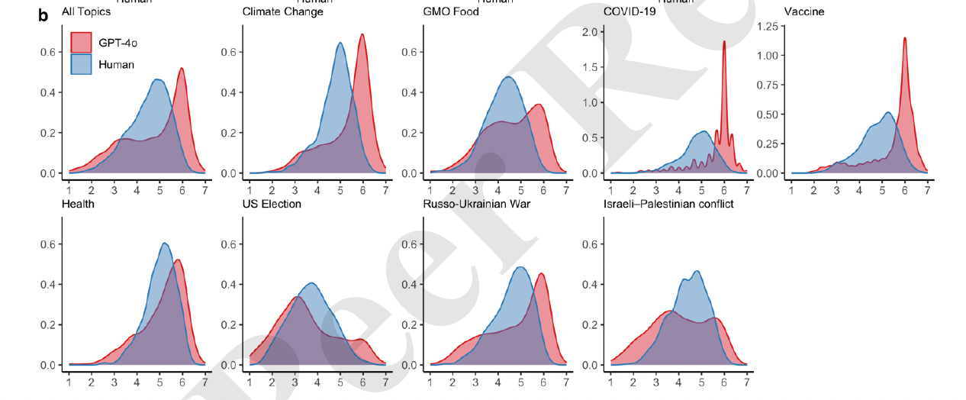

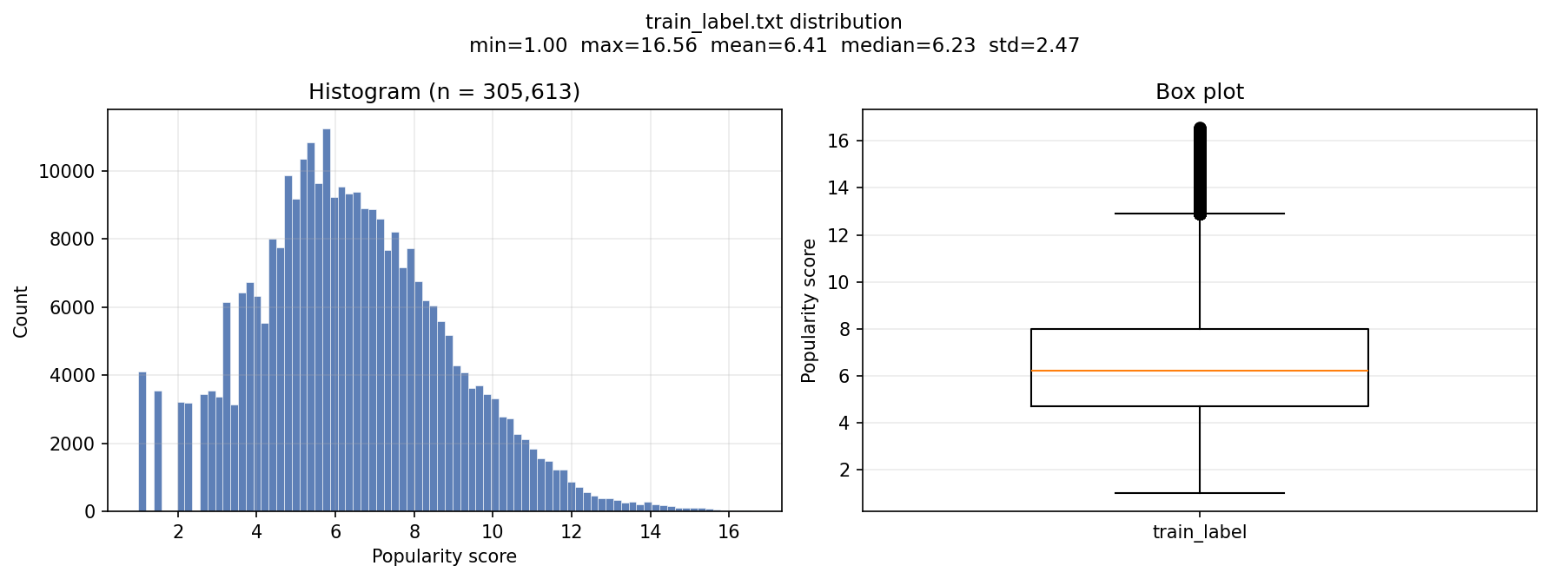
Bin | Meaning | Range
1 | Very low | [1, 3.5)
2 | Low | [3.5, 5.5)
3 | Medium | [5.5, 7.5)
4 | High | [7.5, 10.5)
5 | Viral | [10.5, 16.56]

Popularity Bins:
- Bin 1: [1.000, 4.112)
- Bin 2: [4.112, 7.224)
- Bin 3: [7.224, 10.336)
- Bin 4: [10.336, 13.448)
- Bin 5: [13.448, 16.560]

Option 1 — Quantile-Based Bins
Bin | Range | percentile
1 | [1.0, 4.5) | 20th
2 | [4.5, 5.7) | 40th
3 | [5.7, 6.9) | 60th
4 | [6.9, 8.6) | 80th
5 | [8.6, 16.56] | 100th

Model | Accuracy
Google gemini-2.0-flash | 26.67%
Google gemini-2.5-flash | 26.67%
Google gemini-2.0-flash-lite | 26.67%
Google gemini-2.5-flash-lite | 26.67%
Google gemini-2.5-pro | 26.67%
OpenAI gpt-4o-mini | 13.33%
OpenAI gpt-4o | 13.33%
OpenAI gpt-4-turbo | 13.33%
OpenAI gpt-3.5-turbo | 13.33%
OpenAI o1 | 13.33%
OpenAI o3-mini | 6.67%

Option 2 — Human-Meaningful Popularity Levels

Bin | Meaning | Range
1 | Very low | [1, 3.5)
2 | Low | [3.5, 5.5)
3 | Medium | [5.5, 7.5)
4 | High | [7.5, 10.5)
5 | Viral | [10.5, 16.56]

Model | Accuracy
Google gemini-2.0-flash | 26.67%
Google gemini-2.5-flash | 26.67%
Google gemini-2.0-flash-lite | 26.67%
Google gemini-2.5-flash-lite | 26.67%
Google gemini-2.5-pro | 20.00%
OpenAI gpt-4o-mini | 13.33%
OpenAI gpt-4o | 13.33%
OpenAI gpt-4-turbo | 13.33%
OpenAI gpt-3.5-turbo | 13.33%
OpenAI o1 | 13.33%
OpenAI o3-mini | 6.67%

Bin | Meaning | Range | 5 example
1 | Very low | [1, 2) | As much as you can try to select posts (example) with log-view close to 1
2 | Low | [4, 5) | center
3 | Medium | [6, 7) | center
4 | High | [9, 11) | center
5 | Viral | [14, 16.56] | As much as you can try to select posts (example) with log-view close to 16.56

XinYan:
Animal
Electronics
Entertainment
Family
Urban
Food => level 1 to 2
Test _ example: 10 examples try to be in very low or viral popularity level (row 1 to 10)

JingJing:
Food => level 3 to 5
Holiday&Celebrations
Social&People
Travel&Active&Sports
Fashion
Whether&Season
Test _ example: 10 examples try to be in very low or viral popularity level (row 11 to 20)
XinYan:

Animal:
Electronics:
Entertainment:
Family:
Urban:
Food:

Holiday & Celebrations:
Social & People:

Travel & Active & Sports:

Fashion:

Weather & Season:

Food:

Install if you receive error:

pip install -q -U google-genai

XinYan: model='gemini-3.5-flash',
Jinging: model='gemini-2.5-flash',

Input ID = post image + post meta data
Agent_instruction_prompt = “
You are a senior social media analyst. You evaluate the post based on the provided image and metadata.
The metadata of the post includes:

Category
- Category: the primary category of the post (11 classes).
- Subcategory: one of 77 second-level categories.
- Concept: one of 668 different descriptions.

Text
- Title: the title of the post defined by the user.
- Mediatype: the type of attached media, including photo and video.
- Alltags: user-defined tags.

Temporal-spatial
- Postdate: the publication timestamp of the post. It can be converted to datetime using the following Python code:
import time
timestamp = 1457068974
timeArray = time.localtime(timestamp)
datetime = time.strftime("%Y-%m-%d %H:%M:%S", timeArray)
- Latitude: latitude in the range [-90, 90]. Values beyond 6 decimal places are truncated.
- Longitude: longitude in the range [-180, 180]. Values beyond 6 decimal places are truncated.
- Geoaccuracy: accuracy level of the location information.
  - World level ≈ 1
  - Country ≈ 3
  - Region ≈ 6
  - City ≈ 11
  - Street ≈ 16 The valid range is 1–16, with a default value of 16 if unspecified.

User Profile
- Photo_firstdate: the upload date of the user's first photo.
- Photo_count: the total number of photos posted by the user.
- Ispro: whether the user is a Pro member.
- Photo_firstdatetaken: the capture date of the user's first photo.
- Timezone_offset: the user's timezone offset.
- User description: descriptive information about the user.
- Location description: descriptive information about the user's location.

Additional Information
- Pathalias: the user-defined path alias.
- Ispublic: indicates whether the post has public read permissions.
- Mediastatus: indicates whether the media is ready to be accessed by others.

Here are some example inputs with ground truth Lable:

Examples

Your task is to predict the popularity_level of a post relative to typical user-generated photo content on a large social media platform, using the provided image and metadata.

Scoring Rubric (1–5)
- 1 = Very low expected engagement
- 2 = Below average engagement
- 3 = Average content
- 4 = Above average engagement
- 5 = High viral potential

Output format
Return ONLY valid integer from 1 to 5 (no markdown, no explanation):
"popularity_level": <integer from 1 to 5> """
Rubric: Content, user profile, location
give me the reason that why you select this score
Market Information= ““the current market estimation is “2”.””
Agent history= “Your previous estimation for popularity level of this post was “3”.“
INPUTDATA:
........

Experiment on prompts:

 | Post Id | Category | Model | W or w/o market info | W or w/o agent history | Output with 1st prompt | Output with 2nd prompt | Output with 3rd prompt | Output with 4th prompt | Output with 5th prompt | Actual Popularity Level
1 | train/88834@N60/1033252.jpg | Animal | gemini-3.5-flash | w/o | w/o | 1 | 1 | 1 | 1 | 1 | 1
2 | train/41900@N53/395334.jpg | Fashion | gemini-3.5-flash | w/o | w/o | 1 | 1 | 1 | 1 | 1 | 1
3 | train/11805@N4/649848.jpg | Holiday&Celebrations | gemini-3.5-flash | w/o | w/o | 4 | 4 | 4 | 4 | 4 | 5
4 | train/25535@N90/232779.jpg | Family | gemini-3.5-flash | w/o | w/o | 1 | 3 | 2 | 2 | 2 | 2
5 | train/19347@N15/188587.jpg | Urban | gemini-3.5-flash | w/o | w/o | 4 | 4 | 4 | 4 | 4 | 4
6 | train/69099@N68/822183.jpg | Entertainment | gemini-3.5-flash | w/o | w/o | 4 | 4 | 5 | 4 | 4 | 4
7 | train/4728@N7/148698.jpg | Social&People | gemini-3.5-flash | w/o | w/o | 1 | 3 | 2 | 3 | 1 | 3
8 | train/45694@N26/383007.jpg | Weather&Season | gemini-3.5-flash | w/o | w/o | 3 | 3 | 3 | 3 | 3 | 3
9 | train/29942@N86/224269.jpg | Electronics | gemini-3.5-flash | w/o | w/o | 2 | 2 | 2 | 2 | 2 | 2
10 | train/53515@N9/649591.jpg | Travel&Active&Sports | gemini-3.5-flash | w/o | w/o | 4 | 3 | 4 | 4 | 4 | 5
11 | train/73562@N15/885188.jpg | Travel&Active&Sports | gemini-2.5-flash | w/o | w/o | 1 | 1 | 1 | 1 | 1 | 1
12 | train/53741@N75/423416.jpg | Weather&Season | gemini-2.5-flash | w/o | w/o | 1 | 2 | 1 | 1 | 1 | 1
13 | train/39157@N89/354551.jpg | Fashion | gemini-2.5-flash | w/o | w/o | 3 | 3 | 3 | 3 | 2 | 2
14 | train/27882@N8/194351.jpg | Urban | gemini-2.5-flash | w/o | w/o | 2 | 2 | 2 | 2 | 2 | 2
15 | train/50564@N82/1111339.jpg | Food | gemini-2.5-flash | w/o | w/o | 2 | 2 | 2 | 5 | 4 | 3
16 | train/22414@N50/160403.jpg | Animal | gemini-2.5-flash | w/o | w/o | 3 | 3 | 3 | 3 | 3 | 3
17 | train/7739@N23/150665.jpg | Electronics | gemini-2.5-flash | w/o | w/o | 4 | 4 | 4 | 4 | 4 | 4
18 | train/55361@N36/495018.jpg | Family | gemini-2.5-flash | w/o | w/o | 4 | 5 | 4 | 5 | 4 | 4
19 | train/22824@N84/161496.jpg | Entertainment | gemini-2.5-flash | w/o | w/o | 5 | 5 | 5 | 5 | 5 | 5
20 | train/59523@N5/471110.jpg | Holiday&Celebrations | gemini-2.5-flash | w/o | w/o | 5 | 5 | 5 | 5 | 5 | 5
 |  |  |  |  |  | 6 missed | 6 missed | 6 missed | 5 missed | 4 missed

XinYan: download ICIP dataset. It is in shared flolder (ICIP.zip). Find a unique ID for each post (Image). Create a similar code like lookup_train_post.py for SMPD dataset.

Jingjing: Qwen2.5-VL-7BInstruct
Link: https://arxiv.org/pdf/2508.02324 Please, create similar code like Gemini.py. Test on prompt5 with exact 20 example. Just repeat (Experiment on Prompts with Qwen model)
The 5th prompt with 20 selected examples and the test input belong to the same category (without any market or historical information).

