Devops Assessment – Final

Section 1: Multiple-Choice Questions (MCQs)

1. What does WSL stand for in the context of Windows?
Answer: c. Windows Subsystem for Linux

2. What is the primary goal of continuous integration (CI) in DevOps?
Answer: b. Frequent integration of code changes

3. In the Linux command line, what does the cd command do?
Answer: b. Change the working directory

4. Which of the following is not a Linux distribution?
Answer: c. Docker

5. What is Docker primarily used for in DevOps and containerization?
Answer: c. Packaging and deploying applications in containers

6. What is the primary purpose of Azure DevOps?
Answer: b. Software development and delivery

7. Which components are part of Azure DevOps?
Answer: c. Azure Boards and Azure Pipelines

8. How does Azure DevOps support version control in software development?
Answer: b. It tracks changes in source code and manages versions.

9. In Linux, what is the primary role of the root user?
Answer: c. Administrative tasks with superuser privileges

10. In Azure DevOps, which component is used to define, build, test, and deploy applications?
Answer: c. Azure Pipelines

Section 2: Labs

Lab 1: File and Directory Management
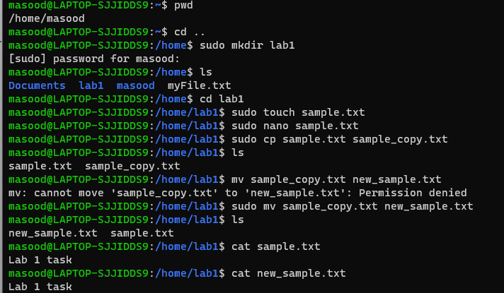

Lab 2: Permissions and Ownership
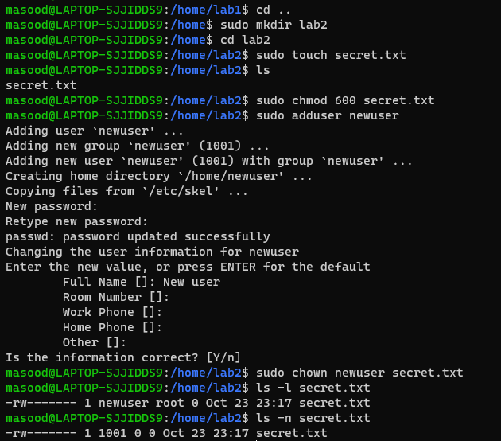

Lab 3: Text Processing with Command Line Tools
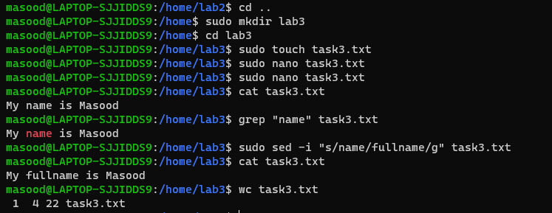

Lab 4: Creating a Simple YAML File
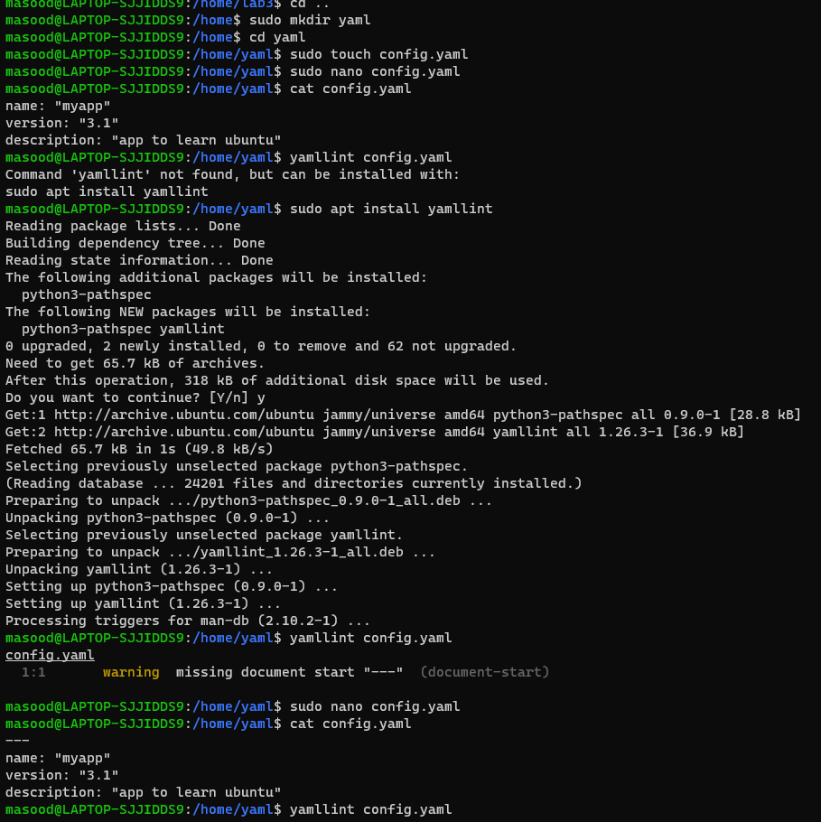

Lab 5: Working with Lists in YAML
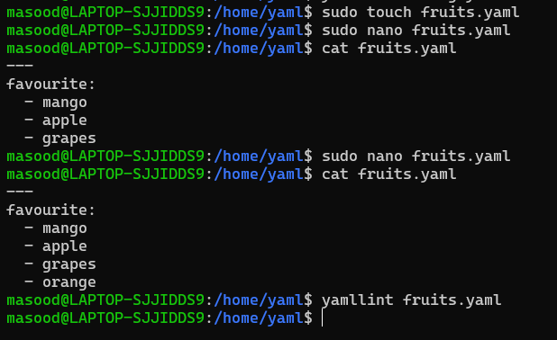
Lab 6: Nested Structures in YAML