Alberta Export Growth and Diversification Potential
Question 1: Decision Brief | Priority export markets, products and diversification opportunities
Methodology

- Built two complementary evidence layers: observed 2025 Alberta domestic exports from Trade Data Online, and a forward-looking opportunity model trained on 2024 CEPII BACI HS4 trade among seven benchmark exporters. This separates “where Alberta sells now” from “where comparable trade patterns suggest room to grow.”
- Converted bilateral trade into an exporter–destination–product panel and added economic mass and trade-friction signals from CEPII Gravity (GDP, population, distance, border, language and FTA). Log transforms reduced the leverage of extreme trade values; incomplete feature rows were excluded consistently before estimation.
- Anchored the model to Alberta’s economy using its 2024 top-25 HS4 export profile, 2024 GDP at market prices ($367.7B) and provincial population. Alberta specialization acts as a capability constraint, preventing the algorithm from recommending products with no demonstrated provincial export base.
- Benchmarked Random Forest against XGBoost on the same stratified 80/20 holdout. XGBoost was retained because it reduced error and raised explained variation. Predictions are reported as unitless opportunity scores for ranking—not dollar forecasts—because Alberta itself was not an exporter in the international training panel.

Analysis

- Alberta exported $177.96B in 2025; the United States absorbed $152.04B (85.4%). This scale is a major advantage but also the central concentration risk. China was a distant second at $10.19B; all other individual markets were below $2.4B (Attachment 1).
- The product mix confirms two diversification pathways. Energy remains the anchor, while canola, wheat, meat, polymers, pulp, sulphur and machinery create market-specific growth options. The complete destination-by-product evidence is in Attachment 2.
- XGBoost outperformed Random Forest on held-out data (R² 0.627 vs. 0.588; RMSE 2.219 vs. 2.396 on log trade). Alberta specialization, importer GDP and product identity jointly account for 57.7% of model gain: proven capability and market scale matter more than institutional indicators alone (Attachment 3).
- The top modeled opportunities are the United States, China, Mexico, Japan, United Kingdom, South Korea, Netherlands, India, Singapore and Peru. The United Kingdom and India are the clearest diversification additions because neither was in Alberta’s observed 2025 top ten, while Hong Kong falls to 11th in modeled potential (Attachment 4).
- Recommended action: protect U.S. access, deepen high-value energy and petrochemical channels in China/Mexico/Japan, and commission buyer-level validation in the United Kingdom and India. Use the score as a screening tool; investment decisions should follow tariff, logistics, regulatory and customer-demand due diligence.

Attachment 1 — Observed Market Concentration
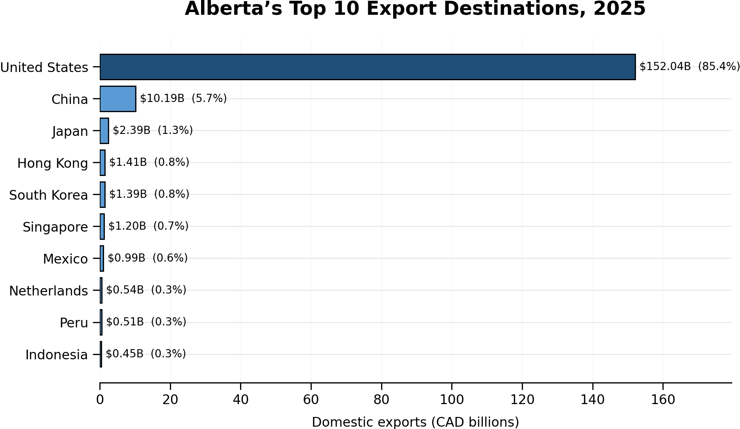
Source: Trade Data Online, Canadian domestic exports, Alberta origin, 2025 (accessed October 2, 2026). Values converted from thousands of Canadian dollars to billions. Total all countries: $177.96B.

Attachment 2 — Top Five HS4 Products in Each Observed 2025 Market
Destination | HS4 | Product | Value (CAD) | Destination | HS4 | Product | Value (CAD)
United States | 2709 | Petroleum oils, crude | $110,821,617 | Singapore | 2709 | Petroleum oils, crude | $1,088,166,780
United States | 2711 | Petroleum gases | $11,573,399 | Singapore | 3901 | Ethylene polymers | $42,054,007
United States | 0201 | Fresh/chilled bovine meat | $2,845,291 | Singapore | 8431 | Parts for machinery HS8425–8430 | $17,182,329
United States | 3901 | Ethylene polymers | $2,633,250 | Singapore | 7502 | Unwrought nickel | $12,803,972
United States | 2710 | Refined petroleum oils | $2,129,225 | Singapore | 8412 | Engines and motors, n.e.s. | $4,986,717
China | 2709 | Petroleum oils, crude | $6,319,507 | Mexico | 0201 | Fresh/chilled bovine meat | $231,853
China | 2905 | Acyclic alcohols and derivatives | $611,200 | Mexico | 1205 | Canola seed | $206,314
China | 3901 | Ethylene polymers | $588,630 | Mexico | 1001 | Wheat and meslin | $79,099
China | 4703 | Chemical wood pulp | $437,253 | Mexico | 0206 | Edible offal | $67,108
China | 1205 | Canola seed | $431,047 | Mexico | 0203 | Pork | $62,532
Japan | 1205 | Canola seed | $364,111 | Netherlands | 7502 | Unwrought nickel | $237,632,734
Japan | 0203 | Pork | $362,000 | Netherlands | 2309 | Animal feed preparations | $117,699,809
Japan | 2701 | Coal | $345,360 | Netherlands | 1205 | Canola seed | $54,012,966
Japan | 1001 | Wheat and meslin | $230,737 | Netherlands | 8105 | Cobalt products | $39,899,692
Japan | 0206 | Edible offal | $134,732 | Netherlands | 0201 | Fresh/chilled bovine meat | $14,837,969
Hong Kong | 2709 | Petroleum oils, crude | $1,215,445,736 | Peru | 2710 | Refined petroleum oils | $286,256,811
Hong Kong | 3901 | Ethylene polymers | $32,948,764 | Peru | 1001 | Wheat and meslin | $172,856,620
Hong Kong | 8517 | Telecommunications equipment | $28,888,635 | Peru | 1514 | Canola/rapeseed oil | $17,654,394
Hong Kong | 7602 | Aluminum waste and scrap | $25,766,303 | Peru | 8705 | Special-purpose motor vehicles | $5,233,384
Hong Kong | 2701 | Coal | $22,700,000 | Peru | 8431 | Parts for machinery HS8425–8430 | $4,547,983
South Korea | 2709 | Petroleum oils, crude | $399,927 | Indonesia | 1001 | Wheat and meslin | $258,215,425
South Korea | 2701 | Coal | $179,580 | Indonesia | 2503 | Sulphur | $98,721,609
South Korea | 7502 | Unwrought nickel | $125,242 | Indonesia | 2301 | Meat/fish meal | $38,511,659
South Korea | 0203 | Pork | $123,516 | Indonesia | 3901 | Ethylene polymers | $13,344,168
South Korea | 0202 | Frozen bovine meat | $91,377 | Indonesia | 4705 | Semi-chemical wood pulp | $7,801,859
Source: Trade Data Online, Alberta origin, 2025. Product values are Canadian dollars (not thousands). Each panel continues the same table.

Attachment 3 — Model Validation and Drivers
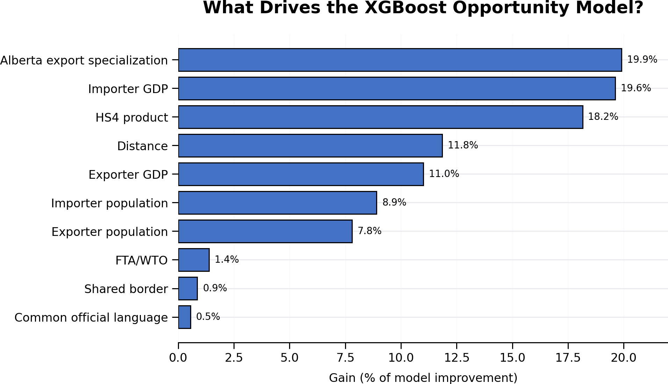
Model | RMSE | MAE | R²
Random Forest | 2.396 | 1.904 | 0.588
XGBoost | 2.219 | 1.709 | 0.627
Validation metrics are computed on the held-out test set and apply to log(1 + trade value). Lower RMSE/MAE and higher R² are better. “Gain” measures each feature’s share of improvement across XGBoost tree splits.

Attachment 4 — Modeled Export Opportunity Ranking
Rank | Destination | Opportunity score | Top five modeled HS4 opportunities, in rank order
1 | United States | 317.1 | 2710 Refined petroleum oils; 2711 Petroleum gases; 3901 Ethylene polymers; 8411 Gas turbines; 2905 Acyclic alcohols
2 | China | 271.5 | 3901 Ethylene polymers; 2710 Refined petroleum oils; 2711 Petroleum gases; 2709 Crude petroleum; 8411 Gas turbines
3 | Mexico | 263.0 | 2710 Refined petroleum oils; 8411 Gas turbines; 2711 Petroleum gases; 3901 Ethylene polymers; 2905 Acyclic alcohols
4 | Japan | 252.7 | 8411 Gas turbines; 2710 Refined petroleum oils; 2711 Petroleum gases; 3901 Ethylene polymers; 2905 Acyclic alcohols
5 | United Kingdom | 251.6 | 2710 Refined petroleum oils; 8411 Gas turbines; 2711 Petroleum gases; 2709 Crude petroleum; 3901 Ethylene polymers
6 | South Korea | 247.2 | 2710 Refined petroleum oils; 2711 Petroleum gases; 8411 Gas turbines; 3901 Ethylene polymers; 2905 Acyclic alcohols
7 | Netherlands | 240.1 | 2710 Refined petroleum oils; 2711 Petroleum gases; 8411 Gas turbines; 3901 Ethylene polymers; 2709 Crude petroleum
8 | India | 225.5 | 2710 Refined petroleum oils; 2711 Petroleum gases; 8411 Gas turbines; 2709 Crude petroleum; 3901 Ethylene polymers
9 | Singapore | 213.3 | 8411 Gas turbines; 2710 Refined petroleum oils; 2709 Crude petroleum; 2711 Petroleum gases; 3901 Ethylene polymers
10 | Peru | 197.8 | 2710 Refined petroleum oils; 3901 Ethylene polymers; 2711 Petroleum gases; 8411 Gas turbines; 2709 Crude petroleum
Note: the opportunity score is the sum of XGBoost log-scale product scores across Alberta’s 2024 top-25 HS4 products. It is unitless and supports relative prioritization only; it is not a predicted dollar value. Hong Kong ranked 11th (173.5).

