Canada's Export Exposure to U.S. Section 338 Tariffs
Question2 | 2025 export baseline | Section 338 measures effective August 22, 2026

Methodology
• Used Statistics Canada’s 2025 merchandise exports to the United States and the U.S. Customs and Border Protection consolidated Section 338 list under Proclamations 11046–11048. The source list contains 554 covered U.S. HTS8 lines.
• Converted covered HTS8 lines to internationally harmonized six-digit codes and removed duplicates, producing 373 HS6 codes. Matching was performed at HS6 because Canadian and U.S. eight-digit codes do not correspond one-to-one.
• Defined exposure as 2025 exports to the United States whose Canadian HS6 matched at least one covered U.S. HTS8 line. Exposure intensity is exposed exports divided by total U.S. exports for the same province or HS4 group.
• Results are screening estimates, not customs-entry determinations. HS6 matching may overstate exposure, and entry-level Section 232, civil-aircraft and other exclusions cannot be identified. National and provincial totals were reconciled (Attachment 1).

Analysis
• Canada’s estimated exposure is $36.58 billion, or 6.5% of $562.70 billion in 2025 U.S. exports. A mechanical 50% calculation gives a maximum gross duty exposure of $18.29 billion before exemptions, price changes, drawback, sourcing shifts or reduced demand (Attachment 1).
• Exposure is concentrated in Ontario ($17.18 billion; 47.0% of Canada’s exposure) and Quebec ($9.09 billion; 24.8%). British Columbia accounts for $3.80 billion and has the highest intensity among major exporters at 13.6% (Attachments 1, 3 and 4).
• Alberta is Canada’s second-largest provincial exporter to the United States, but exposure is comparatively limited at $1.58 billion: 1.0% of Alberta’s U.S. exports and 4.3% of Canada’s exposure. A mechanical 50% calculation equals $788.7 million before mitigation or market response (Attachments 1 and 4).
• Alberta’s top exposed groups are HS4 8414 pumps, compressors and fans; 8537 electrical control equipment; and 3824 specialty chemical preparations. Together they account for $549.2 million, or 34.8% of Alberta’s exposure (Attachment 2).
• Product-level intensity is very high for radar/navigation equipment (100.0%), cement (99.7%), paper products under HS4 4811 (99.2%) and fibreboard (98.2%). Affected firms may face acute margin and competitiveness pressure despite Alberta’s low province-wide intensity (Attachment 2).
• Ontario, Quebec and British Columbia have larger, broader exposure. Alberta resembles Saskatchewan in intensity, but Alberta’s exposed value is over five times larger and is led by machinery, electrical equipment and chemicals rather than telecommunications and dairy-related products (Attachment 3).
• Priorities are targeted firm outreach; exact U.S. HTS8 verification for HS4 8414, 8537 and 3824; assessment of pass-through, contracts, exclusions and drawback; and market diversification support for highly exposed manufacturers.

Sources: Statistics Canada, Canadian International Merchandise Trade Web Application; U.S. Customs and Border Protection, CSMS #69606660 and attached Section 338–Canada HTS List; Presidential Proclamations 11046–11048.

Attachment 1 - Estimated Section 338 exposure by province
Cited in Methodology bullet 4 and Analysis bullets 1–3

Province / geography | Total U.S. exports ($) | Exposed exports ($) | Exposure intensity | Illustrative 50% duty ($) | Share of Canada exposure
Ontario | $190,317,873,807 | $17,181,541,936 | 9.0% | $8,590,770,968 | 47.0%
Alberta | $152,042,164,486 | $1,577,349,294 | 1.0% | $788,674,647 | 4.3%
Quebec | $84,339,012,465 | $9,086,429,357 | 10.8% | $4,543,214,679 | 24.8%
British Columbia | $27,916,212,374 | $3,800,855,145 | 13.6% | $1,900,427,573 | 10.4%
Saskatchewan | $23,683,450,602 | $285,093,240 | 1.2% | $142,546,620 | 0.8%
New Brunswick | $14,473,068,963 | $265,474,106 | 1.8% | $132,737,053 | 0.7%
Manitoba | $12,942,004,807 | $669,929,380 | 5.2% | $334,964,690 | 1.8%
Newfoundland and Labrador | $4,760,459,611 | $17,746,740 | 0.4% | $8,873,370 | 0.0%
Nova Scotia | $4,584,131,237 | $279,037,761 | 6.1% | $139,518,881 | 0.8%
Reported jurisdictions sum | $515,058,378,352 | $33,163,456,959 | 6.4% | $16,581,728,480 | 90.7%
Unallocated / national difference | $47,639,806,746 | $3,417,544,316 | 7.2% | $1,708,772,158 | 9.3%
Canada national series | $562,698,185,098 | $36,581,001,275 | 6.5% | $18,290,500,638 | 100.0%
Note: The national-provincial difference reflects exports reported in the national series that are not allocated to a province in the supplied extract.

Attachment 2 - Alberta's ten largest exposed HS4 product groups
Cited in Analysis bullets 4–5

Rank | HS4 | Product name | Total U.S. exports ($) | Exposed exports ($) | Intensity | Share of Alberta exposure | Illustrative 50% duty ($)
1 | 8414 | Pumps, compressors and fans | $237,690,803 | $214,105,478 | 90.1% | 13.6% | $107,052,739
2 | 8537 | Electrical control or distribution equipment | $184,190,875 | $175,514,423 | 95.3% | 11.1% | $87,757,212
3 | 3824 | Specialty chemical preparations | $172,206,002 | $159,622,758 | 92.7% | 10.1% | $79,811,379
4 | 9403 | Other furniture and parts | $175,997,528 | $103,913,815 | 59.0% | 6.6% | $51,956,908
5 | 8526 | Radar and radio-navigation equipment | $95,205,930 | $95,205,930 | 100.0% | 6.0% | $47,602,965
6 | 4411 | Fibreboard of wood or other ligneous materials | $85,253,822 | $83,702,096 | 98.2% | 5.3% | $41,851,048
7 | 8419 | Temperature-treatment machinery and equipment | $171,063,628 | $73,686,087 | 43.1% | 4.7% | $36,843,044
8 | 3923 | Plastic packing and conveyance articles | $103,956,868 | $72,906,540 | 70.1% | 4.6% | $36,453,270
9 | 4811 | Coated or treated paper and paperboard | $67,281,959 | $66,711,898 | 99.2% | 4.2% | $33,355,949
10 | 2523 | Hydraulic cement and clinker | $65,198,212 | $64,994,002 | 99.7% | 4.1% | $32,497,001
Note: Product names are shortened for presentation. Exposure intensity equals exposed exports divided by total exports to the United States within the same HS4 group.

Attachment 3 - Alberta compared with major exporting provinces
Cited in Analysis bullets 2 and 6

Province | Total U.S. exports ($) | Exposed exports ($) | Intensity | Top exposed HS4 | Top product name | Top HS4 share | Top 3 exposed HS4 groups
Ontario | $190,317,873,807 | $17,181,541,936 | 9.0% | 3923 | Plastic packing articles | 8.8% | 3923 plastics; 9401 seats; 8537 electrical controls
Alberta | $152,042,164,486 | $1,577,349,294 | 1.0% | 8414 | Pumps, compressors and fans | 13.6% | 8414 pumps/compressors; 8537 electrical controls; 3824 chemicals
Quebec | $84,339,012,465 | $9,086,429,357 | 10.8% | 9405 | Lighting fittings | 7.0% | 9405 lighting; 3923 plastics; 7113 jewellery
British Columbia | $27,916,212,374 | $3,800,855,145 | 13.6% | 8537 | Electrical control equipment | 24.0% | 8537 electrical controls; 4408 veneer sheets; 4412 plywood
Saskatchewan | $23,683,450,602 | $285,093,240 | 1.2% | 8517 | Telecommunications equipment | 32.5% | 8517 telecom; 8419 machinery; 0404 whey/milk constituents
New Brunswick | $14,473,068,963 | $265,474,106 | 1.8% | 4819 | Paper packing containers | 23.5% | 4819 paper containers; 4803 tissue stock; 0602 live plants
Decision-maker interpretation
• Alberta has the lowest exposure intensity among the provinces shown, despite being the second-largest exporter to the United States.
• Alberta exposure is more concentrated than Ontario and Quebec, but less concentrated than British Columbia and Saskatchewan based on the leading HS4 share.
• Alberta’s product mix is led by industrial machinery, electrical controls and chemicals, indicating a targeted manufacturing risk rather than a broad province-wide trade shock.

Attachment 4 - Provincial exposure value and intensity
Cited in Analysis bullets 2–3

Figure 1. Section 338 exposure across major exporting provinces
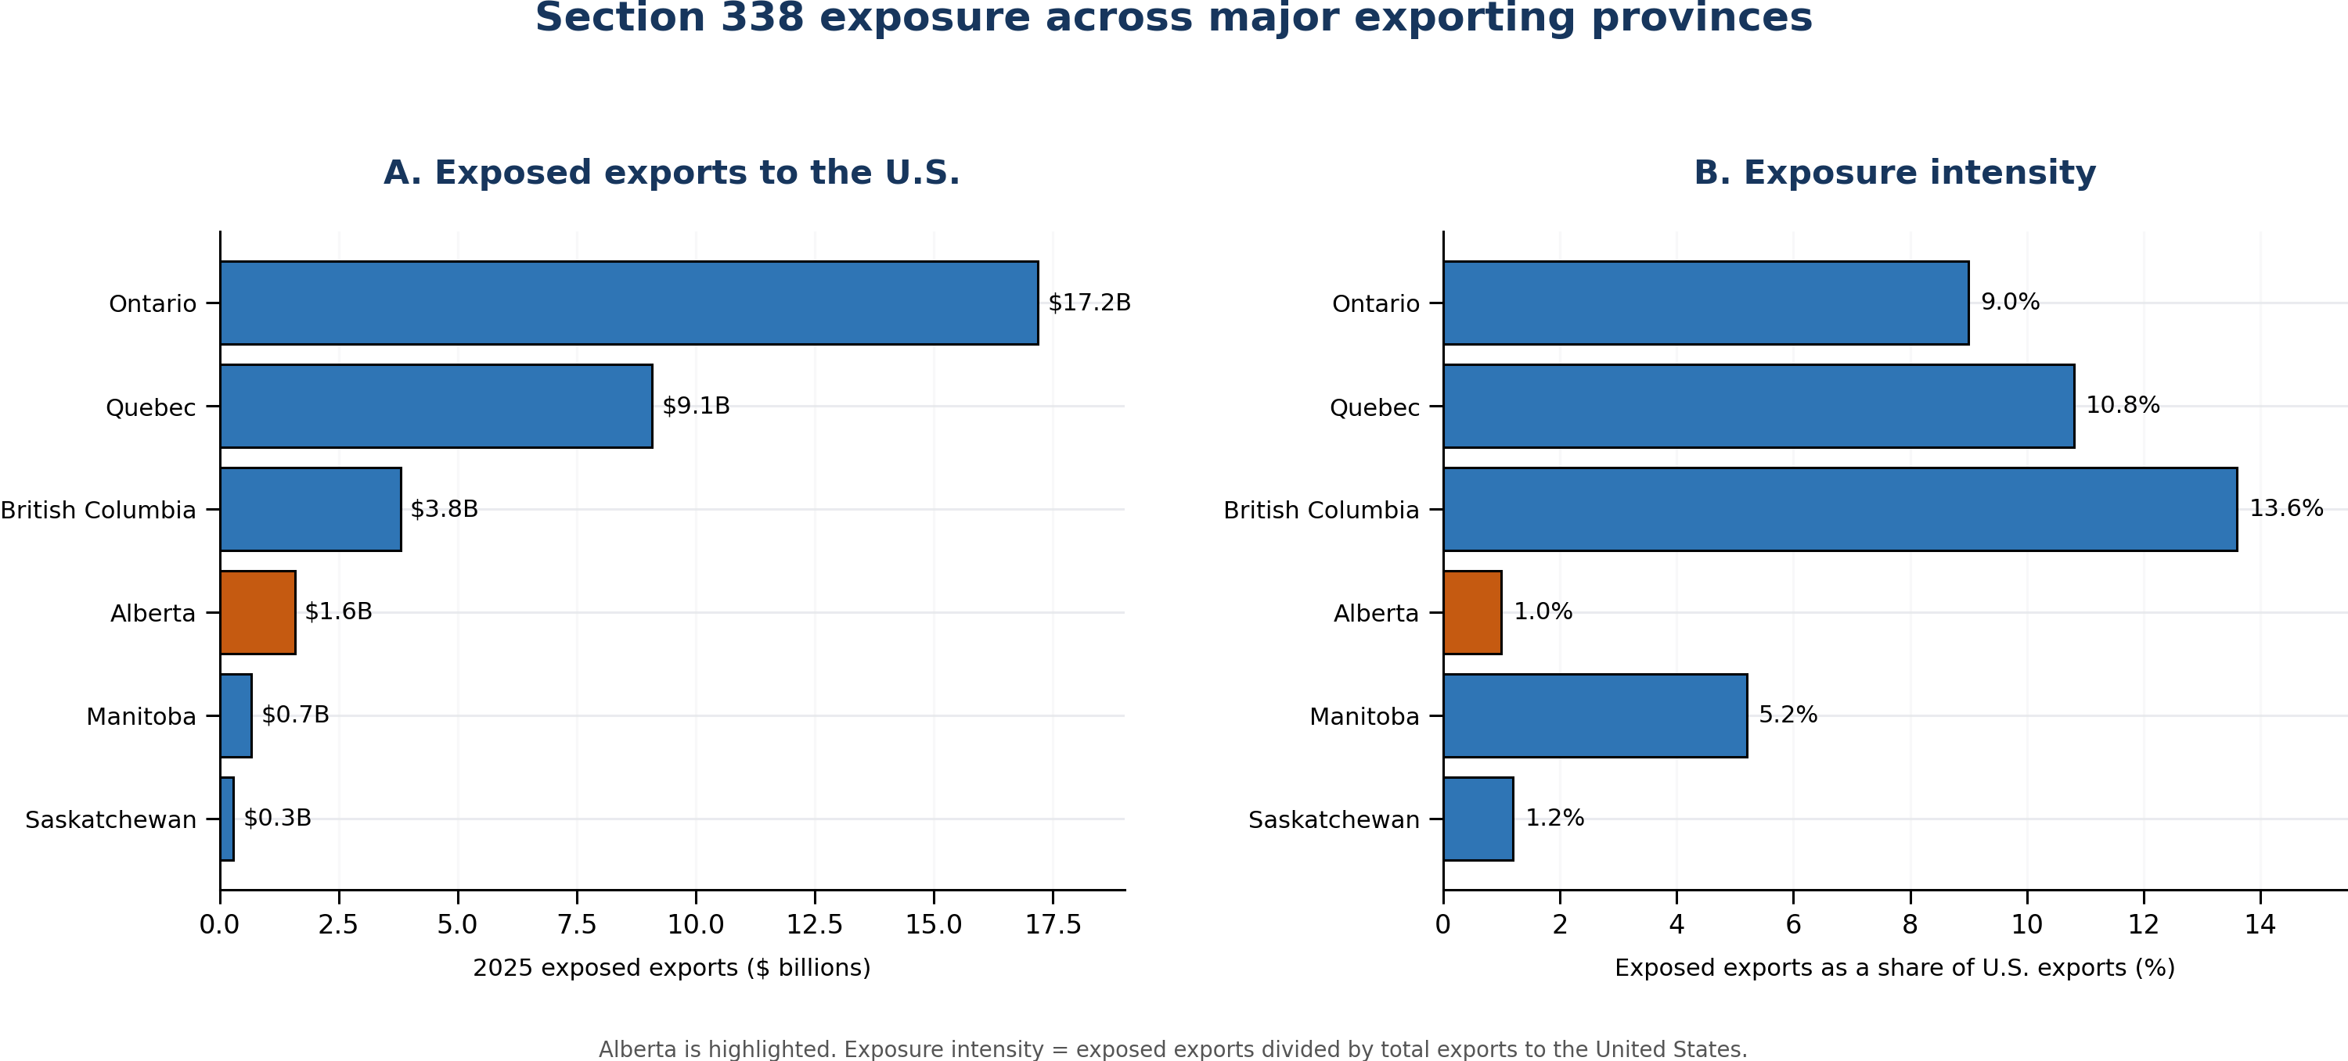
Note: Alberta is highlighted. Values use the 2025 export baseline. Exposure intensity equals exposed exports divided by total exports to the United States.

