DYNAMICS 365 FINANCE
Chart of Accounts & Main Accounts
Complete Step-by-Step Configuration Guide
About This Guide
This document provides a comprehensive, step-by-step reference for configuring the Chart of Accounts (COA) and Main Accounts in Microsoft Dynamics 365 Finance. It consolidates three community blog articles authored by CA Gaurangkumar Jani, covering every key field, parameter, and best practice across all configuration tabs.
Audience: Finance Consultants, Implementation Teams, Finance Managers

March 2026

Table of Contents
Table of Contents 1
Part 1: Chart of Accounts (COA) 1
1.1 What is a Chart of Accounts? 1
Key Takeaways 1
1.2 Planning Considerations 1
1.3 Navigation Path in Dynamics 365 Finance 1
1.4 Screenshots: COA Navigation & List 1
1.5 Step-by-Step: Creating a Chart of Accounts 1
Part 2: Main Accounts — Configuration Guide 1
2.1 Overview 1
2.2 Tab: General 1
A. Identification 1
B. Ledger 1
C. Related Accounts 1
D. Administration 1
E. Consolidation 1
F. Currency 1
G. Standard Ledger Journal Account 1
H. Totals 1
I. Assign Template 1
J. Additional Consolidation Accounts 1
K. Currency Code Validation 1
2.3 Tab: Legal Entity Overrides 1
A & B. Legal Entity Selection 1
C. Default Dimensions 1
D. Suspended (Legal Entity Specific) 1
E. Active From / Active To (Legal Entity Specific) 1
F. Allocation Terms 1
G. Exchange Rate Type (Legal Entity Specific) 1
H. Reporting Currency Exchange Rate Type (Legal Entity Specific) 1
2.4 Tab: Posting Validation 1
A. User Validation 1
B. Posting Type Validation 1
2.5 Tab: Financial Reporting 1
Currency Translation 1
2.6 Tab: Advanced Rules 1
Part 3: Quick Reference — Main Account Types 1
Part 4: Best Practices Summary 1
Appendix: Screenshots Index 1

Part 1: Chart of Accounts (COA)

1.1 What is a Chart of Accounts?
A Chart of Accounts (COA) is an index of all the financial accounts in the general ledger of a company. It is an organizational tool that provides a complete breakdown of all financial transactions conducted during a specific accounting period, categorized into subcategories.

Key Takeaways
- The COA is a financial organizational tool providing a complete listing of every account in the general ledger, broken down into subcategories.
- It is used to organize finances and give stakeholders — such as investors and shareholders — a clearer insight into a company's financial health.
- Each account in the COA typically contains a Name, a brief Description, and an Identification Code.

ℹ | A Chart of Accounts can be shared and used by multiple legal entities in an organization. However, Main Accounts must be unique to each legal entity. You assign a Chart of Accounts to a legal entity through the Ledger form.

1.2 Planning Considerations
Before setting up a COA in Dynamics 365 Finance, you must consider the following factors:
- The reporting requirements of the country/region where your organization is based.
- The reporting requirements of your specific legal entity.
- The degree of account specification needed for both external organizations and internal reporting.
- Multi-country implementations — Dynamics 365 Finance allows more than one COA, enabling each legal entity to have its own structure.

ℹ | Best Practice: Proper planning of the Chart of Accounts is critical — it forms the core of the entire Finance system. Poorly designed COA structures are very difficult to change after go-live.

1.3 Navigation Path in Dynamics 365 Finance
To access the Chart of Accounts setup, follow this navigation path:

General Ledger ► Chart of Accounts ► Accounts ► Chart of Accounts

1.4 Screenshots: COA Navigation & List

📸 Screenshot 1: Chart of Accounts Navigation
General Ledger > Chart of Accounts > Accounts > Chart of Accounts — showing the menu path in the D365 Finance left navigation panel

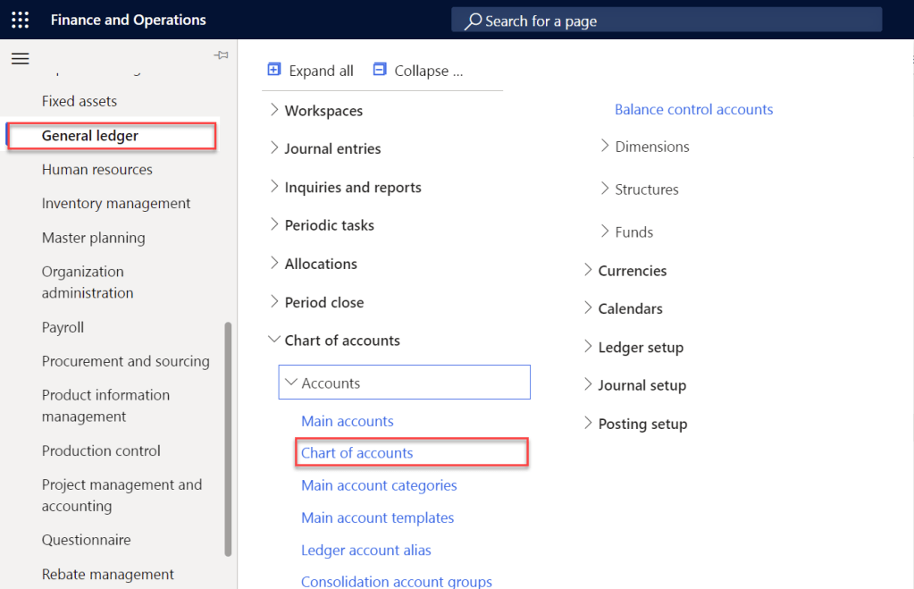

📸 Screenshot 2: Chart of Accounts List
The Chart of Accounts list page showing multiple COA entries. Each row represents a distinct Chart of Accounts that can be assigned to different legal entities.
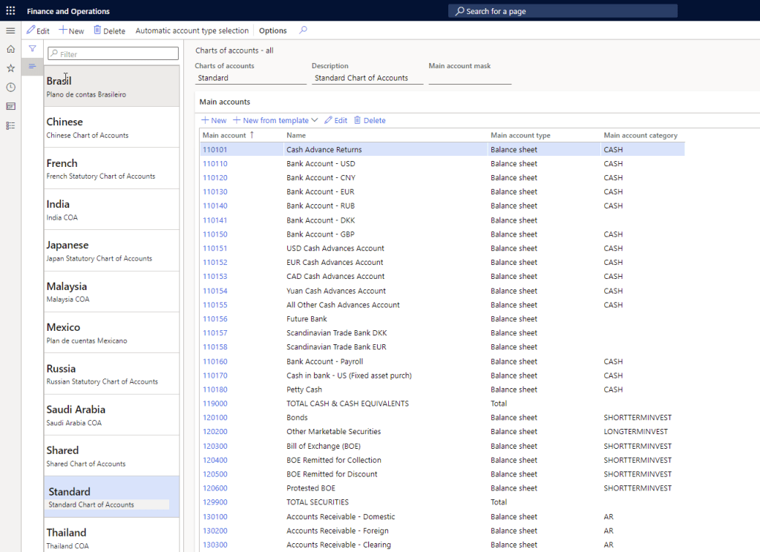

1.5 Step-by-Step: Creating a Chart of Accounts
- Navigate to General Ledger > Chart of Accounts > Accounts > Chart of Accounts.
- Click New on the Action Pane to create a new COA.
- Enter a unique Chart of Accounts code (alphanumeric identifier).
- Enter a descriptive Name for the COA.
- Click Save to save the record.
- Proceed to add Main Accounts under this COA (covered in Part 2 below).

ℹ | Dynamics 365 Finance supports multiple Charts of Accounts simultaneously. This is particularly useful for multi-country implementations where each legal entity may require a different account structure due to local statutory reporting requirements.

Part 2: Main Accounts — Configuration Guide

2.1 Overview
Main Accounts are the individual ledger accounts that make up the Chart of Accounts. Every financial transaction in Dynamics 365 Finance is ultimately posted to a Main Account. Understanding and correctly configuring Main Accounts is critical for accurate financial reporting and control.
The Main Account form is organized into multiple tabs, each controlling a specific aspect of the account's behavior. This guide walks through each tab in detail.

ℹ | Navigation: General Ledger > Chart of Accounts > Accounts > Main Accounts

2.2 Tab: General
📸 Screenshot 3: Main Account Form — General Tab
The General tab of the Main Account form, showing sections: Identification, Ledger, Related Accounts, Administration, Consolidation, Currency, and more.

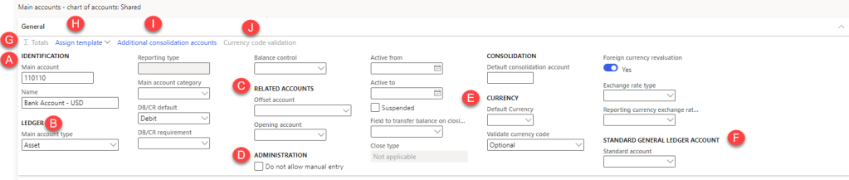

A. Identification
This section defines the unique identity of the Main Account within the COA.
Field / Option | Description / Guidance
Main Account ID | A unique numeric or alphanumeric code identifying this ledger account. Careful planning is required as this is the core identifier of the Finance system.
Name | A descriptive name for the account, clearly indicating its purpose (e.g., 'Cash at Bank – USD', 'Accounts Receivable – Trade').

ℹ | Best Practice: Develop a consistent naming convention before creating accounts. Account IDs and names are difficult to change after transactions have been posted.

B. Ledger
This section determines the accounting nature and behavior of the Main Account.

Main Account Type
Select the appropriate type based on the account's accounting nature:
Field / Option | Description / Guidance
Profit & Loss | Use when you are uncertain whether the account is Revenue or Expense, but it is short-term in nature (affects the Income Statement).
Revenue | For Sales / Income transactions — the upper part of the Income Statement.
Expense | For Expense transactions — the lower part of the Income Statement.
Balance Sheet | Use when you are uncertain whether the account is Asset, Liability, or Equity, but it is long-term in nature.
Assets | For Property and Asset transactions (e.g., Fixed Assets, Cash, Receivables).
Liability | For Liability and Loan transactions (e.g., Accounts Payable, Bank Loans).
Equity | For Owner's / Shareholders' transactions (e.g., Share Capital, Retained Earnings).
Total | Calculates the sum/total of multiple Main Accounts. Activates the 'Σ Totals' field where you specify which accounts to sum. Used for management reports.
Reporting | Used as a header or visual separator in financial statements — does NOT post accounting entries. Types: Header, Empty Header, Page Header.
Common | Used only in China (banks/financial institutions). Recorded as an Asset when the balance is positive, and as a Liability when negative. Example: currency hedging accounts.

Reporting Type (active when Main Account Type = Reporting)
Field / Option | Description / Guidance
Header | Prints account information at the top of the financial statement.
Empty Header | Prints an empty row at the top of the financial statement (for spacing).
Page Header | Prints account information at the top of each page of the financial statement.

Main Account Category
This is one of the most important components of a Main Account. Main Account Categories are used extensively for financial reporting, especially with the embedded Power BI dashboards in D365 Finance where standard reports use Accounting Categories to generate Financial Statements.
- Over 70 standard Main Account Categories are pre-configured in the system.
- Best Practice: Always assign a Main Account Category — it drives standard financial reporting and BI dashboards.

DB/CR Default
Sets the default transaction nature (Debit or Credit) when posting to this account. For example, an Asset account typically defaults to Debit. Users can override this default when entering transactions.

DB/CR Requirement
Restricts posting to only Debit or only Credit transactions. Validated when journal lines are saved and posted.
Example: Audit Fees Expense should always be debited and never credited. Setting the requirement to 'Debit' prevents accidental credit postings to this account.

Balance Control
A special balance control that restricts posting if it would violate a defined balance rule.
Example: A Cash Account should always maintain a Debit (positive) balance. Enabling Balance Control ensures the account balance never goes below zero.

C. Related Accounts
Field / Option | Description / Guidance
Offset Account | Defines a default offset (counter) account for journal lines, reducing manual entry. Commonly used for control accounts.
Opening Account | Specifies the account to which the opening balance is transferred when running the Opening Transactions periodic job for a new fiscal year. Applicable only to Asset and Liability accounts — P&L/Revenue/Expense accounts are set to zero during year-end closing.

D. Administration
Controls that govern how and when the account can be used for transaction posting.
Field / Option | Description / Guidance
Do Not Allow Manual Entry | Prevents users from manually selecting this account in journals. Use for all sub-ledger control accounts (e.g., Accounts Receivable, Accounts Payable, Bank, Inventory) to prevent direct manual postings that would create mismatches between the sub-ledger and general ledger.
Active From | Activates the account for posting from this date onwards. Leave blank for no start restriction.
Active To | Deactivates the account for posting after this date. Example: Set to 31-Dec-20XX to prevent postings in the following year.
Suspended | Immediately suspends the account — no transactions can be posted. Can be re-activated by removing the suspension.
Field to Transfer Balance on Closing Sheet | Determines where this account's balance is transferred during period-end closing adjustment: Result, Balance, or Capital.

ℹ | Best Practice: Enable 'Do Not Allow Manual Entry' on all accounts linked to sub-ledgers (Bank, AR, AP, Inventory). This prevents direct journal entries that bypass the sub-ledger, which can cause significant reconciliation issues.

E. Consolidation
Field / Option | Description / Guidance
Default Consolidation Account | Maps this Main Account to its corresponding account in a Consolidation company's Chart of Accounts. During the consolidation process, the system transfers balances/transactions to the specified consolidation account.

F. Currency
Field / Option | Description / Guidance
Default Currency | Sets the default transaction currency for this account. Example: A foreign currency loan account defaults to GBP. Users can override if needed.
Validate Currency Code — Optional | The Currency field does not require a value in journal lines.
Validate Currency Code — Required | The Currency field must contain a value for each journal voucher, but the specific currency is not validated.
Validate Currency Code — Specify Single Valid Option | The Currency field must match the Default Currency configured on this account.
Validate Currency Code — Specify Multiple Valid Options | The Currency field must be one of the currencies defined in the Currency Code Validation list (Section K).
Foreign Currency Revaluation | Set to Yes to include this account in the foreign currency revaluation batch job for ledger accounts.
Exchange Rate Type | Specifies which exchange rate type to use during foreign currency revaluation for accounting currency conversion.
Reporting Currency Exchange Rate | Specifies the exchange rate type to use for revaluation of transactions in the reporting currency.

G. Standard Ledger Journal Account
Field / Option | Description / Guidance
Standard Account | Norway-specific localization field. Maps the system's Main Account to the standard ledger accounts required by Norwegian local reporting regulations.

H. Totals
This button is activated only when the Main Account Type is set to 'Total'. It allows you to define which Main Accounts are summed to produce the total. This feature is commonly used in Management Reporter for summary line items.
📸 Screenshot 4: Totals Configuration
The Totals popup window showing the configuration for a 'Total' type Main Account — specify ranges or individual accounts whose balances will be aggregated.

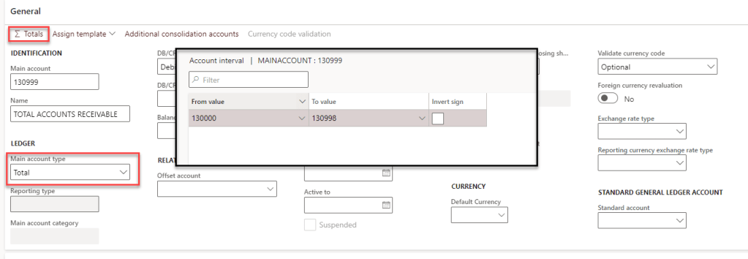

I. Assign Template
Templates allow you to create a standardized set of Main Account configurations that can be applied when creating new accounts. Instead of configuring every field from scratch, select a pre-built template to populate the fields automatically, then modify as needed.

J. Additional Consolidation Accounts
This feature allows mapping a Main Account to additional consolidation account groups, supporting scenarios where multiple consolidations are required — each with a different consolidation Chart of Accounts structure.
📸 Screenshot 5: Additional Consolidation Accounts
The Additional Consolidation Accounts tab showing the mapping of a Main Account to multiple consolidation groups across different consolidation legal entities.

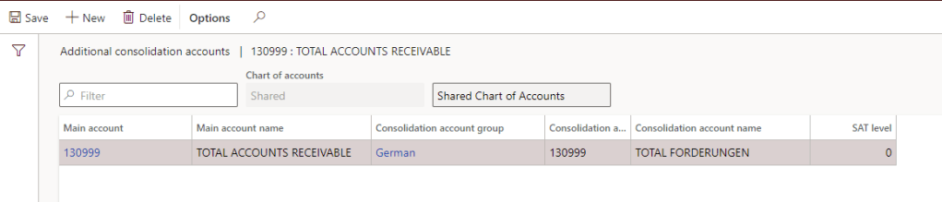

K. Currency Code Validation
This section is only available when 'Validate Currency Code' is set to 'Specify Multiple Valid Options'. It allows you to define a list of permitted currencies for this account. Any transaction in a currency not on this list will be rejected during posting.
📸 Screenshot 6: Multiple Currency Validation
The Currency Code Validation screen showing the list of permitted currencies configured for a Main Account with multi-currency restrictions.

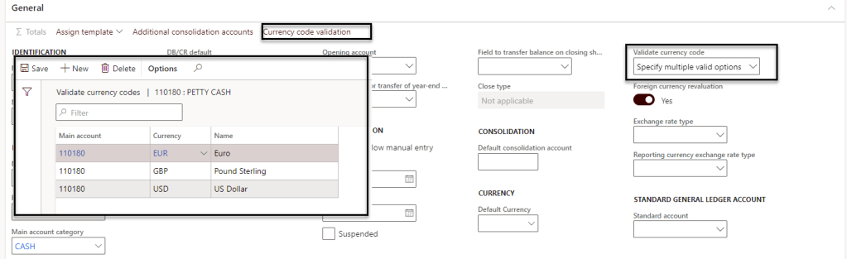

2.3 Tab: Legal Entity Overrides
📸 Screenshot 7: Legal Entity Overrides Tab
The Legal Entity Overrides tab on the Main Account form, showing the grid where legal entity-specific configurations are set including suspension, dimensions, active periods, allocation terms, and exchange rate types.

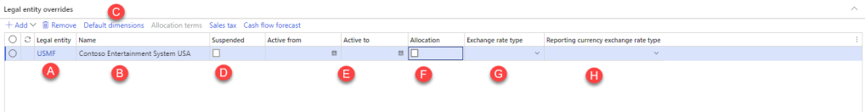

This tab is especially powerful in multi-legal-entity environments using a Shared Chart of Accounts. It allows different control settings per legal entity for the same Main Account, without creating separate accounts.

Controls available per Legal Entity:
- Suspension of the account for a specific legal entity
- Default Financial Dimensions
- Active From / Active To period restrictions
- Allocation Terms
- Exchange Rate Type (overrides the global setting)
- Reporting Exchange Rate Type (overrides the global setting)

A & B. Legal Entity Selection
Click Add to insert a row, then select the specific Legal Entity (e.g., USMF). All settings in that row apply only to the selected legal entity.

C. Default Dimensions
Assign default Financial Dimensions for this account specific to the selected legal entity. You can also set 'Fixed' dimension values, which replace any user-entered dimension value when transactions are posted.
📸 Screenshot 8: Default Dimensions on Main Account
The Default Dimensions dialog for a Legal Entity Override, showing dimension fields with optional fixed values that override user input during transaction posting.

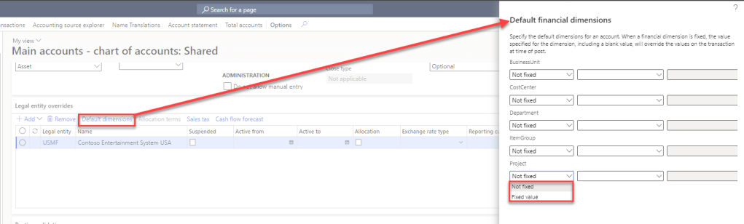

D. Suspended (Legal Entity Specific)
Set to Yes to suspend this account for a specific legal entity only. This is the recommended approach when a Shared COA contains accounts that should only be used by certain legal entities (e.g., Bank Ledger accounts, specific Loan accounts). Other legal entities continue to have access to the account.

E. Active From / Active To (Legal Entity Specific)
Controls the usable date range for this account within the selected legal entity. Use this to create temporary accounts, phase out existing accounts, or restrict usage to specific periods — without affecting other legal entities.

F. Allocation Terms
Defines automatic allocation rules for transactions posted to this account. When a transaction is posted to the source dimension, the system automatically reallocates it to the specified destination dimensions based on the allocation terms defined here.
📸 Screenshot 9: Allocation Terms
The Allocation Terms configuration screen showing source and destination dimension combinations for automatic transaction allocation.

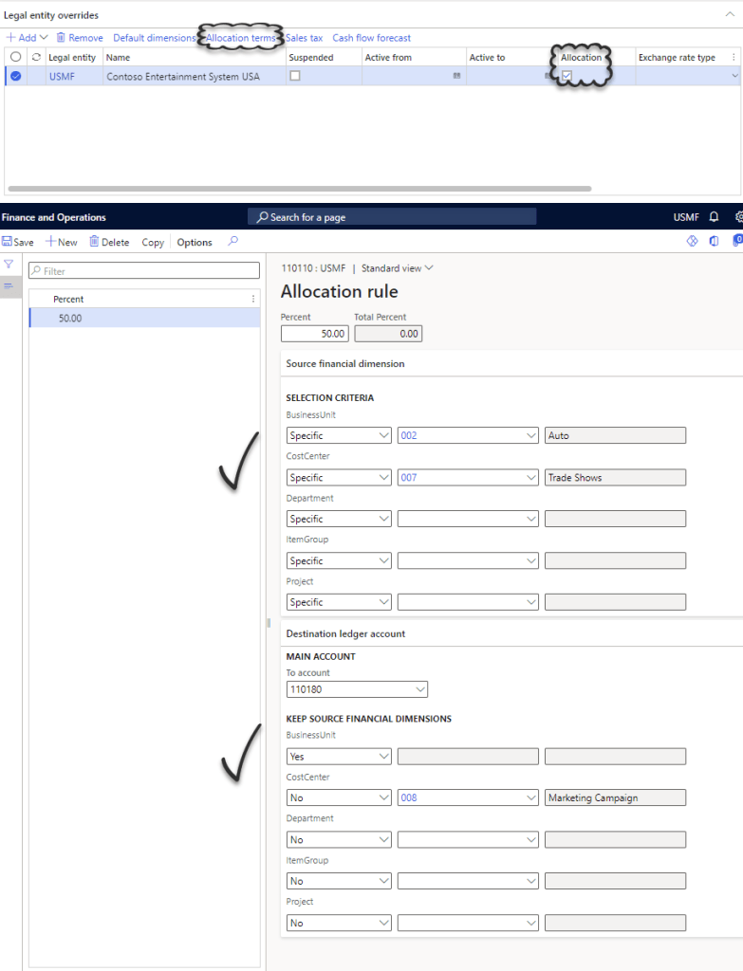

G. Exchange Rate Type (Legal Entity Specific)
Overrides the global Exchange Rate Type setting for accounting currency conversion within this legal entity. Useful when different legal entities operate with different exchange rate methodologies.

H. Reporting Currency Exchange Rate Type (Legal Entity Specific)
Overrides the global Reporting Currency Exchange Rate Type for the selected legal entity. Enables entity-specific reporting currency translation methodology.

2.4 Tab: Posting Validation
📸 Screenshot 10: Posting Validation Tab
The Posting Validation tab showing the User Validation and Posting Type Validation sections with grids for adding specific users and posting types.

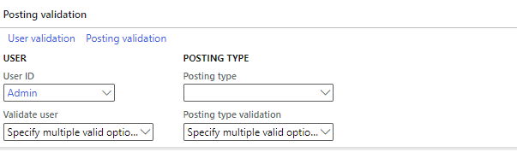

The Posting Validation tab provides two levels of access restriction for a Main Account, allowing fine-grained control over who can post and what types of transactions are permitted.

A. User Validation
Restrict posting to this account to a specific list of users. When users are added here, only those users can post transactions to this account. All other users will be blocked.
Use Case: Sensitive accounts such as Directors' Loan Accounts, Shareholder Accounts, or intercompany clearing accounts where only the finance manager should post.

B. Posting Type Validation
Restrict posting to this account to specific posting types (e.g., only Customer Payment, only Vendor Invoice). When posting types are specified, the system validates that the transaction's posting type matches one of the permitted types before allowing the post.
Use Case: Revenue accounts that should only receive postings from Sales Order invoicing — not from manual general journals.

ℹ | Both User Validation and Posting Type Validation can be combined. For example, you can restrict an account so that only specific users can post, AND only via specific posting types.

2.5 Tab: Financial Reporting
📸 Screenshot 11: Financial Reporting Tab — Currency Translation
The Financial Reporting tab displaying the Currency Translation section with Exchange Rate Type and Translation Type dropdown fields.

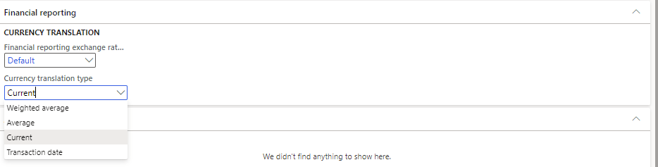

Currency Translation
This tab controls how account balances are translated when generating financial reports in a currency different from the accounting currency.

Field / Option | Description / Guidance
Exchange Rate Type | The exchange rate type to use when translating balances for financial reporting.
Translation Type — Weighted Average | Uses a time-weighted average exchange rate over the reporting period.
Translation Type — Average | Uses the simple average exchange rate for the period.
Translation Type — Current | Uses the exchange rate at the period-end date (commonly used for Balance Sheet accounts).
Translation Type — Transaction Date | Uses the exchange rate as of each individual transaction's date.

ℹ | Typical approach: Balance Sheet accounts use 'Current' (period-end rate), while Income Statement accounts use 'Average' or 'Weighted Average'. This aligns with IAS 21 / IFRS currency translation requirements.

2.6 Tab: Advanced Rules
📸 Screenshot 12: Advanced Rules Tab
The Advanced Rules tab displaying the list of account structures and advanced rules applied to the selected Main Account, showing rule names and associated dimension combinations.

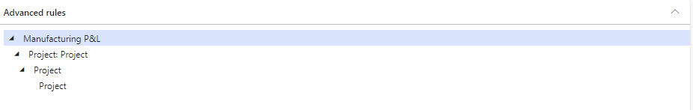

The Advanced Rules tab is a read-only reference tab that shows which Advanced Rules are currently applied to the selected Main Account. Advanced Rules extend the standard Account Structure to require additional Financial Dimensions under specific conditions.
Example: When posting to a Travel Expense account, an Advanced Rule may require the user to also specify a Project dimension — even though the standard account structure does not mandate Project for all accounts.

ℹ | Advanced Rules are configured separately in General Ledger > Chart of Accounts > Structures > Advanced Rules. This tab simply shows which rules are in effect for the current account.

Part 3: Quick Reference — Main Account Types

Account Type | Statement | Example Accounts
Revenue | Income Statement | Sales Revenue, Service Income, Interest Income
Expense | Income Statement | Salaries, Rent, Audit Fees, Depreciation
Profit & Loss | Income Statement | Generic P&L accounts (when Revenue/Expense unclear)
Assets | Balance Sheet | Cash, Bank, Trade Receivables, Fixed Assets
Liability | Balance Sheet | Trade Payables, Bank Loans, Tax Payable
Equity | Balance Sheet | Share Capital, Retained Earnings, Dividends
Balance Sheet | Balance Sheet | Generic BS accounts (when Asset/Liability/Equity unclear)
Total | Reporting Only | Sub-totals and totals in Management Reporter
Reporting | Reporting Only | Section headers in financial statements
Common | Balance Sheet | Currency hedging accounts (China only)

Part 4: Best Practices Summary

1 | Plan your Chart of Accounts thoroughly before go-live. The COA is the foundation of the Finance system and structural changes post-go-live are complex.
2 | Always assign a Main Account Category to every Main Account — this is required for standard Power BI financial reports and Management Reporter.
3 | Enable 'Do Not Allow Manual Entry' on all Control Accounts linked to sub-ledgers (AR, AP, Bank, Inventory) to prevent reconciliation issues.
4 | Use the Legal Entity Override tab (not separate accounts) to apply entity-specific restrictions in a Shared COA environment.
5 | Use 'Active To' dates instead of immediately suspending accounts when decommissioning them — it provides a cleaner audit trail.
6 | Leverage 'DB/CR Requirement' for accounts that should only ever be debited or credited (e.g., Expense accounts = Debit only).
7 | Use 'Balance Control' on Cash and Bank accounts to prevent negative balances that would indicate a data entry error.
8 | Assign Posting Type Validation to revenue and cost accounts to enforce that transactions only originate from the correct modules.
9 | Configure Currency Translation Types on all accounts before running your first financial period close — Balance Sheet accounts should use 'Current'; P&L accounts should use 'Weighted Average' or 'Average'.
10 | Document your COA design decisions — account types, categories, and control settings — so that future implementations and upgrades have a clear reference.

Appendix: Screenshots Index
The following table lists all screenshots referenced in this guide. Screenshots are sourced from the original blog articles by CA Gaurangkumar Jani on the Dynamics 365 Community portal.

Field / Option | Description / Guidance
Screenshot 1 | Chart of Accounts — Navigation path in the D365 Finance left navigation panel (General Ledger > Chart of Accounts > Accounts > Chart of Accounts)
Screenshot 2 | Chart of Accounts — List page showing multiple COA records that can be assigned to different legal entities
Screenshot 3 | Main Account Form — General Tab overview showing all configuration sections
Screenshot 4 | Totals Configuration — Popup for 'Total' type Main Accounts specifying which accounts to aggregate
Screenshot 5 | Additional Consolidation Accounts — Mapping to multiple consolidation groups
Screenshot 6 | Multiple Currency Validation — Permitted currencies list for a restricted Main Account
Screenshot 7 | Legal Entity Overrides Tab — Grid for entity-specific account configurations
Screenshot 8 | Default Dimensions on Main Account — Legal entity-specific dimension defaults with fixed value option
Screenshot 9 | Allocation Terms — Source and destination dimension allocation configuration
Screenshot 10 | Posting Validation Tab — User and Posting Type restriction configuration
Screenshot 11 | Financial Reporting Tab — Currency Translation type configuration
Screenshot 12 | Advanced Rules Tab — Shows applied Advanced Rules for the Main Account

ℹ | Note: Screenshots in this document are placeholder boxes. The original screenshots can be found in the source articles at community.dynamics.com. To insert the actual screenshots, paste them directly into the corresponding placeholder boxes in this document.

Source Articles
1. Heart of Dynamics 365 Finance: Chart of Accounts (COA)
2. Heart of Dynamics 365 Finance: Main Accounts (Part 1)
3. Heart of Dynamics 365 Finance: Main Accounts (Part 2)
All articles authored by CA Gaurangkumar Jani, published on the Dynamics 365 Community Blog.

