DREAMCABS

Project Guide
A simple guide to the complete platform
Customer app · Driver app · Admin dashboard · Backend
Version 2 | 18 September 2026
For the internship team
Learn the product first. Follow the examples. Use the code map when you are ready to build.
This document explains the source in the current workspace. Planned work and items needing confirmation are marked clearly.

Contents
Start here
1. What is DreamCabs?
2. The customer app
3. The driver app
4. The admin dashboard
5. How a Private ride works
6. How Fixed and Shuttle bookings work
7. Prices, payments and driver money
8. Cancellations, refunds and support
9. How the backend works
10. Understanding the data
11. Outside services and configuration
12. Set up the project locally
13. Use the API without the app
14. How to test a change
15. The planned AI integration
16. Where to change a feature
17. Common problems and the first checks
18. What the owner still needs to hand over
19. Small glossary
20. Technical reference and document status
The contents entries are clickable. Detailed source inventory and test tools are in the reference folder.

Start here
This guide explains what DreamCabs does, how its main features work, and where developers should look when making changes. It is written for the internship team joining the project.
Read sections 1–8 to understand the product. Read sections 9–14 to work on the code. Section 15 explains the planned AI work. The final sections provide a code map, common problems and a glossary.
About this version: Prepared on 18 September 2026 from the code in this workspace, including changes that have not yet been committed. A feature described as present has supporting code. This does not mean it has been checked on the live server or on every phone. Planned work is clearly marked.
Keep these three ideas in mind: A ride can be Private, Fixed or Shuttle. A vehicle journey and a passenger booking are different records. Completing a ride, receiving a payment and finishing a refund are different events.

1. What is DreamCabs?
DreamCabs is a transport booking platform. Customers book transport, drivers carry out journeys, and the operator manages the service through an admin dashboard.
There are five main parts:
Part | Who uses it? | What it does
Customer app — DREAMCABS | People booking transport | Finds services, books rides or seats, tracks journeys and handles payment
Driver app — CABBIES | Drivers | Handles registration, availability, ride requests, passenger boarding and earnings
Admin dashboard | Operator and authorised staff | Sets up cities, vehicles, routes, prices, drivers, bookings and finance
Backend | All three applications | Checks rules, saves records, finds drivers, processes payments and sends updates
Public website | Visitors and app users | Shows public information and legal pages

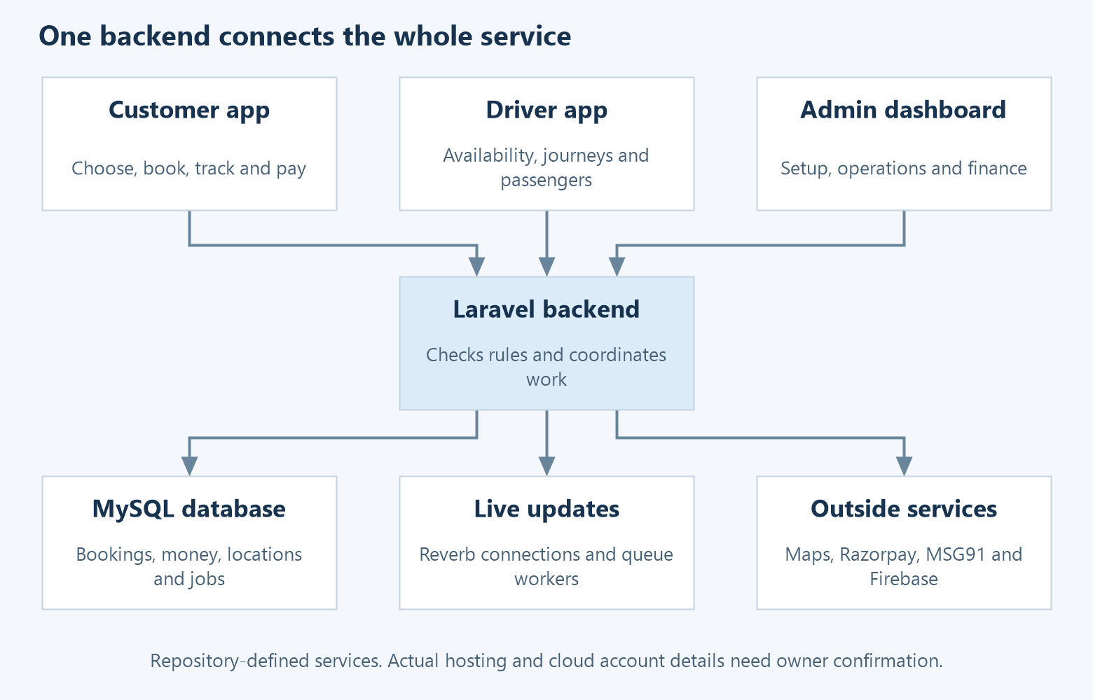
How the five parts connect
The backend is the shared decision-maker. For example, the customer app can ask to reserve a seat, but the backend decides whether the seat is still available. The app must not make that decision on its own.

1.1 Where is the code?
The verified repository is https://github.com/masoodimubashir/cab. It contains all the applications in one place. Separate customer, driver, admin and backend repositories were not found.
Folder | What you will find
customer-mobile/ | Customer app screens and Android project
driver-mobile/ | Driver app screens and Android project
frontend/ | Admin dashboard
backend/ | API, database changes, business rules and tests
website/ | Public website and legal pages
scripts/ | Development tools, Android helpers and small regression checks
docs/ | Project notes, release history and feature specifications

Both mobile apps have Android projects. They also include Capacitor iOS dependencies, but there is no checked-in native iOS project in this workspace. Do not assume that a working Android feature has already been delivered or tested on iOS.

1.2 The three ride types
Type | Simple meaning | Example
Private | The customer books the vehicle for a journey | One customer books a car from home to a hospital
Fixed | The customer books seats on an operator-defined route with stops | A passenger books a seat from Stop A to Stop C
Shuttle | The system groups suitable passenger bookings into a shared journey | Passengers with compatible pickup and drop areas share a vehicle

Local and Outstation describe the service area. They are separate from the three ride types. Scheduled means the customer wants a later time; it is not a fourth sharing model.
The operator controls which combinations are offered. A service can be hidden because it is switched off or because the selected city has no suitable configuration. The app should use the server's service list rather than display every possible option.

1.3 Features that need a clear status label
The source contains the main customer, driver and admin features described below. The Phase 2 notes also describe work still being assessed, including company travel accounts and AI voice booking. Their inclusion in a plan does not make them finished features.
App Assets is explicitly hidden in the admin route configuration. Older screens and older URLs also remain in the repository. Use the current routes to decide which screen to edit.

2. The customer app
The customer app helps someone move from choosing a journey to completing it. The current booking home is under customer-tabs/go and uses pages/booking/. This is an important starting point: the repository also contains older booking pages.

2.1 Sign in and manage an account
The customer enters a phone number and verifies a one-time code. The app stores the login token returned by the backend and sends it with later requests.
The customer can manage profile information, including name, contact details, date of birth, address and profile photo. Profile validation includes an adult date-of-birth requirement. The app also has logout, account deletion, privacy and terms pages.
Saved locations let the customer reuse places such as Home or Work. Emergency contacts and support details are separate features: an emergency contact is chosen by the user, while support numbers are set by the operator.
Code to start with: customer-mobile/src/app/auth/, core/auth.service.ts, core/phone-auth.service.ts, pages/profile/, pages/saved-locations/ and pages/emergency-contacts/.

2.2 Choose a service and places
The booking home keeps a draft containing the selected city, service area, ride type, pickup and destination. Going back to change a step should not lose the other choices.
The code first tries to identify the city whose boundary contains the location. If that is not available, it can use the nearest configured city centre. The selected city matters because it controls which products and routes are available.
The customer can search for a place, use location information or reuse a saved location. Google Maps services help with places, directions and travel estimates. The backend still checks the booking rules.
Code to start with: pages/booking/home/, pages/booking/booking.service.ts, pages/booking/booking.models.ts and pages/booking/place-search.component.ts.

2.3 Book and follow a journey
The booking area has separate Private, Fixed and Shuttle screens. They share the same journey draft but call different backend flows. Sections 5 and 6 explain why these flows must stay separate.
For a Private ride, the app supports fare estimates and a negotiation flow. For Fixed and Shuttle, it handles passenger bookings, seat choices where available, payment and boarding details.
After booking, customers can open their active ride, see the relevant journey details, follow location updates and use the available safety or support actions. The app includes a start-code flow for Private rides and boarding-code flows for shared services.

2.4 Features beyond booking
Customer feature | What it is for
My Trips and trip details | Review journeys and their details
Scheduled rides | Review rides booked for a later time
Fixed bookings and route map | Follow a specific seat booking and its vehicle
Shuttle bookings | Review shared passenger bookings
Coupons | View assigned offers and use eligible discounts
Refunds | See refund records and their progress
Notifications | Read messages stored inside the app
Support | Find operator support information
Ratings and tips | Give feedback or add a tip where the feature is enabled
Invoice access | View or download available trip invoices
Safety and sharing | Use the supported trip-sharing and SOS flows

Do not treat a refund screen as proof that money has reached the customer's bank. The refund status must come from the backend's payment and refund records.
Where to find all current customer routes: customer-mobile/src/app/customer-tabs/customer-tabs-routing.module.ts and app-routing.module.ts.

3. The driver app
The driver app covers both the driver's working day and the driver's account with the operator.

3.1 Register and get approved
The driver signs in, provides a vehicle profile and uploads the required documents. The document catalogue is configurable. Driver documents can be uploaded, approved or rejected; a rejected document can have a reason.
Driver approval is a separate state from document approval. A driver profile can be pending, approved or rejected, and the operator also has deactivation controls. The main working tabs are protected by an approved-driver guard.
The driver account includes vehicle type, registration number, make, model, colour, city and fleet information. A fleet is an operator-managed group of drivers or vehicles.
Code to start with: driver-mobile/src/app/pages/profile/, pages/driver-pending-review/, core/approved-driver.guard.ts, and backend DriversController / AdminDriversController.

3.2 Go online and receive work
Going online means the driver is asking to receive work. It does not guarantee that every nearby request will be offered to that driver.
The backend checks the driver's approval, selected service, vehicle, current work, recent location and relevant wallet rules. Route access also matters for route-based work. A driver who has not sent a recent location may no longer be treated as reachable.
The app has location permission and disclosure handling. It uses foreground and background services according to the active flow. Logout must stop location activity and remove the session; developers must preserve the existing cleanup behavior.

3.3 Carry out a ride
Drivers can review available or assigned rides and perform the actions allowed for that service. Private rides include acceptance, travel to pickup, arrival, start-code checking and journey progress. Fixed and Shuttle work includes passenger lists and boarding/drop actions.
The passenger list is called a manifest. It is used to understand who should board, where they should leave, and which bookings are still active.
The Fixed screen also supports the vehicle/departure workflow. Do not replace it with the Private ride flow: one Fixed vehicle can carry several separately paid bookings.

3.4 Money and account screens
Driver area | What it shows or controls
Dashboard | Working status and operational overview
Rides | Ride requests and active work
Fixed | Route/departure and passenger work
Scheduled | Upcoming assigned or relevant scheduled work
Earnings | Earnings information returned by the backend
Wallet | Balance and transaction records, including top-ups
History | Previous rides
Subscriptions | Available plans, current plan and renewal choices
Refunds | Relevant refund information
Notifications and support | Messages and help
Profile and More | Personal, vehicle and account settings

The wallet is an accounting record. A positive balance does not necessarily mean that a bank transfer has just happened. Section 7 explains how it connects to settlement.
Where to find current driver routes: driver-mobile/src/app/app-routing.module.ts and tabs/tabs-routing.module.ts.

4. The admin dashboard
The dashboard is where the operator sets up the transport business and supports everyday operations. Some staff can see only certain pages or cities.

4.1 Set up the business
Admin area | Plain-English purpose
Setup and Cities | Create operating areas, centres and map boundaries
Vehicles | Configure the vehicles offered in a city and their service settings
Seat layouts | Draw reusable vehicle seat maps
Pricing | Set fare rules and rule-based price adjustments
City settings | Set service-specific booking, waiting, location and support rules
Operator settings | Set global payment options, tips, wallet limits, service visibility and message settings
Fleets | Organise fleet records and related drivers
Roles and permissions | Define which actions staff may perform
Managers | Create or maintain staff access and scope

The vehicle workspace brings together common vehicle details, service-specific settings, routes or driver access where relevant, and seat layouts. Several older URLs redirect to this workspace.

4.2 Run daily operations
Staff can review customers, manage driver approval, inspect uploaded documents, contact drivers, follow rides and view live locations. Manual Dispatch supports staff-created or staff-assigned work through its own permitted flow.
The Rides navigation includes History and Live. In the current Fixed live work, Live opens active Fixed rides and their passenger controls. A booking's history, payment information and support notes are related but separate views.
The dashboard also has Shuttle booking management, safety events and notifications. An SOS record is an application alert; it should not be described as an automatic emergency-services dispatch unless a separate integration proves that behavior.

4.3 Handle money and reporting
Finance brings together money records, driver wallets, commissions, earnings and settlement information. The refund register supports customer-refund follow-up. Coupons and subscriptions have their own management screens.
Analytics includes live information, graphs and reports. An AI reporting feature should start by understanding these existing records rather than creating a second set of financial totals.

4.4 Important Fixed ride controls
Action | When staff can use it | What happens
Admin trip start | Existing eligible trip with an assigned driver | Admin trip controller provides a start action; this is separate from proving the newer Fixed departure-start design is present
Cancel whole Fixed vehicle | Subject to departure and booking checks | Calls the departure cancellation flow and applicable booking refunds
Cancel one passenger booking | Eligible booking that has never boarded | Cancels that booking; other passengers continue
Change a passenger's drop | Existing open trip and eligible passenger | Current admin trip controller updates the stop after basic validation; stronger same-route, ahead-of-vehicle and capacity rules described in older notes need reconciliation
Close new bookings | Open Fixed vehicle | Stops new bookings while existing passengers remain active
Record an offline refund | Eligible outstanding refund already paid outside the app | Records evidence of that payment; it does not send money

The inspected passenger-drop method updates destination fields without recalculating the fare. It rejects finished/cancelled trips and closed passenger bookings. Its checks are not the same as every rule described in the older live-controls note.
A difference between the notes and the code: The older note describes a dedicated early-exit action and shared Fixed start/drop services. The named services are absent from this workspace, and the current Fixed screen does not establish that full workflow. Treat those items as work to reconcile with the owner, not as finished features. This matters when the team decides what still needs building.
Internal support notes stay staff-only. Refund history records the amount, method, reference, staff member and time. A completed or already processing refund must not be paid again.
Code to start with: frontend/src/app/app.routes.ts, admin/fixed/fixed-departures.component.ts, backend AdminTripsController, FixedDepartureService, FixedManifestService and AdminFixedDeparturesController.

5. How a Private ride works
The following is a simple explanation of the normal stages. A configured booking can also fail, be cancelled or wait for a later dispatch time.
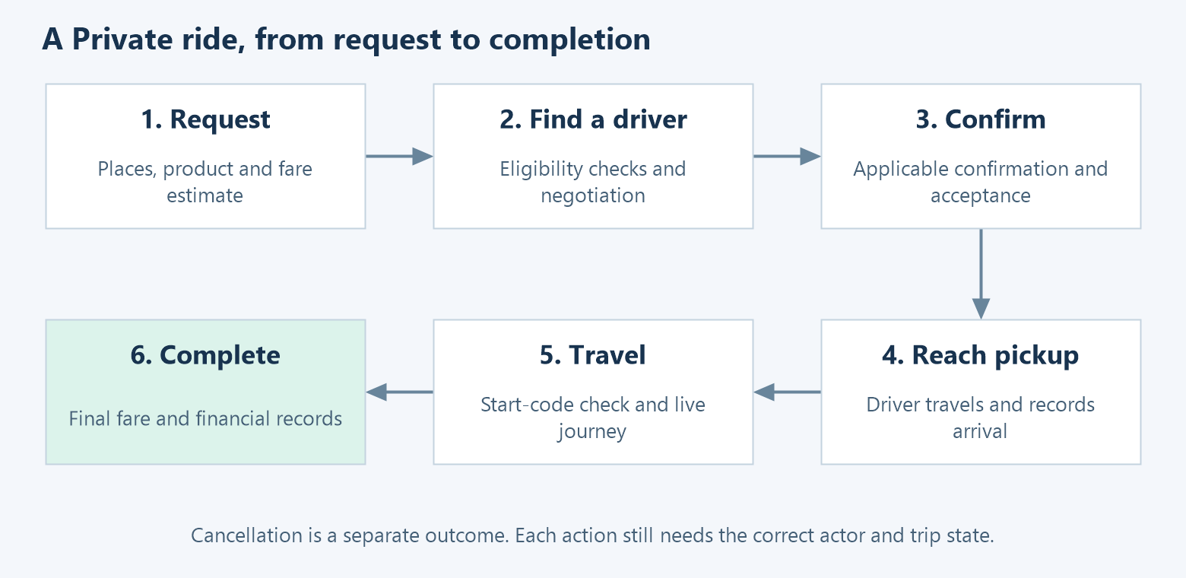
Private ride stages
1. The customer selects pickup, destination and an available product.
2. The backend checks the locations and booking rules, calculates an estimate and creates a trip.
3. The search/negotiation flow looks for eligible drivers and handles offers.
4. The customer and driver complete the applicable confirmation/acceptance steps.
5. The driver travels to pickup and records arrival.
6. The correct start-code flow allows the passenger journey to begin.
7. The driver completes the journey. The backend calculates the final result and updates the financial records.

5.1 The exact states developers will see
Stored state | Meaning
REQUESTED | The trip record has been created
NEGOTIATION | Search or fare negotiation is in progress
CONFIRMED | The trip has reached the confirmation stage
ASSIGNED | A driver has been assigned
EN_ROUTE_PICKUP | Driver is travelling to the pickup
ARRIVED_PICKUP | Driver has reached the pickup
EN_ROUTE_DROP | Passenger journey has started
ARRIVED_DROP | Driver has reached the destination
COMPLETED | Journey is finished
CANCELLED | Trip ended through cancellation

The state service allows the forward sequence shown in the table. It also allows cancellation from each non-terminal state, but individual endpoints add stricter rules about who may cancel and when. A customer cannot assume that every state-service transition is available from the app.
COMPLETED and CANCELLED are different final results. The system does not normally move from a completed ride to a cancelled ride. A later refund is a financial update, not a reason to invent a new ride transition.

5.2 How driver search works
The current search expands the distance around pickup in steps. It first chooses drivers who meet the rules, then uses their recent coordinates to check distance.
The rules include approval, online status, active service area/mode, requested vehicle, configured city pricing, existing busy trips and commission affordability. The job reads recent database location records and calculates distance in PHP.
Search settings come from the selected city's dispatcher settings. Code fallback values are a five-second interval, 500-metre steps and five steps. The live configuration may use other values. A queue worker carries out each step and schedules the next one.
The search stops when the trip leaves negotiation, reaches the configured limit or is replaced by a newer search. Discovery mode shows candidates without sending driver push invitations.
Code to start with: DispatchHopJob, SendDispatchNotificationsJob, FareNegotiationController, RideAssignmentController, TripAssignmentService and TripStateMachineService.

5.3 Scheduled and Outstation rides
Scheduled bookings have rules such as minimum notice, maximum days ahead and how many pending scheduled rides a customer may have. Settings also decide whether matching starts immediately, later or at both stages. The scheduler wakes eligible bookings at the required time.
Outstation is a service scope. The repository has package and related pricing support, but availability depends on operator configuration. Do not assume that every city offers every package or that all planned return/rental changes are already complete.
Code to start with: SchedulingPolicyService, WakeScheduledTrips, OutstationPackage, PricingController and the city's DispatcherSetting.

6. How Fixed and Shuttle bookings work
Shared transport needs more than one trip row. The system must track the vehicle, the passengers, the seats and the money separately.

6.1 Fixed: route, departure and booking
Think of a route as the path, a departure as one vehicle run, and a booking as one customer's place on that run.
Example: Route R goes A → B → C → D. Today's 10:00 vehicle is departure D1. One booking uses two seats from A to C. Another booking uses a seat from B to D. These are two bookings on one departure.
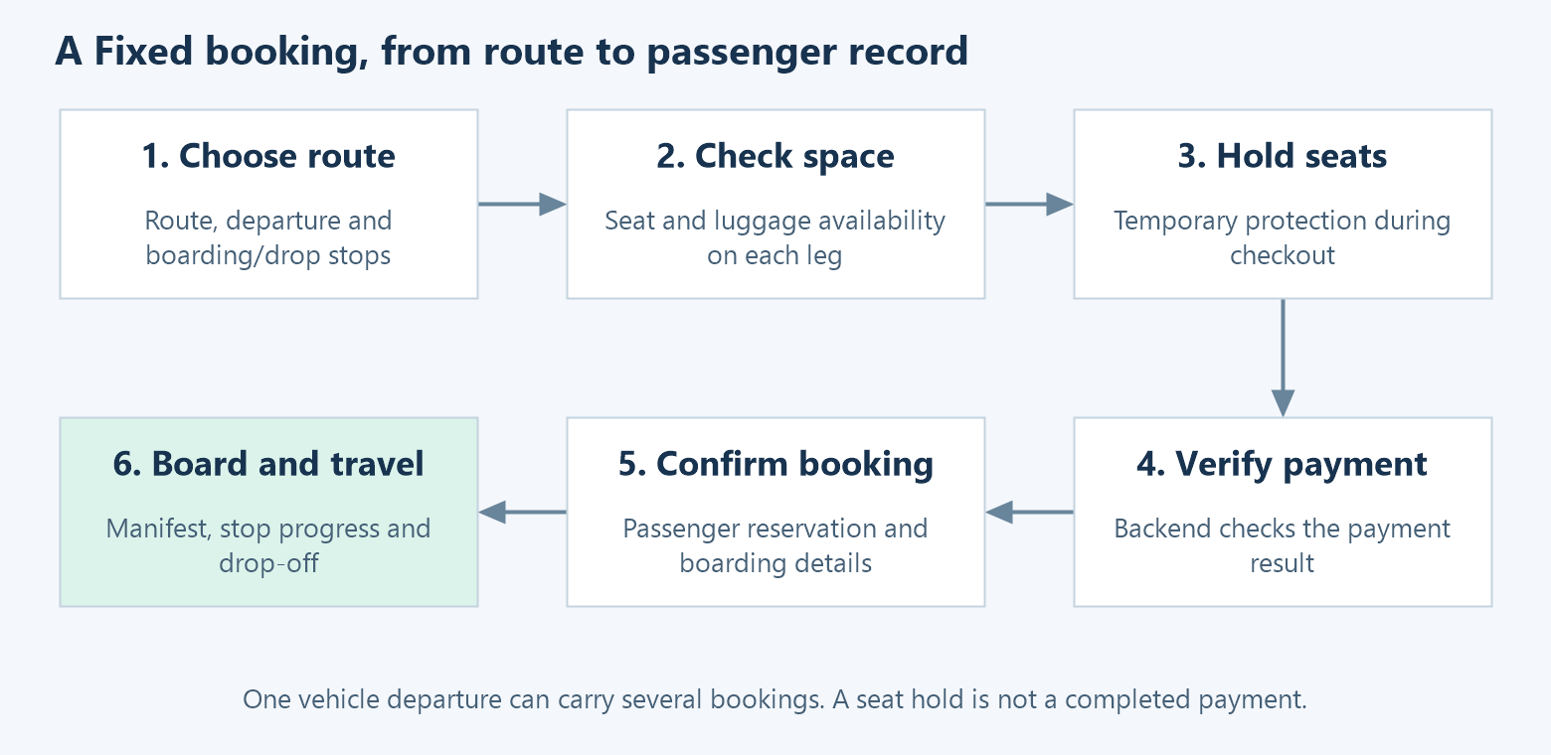
Fixed booking and seat flow
The customer chooses a route, departure, boarding/drop points, seats and any supported extras. The backend checks the route and available space. A temporary seat hold protects the chosen seats while checkout is in progress. Payment confirmation turns the hold into the confirmed booking flow. A hold is not a completed payment.
The system tracks seat use across route sections. A seat occupied from A to C is not available to another passenger from B to D. It may become available after C, subject to the booking and route rules. Luggage capacity also matters.
The current Fixed pricing service uses a route-level seat fare, plus configured extra-luggage charges. It is not automatically a different fare for every drop stop.
The driver works from the passenger manifest. Boarding confirmation, waiting windows, approach notifications and missed-stop handling depend on the configured rules and the related services. Each passenger can finish or cancel independently when allowed.
Code to start with: customer pages/booking/fixed/; backend FixedSeatHoldService, FixedBookingService, FixedAvailabilityService, SeatMapService, FixedBoardingOtpService, FixedStopAutomationService and FixedRefundService.

6.2 Shuttle: forming a shared journey
Shuttle groups passenger bookings into a suitable shared journey. Matching rules include pickup/drop proximity, available capacity and the service's configured limits. Settings include a forming window, waiting rules and whether joining after the start is permitted.
The customer sees a quote, creates a booking, selects seats where the flow allows, and completes the required payment confirmation. The system manages the shared vehicle journey separately from each passenger's booking.
The important models are ShuttleJourney, ShuttlePassengerBooking and JourneySeat. Do not use a Private trip's single-customer assumption when editing these features.
Code to start with: customer pages/booking/shuttle/; backend ShuttleBookingService, ShuttleDriverService, ShuttleSeatMapService, ShuttleBoardingOtpService, ShuttleStopAutomationService and ShuttleRefundService.

6.3 Rules common to shared services
• The backend must check space again when saving; a seat map can become out of date while it is on screen.
• A seat hold, a paid booking, an onboard passenger and a completed journey are different things.
• A database lock prevents competing requests from selling the same space at the same time.
• A booking cancellation and a whole-vehicle cancellation can affect different people and different amounts.
• A payment callback can arrive after the app closes. The server still needs to finish or recover the booking correctly.
Shared-ride changes should be checked with at least two customers competing for space, not only one successful booking.

7. Prices, payments and driver money

7.1 How prices are decided
Fare configuration is stored in the backend. The apps display the result and send the user's choice; they should not become a second authority for pricing.
Private fare rules can include base fare, distance/time thresholds, waiting, pickup charges, tax, tolls and cancellation or no-show settings. Rule-based dynamic pricing can change a price according to configured conditions. That is existing business logic, not proof of an AI pricing model.
Fixed pricing starts with the route seat fare and the number of seats. Extra luggage can add a charge. Shuttle has its own quote and booking rules. Coupons and tips are additional inputs, subject to eligibility and operator settings.
Example — for explanation only: If a Fixed route costs INR 120 per seat and one extra bag costs INR 20, two seats plus one bag give INR 260 before any applicable discount or other adjustment. These figures are not the project's live rates.

7.2 Coupons and subscriptions
Coupons can have city, location, vehicle and per-user restrictions. The backend checks whether an assigned coupon applies and calculates the discount. A coupon appearing on a screen does not make it valid for every trip.
Driver subscription plans can be based on rides, days, a daily period or earnings. Plan pricing can be subscription-only, commission-only or a combination. The plan can affect the commission used for a journey. Renewal, queued plans and expiry are handled by services and scheduled work.
Code to start with: FareEstimationService, DynamicPricingService, FixedPricingService, CouponService, SubscriptionService and CommissionSettlementService.

7.3 Payment choices
The operator controls Online, GPay and Cash choices globally. In the code, Online and GPay use the Razorpay payment path. They are not evidence of two separate payment providers.
Driver payment preferences can narrow the choices when the operator enables that setting. The backend also has fallback behavior to avoid leaving a trip with no payment method. Use PaymentModeService rather than copying only part of that logic into a new screen.
Cash can include an online deposit. The operator sets the percentage, and the driver collects the remaining amount in cash at the end.
Example — for explanation only: With an INR 500 fare and a 20% cash deposit, INR 100 is collected online and INR 400 remains payable to the driver. If a refund is due before the cash is collected, the online payment record does not represent INR 500 received by the operator.

7.4 What happens during an online payment?
1. The app asks the backend to create an order for the correct trip, seat hold, booking or wallet action.
2. The backend uses its Razorpay credentials to create the order.
3. The app opens checkout with the public order information.
4. The app sends the checkout result for server verification.
5. Razorpay can also call the backend's webhook with a payment or refund update.
6. The backend updates the relevant records. Scheduled checks help find payments that remain pending.
A webhook is a message from the provider to the server. The backend verifies its signature. A successful-looking client screen alone must not be used as proof of payment.

7.5 Driver wallet and settlement
The current configuration keeps Razorpay Route automatic split transfers switched off. Online money goes through the operator's collection flow, and driver obligations are tracked through the wallet and settlement records.
The wallet records credits, deductions, top-ups and payouts. The settlement service explains whether the company owes the driver or the driver owes the company.
In simple terms: balance = deposits + credited earnings − deductions − recorded payouts. The service also compares payout entries with settlement records to help identify mismatches.
An example positive balance of INR 800 means the accounting position is INR 800 in the driver's favour. It is not proof that INR 800 was transferred to a bank at that moment.
Residual Route payout-account and transfer code still exists. Do not activate it by assuming an old class name describes the current payment model.
Code to start with: WalletService, NetSettlementService, PaymentReconciliationService, RazorpayService and backend/config/services.php.

8. Cancellations, refunds and support
A cancellation answers “What happens to the ride or seat?” A refund answers “How much money should be returned, and has it been returned?” These need separate records.
The result depends on the service, who cancelled, how far the booking progressed and how much was actually collected online. There is no single correct refund percentage for every ride.
Situation | What developers must check
Customer cancels a Private ride | Current trip state, timing, driver progress and cancellation rule
Customer cancels Shuttle | Passenger state, shared journey/driver state and service refund rule
Fixed passenger booking is cancelled | Passenger status, departure status, collected amount and seat/luggage release
Operator cancels a waiting Fixed departure | Every affected booking and any active holds
Cash booking needs a refund | The online deposit actually collected, not cash that was never received
Refund is already processing | Wait for confirmation or reconcile; do not send another refund
Staff records an outside payment | Require the allowed method and reference; recording must not send money again

The existing code checks for duplicate refunds and handles delayed gateway updates. A refund marked as processing is not the same as a refund confirmed as completed. A late failure must not reopen a completed refund.
Admin support keeps a timeline of actions and internal notes. Notes for staff should not be copied into a customer-visible message without an explicit product reason.
Code to start with: AutoRefundService, FixedRefundService, ShuttleRefundService, RefundRegisterService, BookingPaymentService and the Fixed admin recovery/refund tests.
The detailed notes docs/Fixed-Live-Ride-Controls.md and docs/Fixed-Timeline-Support-Review.md describe the recent local work. Their testing and deployment statements are dated; they do not establish today's live-server status.

9. How the backend works

9.1 A request from screen to database
An API is the set of requests an app can send to the server. For example, POST /api/trips asks the backend to create a trip.
The request passes through login and permission checks where required. A controller validates the input. A service performs the business work. A model reads or saves database records. The server returns a response, and may send a live update or queue a notification.
Backend folder | Meaning
routes/ | Lists the API paths and scheduled commands
app/Http/Controllers/ | Receives requests and returns responses
app/Http/Middleware/ | Checks login, roles, permissions and request rules
app/Services/ | Contains fare, dispatch, booking, payment and other business rules
app/Models/ | Represents records such as User, Trip and SeatReservation
app/Jobs/ | Work run by the queue, such as dispatch steps
app/Events/ | Live messages such as trip status and location updates
database/migrations/ | Ordered changes that build and update the database
database/seeders/ | Starting data and development fixtures
tests/ | Automated checks for expected behavior

9.2 Live updates and location
The apps send location to the backend over HTTP. The backend stores location records and sends updates using Laravel Reverb WebSockets. A WebSocket keeps a connection open so the server can send new information without waiting for another screen refresh.
FCM push is a separate channel used for notifications, especially when the user is not actively watching the screen. Some screens also poll, meaning they fetch the latest record again after a short interval.
Private channels require permission. For example, a trip participant can access the relevant trip channel, while the global live driver map requires the admin live-operations permission. An AI feature must not bypass these checks.
The project does not use a verified Redis GEO location index or Firebase Realtime Database ride store in the reviewed flow. Nearby drivers are found from ordinary database coordinates and distance calculations.

9.3 Workers and scheduled work
The API, queue worker and scheduler do different jobs. Starting the API alone does not start everything.
The queue runs delayed dispatch and notification tasks. The scheduler wakes scheduled rides, dispatches due shared journeys, cleans stale records, expires subscriptions and checks pending payments. If these processes stop, the app may still open while delayed actions fail to happen.

9.4 Server layout
The repository provides a Docker Compose layout with Nginx, PHP/Laravel, MySQL, Reverb, a queue worker and a scheduler. Nginx handles incoming web traffic and serves the website/admin build. Database and uploaded files use persistent volumes.
The real cloud provider, server size, domain setup, backup schedule and monitoring details need the infrastructure owner's confirmation. The code does not prove that a cloud load balancer, managed database or Redis cluster is deployed.
Reference files: backend/docker-compose.yml, backend/Dockerfile, backend/deploy/, DEPLOY.md and .github/workflows/deploy.yml.

10. Understanding the data
A table stores a kind of record. A foreign key connects one table to another. An index helps the database find matching records more efficiently.
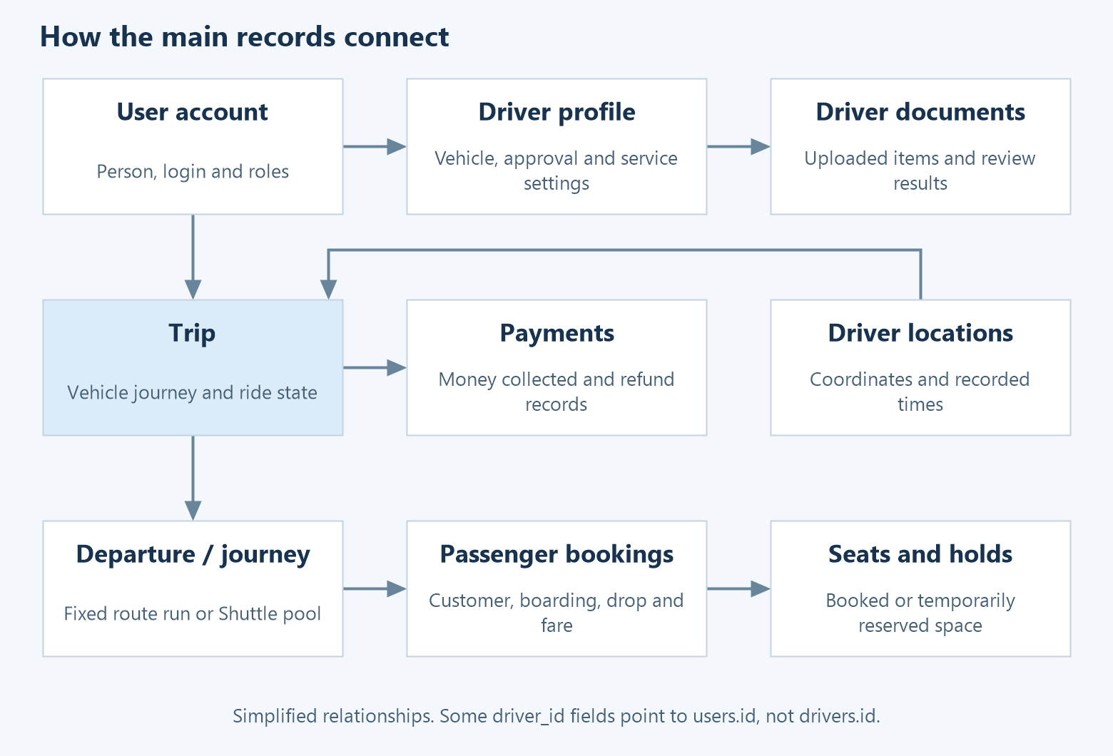
The main records and their connections

10.1 The records most developers need first
Record or table | What one record means
users | A person/account with login and profile details
user_roles | A role attached to a user
drivers | A driver's vehicle and operating profile attached to a user
driver_documents | One uploaded driver document item
cities | One operating area
vehicle_types / city_vehicle_types | Vehicle catalogue and city-specific vehicle/product configuration
pricing_rules | A configured price rule for a product
trips | A vehicle journey with lifecycle and fare information
fare_negotiations / offers | The negotiation and individual price offers
driver_locations | A recorded driver coordinate and time
routes / route_stops | A route and its ordered stops
route_departures | One run or forming vehicle for a route
seat_reservations | A customer's Fixed/shared-route booking
fixed_seat_holds | Temporary checkout reservation
departure_seats | Seat records attached to a departure
shuttle_journeys | A shared Shuttle vehicle journey
shuttle_passenger_bookings | One Shuttle passenger booking
journey_seats | Seat records for a Shuttle journey
payments / invoices | Financial receipt/payment and invoice records
wallet_transactions | Credits and deductions for an account
driver_settlements | Driver settlement records
coupons / assignments | Discount rules and their allocation to users
subscription_plans / driver subscriptions | Driver plan definitions and purchased plan records

The database also stores notifications, device tokens, support/safety information, admin permissions, settings and other supporting records. The separate technical reference includes the wider model and migration inventory.

10.2 The driver ID rule
This is easy to get wrong. In trips.driver_id and driver_locations.driver_id, the value points to users.id. In driver_documents.driver_id, it points to drivers.id.
Example: A person's user ID may be 42 while their driver-profile ID is 7. Their trip uses driver ID 42, but their uploaded document uses driver ID 7. Connect the two through drivers.user_id.

10.3 Main fields in plain English
Object | Important fields
User | Name, phone/email, password hash, date of birth, address, roles, preferences and account restrictions
Driver | User link, city/fleet/vehicle links, approval, service scope/mode, vehicle details and online timestamps
Document | Driver-profile link, document definition, file path, image number, entered values, review status and reason
Trip | Customer/driver links, product, pickup/drop coordinates, status, estimated/final fare, payment method and stage timestamps
Driver location | Driver-user link, optional trip link, latitude, longitude, accuracy, speed, bearing and recorded time
Passenger booking | Journey/departure link, customer, seats, boarding/drop points, fare, payment, refund and boarding state

Driver location latitude and longitude use decimal columns. The main location indexes include driver plus recorded time, and trip plus recorded time. Trip indexes include customer plus status, and driver plus status. Bearing records direction; it is not a special geographic index.
Migrations add and change fields over time. For an exact final SQL schema, apply the migrations to an isolated database or ask the owner for a schema-only export. A list of old migration statements alone cannot prove which columns exist in production.

11. Outside services and configuration
Service | What DreamCabs uses it for | What the owner must provide
Google Maps | Place search, geocoding, directions, maps and travel estimates | Restricted development key and enabled APIs
Razorpay | Online payments, order verification, refunds and payment callbacks | Test key pair and webhook secret/configuration
MSG91 | Server-generated phone OTP delivery | Test/live credentials and approved messaging configuration where needed
Firebase / FCM | Push notifications and the retained Firebase authentication path | Correct project registration and server/app configuration
Email transport | Configured email notifications | Appropriate mail settings; local setup uses log output

The reviewed code does not establish Stripe, Braintree or Twilio as active providers. Do not configure them simply because they appear in a generic handover checklist.

11.1 Public settings versus secrets
An API address, Firebase Web project settings, Reverb app key and restricted browser Maps key can appear in client configuration. They identify the connection or project.
A database password, Razorpay secret, webhook secret, MSG91 credential, Reverb secret and Firebase service-account private key must stay on the server or in the authorised secret store. They do not belong in an app build, document or Postman export.
The supplied examples use placeholders and local fixture values. Existing older sample/test files in the repository contain credential-like or machine-specific values. The owner should review any still-valid exposed credentials before giving broader access.

11.2 Android, Firebase and iOS
The Android IDs are product.customer.dreamcab and product.driver.dreamcab. Native Firebase files, Web Firebase settings and messaging service workers must refer to the intended projects and registrations. A matching project name alone does not prove push works.
Before signing or Firebase migration work, read docs/Android-Release-Handoff.md, then docs/Google-Play-Release-Setup.md. These notes preserve what was checked locally, what the user reported and what still needs external confirmation.
The current documentation does not establish an iOS native build, APNs credentials or an approved iOS toolchain. Treat that as a separate handover task for the mobile owner.

12. Set up the project locally
The aim is to run a separate development system on your computer. Do not point an internship experiment at the live API or production database.

12.1 What to install
Tool | Project requirement or checked version
PHP | 8.3 or a compatible version allowed by Composer; deployment image uses 8.3
Composer | Major version 2; exact patch is not pinned
MySQL | Version 8.0 is the supplied deployment baseline
Node.js | Use a team-approved Node 22 version at least 22.12; local documentation tooling ran on 22.22.3
Java for Android | JDK 21
Android SDK | Compile/target API 36; minimum app API 24
Gradle | Use the included 8.14.3 wrapper

The admin is on Angular 17. The mobile apps are on Angular 20, Ionic 8 and Capacitor 8. Use each project's lockfile with npm ci. Do not try to make every application use one global Angular installation.
Exact locked versions: admin Angular 17.3.12; customer Angular 20.3.21 / Ionic 8.8.8 / Capacitor 8.3.4; driver Angular 20.3.18 / Ionic 8.8.1 / Capacitor 8.3.3; Laravel 13.1.1 / Reverb 1.8.1 / Sanctum 4.3.1. These are source snapshot versions, not promises about the deployed server.
Use MySQL for the complete local setup. Some later migrations use MySQL-specific operations, so the old SQLite default is not a reliable full-project setup.

12.2 Prepare the backend
Create a new checkout. Install the PHP extensions listed in backend/Dockerfile. Create a local MySQL database named dreamcabs_internship and a dedicated development database user.
From the new checkout, run:
Set-Location backend
composer install
Copy-Item ../docs/internship-handover/templates/backend.env.example .env
Edit the new .env and enter your local database username/password. Do not overwrite an existing configured environment without checking it. Then run:
php artisan key:generate
php artisan config:clear
php artisan migrate
php artisan db:seed
php artisan storage:link
php artisan serve --host=127.0.0.1 --port=8000
Open three more terminals in backend/. Run one command in each:
php artisan reverb:start --host=127.0.0.1 --port=8080
php artisan queue:work --tries=3 --timeout=90 --sleep=2
php artisan schedule:work
Expected result: the API is available at http://127.0.0.1:8000/api, the WebSocket server runs on 8080, and background jobs can run. Linux or WSL is preferable when checking scheduled background-process behavior.

12.3 Start the admin and mobile web apps
The client applications read TypeScript files under src/environments/. They do not automatically load a .env file. The existing development files point at the live domain, so change them before testing.
Use the corresponding example from docs/internship-handover/templates/ as the local src/environments/environment.ts. The examples use a local API and have no real Maps or Firebase setup.
In separate terminals, install and start each project:
# Inside frontend/
npm ci
npm start -- --port 4200
# Inside customer-mobile/
npm ci
npm start -- --port 8100
# Inside driver-mobile/
npm ci
npm start -- --port 8200
Expected result: admin on 4200, customer on 8100 and driver on 8200. Missing Maps/Firebase configuration will limit those features; it does not mean the basic API setup is wrong.
On a physical phone, 127.0.0.1 refers to the phone. Use the development computer's reachable LAN address and the project's device helpers. Debug/device setup and release signing are different tasks.

12.4 Create useful test data
The default seeder creates service modes and admin permissions. It deliberately does not create a ready-to-book city with vehicles and price cards.
1. Sign into the local admin using the configured local admin account.
2. Create a test city and a boundary covering your pickup and destination.
3. Add a vehicle type, base city vehicle and the service/product you want to test.
4. Add valid pricing and dispatch settings. For Fixed, also set up a route, stops, seat layout and departure.
5. Run php artisan db:seed --class=DummyUsersSeeder from backend/.
6. Check the driver's city, service, route access where needed, wallet requirements and online status.
To add nearby demo pins, the repository includes:
php artisan drivers:simulate-nearby --lat=28.6139 --lng=77.2090 --count=5 --radius-km=2
This creates location fixtures. It does not configure all the rules needed to make those drivers eligible for real dispatch. Re-run with --jitter to refresh positions during a local demo.

12.5 Test accounts and mock OTP
Role | Local fixture | How to use it
Admin | admin@example.com / password by default | Admin email/password login; change through local seed settings
Customer | customer01@dreamcabs.test, phone 9000000001 | Mobile OTP login
Driver | driver01@dreamcabs.test, phone 8000000001 | Mobile OTP login; profile seed requires base vehicles

With MSG91_AUTH_KEY blank, the existing server sends no real SMS and returns a random dev_code. Use that returned code. 123456 is not a permanent bypass password.
Mock delivery is controlled by the missing provider credential, not only by development mode. Do not deploy the local sample as production configuration. This documentation adds no new login bypass.

13. Use the API without the app
Postman lets developers call the backend directly. This helps distinguish a server problem from a screen problem.
Import the provided collection and environment from docs/internship-handover/. They contain local-only requests, sample payloads and automatic customer/driver/admin authentication. Select the local environment before running them.
The collection only accepts localhost or 127.0.0.1. It will not run against the live domain. Its authentication scripts use the mock OTP result. Set a real local city_vehicle_type_id before trying the sample trip request.

13.1 Requests to learn first
All paths below follow the /api prefix unless stated otherwise.
Request | Purpose
GET /health | Check the API responds
POST /auth/otp/sms/start | Ask for a server-generated OTP
POST /auth/otp/sms/verify | Verify it and receive a login token
POST /admin/login | Sign into admin with email/password
GET /pricing/cities | Read available cities
GET /pricing/cities/{city}/products | Read the city's offered products
POST /pricing/estimate | Request a fare estimate
POST /trips | Create a Private trip request
POST /drivers/location | Send a driver's current location
POST /fixed/seat-holds | Hold Fixed seats during checkout
POST /shuttle/bookings | Create a Shuttle passenger booking
POST /payments/webhook/razorpay | Receive a signed Razorpay callback

The {city} or {trip} part means “insert the real record ID here.” Most account or ride actions also need Authorization: Bearer <token>.

13.2 A simple OTP example
Send this to /auth/otp/sms/start:
{"phone":"9000000001","platform":"android"}
Read dev_code from the local mock response, then send this to /auth/otp/sms/verify:
{"phone":"9000000001","code":"THE_RETURNED_CODE","intent":"customer"}
The returned token identifies the signed-in user. Do not put it in a shared document. The non-SMS /auth/otp/verify path belongs to the Firebase flow and has a different contract.

13.3 Where the full API definition lives
backend/routes/api.php lists the routes. Controllers define the validation rules. Run php artisan route:list --path=api in your local backend for the resolved route list.
backend/openapi.yaml also exists, but it does not cover every newer route or guarantee current request shapes. The supplied Postman set is an onboarding collection, not a full automated test of every feature.

14. How to test a change
Start with the feature you changed, then test its neighbours. A changed seat rule needs booking and cancellation checks. A changed refund rule needs duplicate/refailed callback checks. A changed login flow needs logout and permission checks.

14.1 A useful manual test set
Area | What to try
Login | Correct, wrong and expired OTP; cooldown; logout
Private | Estimate, offer, accept, arrival, start code and completion
Driver search | No driver; busy driver; wrong service; stale location
Fixed | Two users select the same seat; hold expiry; pay and board
Shuttle | Suitable and unsuitable shared journeys; capacity and cancellation
Fixed support | Check implemented actions; use the older same-route/capacity/early-exit requirements to identify gaps before claiming completion
Payments | Successful test payment, pending result and callback retry
Refunds | Already refunded, processing, failure and repeated staff action
Access | A customer cannot read another customer's trip; staff city/permission limits
Location | Reconnect, background state and logout cleanup

14.2 Automated checks
Backend tests use MySQL and can refresh tables. First prepare a separate disposable test database. Review backend/phpunit.xml; it contains machine-specific settings that must not be blindly used on a shared database.
# In backend/, after checking the test database:
php artisan test
# In the application you changed:
npm run build
# From the repository root for relevant mobile changes:
node scripts/test-location-cleanup.cjs
node scripts/test-customer-age.cjs
These are instructions for developers. This documentation rewrite does not claim to have rerun the app's full test suite or tested phones, live payments or production deployment.

15. The planned AI integration
The project's Phase 2 scope specifically describes AI voice booking. This should be the starting context for the internship team, rather than assuming the task is to replace driver matching with machine learning.
The intended flow is a short recording, speech-to-text, journey-detail extraction, server checks and customer confirmation. It is planned work in the scope notes; a completed production voice-booking endpoint was not established by this review.
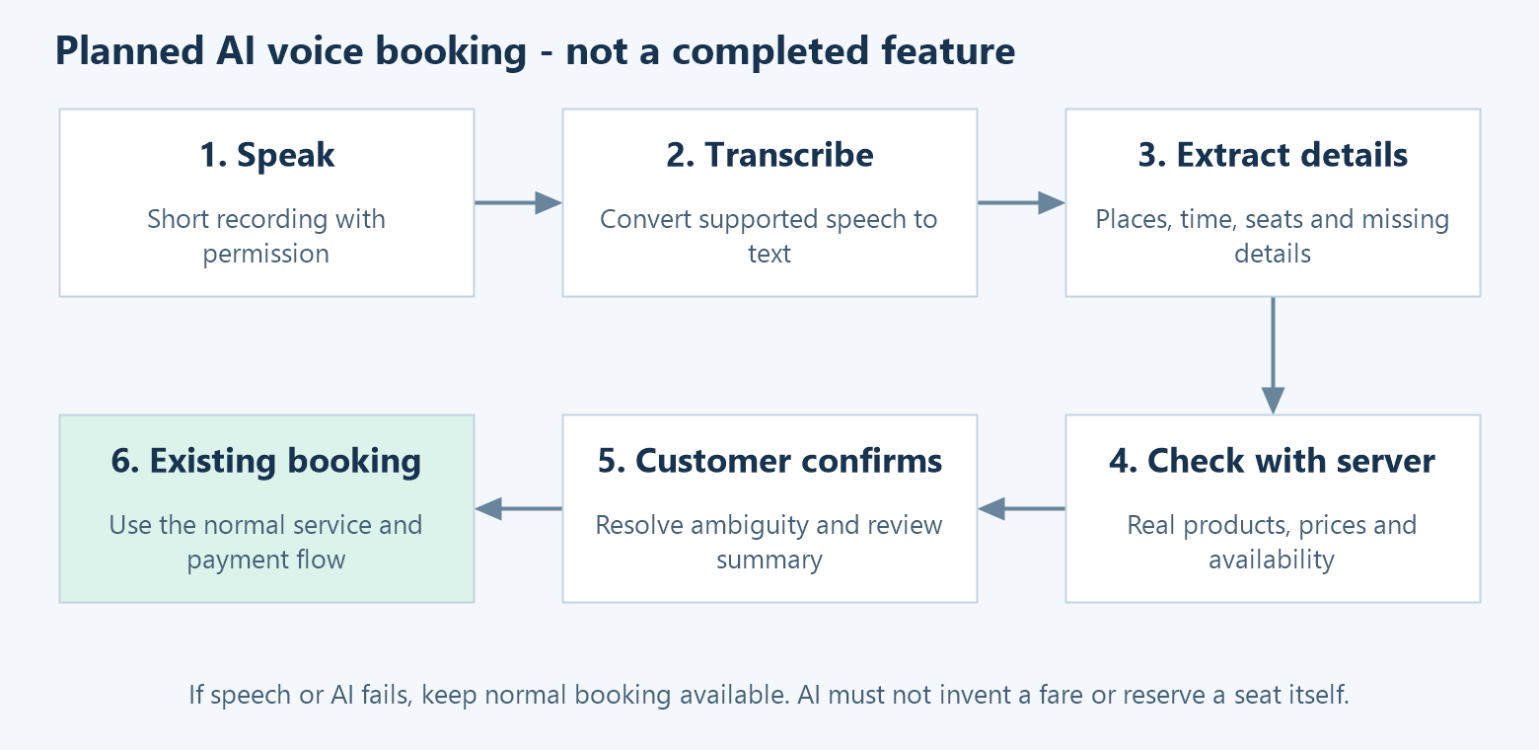
Planned voice-booking flow

15.1 A simple example
The customer says: “I need two seats from Sopore to Srinagar tomorrow morning.”
The AI may identify an origin, a destination, two seats and a broad time. It must not invent the exact departure, price, seat numbers or available vehicle. The app should ask the customer to choose or confirm any missing detail.
The backend then returns the actual services, routes, fares and availability. After the customer confirms, the app uses the appropriate existing booking flow.

15.2 What the AI may do
• Convert a short supported recording into text.
• Extract the locations, requested time, number of seats and any clearly stated service preference.
• Help match wording to supported places, while showing ambiguity.
• Ask for missing information and prepare a clear confirmation summary.

15.3 What the normal backend must still do
• Check the customer's login and permissions.
• Check city boundaries, supported products, routes and schedules.
• Calculate fares and validate coupons.
• Check and reserve seats and luggage capacity.
• Find or assign eligible drivers through the existing rules.
• Verify payment, boarding and ride transitions.
The AI should never invent a booking ID, promise an unavailable seat, declare a payment successful or bypass confirmation. The normal booking screen must remain available when audio, network or AI processing fails.

15.4 Suggested implementation steps
1. Agree the exact Phase 2 task and confirm any decisions still open with the owner.
2. Make one short audio recording flow with permission and failure handling.
3. Put speech and AI provider connections behind Laravel services, keeping keys on the server.
4. Define a small response structure with extracted fields, missing fields and ambiguous places.
5. Validate those fields against the real catalogue. Return choices where there is more than one possible match.
6. Show a customer-readable summary and require confirmation.
7. Reuse BookingService and the existing Private/Fixed/Shuttle API flows; add no parallel payment or reservation system.
8. Test English, Hindi, mixed phrasing, local place names, noise, permission refusal, time ambiguity and provider failures.
Suggested extraction fields, not an implemented API: origin text, destination text, requested time, seat count, explicitly stated mode, missing fields and alternative place matches. Keep server-resolved IDs separate from words guessed by the model.

15.5 Scope and data limits
The current scope describes short-recording English/Hindi booking assistance. It does not establish a telephone agent, continuous voice conversation, custom model training or additional languages. Provider choices and final limits require confirmation from the approved scope.
Use synthetic examples for early work. Rider phone numbers, movement history, identity documents, login codes and bank details do not belong in external AI prompts or training exports without specific owner approval.
Add a feature switch, timeouts, usage limits and useful error messages. Record technical outcomes such as processing time and failures without logging unnecessary personal audio/text. Define recording retention with the owner.

15.6 Other planned work
Phase 2 also lists company travel accounts: company access, employee links, credit limits, ride controls and monthly statements. These are planned items, not proof of existing complete company billing.
ETA prediction, demand forecasting or AI-assisted support could be later projects. They are separate from the voice-booking scope and need their own agreed data and acceptance criteria.
Reference: docs/DreamCabs-Phase-2-Plain-Language-Scope.md. Its tracker includes pending decisions and work that still needs assessment. Read it before deciding what the internship should deliver.

16. Where to change a feature
Use this map as a starting point. Paths without a prefix in the backend column are inside backend/app/.
Feature | Client starting point | Backend starting point
New booking home | Customer pages/booking/home/ | Http/Controllers/PricingController.php
Private booking | Customer pages/booking/private/ | TripsController, FareNegotiationController
Fixed seats and checkout | Customer pages/booking/fixed/ | FixedSeatHoldService, FixedBookingService
Shuttle booking | Customer pages/booking/shuttle/ | ShuttleBookingService
Driver availability/location | Driver core/driver-presence.service.ts | DriversController, DriverLocation
Driver approval | Driver profile; admin drivers area | AdminDriversController, DriverDocument
Live ride status | Client core/realtime.service.ts | TripStateMachineService, Events/
Fixed live controls | Admin admin/fixed/fixed-departures.component.ts | AdminFixedDeparturesController, FixedDepartureService; trip actions in AdminTripsController
Pricing and coupons | Admin pricing/promotions; booking pages | FareEstimationService, CouponService
Payments | Customer checkout and driver top-up screens | PaymentsController, RazorpayService
Refund support | Admin refunds/Fixed drawer | RefundRegisterService, FixedRefundService, ShuttleRefundService
Driver money | Driver wallet/earnings; admin finance | WalletService, NetSettlementService
Driver plans | Driver subscriptions; admin subscriptions | SubscriptionService
Staff access | Admin roles/managers | role/permission middleware and ManagerScope
Push and inbox | Client core/push.service.ts | NotificationService, NotificationCenter, DeviceTokensController
Planned voice input | Customer pages/booking/ | New adapter services around existing booking rules

Start from the routed screen, follow its API call, read the controller validation, then read the service and tests. This order helps avoid editing an older unused page or adding a rule in only one client.

17. Common problems and the first checks
Problem | First checks
No service appears | Correct city, enabled scope/mode, active product, route and price setup
Driver receives no request | Approval, active mode, online freshness, busy trip, vehicle/city eligibility, wallet and queue worker
Map is blank | Maps key, API enablement/restrictions and browser errors
Live screen does not update | Reverb process, host/port/key, channel permission and fallback polling
OTP cannot be tested | Correct /sms/ route, blank local MSG91 key, returned code, cooldown and expiry
Booking returns validation error | Actual response message, correct product ID, city boundary and required fields
Fixed seat becomes unavailable | Another booking/hold, route-leg overlap, hold expiry or layout setup
Payment remains pending | Correct test credentials, webhook verification, queue/scheduler and reconciliation logs
Refund button fails | Booking eligibility, already completed/processing refund, outstanding amount and gateway verification
A new endpoint returns not found | Correct method/path and local route cache; use php artisan route:list
Works in browser but not phone | LAN address, device permissions, native config and network reachability
Finance amounts differ | Wallet entries, payment/refund state, commission snapshot and settlement records

Do not fix an error by removing a permission, seat-capacity or payment-verification check. First understand which rule rejected the action.

18. What the owner still needs to hand over
The code can explain behavior, but it cannot prove account ownership or current server configuration.
Owner task | Why the team needs it
Choose a reviewed starting commit | Everyone develops from the same agreed version
Grant repository and review access | Interns can raise changes through the right process
Provide sandbox credentials securely | Maps, push and payment integration can be tested without live users
Describe actual hosting and deployment | Team knows where services run and how changes are released
Provide schema-only database evidence | Confirms which migrations are applied on the target environment
Explain backups and rollback | Changes can be recovered safely
Confirm Android/iOS responsibilities | Avoids assuming iOS release work is already complete
Confirm Phase 2 decisions and AI acceptance checks | Gives the internship a measurable delivery scope
Approve data access and retention | Makes clear which records/audio the AI work may use

An initial intern milestone is simple: run the isolated system, create a configured test service, complete a test booking, explain where its records are stored, and show the existing flow that voice input will feed into.

19. Small glossary
Word | Simple meaning
API | Requests an application can send to the backend
Backend | The server code that checks rules and stores data
Token | A login credential sent with authenticated requests
OTP | A short-lived, one-time verification code
Dispatch | Finding or assigning a suitable driver
Geofence | A map boundary used by an operating rule
ETA | Estimated arrival time
Manifest | Passenger list for a vehicle journey
Departure | One run of a route
Seat hold | Temporary reservation while checkout is in progress
Queue | Work waiting for a background worker
Scheduler | Process that starts tasks at the required time
WebSocket | Open connection for live server updates
Webhook | A provider's callback to the backend
Migration | A versioned change to database structure or data
Seeder | Code that creates starting or test records
Ledger | A record of money credits and deductions
Settlement | Working out and recording what the driver/company owes
Idempotent action | An action designed so a retry does not create another result
Sandbox | A separate environment for testing

20. Technical reference and document status
This is the readable entry point. The separate reference files contain the detailed model inventory, environment templates and Postman requests. You do not need to read the raw source catalog before understanding the product.
Original handover request | Where this guide covers it
Apps, repositories and architecture | Sections 1, 9 and 16
Live location and matching | Sections 3, 5 and 9
Hosting diagram and service map | Section 9 and the system diagram; actual host inventory is an owner task
Data, relationships and ride states | Sections 5, 6 and 10; detailed source catalog in the reference pack
Maps, payments, OTP and push | Sections 7, 8 and 11
Tools, environment and local setup | Section 12 and the configuration examples
API collection and test accounts | Sections 12–14 and the Postman files
Next AI integration | Section 15 and the Phase 2 scope

This revision expands the product explanation, including the current booking screen, Fixed/Shuttle differences, seat and luggage rules, live passenger controls, coupons, subscriptions, payment deposits, settlement, refunds and planned voice booking.
The documentation build checks the files and document structure. It does not publish an app, change the backend, run a live payment or establish production readiness. Keep future updates dated and distinguish code evidence from a live-system check.

