Spectra Guard – A Privacy-Enhancing Tool (PET)

# Submitted By

Student-1 Name: Masooma Hassan  
Roll Number: 22K-4749  
Student-2 Name: Umer Ahmed  
Roll Number: 22K-4684  
Department of Cyber Security  
**National University of Computer & Emerging Sciences**

# 1. Motivation

This project was undertaken with the goal of addressing growing concerns over online privacy and security. As the digital landscape continues to evolve, users are more vulnerable to privacy breaches, surveillance, and data theft. The increasing use of surveillance technologies, data-driven services, and targeted advertising poses risks to individuals' privacy. The development of a privacy-enhancing tool (PET) that integrates multiple security protocols such as IP masking, secure browsing, encryption, and data anonymization offers a solution to safeguard user data and maintain confidentiality during online interactions. The implementation of Tor, VPNs, DuckDuckGo, and homomorphic encryption provides a multifaceted approach to user privacy protection.

# 2. Overview

## 2.1 Significance of the Project

The Spectra Guard project holds significant academic and practical value. Its importance lies in the growing concerns surrounding privacy issues in digital platforms. By leveraging technologies like Tor, VPNs, and homomorphic encryption, the project aims to provide robust privacy protection for users. The tool enhances anonymity, ensuring that users’ personal data and browsing habits remain confidential, thus minimizing the risk of surveillance, tracking, and cyber threats.

## 2.2 Description of the Project

Spectra Guard is a privacy-enhancing tool designed to secure user data during online activities. By integrating IP masking via Tor and VPNs, it ensures that users’ IP addresses and browsing activities are concealed from potential trackers. The tool supports encrypted communication through Fernet encryption, making user conversations secure. In addition, the tool anonymizes sensitive data by using techniques such as k-anonymity and differential privacy. The project also provides secure cloud storage(simulated cloud) using homomorphic encryption, allowing users to perform operations on their encrypted data without compromising privacy.

## 2.3 Background of the Project

Privacy in digital interactions has become a significant concern, with increasing surveillance by governments, organizations, and hackers. Tor and VPN technologies have been implemented to mask user IP addresses and provide a more secure browsing experience. Moreover, secure messaging and encryption protocols like AES and Fernet have been widely adopted for protecting sensitive data during transmission. Homomorphic encryption, though complex, offers an innovative approach for secure cloud storage, allowing computations on encrypted data without decryption.

## 2.4 Project Category

This project is categorized as a Research-based project, primarily focused on privacy-enhancing technologies and secure communication systems. It aims to provide a comprehensive solution to online privacy challenges by integrating state-of-the-art cryptographic and anonymity technologies.

# 3. Features / Scope / Modules

• IP Masking (Tor/VPN Integration): This feature allows users to anonymize their traffic by routing it through the Tor network or a VPN, preventing websites and ISPs from tracking users' IP addresses and locations.  
• Secure Browsing (DuckDuckGo API): The integration of DuckDuckGo’s anonymous search API ensures that all search queries are not tracked, providing users with a secure browsing experience.  
• Encrypted Communication (End-to-End Encryption): User messages are encrypted with Fernet encryption (AES-128), ensuring that only authorized recipients can decrypt and read the messages.  
• Data Anonymization (K-Anonymity and Differential Privacy): This module ensures that sensitive data is anonymized using k-anonymity and differential privacy techniques to protect user identities in datasets.  
• Secure Simulated Cloud Storage (Fully Homomorphic Encryption): Using Fully Homomorphic Encryption (FHE), users’ cloud-stored data remains encrypted while still allowing computation on the encrypted data.

# 4. Project Planning

* Week 1: Research and Setup - Study privacy technologies (Tor, VPNs, DuckDuckGo, cryptographic tools) and set up the development environment.  
  • Week 2: Core Functionalities - Develop IP masking using Tor/VPN, integrate DuckDuckGo API for secure browsing.  
  • Week 3: Encryption and Secure Communication - Implement end-to-end encryption using Fernet for secure messaging.  
  • Week 4: Data Anonymization and Cloud Security - Implement k-anonymity and differential privacy for data anonymization, and homomorphic encryption for secure cloud storage.  
  • Week 5: Testing, Refinement, and Documentation - Perform functionality testing, refine the tool, and document the project.

# 5. Project Feasibility

• Technical Feasibility: The project is feasible with current technologies such as Python, cryptography libraries, and cloud services. The tools and techniques required are well-established and available for implementation.  
• Economic Feasibility: The project requires minimal financial investment beyond time and effort, as it utilizes open-source technologies and existing platforms (e.g., Tor, VPN services).  
• Schedule Feasibility: The project has been planned to fit within a five-week timeframe, with clear milestones for each phase.

# 6. Hardware and Software Requirements

• Hardware: Computer with internet access, Server for cloud storage (optional)  
• Software: Python 3.x, Cryptography libraries (Fernet, AES), OpenSSL, Tor and VPN software, DuckDuckGo API, Google Cloud or similar for secure cloud storage, Development tools (e.g., Visual Studio Code)

# 7. Diagrammatic Representation of the Overall System

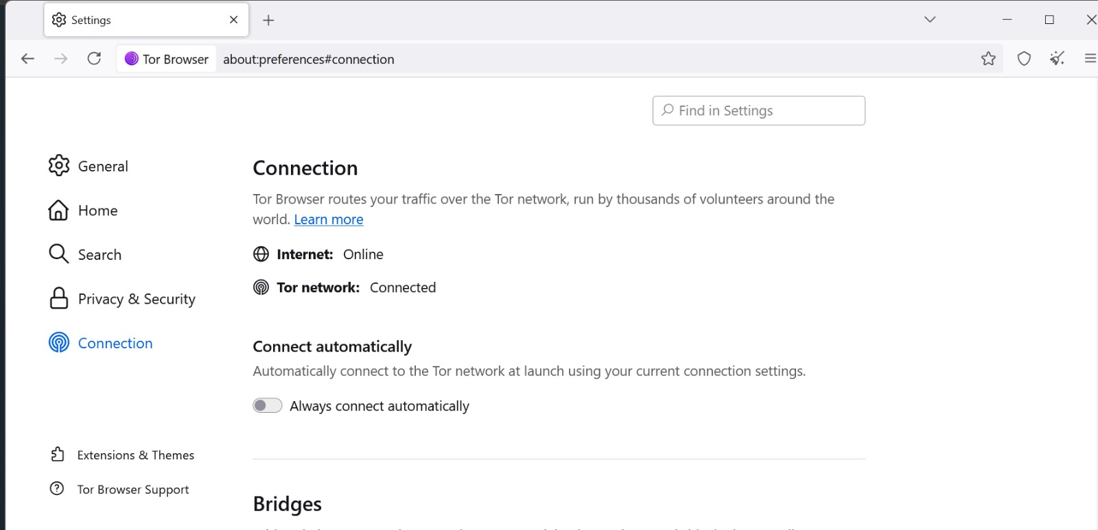

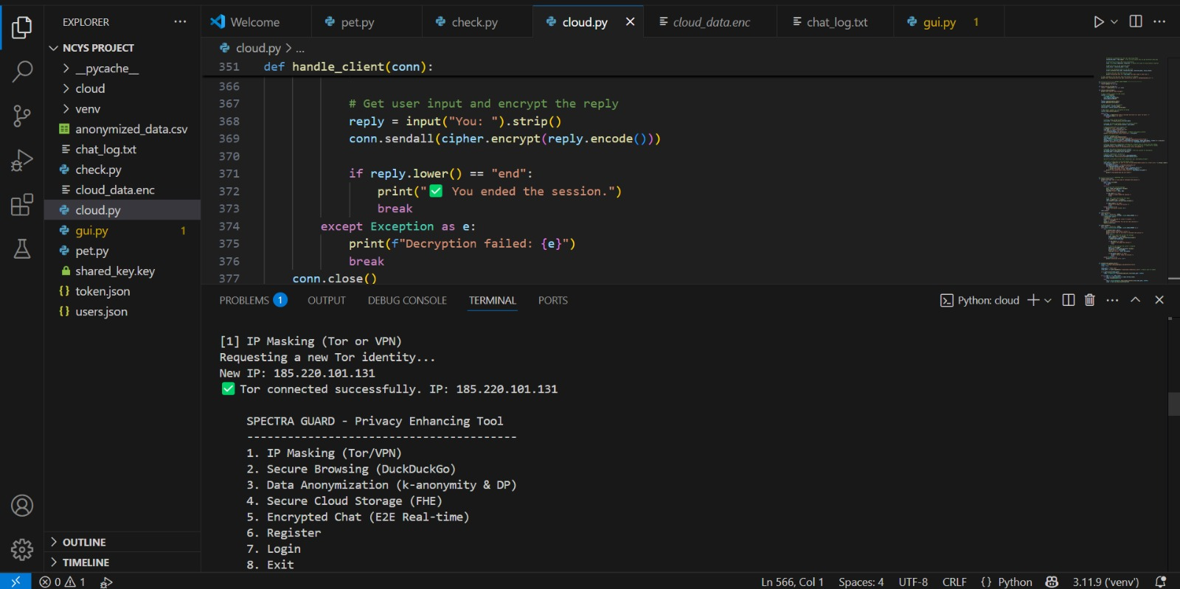

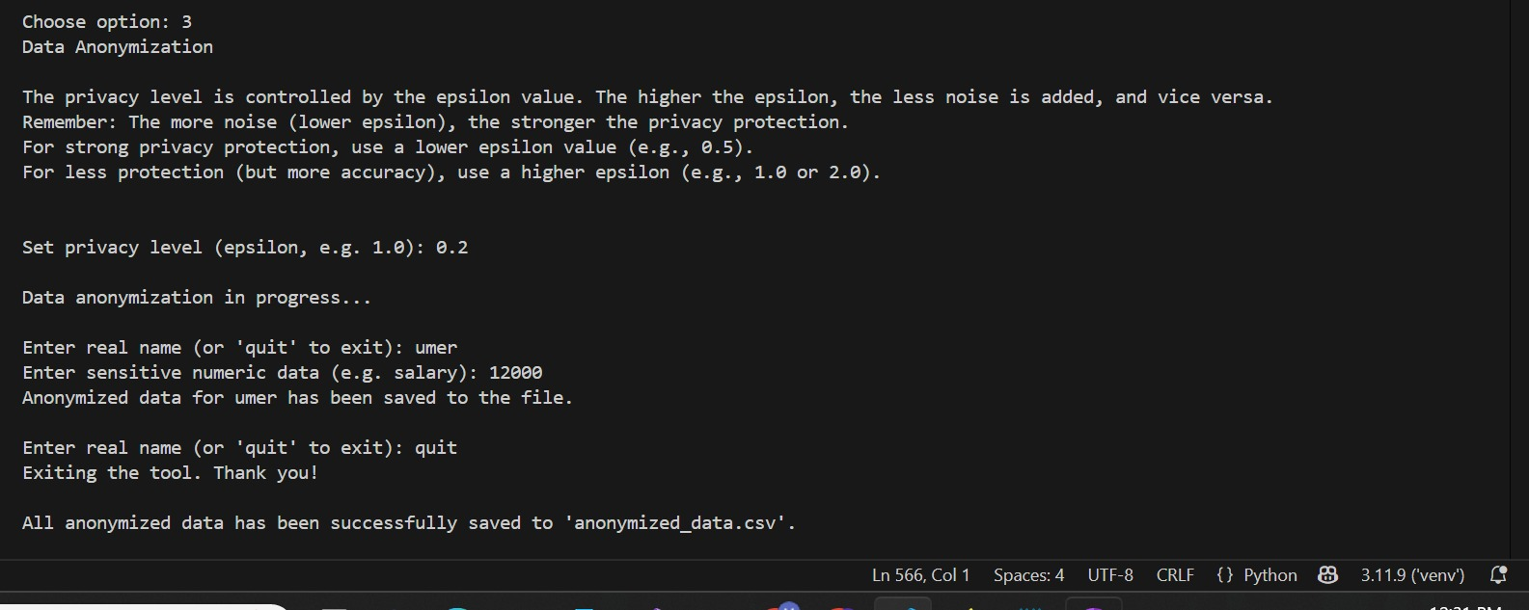

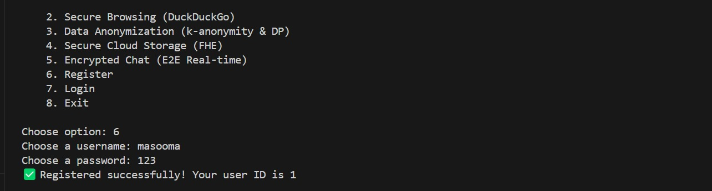



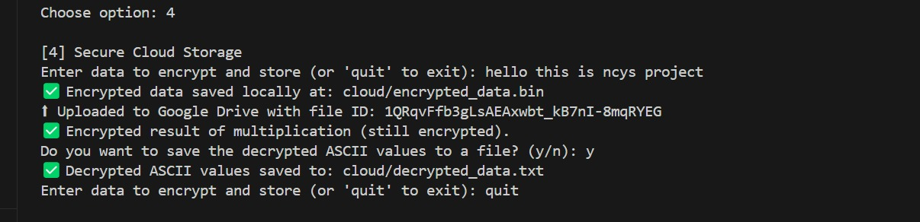

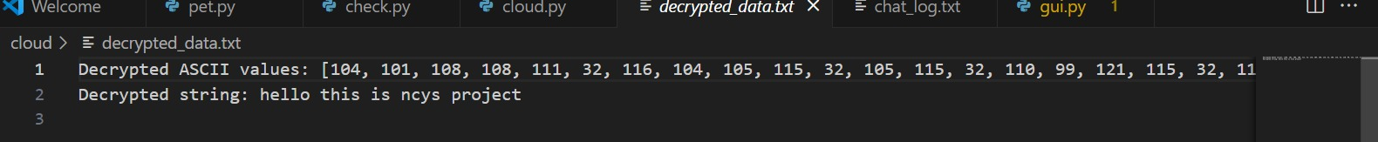

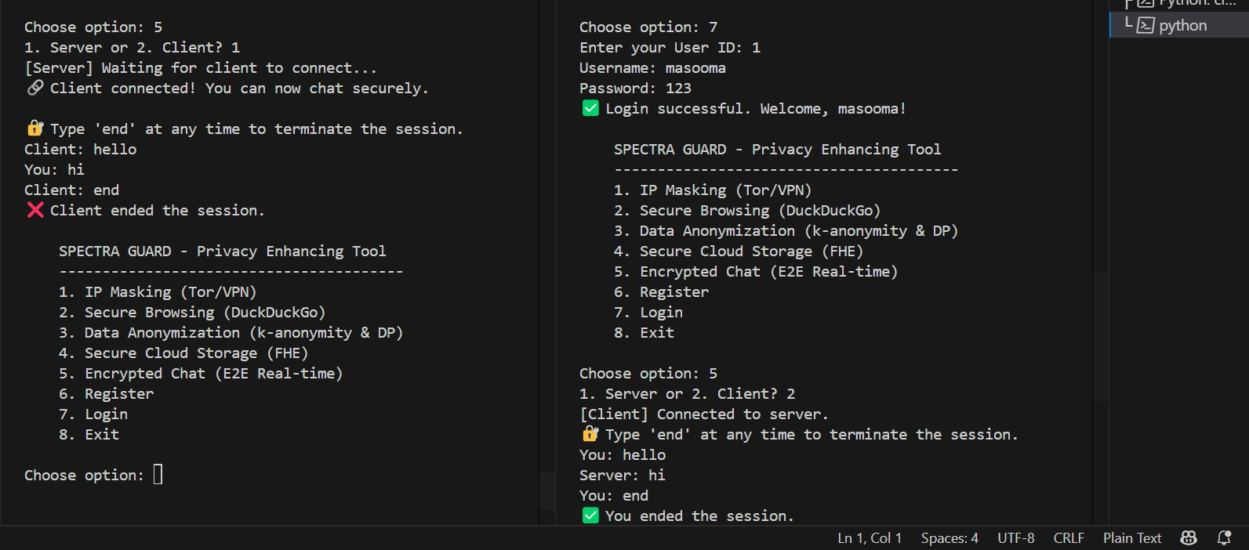

# 8. References

1. [Anonymity communication VPN and Tor: a comparative study (ResearchGate)](https://www.researchgate.net/publication/324251041_Anonymity_communication_VPN_and_Tor_a_comparative_study)
2. [How does DuckDuckGo protect my privacy? | DuckDuckGo Help Pages](https://duckduckgo.com/duckduckgo-help-pages/company/how-does-duckduckgo-protect-privacy/)
3. [Secure browsing: A guide to browsing the internet | LevelBlue](https://levelblue.com/blogs/security-essentials/secure-browsing-a-guide-to-browsing-the-internet-safely)