

|  |  |  |  |  |  |  |  |  |
| --- | --- | --- | --- | --- | --- | --- | --- | --- |
|  | | | | | | | | |
|  | | Homework 1 | | | | |  | |
|  |  | | | | | | |  |
|  | | | |  |  | | | |
|  | | | | Masoud Akbarzadeh |  | | | |
|  | | | | 2/2/2024 Estimate of Time to Completion: 12hr  Maximum Allocated Time to Completion: 18hr  Actual Time to Completion: 18hr  Peers in this homework: Juan, Nari, Amel —Objective Analysis in Atmospheric Science— |  | | | |
|  | | |  | | |  | | |
|  | | |  | | |  | | |

### Problem 1

1. For Y3 I used the raw SO Ion count of Carbitol photooxidation chamber experiment.
2. The standard normal data was created and plotted with standardized Y1 Y2 Y3 in one plot.

The most similar data to normal distribution is temperature while wind speed and ion count do not show a behavior similar to normal distribution.

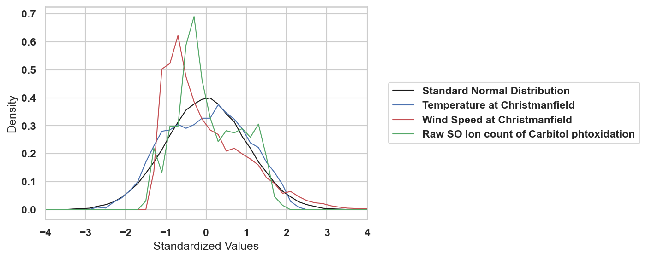

1. The probability that any one of the measurements to be more than +2 standard deviation was calculated by integrating under the PDF cure for each data from +2 standard deviation to infinity.

Pr(Y1 > +2) = 0.78%

Pr(Y2 > +2) = 4.70%

Pr(Y3 > +2) = 0.0%

Pr(Z > +2) = 2.23%

The actual value of datasets at +2 standard deviations is 91.9F, 8.1mph, 7610 ion count for Y1 ,Y2 ,Y3 respectively.

1. The actual rarity was calculated Pr(Y2 > +3) = 0.86% while using normal distribution would give us the probability as Pr(Z > +3) = 0.12%
2. The data is very far from normal distribution and shows qualities more similar to a log-normal distribution and the assumption that this data is normal would result in high errors in calculations.

### Problem 2

1. For N = 20 the pdf plot of all for the time series is as follows:

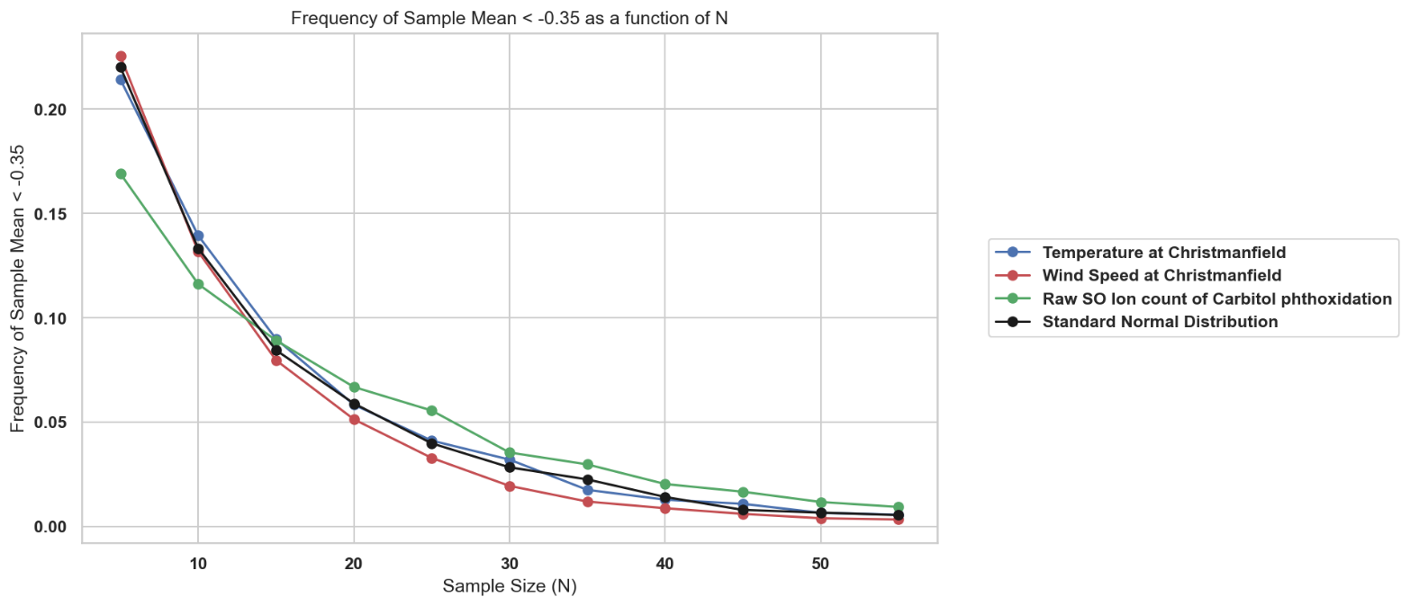

1. Because we are following the requirement of the central limit theorem here, it is expected that all of these data sets have similar behavior especially as the N increases.
2. It showed the usefulness of the central limit theorem even in datasets that are very different from the normal distribution.

### Problem 3

1. The Plot of the histogram of the data using the 1850 control run. The data is transformed into standard data for better visualization.

The mean of the temperature in the absence of climate change = 287.1 K

The variance of the temperature in the absence of climate change = 0.1 K

Comparing the data with the normal distribution I think it is Gaussian.

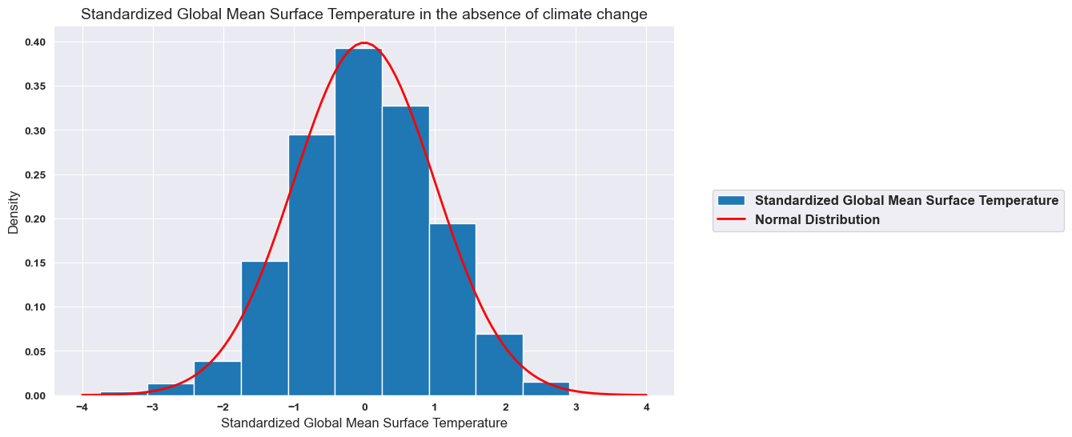

1. Plot of the time series from the control data and the global mean temperature from the first ensemble member:

1. The estimate of the global mean temperature over 1990-2019 for the first ensemble is plotted with the control period temperature frequency.

The mean of the temperature in the absence of climate change = 287.67

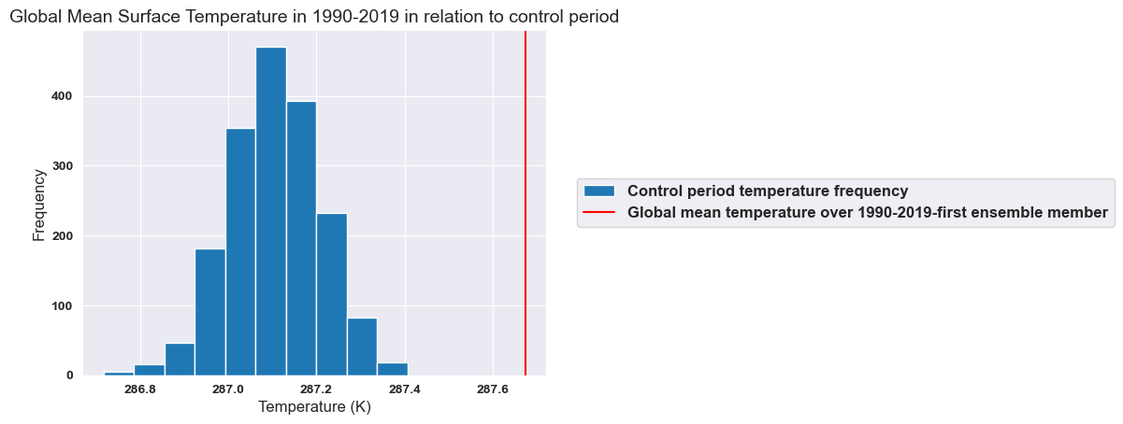

1. Assumptions:

* No global warming
* Normal distribution

Using z-stat the probability of getting a 30-year mean temperature as one in 3.3 was calculated as zero.

1. This probability was calculated to be zero for all ensemble members.

I am very confident that the mean temperature has risen because the probability is zero for all thirty cases.   
We can use a method similar to the jellybeans case and have all 30 cases having this low probability show a significant change in the mean.