

|  |  |  |  |  |  |  |  |  |
| --- | --- | --- | --- | --- | --- | --- | --- | --- |
|  | | | | | | | | |
|  | | Homework 1 | | | | |  | |
|  |  | | | | | | |  |
|  | | | |  |  | | | |
|  | | | | Masoud Akbarzadeh |  | | | |
|  | | | | 2/12/2024—Aerosol Physics & Chemistry— |  | | | |
|  | | |  | | |  | | |
|  | | |  | | |  | | |

### Problem 1

1. a.

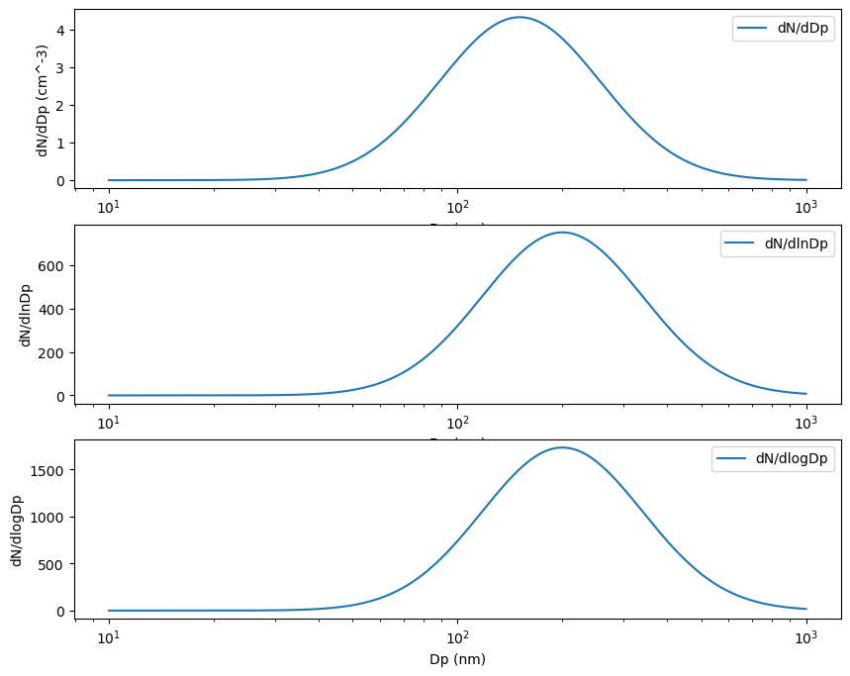

**1. b**

### 

1. **C**

### Problem 2

1. Assumptions:

Air:  
M = 0.289 kg/mol

Viscosity = 1.84e-5 Pa.s

Density = 1.18 kg/m3

Mean free path = 6.67e-8 m



