US ACCIDENT

- How have traffic accidents changed over time?
- Which states and cities have the highest number of accidents?
- Which month has the highest number of traffic accidents?
- How is accident severity distributed across the dataset?
- How do weather conditions influence accident occurrence and severity?
- Are accidents more frequent during the day or at night?
- What are the key factors associated with severe traffic accidents?

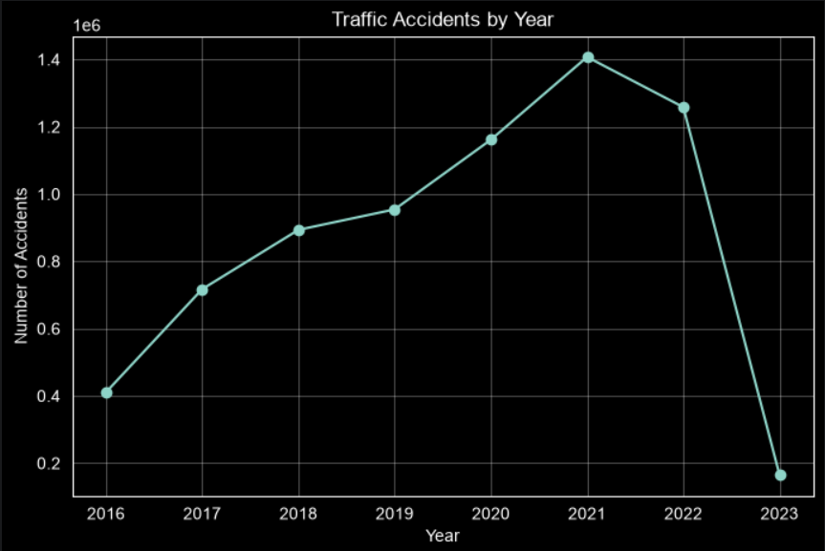The line chart illustrates the annual trend of reported traffic accidents from 2016 to 2023.
- The number of reported accidents increased steadily from 2016 to 2021, indicating a continuous rise in accident reports over this period.
- 2021 recorded the highest number of accidents, with approximately 1.4 million reported cases.
- In 2022, the number of accidents declined slightly, but it remained significantly higher than the levels observed before 2020.
- A sharp drop is observed in 2023. This sudden decrease is most likely due to incomplete data collection for the year, rather than a real reduction in traffic accidents. Therefore, the 2023 value should be interpreted with caution.

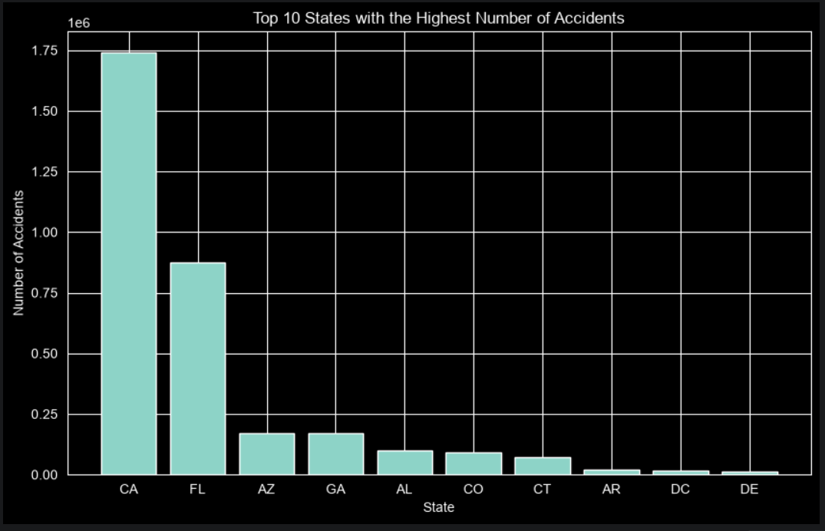 The bar chart presents the top 10 U.S. states with the highest number of reported traffic accidents.
- California (CA) recorded by far the highest number of accidents, with approximately 1.74 million reported cases. Its accident count is significantly higher than every other state in the dataset.
- Florida (FL) ranked second with around 870 thousand accidents, representing roughly half of California's total.
- Arizona (AZ) and Georgia (GA) followed, each reporting approximately 170 thousand accidents.
- The remaining states (Alabama, Colorado, Connecticut, Arkansas, District of Columbia, and Delaware) recorded substantially fewer accidents compared to the top two states.
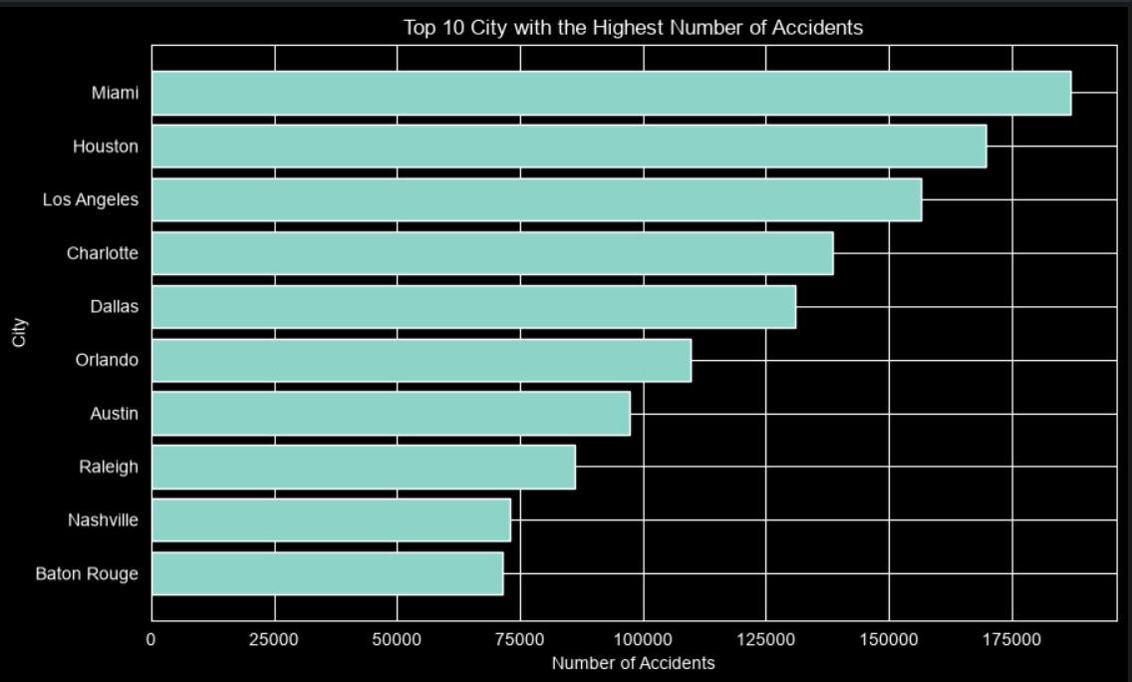The chart displays the top 10 cities with the highest number of reported traffic accidents in the dataset.
- Miami recorded the highest number of traffic accidents, with approximately 187,000 reported cases.
- Houston ranked second, followed closely by Los Angeles, both reporting more than 150,000 accidents.
- Charlotte and Dallas also experienced a high number of accidents, each exceeding 130,000 cases.
- The remaining cities, including Orlando, Austin, Raleigh, Nashville, and Baton Rouge, reported fewer accidents but still ranked among the top ten cities nationwide.

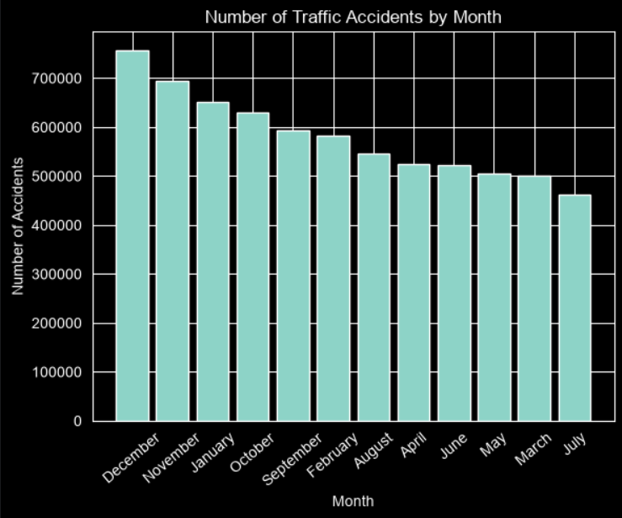The chart illustrates the distribution of reported traffic accidents across different months of the year.
- December recorded the highest number of traffic accidents, with approximately 760,000 reported cases.
- November ranked second, followed by January and October, indicating that accident frequency tends to increase during the late fall and winter seasons.
- July recorded the lowest number of reported accidents among all months.
- Although accident counts vary throughout the year, the differences between most months are relatively moderate, suggesting that traffic accidents occur consistently across all seasons.

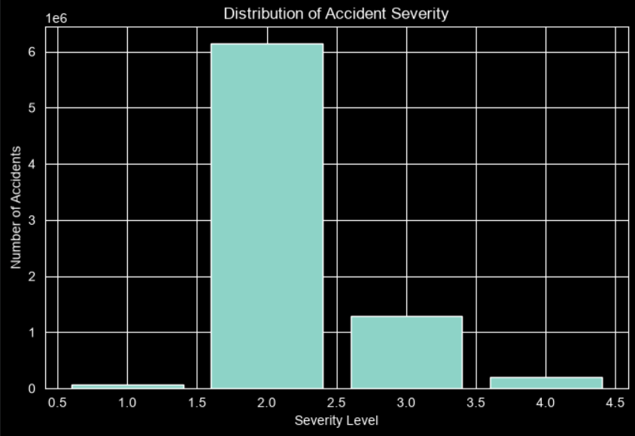The chart shows the distribution of traffic accidents across the four severity levels.
- Severity Level 2 accounts for the vast majority of reported accidents in the dataset, making it the most common severity category by a large margin.
- Severity Level 3 is the second most frequent category, although its number of accidents is significantly lower than Severity 2.
- Severity Levels 1 and 4 represent only a small proportion of the total accidents, indicating that both minor and extremely severe accidents occur less frequently.
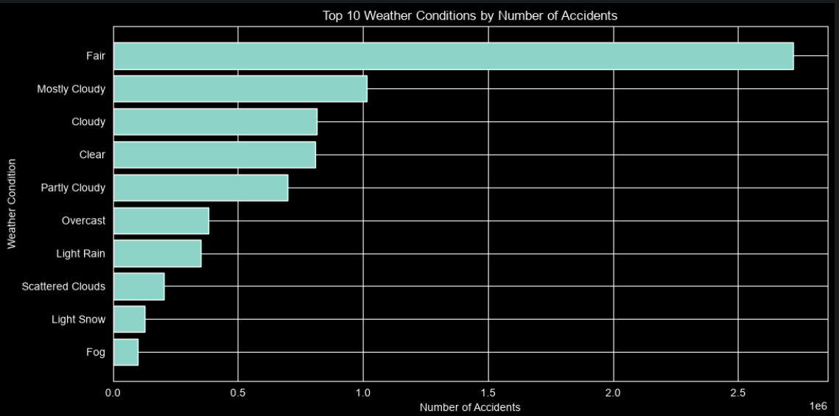The chart illustrates the top 10 weather conditions associated with the highest number of reported traffic accidents.
- Fair weather accounts for the largest number of reported accidents, with approximately 2.7 million cases, making it by far the most common weather condition during accidents.
- Mostly Cloudy ranks second, followed by Cloudy, Clear, and Partly Cloudy.
- Adverse weather conditions such as Light Rain, Light Snow, and Fog account for a much smaller number of reported accidents compared to fair weather.
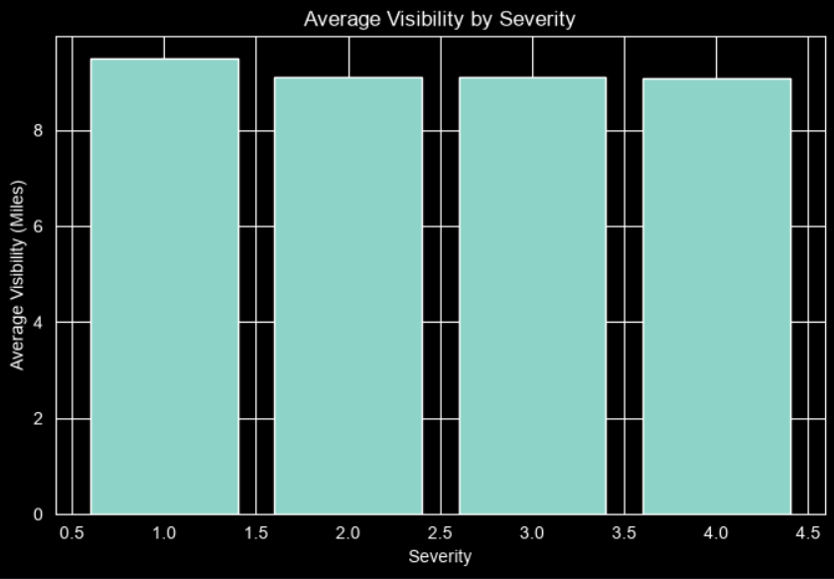The chart presents the average visibility (in miles) for each accident severity level.
- Severity 1 has the highest average visibility, at approximately 9.5 miles.
- Severity Levels 2, 3, and 4 have very similar average visibility values, all close to 9 miles.
- The differences in average visibility across the four severity levels are relatively small.
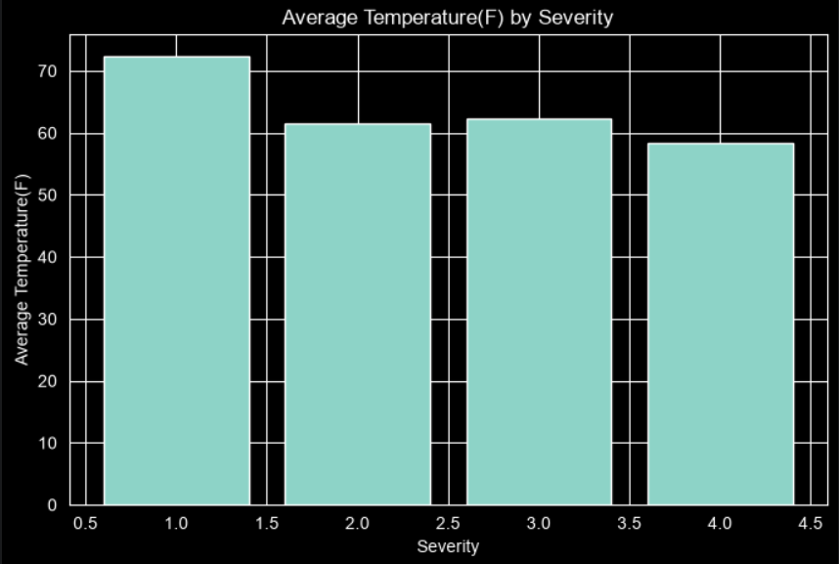The chart illustrates the average temperature (°F) for each accident severity level.
- Severity 1 accidents occurred at the highest average temperature, approximately 72°F.
- Severity 2 and Severity 3 show similar average temperatures, around 61–63°F.
- Severity 4 accidents occurred at the lowest average temperature, with an average of approximately 58°F.
- Overall, the average temperature tends to decrease as accident severity increases, although the differences are moderate.

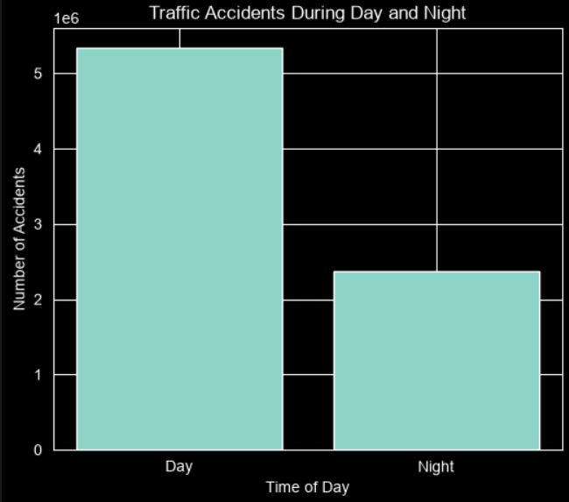 The chart compares the number of reported traffic accidents that occurred during the day and night.
- The majority of traffic accidents occurred during the daytime, with more than 5 million reported cases.
- In comparison, approximately 2.3 million accidents occurred during the night.
- Daytime accidents are more than twice as common as nighttime accidents in the dataset.

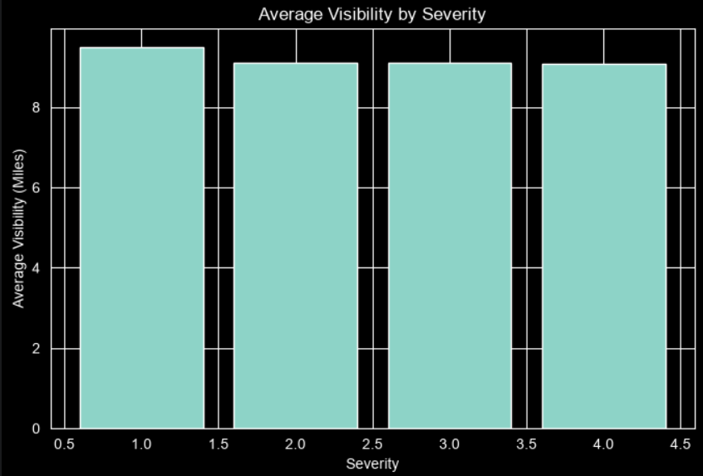 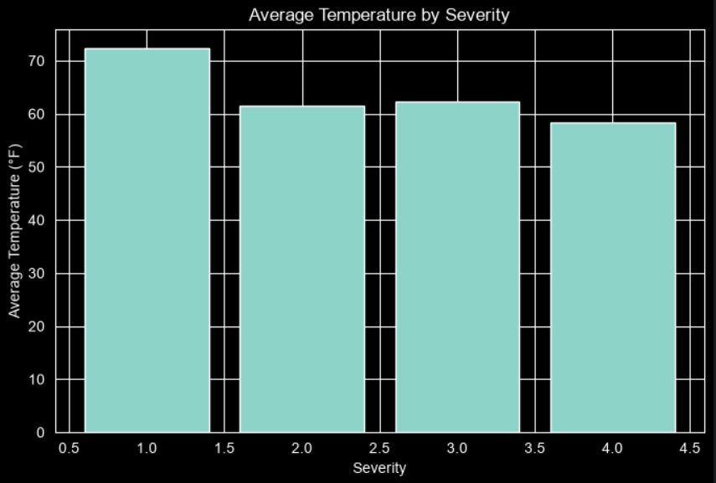 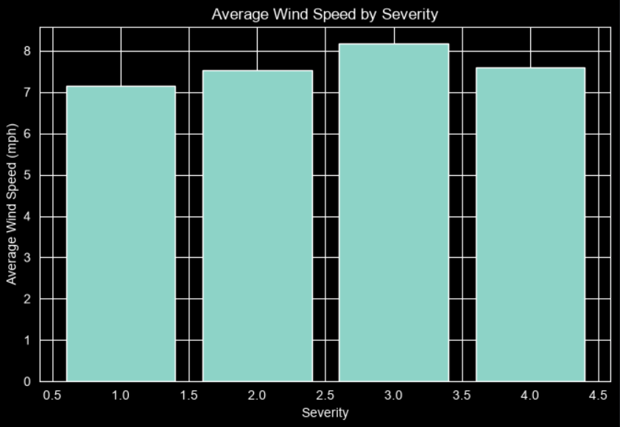 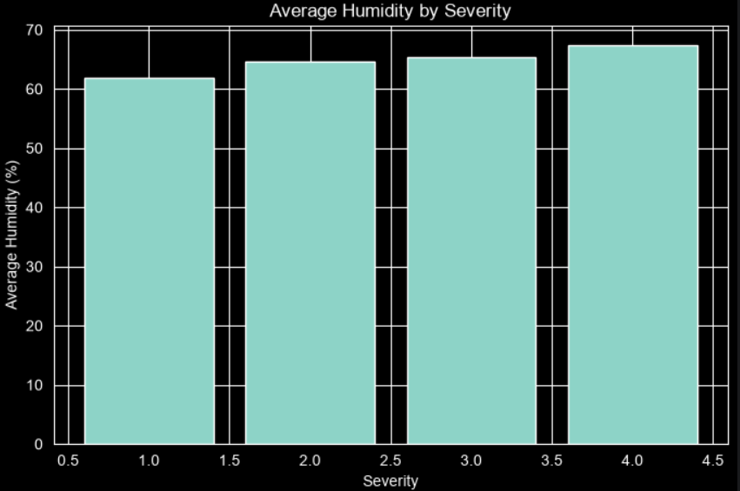 The analysis of weather-related variables suggests that severe traffic accidents are generally associated with:
- Lower average temperatures.
- Slightly lower visibility.
- Higher average wind speeds.
- Higher humidity levels.
- These findings indicate that weather conditions may influence accident severity, but they are unlikely to be the sole determining factors. Driver behavior, road infrastructure, traffic density, and vehicle conditions should also be considered when explaining severe traffic accidents.

